Agenda Papers

11th Meeting
SWAYAM BOARD

11th February 2019

Ministry of Human
Resource Development
Shastri Bhawan
New Delhi – 110001

AGENDA
11th Meeting of the SWAYAM Board

S. No. | Agenda Items | Page No.
1 | Agenda Item No. 1  Confirmation of Minutes of 10th SWAYAM Board Meeting | 2 - 4
2 | Agenda Item No. 2  Action Taken Report | 5 - 8
3 | Agenda Item No. 3  Status Report on SWAYAM Courses | 9 - 10
4 | Agenda Item No. 4  Review Report on Courses by NCs | 11
5 | Agenda Item No. 5  SWAYAM Examination Dates and Timelines for January 2019 Semester | 12
6 | Agenda Item No. 6  Inclusion of 9 Courses of IGNOU for Examination along with ARPIT Exam Cycle | 13
7 | Agenda Item No. 7  Exemption of Examination Fee for Students of Universities / Institutions seeking Credit Transfer through SWAYAM | 14 - 15
8 | Agenda Item No. 8  Charges payable to National Testing Agency (NTA) for Conducting SWAYAM Examination | 16 - 17
9 | Agenda Item No. 9  Extension of Contract of M/s Embee Software Pvt. Ltd. for M/s Azure Cloud Services for SWAYAM MOOCs Platform for 6 Months w.e.f. 08.02.2019 | 18
10 | Agenda Item No. 10  Payment of GST Charges on the translation proposals of IIT Madras and  IIIT Hyderabad & C-DAC | 19
11 | Agenda Item No. 11  Finalization of Courses for July 2019 Semester | 20
12 | Agenda Item No. 12  Training of SWAYAM Course Coordinators | 21
13 | Agenda Item No. 13  SWAYAM Prabha - Revision of SME Honorarium & Channel Maintenance Cost | 22
14 | Agenda Item No. 14  SWAYAM Prabha - inclusion of GYAN DHARSHN in SWAYAM Prabha | 23
15 | Agenda Item No. 15  Any other item with the permission of Chair

Agenda Item No. 1

Confirmation of Minutes of the 10th SWAYAM Board Meeting held on 12.12.2018

Minutes

The 10th Meeting of the SWAYAM Board was held under the Chairmanship of Shri R. Subrahmanyam, Secretary (HE), M/o HRD on 12.12.2018. List of Participants is enclosed.
2. Confirmation of Minutes of the 9th SWAYAM Board Meeting:
Board agreed to include the following point, which was discussed, as part of the Minutes of the 9th SWAYAM Board meeting:
IIT Madras presented that, the nature of SWAYAM Platform is such that the number of personnel required for development and maintenance would keep varying depending upon the requirements of the course coordinators, Ministry and students. The rates for hiring different types of personnel required for the development and maintenance of SWAYAM Platform has been finalized through the SWAYAM -ASP Tender.
The Board after discussions authorized SWAYAM-NPTEL IIT Madras who is handling the SWAYAM ASP Project to take appropriate decisions on the actual number of personnel required on a monthly basis, duly following the procedure prescribed by the Institute, within the overall amount sanctioned for the project. The Status may be reported to the Board on regular basis.
3. The status of SWAYAM Courses that was placed before the Board is summarized below:
- Total Courses : 1899
- Active Courses : 269
- Courses Completed : 1344
- Upcoming Courses : 286
- Students Registered on SWAYAM : 25,12,140
- Students Enrolled for courses on SWAYAM : 40,23,434
- Students Registered on NPTEL : 14,57,791
- Students Enrolled for courses on NPTEL : 35,65,520

It was noted that there are 108 courses which are having less than 500 learners which is a matter of concern. It was discussed that purpose of MOOCs is to cater the requirement of large number of people i.e. in masses. So the quality of courses should be high enough to attract and benefit learners in large numbers.

4. Board requested Director (CEC) to review and do a detailed analysis of the less popular courses (45 courses) and make a presentation in next Board meeting.

5. Board also requested all NCs to review their less popular courses and present a review report. The NCs should properly explore the issues that are leading to less turn out in these courses and work constructively to overcome these issues.

6. It was discussed and decided that since the ARPIT courses are going to end in month of February 2019 the enrollment to these courses should be allowed only till 15th January 2019. Accordingly, AICTE will act on this.

7. SWAYAM-NPTEL showcased the new report in the SWAYAM dashboard which gives the Health of the courses of all NCs based on different parameters. Board requested IIT Madras to work primarily on MHRD Dashboard and integrate the numbers of NPTEL platform to give complete picture. Board also requested IIT Madras to give the facility of participation in discussion forum through SWAYAM mobile app. It will enable students to participate actively on discussion forum.

8. Board requested IIT Madras to create a report indicating the major engineering disciplines covered by their SWAYAM courses and identify the gap areas in the core engineering graduate programmes.

9. CEC and other NCs were requested to plan their activities and courses for their July 2019 courses well in advance and to take necessary steps for their question papers and monitoring discussion forum activities. There should be uniform guidelines for setting up of question papers. Board requested Prof. Prathap Haridoss and Prof. Andrew Thangaraj to share their experiences with all NCs regarding the same.

10. Board requested IIM Bangalore to extend their course basket to other IIMs and request other IIMs to participate in the SWAYAM initiative. Board also suggested that since the courses on Soft skills are in demand, they may be offered by IIMs.

11. The Board desired that all NCs should have supporting manpower in place, on the lines of NPTEL, to effectively run and monitor the courses being offered in SWAYAM platform.

12. Report on SWAYAM Examination: Board recorded its appreciation for the MHRD and AICTE teams who have worked round the clock to ensure that the first ever SWAYAM examination is successfully organised.

13. Format of SWAYAM Certificate: After discussion it was decided that the certificate will bear the logo of SWAYAM and will be signed by NC and may be Course Coordinator. The SWAYAM certificates may be uploaded to the National Academic Depository also. The final formal of the certificate may be decided by SWAYAM Examination committee.

14. SWAYAM Examination for January, 2019 Semester Courses: The SWAYAM examination committee would give their recommendations on how to organise the future SWAYAM examinations.

15. SWAYAM Academic Board (SAB): It was decided that this should be as per the approved SWAYAM guidelines dated 1st June 2017. This Board is expected to ensure the quality of courses being run in SWAYAM Platform.

16. Courses on offer during January, 2019 Semester: Board approved the course list proposed by CEC- 61 courses and UGC - 58 Courses.

Board mentioned that the repurposed courses are not to be encouraged and if repurposed courses are on offer they must comply with all the quality parameters. Courses with less than 500 enrolments should be offered only with the specific approval of respective Academic Councils.

17. Channel Schedule for SWAYAM Prabha Channel No. 29: Board approved the proposal of INFLIBNET Centre for Channel Schedule and the strategy for delivery of SWAYAM Prabha Channel No. 29.

18. Telecasting of Health Science Education Videos through SWAYAM Prabha: Board approved the recording and telecasting of Health Science Education Videos in SWAYAM Prabha DTH Channels.

19. Conduct of ‘Yoga Programmes’ Examinations by Swami Vivekananda Yoga Aunsandhana Samsthana (S-Vyasa), Bangalore

After discussions the following was decided regarding conduct of examinations:

(i) The examination fees would be collected through the platform by AICTE
(ii) The NCs would organize the examinations
(iii) The NCs would incur the expenditure for conducting the examination from the funds provided to them under the SWAYAM project.
20. SWAYAM 2.0:

IIT Madras presented the status on SWAYAM 1.0 and SWAYAM 2.0.
Board approved the Technical Committee for SWAYAM 2.0 proposed by IIT Madras: Prof. Sudarshan (IIT Bombay), Prof. Huzur Saran (IIT Delhi), Prof. Andrew Thangaraj (IIT Madras), Shri Shekhar Patankar (Persistent Systems), Prof. Prathap Haridoss (IIT Madras), Shri ParameswaranN. (Advisor, MHRD). The Committee would have powers to co-opt members.
The Timelines for Development and Implementation of SWAYAM 2.0 are as follows:
Dec 2018: Tender for cloud service (linked to funds release)
Jan 2019: Alpha release,
Feb 2019: Beta release,
Mar 2019: Go Live

****

Agenda Item No. 2

Action Taken Note on the Points decided in the 10th SWAYAM Board Meeting held on
12th December, 2018

S.No | Items | Action Taken Note
1 | Awareness Creation & Publicity.  A. Local Chapters activity | NPTEL: Local Chapter felicitation cum Interaction events were organized in the 4 zones where SPOCs of more than 700 LCs participated. 19 Jan – IITM; 19 Jan – IITK; 25 Jan – IITB; 2 Feb – Kolkata. Campaigns are being run on various social media for promoting the courses.
 | B. Social Media Campaign Strategy for SWAYAM | M/s EdCIL (India) Ltd.:
 | C. Complete status reg. the number of Courses adopted for credit transfer:  The number of courses adopted for credit transfer, total number of students benefited from credit transfer, process of credit transfer in the in 92 Universities / Institutions. This may be seriously pursued by UGC. | UGC: The information is being obtained.
2 | Review Report of running courses by NCs and activity plan :  A. Director (CEC) to review and do a detailed analysis of the less popular courses (45 Courses) and make a presentation in next Board meeting. | Agenda Item No. 4
 | B. Requested all NCs to review their less popular courses and present a review report.  CEC and other NCs were requested to plan their activities and courses for their July, 2019 Courses well in advance and to take necessary steps for their question papers and monitoring discussion forum activities. | Agenda Item No. 4
3 | Inclusion of SWAYAM Learners to calculate GER:  The NCs may deliberate on the issue and present their views in the next SWAYAM Board meeting. Subsequently, method can be derived in consultation with DDG (Statistics). | UGC: As SWAYAM learners for credit are already enrolled in university, they are counted under GER automatically.  NCERT: For the learners who are not enrolled in any school/institution, they can be part of the GER calculation.
4 | Courses on offer for January, 2019 Semester : | NC | Committed | Uploaded
 |  | NPTEL | 290 (144 New + 146 Rerun) | 291
 |  | IIM B | 9 ( 2 New + 7 Rerun ) | 8
 |  | UGC | 58 (7 New + 4 rep. + 47 rerun) | 58
 |  | CEC | 61 (53 Courses + 8 Rerun) | 61
 |  | NITTTR | 24 (22 New + 2 Rerun) | 9
 |  | IGNOU | 16 (3 New + 13 Rerun) | 8
 |  | NCERT | 14 (3 New + 11 Rerun) | 14
 |  | NIOS | 11 (11 New ) | 8
 |  |  | 483 | 457
5 | Integration of SWAYAM & NPTEL statistics in MHRD Dashboard :  Board requested IIT Madras to work primarily on MHRD Dashboard and integrate the numbers of NPTEL platform to give complete picture. Board also requested IIT Madras to give the facility of participation in discussion forum through SWAYAM mobile app. | IIT Madras: Completed for January, 2018 and July, 2018  Discussion forum: Under progress – will be done as part of SWAYAM 2.0
6 | Gap areas in the core engineering graduate programmes:  IIT Madras to create a report indicating the major engineering disciplines covered by their SWAYAM courses and identify the gap areas in the core engineering graduate programmes. | IIT Madras  Under progress – Will be completed by March 2019
7 | Guidelines for setting up of question papers :  Board requested Prof. Prathap Haridoss and Prof. Andrew Thangaraj to share their experiences with all NCs regarding the same. | IIT Madras  Will be shared shortly to all NCs.
8 | NC Office Setup :  All NCs should have supporting manpower in place, on the lines of NPTEL, to effectively run and monitor the courses being offered in SWAYAM platform. | UGC: Interview for these posts are going to be conducted soon.  CEC: Have requested additional budget.  NCERT: A dedicated lab for SWAYAM MOOCS has been created at CIET- NCERT. Total four persons deployed on project (One Consultant and one project staff and two teaching assistants) More teaching assistants will be appointed as per the course strength and requirement.  NIOS: is in the process of setting up NC office, however the SWAYAM courses are being monitored by 2 officers.
9 | Certificate Format:  The final format of the certificate may be decided by SWAYAM Examination committee | MHRD : Attached as Annexure-I
10 | Recommendations on how to organize the future SWAYAM examinations. | Agenda item No. 5
11 | SWAYAM 2.0 Status | IIT Madras: Prof. Andrew Thangaraj to update in the meeting.
12 | Application Service Provider  A. Cloud Transition progress report of M/s CtrlS  B. Cloud Consumption report (Azure)  C. YouTube video on new features | IIT Madras:  Expert committee has submitted recommendations to AICTE and further updates from AICTE in the meeting  - Will be presented in the meeting  - Will be done soon

Annexure I

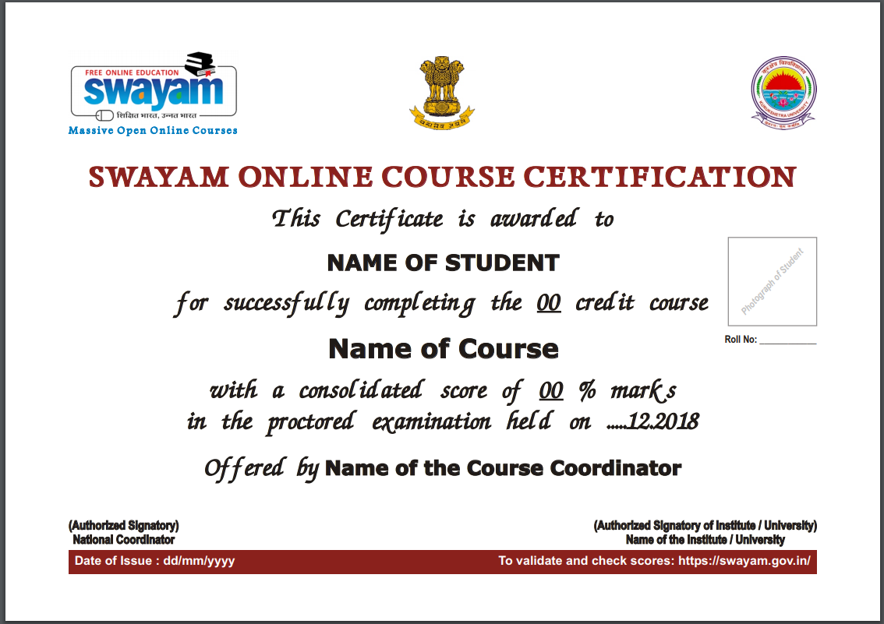

Agenda Item No. 3

Status Report on SWAYAM Courses

Status of SWAYAM Courses as on 07.02.2019
Total Number of Courses Listed on SWAYAM | 2081
Past Courses listed on SWAYAM | 1416
Current Courses listed on SWAYAM | 565
Upcoming Courses listed on SWAYAM | 100

Registration & Enrollment Status as on 07.02.2019
Total number of Registration on SWAYAM Platform | 27,23,651
Total number of Registration on NPTEL Platform | 22,15,614
Total Registrations | 49,39,265
Total number of Enrollment on SWAYAM Courses | 42,38,677
Total number of Enrollment on NPTEL Courses on NPTEL Platform | 50,67,452
Total Enrollments | 93,06,129

Status of January 2019 Semester Courses (as on 07.02.2019)
NC | Committed | Uploaded | Enrollments
NPTEL | 290 (144 New + 146 Rerun) | 291 | 15,01,932  On NPTEL
IIM B | 9 ( 2 New + 7 Rerun ) | 8 | 9,801
UGC | 58 (7 New + 4 rep. + 47 rerun) | 58 | 32,985
CEC | 61 (53 Courses + 8 Rerun) | 61 | 49,820
NITTTR | 24 (22 New + 2 Rerun) | 9 | 25,990
IGNOU | 16 (3 New + 13 Rerun) | 8 | 313
NCERT | 14 (3 New + 11 Rerun) | 14 | 2,024
NIOS | 11 (11 New ) | 8 | 329
 | 483 | 457 | 1,21,262 on SWAYAM

Enrollment in January, 2019 Semester Courses (as on 7th February, 2019)
NC Name | Total Courses | Total Enrollments | Courses Enroll. ≤ 500 | Courses Enroll. 500 < 1000 | Courses  Enroll. ≥ 1000
NPTEL | 291 | 15,01,932 | 8 | 22 | 188
IIM B | 8 | 9,801 | 2 | 2 | 4
UGC | 58 | 32,985 | 35 | 16 | 7
CEC | 61 | 49,820 | 19 | 28 | 14
NITTTR | 9 | 25,990 | 1 | 1 | 7
IGNOU | 8 | 313 | 8 | - | -
NCERT | 14 | 2,024 | 13 | 1 | -
NIOS | 8 | 329 | 8 | - | -
Total | 457
IGNOU: All courses are set to start on 3rd March and ending on 30th April. Content yet to be uploaded
NIOS: All Courses start date 1st April & End Date 30th September.
NITTTR: A Course “Industry-Institute - Community Partnership” having 1431 Enrolments started on 1st January and end date as 2nd February, but not having a single content uploaded in it.
UGC: Start Date for all the Courses are 25th & 28th January, 2019 .End Dates are scheduled for 54 Courses are 10th May, 2019. Credit allocated for the courses for the same length is mentioned as 3,4,5,6. Why?
IIM Bangalore: End dates for seven courses are set as 2nd June 2019.

Top 15 Certificate / Credit Courses of January, 2019 Semester (Enrollment-wise)

S.No. | Course Name | NC | Enrollment
1 | ICT in Teaching and Learning.. | NITTTR | 8612
2 | Academic and Research Report Writing | NITTTR | 4577
3 | Problem Based Learning | NITTTR | 4359
4 | Artificial Intelligence | UGC | 4185
5 | Nature of Language | CEC | 2741
6 | Redefining Laboratory Instruction using Virtual Laboratory | NITTTR | 2640
7 | Basics of Photography | CEC | 2633
8 | Advertising and Consumer Behaviour | CEC | 2601
9 | IT Fundamentals | CEC | 2522
10 | Introduction to Marketing Essentials | IIM B | 2274
11 | Introduction to Managerial Economics | IIM B | 2110
12 | Fundamentals of Outcome-based Curriculum in Engineering Education | NITTTR | 1867
13 | Plant biochemistry and plant biotechnology | CEC | 1750
14 | Intellectual Property Rights | IIM B | 1718
15 | Better Spoken English | NPTEL | 1584

Agenda Item No. 4

Review Report on Courses by NCs

Presentation to be made by individual NCs

Agenda Item No. 5

SWAYAM Examination Dates and Timelines for January 2019 semester

Purport
The note is to seek the approval of the Board for the dates of Examination for SWAYAM January 2019 Semester Courses and other timelines associated with it.

Background
On 18th January, 2019 in SWAYAM Review meeting held under the Chairmanship of Joint Secretary (TEL & ICC), MHRD, detailed discussion were held on Examination Dates, Course End Dates and Enrollment cut off dates for January 2019 Semester Courses. After deliberations, it was decided that the outer limit for the Course End Date for all the January, 2019 Semester Courses would be 20th April, 2019. The outer limit for the Cutoff date for enrollment should be 28thFebruary 2019 or one month before the course end date, whichever is earlier.
In consultation with National Testing Agency Examination dates for the January 2019 Semester Courses of SWAYAM have been finalized as 11th & 12th May, 2019.

Approval Sought:

The Board is requested to kindly approve the schedule of examination for the January 2019 Semester Courses of SWAYAM as 11th & 12th May 2019 along with other timelines regarding Course End Date as 20th April 2019 and Enrollment Cutoff Date as 28th February 2019.

Agenda Item No. 6

Inclusion of 9 Courses of IGNOU for Examination along with ARPIT Exam Cycle

Purport

The objective of this Note is to seek approval of the Board to include 9 Courses of IGNOU along with ARPIT Exam Cycle.

Proposal

The exams for 9 Courses of IGNOU could not be conducted in December, 2018 Cycle. IGNOU has requested to include these courses along with the ARPIT Exams, to be held on 30th March 2019.

S.No | Programme Title | Start date | end date | Enrolment
1. | Food Laws and Standards | 9/7/2018 | 31/12/2018 | 1151
2. | Technology of Fermented, Cheese, Ice-cream and By- Products | 9/7/2018 | 31/12/2018 | 811
3. | Indian Agricultural Development | 9/7/2018 | 31/12/2018 | 2934
4. | Sustainable Management of Biodiversity | 1/7/2018 | 31/12/2018 | 2102
5. | Introduction to Poultry Farming | 9/7/2018 | 31/12/2018 | 557
6. | Design and Facilitation of E- Learning Courses | 1/7/2018 | 31/12/2018 | 821
7. | Russian Language | 2/7/2018 | 31/12/2018 | 1484
8. | Library Automation and Digitisation | 1/7/2018 | 31/12/2018 | 2053
9. | Database and Content Organisation | 1/7/2018 | 31/12/2018 | 1914

Approval Sought
Approval is sought for Inclusion of 9 Courses of IGNOU for Examination along with ARPIT Exam on 30th March 2019.

Agenda Item No. 7
Exemption of Examination Fee for Students of Universities / Institutions seeking
Credit Transfer through SWAYAM

Purport
The objective of this Note is to seek approval for exemption of Examination Fee for Students of Universities/Institutions seeking Credit Transfer through SWAYAM.

Background
The ‘Credit Framework for online learning courses through SWAYAM, Regulation 2016’, allows up to 20% online courses taken through SWAYAM, to be counted for credit. Grades earned by successful students studying in regular Institutes shall be transferred to the academic record of such Students.
The students enrolled in Universities / Institution already make payment of examination fees to their respective Universities / Institution for programmes. Thus opting and writing for exams for a course seeking credit transfer through SWAYAM becomes an extra burden on them.
Also UGC has received many requests from Universities / Institutions regarding exemption of examination fee for students enrolled in their programmes. Specifically the Vice Chancellor of Shri LBS Sanskrit Vidyapeetha has requested to exempt the fees for Sanskrit students, as there is no tuition fee for Sanskrit students (Annexure II).

Proposal

It is proposed to exempt the Examination Fee for regular Students of Universities/Institutions seeking Credit Transfer through SWAYAM. The registration of such students would be done through the educational institutions.

Approval Sought:

The Board is requested to kindly consider for approval the above proposal for Exemption of Examination Fee for Students of Universities/Institutions seeking Credit Transfer through SWAYAM.

Annexure II
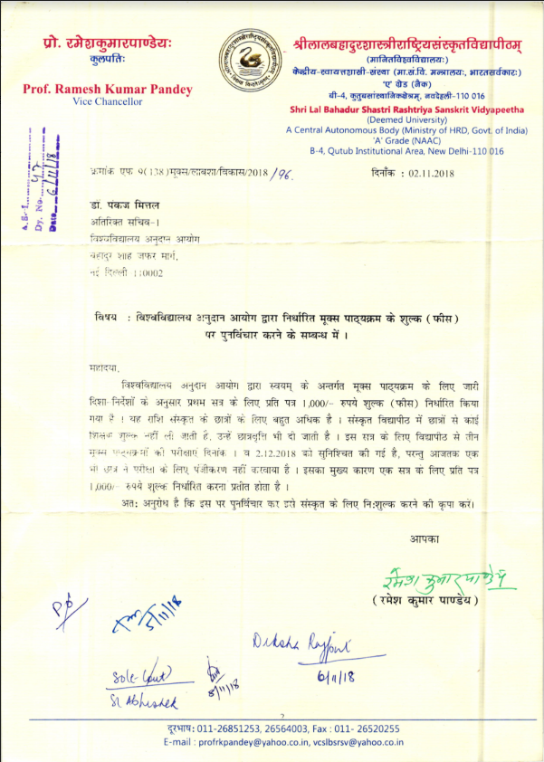

Agenda Item No. 8

Charges payable to National Testing Agency (NTA) for Conducting SWAYAM Examination

Purport

The objective of this Note is to seek the approval of the Board on the Charges payable to NTA for conducting SWAYAM Examination and accordingly payment of charges for the December 2018 Examinations.

Background
NTA has conducted the SWAYAM Examinations of July 2018 Semester Courses on 1st & 2nd December 2018 for 3807 candidates. NTA is also going to conduct the exams of January 2019 Semester Courses on 11th & 12th May, 2019.
NTA vide their letter dated 25.01.2019 (Annexure-III) informed that the Chairman (Secretary, Higher Education, MHRD), Governing council NTA has approved Rs. 600/- as fee per candidate for such examinations. NTA has also requested for payment of Rs. 22,84,200/- for the exams held on 1st & 2nd December 2018 for 3807 candidates (3807 x Rs.600).

Approval Sought
Board is requested to kindly consider and approve the per candidate fee of Rs. 600/- payable to NTA for conducting examination for SWAYAM Courses and payment of Rs.22,84,200/- to NTA for examinations held on 1st & 2nd December 2018 for 3807 candidates.

Annexure III

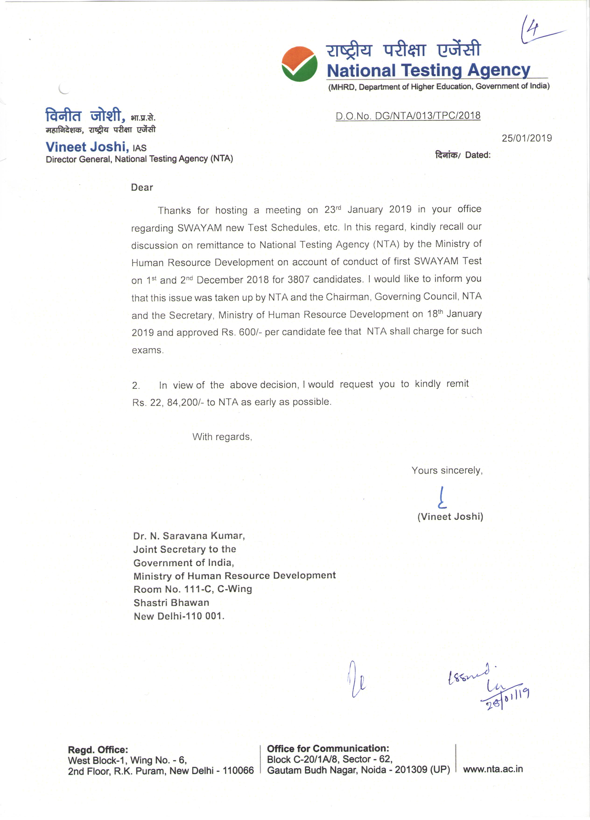

Agenda Item No. 9

Extension of Contract of M/s Embee Software Pvt. Ltd. for M/s Azure Cloud Services for SWAYAM MOOCs Platform for 6 Months w.e.f. 08.02.2019

Purport

The objective of this note is to seek post-facto approval of the Board for the Extension of Contract of M/s Embee Software Pvt. Ltd. for M/s Azure Cloud Services for SWAYAM MOOCs Platform for 6 months w.e.f. 08.02.2019.

Background

M/s Embee Software Pvt. Ltd. was selected for providing M/s Azure Cloud Services for SWAYAM Platform for a period of Six Months from 8thFebruary, 2018 to 7th August, 2018.The SWAYAM Board in its 5th Meeting held on 11.06.2018 approved the extension of contract of M/s Embee Software Pvt. Ltd. for further six months i.e. from 08.08.2018 to 07.02.2019 for providing M/s Azure Cloud Services for SWAYAM Platform, on the existing terms and conditions of the Contract of Agreement and the Work Order with the condition that services could be terminated by giving one month notice.

On 18th January 2019 in the SWAYAM Review meeting chaired by JS (TEL & ICC), AICTE informed that the M/s Azure Cloud Contract would end on 7th February 2019. Further, since the new cloud tender that is being done by IIT Madras would take some more time to get finalized the existing contract for cloud services is to be extended for another 6 months. Since the next Board meeting was scheduled on 11th February 2019, it was decided that AICTE may go ahead with the extension of the contract for a period of 6 months with the provision that it could be terminated with one months notice.

The details of month-wise payments being made to M/s Embee Software Pvt. Ltd. providing M/s Azure Cloud Services for SWAYAM Platform w.e.f. 08.02.2018 till November, 2018 are as under:

Month | Expenditure  (in Rs.) | Month | Expenditure  (in Rs.)
February, 2018  (08.02.2018 to 28.02.2018) | 38,68,744/- | August, 2018 | 60,85,435/-
March, 2018 | 54,35,600/- | September, 2018 | 54,03,026/-
April, 2018 | 52,68,613/- | October, 2018 | 55,18,251/-
May, 2018 | 56,25,052/- | November, 2018 | 50,75,701/-
June, 2018 | 52,91,711/- | December, 2018 | Bill Yet to be received
July, 2018 | 56,72,152/- | January, 2019 upto 07.02.2019 | Bill Yet to be received
TOTAL | 3,11,61,872/- | TOTAL | 2,20,82,413/-
GRAND TOTAL  (Rs. 31161872 + Rs. 22082413) |  |  | 5,32,44,285/-

The average monthly expenses towards M/s Azure Cloud Services for SWAYAM Platform come to Rs.53,24 Lakhs

Approval Sought

Board is requested to kindly ratify the extension of the Contract of M/s Embee Software Pvt. Ltd. for providing M/s Azure Cloud Services for a further period of six months from 8th February 2019 to 7th August 2019 on the existing terms & conditions with provision for termination of service anytime by giving one month notice.

Agenda Item No. 10

Payment of GST Charges on the translation proposals of IIT Madras and
IIIT Hyderabad & C-DAC

Purport
The objective of this note is to seek approval of the Board for payment of GST Charges on the translation proposals of IIT Madras and IIIT Hyderabad &C-DAC.

Background
SWAYAM Board in its 4thmeeting held on 07.05.2018 had given its approval on proposal of
Rs.10.79 Crore for translation of SWAYAM Courses by IIT Madras. In the meeting it was decided to give to IIT Madras video content of 1600 Hours (i.e. top 40 SWAYAM Courses of 40 Hours Video) for translation. Also it was decided that in case C-DAC is able to match the prices they would also be given courses for translation. In line with the proposal of IIT Madras the same prices were matched by consortium of IIIT Hyderabad & C-DAC in their proposal.
For some of the components in the proposal GST is applicable. Both IIT Madras and IIIT Hyderabad & C-DAC have clarified that the proposals of Rs.10.79 Crore for translation of SWAYAM Courses does not include the GST payable.

Approval Sought
Board is requested to kindly approve payment of GST Charges as applicable on actuals, in addition of the approved amount of Rs.10.79 Crore for translation of 1600 hours of Video contents. Further allocation of work of translation of SWAYAM courses on same terms and conditions to IIIT Hyderabad & C-DAC.

Agenda Item No. 11

Finalization of Courses for July 2019 Semester

Purport

The objective of this note is to set the time lines for finalising the list of courses to be offered in the July 2019 Semester.
Background
In the SWAYAM Review meeting held on 18th January 2019 all NCs are requested to finalize and submit the list of July, 2019 Semester Courses to MHRD so that there will be sufficient time for publicity and approval of the courses in the respective senate / councils of Universities /Institutions. MHRD has not received the July 2019 course list as requested.
In the 9th SWAYAM Board meeting the Board reiterated the following guidelines while offering SWAYAM Courses which are to be kept in consideration.
(a) Repurposing of courses are not to be encouraged. (b) The courses that are chosen for rerun should have at least 500 enrolments in the earlier run. (c) The course should have the approval of Academic Council. (d) One faculty should not handle more than two courses as Course Coordinator, at a time. (e) Start dates of all the courses should be within 15 days of start of the Semester, so that exams can be planned at the same time.

Decision Sought
The Board is requested to kindly finalize the date by which the NCs should submit the list of courses that would be offered during the July 2019 semester.

Agenda Item No. 12

Training of SWAYAM Course Coordinators

Purport
The objective of this note is to request the Board to nominate a Committee for working out the details of the training that is to be offered to the SWAYAM course coordinators so that quality courses are offered in SWAYAM.

Background

It has been observed that the trends and technology in online education is changing frequently. New age trends and skills are getting introduced in the fast changing arena. The on line courses are to be Designed, Developed, Delivered and Transacted effectively. The students are to be motivated and engaged properly. All this would require that the course coordinators are trained properly so that they can offer quality courses in SWAYAM.

Proposal

The proposal is to constitute a Committee which could work out the training requirements, finalize a training plan and implement the same.

Decision Sought

Board is requested to kindly constitute a Committee for planning and implementation of the training programme for SWAYAM course coordinators.

Agenda Item No. 13

SWAYAM Prabha - Revision of SME Honorarium & Channel Maintenance Cost

Purport
The objective of this agenda item is to take approval for revised SME honorarium and channel maintenance cost.

Background:

A review meeting with all national coordinators of SWAYAM Prabha was held on 11th January, 2019 at CEC Office, New Delhi and was chaired by Prof. K. Mangala Sunder, Chief Coordinator, DTH SWAYAM Prabha.

In the meeting, it was felt that the present SME Honorarium of Rs. 2500/Half Hour should be revised to Rs. 5000/Half hour, in line with SWAYAM guidelines (as per the Financial Norms for Development of MOOCs for SWAYAM dated 04.12.2017). The contents could be used both in SWAYAM and SWAYAM Prabha.

Similarly, the present Annual Channel Maintenance Cost of Rs. 10 Lakhs/channel should be revised to
Rs. 17.26 Lakhs/channel as per details given below:

S.No. | Expenditure Heads for One DTH Channel | Per Month (Rs.) | Total Per Year (Rs.)
1. | Wages  - Academic Coordinator  - Editor  - Data Entry Operator  - MTS | 50,000/-  38,000/-  20,000/-  15,000/- | 6,00,000/-  4,56,000/-  2,40,000/-  1,80,000/-
2. | Trainings/Workshops/Coordination Meetings/others |  | 1,50,000/-  per year
3. | Miscellaneous |  | 1,00,000/-  per year
 | Total |  | 17,26,000/-

Approval Sought:

Board is requested to kindly approve the revision of he SME honorarium from Rs. 2500/Half Hour to Rs. 5000/Half hour and annual channel maintenance cost from Rs. 10 Lakhs to Rs. 17.26 Lakhs per Channel.

Agenda Item No. 14

SWAYAM Prabha – Inclusion of GYAN DARSHAN in SWAYAM Prabha

Purport
The objective of this note is to take approval of the Board for inclusion of GYAN DARSHAN in SWAYAM Prabha.

Background:

A review meeting with all national coordinators of SWAYAM Prabha was held on 11th January, 2019 at CEC Office, New Delhi and was chaired by Prof. K. Mangala Sunder, Chief Coordinator, DTH SWAYAM Prabha.

In the meeting, it was mentioned by IGNOU that they would like to reorient their SWAYAM Prabha channels by including GYAN DARSHAN as one of their channels. .

Approval Sought:

Approval of the Board is sought for inclusion of GYAN DARSHAN as one of the IGNOU channels in SWAYAM Prabha.

Thank You

