Agenda Papers

15th Meeting
SWAYAM BOARD

14th August 2019

Ministry of Human
Resource Development
Shastri Bhawan
New Delhi - 110001

AGENDA
15th Meeting of the SWAYAM Board

S.No. | Agenda Items | Page No.
1 | Agenda Item No. 1  Confirmation of Minutes of 14th SWAYAM Board Meeting | 2 - 5
2 | Agenda Item No. 2  Action Taken Report | 6 - 10
3 | Agenda Item No. 3  Status Report on SWAYAM Courses | 11
4 | Agenda Item No. 4  Presentation by NCs - Delivering Courses as a Package on SWAYAM and Review Report on Courses | 12
5 | Agenda Item No. 5  Approval of the Recommendations of three-member Committee headed by Retired Judge of the High Court in the matter of M/s CtrlS Datacenters Ltd., Hyderabad for non-compliance of agreement to migrate all SWAYAM applications and services on SWAYAM Platform for taking appropriate action by AICTE | 13 - 17
6 | Agenda Item No. 6  AICTE - Creation of Online Courses on “Human Excellence” by Vivekananda Institute of Human Excellence, Ramakrishna Math, Hyderabad | 18
7 | Agenda Item No. 7  LSC - Proposal for Creating MOOC relating to Logistics Courses in SWAYAM Portal | 19 - 25
8 | Agenda Item No. 8  NC / CC Guidelines for Running of SWAYAM Courses | 26 - 29
9 | Agenda Item No. 9  NIOS - Hosting “D.El.Ed. Course for Elementary Teachers” material on SWAYAM as self paced Teacher Refresher Course | 30 - 31
10 | Agenda Item No. 10  NIOS - Integration of NIOS Student Portal with SWAYAM 2.0 Portal through Web Services for Single Registration | 32
11 | Agenda Item No. 11  AICTE - Extension of Contract of M/s Embee Software Pvt. Ltd. for M/s Azure Cloud Services for SWAYAM MOOCs Platform from 8th August, 2019 till 31st December, 2019 - Information Agenda | 33 - 35
12 | Agenda Item No. 12  AICTE - Extension of Contract of Bulk SMS Gateway and e-Mail Services through M/s Netcore Solutions Pvt. Ltd., New Delhi from 01.04.2019 to 31.03.2020 - Information Agenda | 36
13 | Agenda Item No. 13  Allocation of SWAYAM Prabha Channel to AICTE | 37 - 38
14 | Any other item with the permission of Chair

Agenda Item No. 1

Confirmation of Minutes of the 14th SWAYAM Board Meeting held on 10.06.2019

Minutes

The 14th Meeting of the SWAYAM Board was held under the Chairmanship of Shri R. Subrahmanyam, Secretary (HE), M/o HRD on 10.06.2019.
2. Confirmation of Minutes of the 13th SWAYAM Board Meeting: SWAYAM Board confirmed the minutes of 13th SWAYAM Board meeting.

3. The status of SWAYAM Courses that was placed before the Board. A total of 2769 courses have been offered through SWAYAM till date. The total enrollments in these courses stand at 1,02,60,214.
4. Local Chapters:
UGC reported that they are planning to organize Workshops in 4 locations as below:
- 2nd Last week June 2019:-Kolkata (covering States Bihar, Jharkhand, West Bengal)
- 21st June 2019:- NLU Bhopal (for the zone Madhya Pradesh & Chhattisgarh)
- 1st Week July 2019:- Bangalore (covering Southern States)
- 2nd week July:- Tezpur (covering North East State)

Secretary (HE), MHRD made the following observations. In order to ensure that the workshops are effective, active participation of State Governments should be ensured. A letter to be written to the Secretary (Education), MHRD in the respective States. Workshops should also be conducted in highly populated states like Uttar Pradesh and Bihar.
5. Status reg. the number of Courses adopted for Credit Transfer: NPTEL reported that about 10,000 students get the benefit of credit transfer for NPTEL Courses. UGC said that they are unable to get accurate data regarding this.
Secretary (HE), MHRD emphasized the need to use proper mechanism to capture the figure related to credit transfer. This could be done through College/Institution or taken while enrollment or exam registration process on SWAYAM Portal. The Board decided that this should be ensured in SWAYAM 2.0
6. Annual Schedule of SWAYAM Courses: The schedule of SWAYAM was approved in the 13th SWAYAM Board meeting and an Office Memorandum has been issued for the same. It was decided that the schedule for the NPTEL courses shall be synchronized with SWAYAM.
7. Gap areas in the UG and PG Non Engineering Courses: CEC agreed to identify and report the gap areas and courses for UG and PG Non Engineering and present it in the upcoming 15th SWAYAM Board meeting. Secretary (HE), MHRD mentioned that the top 30 - 40 Courses which are generally opted by the 80% of the Degree students should be identified.

8. NC Office Setup: UGC requested that the CEC may be made the National Coordinator for all the PG Non-Engineering courses also (which are currently handled by UGC), as UGC is not able to perform the function effectively and would focus primarily on policy issues. The proposal was acceptable to CEC, as confirmed by Director CEC who was present in the meeting. Board agreed to this proposal with the direction to UGC to support CEC with adequate funding and powers to set up a strong support setup. Further, UGC was requested to present a plan of action & strategy in this regard, in the next SWAYAM Board meeting. For the smooth running of July 2019 courses UGC would continue to work as the NC along with CEC.

IIT Madras requested that they had funds under ASP which they may be allowed to use it for other platform charges like cloud etc. Board considered and approved the same.
9. Separate Category for ARPIT Courses: The issue of having a separate category for ARPIT courses was discussed. It was decided that a separate category for ARPIT courses should continue so that they are easily searched by the faculty. IIT Madras was requested to ensure this.
10. Status Report on SWAYAM Examination & Feedback: The Board discussed the feedback received from the 1632 students. The discussion forum is not being handled properly in most of the courses. Improvement is also required in other aspects like course material, videos, question papers etc. NCs were strongly advised to deliver quality courses with adequate animations and graphics that will engage the students properly.
11. NCs Review: For July 2019 semester, as reported by NCs - UGC 43 Courses, CEC 91 Courses, NPTEL 359 Courses, IIM Bangalore 22 Courses, IGNOU 16 Courses and NITTTR 15 Courses. The introductory video and weekly schedule (syllabus) are uploaded on SWAYAM 2.0.
NCERT & NIOS are running their courses as April and October semesters, as per School calendar. The April Semester courses are running on SWAYAM 1.0.
12. Social Media Campaign: Secretary (HE) emphasized the need for a well-planned Social Media campaign. M/s EdCIL was requested to submit a proposal for one year with deliverables, proper plan and strategy for Social Media campaign by the 17th June 2019. The campaign should be aggressive in its first burst during 15th June 2019 – 15th July 2019, Second Burst during Examination time i.e. September 2019 – October 2019 and during the intervening period brand sustaining.
All NCs were requested to provide crisp content for each course by the 17th June 2019 in a template to be provided by the EdCIL. Nikhil Mahajan (nikhilmahajan@edcil.co.in) from M/s EdCIL (India) Ltd would be the SPOC for the Social Media Activities.
13. Utilization of SWAYAM Platform by Universities on commercial basis: The Board deliberated on the issue. The various aspects of the on line regulation were discussed. In SWAYAM, the courses are offered free and there could be charges only for the conduct of examination (Examination Fee)

14. Usage of SWAYAM Courses by African Universities under eVBAB Project of Ministry of External Affairs (MEA): The Board ratified the approval granted for usage of SWAYAM platform and courses by African Universities under the eVBAB project of MEA. All NCs were requested to identify the type of courses or Degree/Diploma/Certificate programmes that can be offered to African Countries.

15. Report on Capacity Building Workshop held at NITTTR Chennai: The Board recorded its appreciation for organizing a successful workshop, especially to the Resource persons and NITTTR, Chennai for hosting the workshop. UGC and CEC were requested to identify the Course Coordinators for January 2020 Courses so that they can be trained. The request of NIOS to organize a separate Capacity Building workshop for NIOS and NCERT was agreed to. The dates shall be finalized considering the availability of resource persons.
The Capacity Building workshops are to be organized in all regions for which the facilities of other NITTTRs may be utilized. IGNOU also volunteered to host the workshop.
Board approved the proposal that four workshops to train about 100 course coordinators should be organized in the next two months.
16. Examination Committee Recommendation: The Board discussed in detail the recommendation of the Committee. The Board felt that, going forward, we should have examination centers in colleges who are volunteering and have the necessary IT infrastructure and also partner with universities. The standards and procedures for this should be worked out. As regards examination fees, the present model should be continued for now. The Board felt that a number of aspects need further discussion.
17. Proposal of constituting new Local Chapters in School Education by NIOS: Board approved the proposal for the establishment of the 22 Local Chapters of NIOS for School Education in its Regional Centres.
18. Review of SWAYAM Guidelines and Financial Norms: Board approved the proposal to review SWAYAM guidelines and financial norms and to nominate a committee. Board suggested to include Shri Anil Kumar, Director (Finance), MHRD in the Committee.
19. Extension of Content Delivery Network (CDN Services for SWAYAM MOOCs Platform from NICSI through its empanelled Vendor M/S. SIFY TECHNOLOGIES LTD., for a period of Six Months from 03.03.2019 TO 02.09.2019 : Board noted the information submitted by the AICTE .
20. Engagement of Two (2) Software Developers (Devops) through NICSI for SWAYAM Project at AICTE HQ initially for 9 months i.e. from 1.4.2019 to 31.12.2019: Board noted the information submitted by the AICTE.
21. Presentation on Translation & Subtitling of SWAYAM Courses by IIT Madras and IIIT Hyderabad: Both IIT Madras and IIIT Hyderabad made presentation on the Translation & Subtitling of SWAYAM Courses. Secretary (HE) requested IIT Madras to deploy the translated courses of July 2019 semester at the earliest so that student will get the benefit. He also suggested to take a pilot course translate in Tamil language and take feedback from the students locally at Chennai. With IIIT Hyderabad and CDAC, JS would have a detailed meeting.

UGC, CEC and IGNOU were requested to share the list of their best courses with 1000+ enrollments to MHRD for translation, by 20th June 2019. The courses should be the ones which are going to be offered again.

22. SWAYAM 2.0: IIT Madras presented the status as below :
- SWAYAM 2.0 was launched on May 15 2019.
  - Central: umbrella portal, Node: MOOC delivery portal
  - Support applications
    - Course dashboard for faculty and NCs – up
      - URL: http://swayam2.southindia.cloudapp.azure.com/noc/newprofile/noc/login.php
    - Course statistics and certificate portal – under deployment
    - Exam registration portal – under deployment
  - Central and two nodes have been working smoothly so far
  - Central (initial version): newly built and currently deployed on Google cloud
  - Two nodes: NPTEL’s MOOC portal + modifications, deployed on Google cloud
  - Mobile app: launch expected by June 20
- Nearly 560+ courses currently open for enrolment.
- User personal data has been migrated from SWAYAM 1.0 and NPTEL portals.
- Tender for Cloud Service Provider for SWAYAM central
  - All 3 major providers responded to tender
  - Central (final version): cloud-neutral version of SWAYAM central application was deployed on each provider’s cloud and tested for performance/cost
  - Technical and financial evaluation have been completed
  - Under final administrative processing
  - CDN is part of the tender
- Migration
  - Central application: from initial version to final version on chosen CSP (expected time: 10 days from acceptance of CSP work order)
    - User/course data migration
  - Old courses from SWAYAM 1.0 and NPTEL portal will be migrated once the application stabilizes
    - User enrolment data and course data are not fully consistent with the new portal – not a cut-paste operation and needs study
    - Old sites – SWAYAM 1.0 and NPTEL – are being kept active with links from the main SWAYAM Portal

******

Agenda Item No. 2

Action Taken Note on the Points decided in the 14th SWAYAM Board Meeting held on
10th June, 2019

S.No. | Items | Action Taken Note
1 | Awareness Creation & Publicity  A. Local Chapters activity  UGC reported that they are planning to organize workshops in 4 locations as below:  - 2nd Last week June 2019:-Kolkata (covering states Bihar, Jharkhand, west Bengal).  - 21st June 2019- NLU Bhopal (for the zone Madhya Pradesh & Chhattisgarh).  - 1st Week July 2019:- Bangalore (covering southern states). 2nd week July:- Tezpur (covering north east state) | UGC  - A letter addressed to all Vice Chancellors informing them regarding details of UGC 43 Courses and an exam schedule of the SWAYAM & NPTEL.  - The scheduled workshops were delayed due to parliament session.  - One day regional Workshop on "Awareness, Adoption & Promotion" of the MOOCs Courses offered on SWAYAM Platform is scheduled for 9th August, 2019 at 10:00am in The National Law Institute University, Bhopal. The UGC has written a personal letter and invited all the Vice Chancellors of Universities, Principals of Colleges, SWAYAM coordinators and SWAYAM Mentors, Secretary / Commissioner Higher Education from the states of Madhya Pradesh, Rajasthan & Chhattisgarh.  - The next One day regional Workshop on "Awareness, Adoption & Promotion" of the MOOCs Courses offered on SWAYAM Platform has been planned for 22-23rd August, 2019 at Ranchi covering the region Bihar, West Bengal, Orissa and Jharkhand  - Due to Incessant Rain and floods at North East, The NERO UGC has suggested to hold the Workshop of SWAYAM in the month of September.  NIOS: Letter with Local Chapter Application Form is being sent to all Regional Directors for identification of the Schools/Study Centres to function as Local Chapter for School Education.
 | B. M/s EdCIL (India) Ltd. was requested to submit a proposal for one year with deliverables, proper plan and strategy for Social Media campaign by the 17th June 2019.  All NCs were requested to provide crisp content for each course by the 17th June, 2019 in a template to be provided by the M/s EdCIL (India) Ltd. | Proposal received from M/s EdCIL (India) Ltd (under process)  Creatives and Course content are shared to M/s EdCIL (India) Ltd. by respective NCs on WhatsApp Group administered by M/s EdCIL (India) Ltd. NPTEL is posting the creatives and content on their handles and getting M/s EdCIL (India) Ltd. to repost the same.
2 | Status regarding the number of Courses adopted for Credit Transfer  Secretary (HE), MHRD emphasized the need to use proper mechanism to capture the figure related to credit transfer. This could be done through College/ Institution or taken while enrollment or exam registration process on SWAYAM Portal. The Board decided that this should be ensured in SWAYAM 2.0 | IIT Madras:  The exam form will have a question which asks if the exam is being taken for credit transfer. Assuming learners answer this correctly, this number can be shared.
3 | Review Report of running courses by NCs and activity plan | All NCs (Included as Agenda Item No. 4)
4 | Annual SWAYAM Conference  An ANNUAL SWAYAM Conference and proposed that the first Conference to be organized in mid of August 2019.  Prof. P.D. Jose IIM Bangalore was requested to coordinate the same. | IIM Bangalore & MHRD (Work in Progress)
5 | Gap areas in the core engineering graduate programmes:  IIT Madras to create a report indicating the major engineering disciplines covered by their SWAYAM courses and identify the gap areas in the core engineering graduate programmes. | IIT Madras :  Work completed for Faculty domain, Chemical Engg., Biosciences, Metallurgical Engg., Electrical Engg. Other domains underway. Work completed for most Engg. domains – last check being done.
6 | Gap Areas in the UG and PG Non Engineering Courses: CEC agreed to identify and report the gap areas and courses for UG and PG Non Engineering and present it in the upcoming 15th SWAYAM Board meeting. Secretary (HE), MHRD mentioned that the top 30 - 40 Courses which are generally opted by the 80% of the Degree students should be identified. | CEC began work in 8 subjects, Completed the work for 4 subjects (identified 13 courses in Geography, 19 courses in Commerce, Mathematics - 14, History - 42). Work is under progress for other 4 subjects i.e. Chemistry, Physics, Zoology and Botany.
7 | NC Office Setup:  UGC was requested to present a plan of action & strategy in this regard, in the next SWAYAM Board meeting. For the smooth running of July 2019 courses UGC would continue to work as the NC along with CEC. | CEC has assigned resources for 91 UG and 43 PG MOOCs from media centers for smooth delivery and timely monitoring of the courses.  UGC: A UGC SWAYAM “WhatsApp” Group has been created for all 43 Course Coordinators with UGC Team, NPTEL and Persistence to clarify and solve the doubts & assist these CCs. The group got a successful response till date and UGC Team has solved all the problems faced by CCs through the “WhatsApp” Group. UGC has written a letter to Director CEC to provide a plan of action to evolve as National Coordinator for PG Programme.  NCERT has recruited a team of 12 staff including consultants, project associate, teaching assistants, office assistant and DEO for smooth functioning of School MOOCs on SWAYAM
8 | Separate Category for ARPIT Courses:  It was decided that a separate category for ARPIT Courses should continue so that they are easily searched by the faculty. IIT Madras was requested to ensure this. | IIT Madras: Currently courses tagged as ARPIT can be directly searched. There is a button on main page also that lists all the courses.
9 | Usage of SWAYAM Courses by African Universities under eVBAB Project of Ministry of External Affairs (MEA): NCs were requested to identify the type of courses or Degree/Diploma/Certificate programmes that can be offered to African Countries | UGC: Identified 2 Certificate Courses  1. Diploma in Criminal Justice Administration (4 courses) of 16 Credits from NLU Delhi.  2. Certificate Course in Access to Justice of (2 courses ) of 8 credits from NLU Delhi  The details w.r.t. above have been shared with CEC  CEC: Identified 3 Certificate Courses  - Digital Journalism and Visual Communication (20 Credits)  - Integrated Accounting and Finance Management (12 Credit)  - Basics in Marketing (12 credit)
10 | Capacity Building Workshop:  - UGC and CEC were requested to identify the Course Coordinators for January 2020 Courses so that they can be trained.  - To organize a separate Capacity Building workshop for NIOS and NCERT. The dates shall be finalized considering the availability of resource persons.  - The Capacity Building workshops are to be organized in all regions for which the facilities of other NITTTRS may be utilized | Screening committee Meeting held with UGC and CEC on 20th June, 11th July & 19th July 2019 and finalized the candidates for the Capacity Building Workshop.  Workshop is scheduled on 11th - 13th September, 2019 at NITTTR Chennai.  Under Process  Letters have been written to 4 NITTTRS
11 | Review of SWAYAM Guidelines and Financial Norms:  Board approved the proposal to review SWAYAM guidelines and financial norms and to nominate a committee. Board suggested to include Shri Anil Kumar, Director (Finance), MHRD in the Committee. | Committee constituted and O.M. issued. First meeting was held on 08.07.2019 (Under Progress). Inputs from different stakeholders invited.
12 | Translation & Subtitling of SWAYAM Courses by IIT Madras and IIIT Hyderabad:  - Secretary (HE) requested IIT Madras to deploy the translated courses of July 2019 semester at the earliest. He also suggested to take a pilot course translate and dub in Tamil language and take feedback from the students locally at Chennai. With IIIT Hyderabad and CDAC, JS would have a detailed meeting.  - UGC, CEC and IGNOU were requested to share the list of their best courses with 1000+ enrollments to MHRD for translation, by 20th June 2019 | Meeting held with IIT Madras and IIIT Hyderabad on 20th June 2019 and necessary clarifications and directions issued related to Translation task. Requested NPTEL to ensure the same and run the pilot.  UGC and CEC has submitted the list of 17 and 21 courses respectively. Work is under progress for finalized 14 PG courses of UGC. The MOOCs Course Content of 14UGC PG Courses have been shared with C-DAC Noida in a hard drive on 05.08.2019  NPTEL: NPTEL informed that they will collect feedback about the translated scripts at the end of the course run. This was agreed to in the meeting held on 20th June, 2019. NPTEL will share whatever was collected last run as feedback in the meeting.
13 | SWAYAM 2.0 Status  - Status on Migration (from SWAYAM1 to SWAYAM 2) | Status to be presented by IIT Madras
14 | Application Service Provider  - Cloud Transition progress report of M/s CtrlS  - Cloud Consumption report (Azure)  - YouTube video on new features  - Share the best practices and process of uploading videos, tests, assignments to all NCs.  - Board also requested IIT Madras to give the facility of participation in discussion forum through SWAYAM mobile app.  - To capture the Statistics of Afghanistan students getting enrolled in SWAYAM Courses. | Status to be presented by IIT Madras
15 | Other Important Items:  1. NITTTR has not uploaded and started any course in JULY 2019 Semester, of the committed 15 courses.  2. All NCs are requested to upload the marks (internal & external) & Certificates in stipulated time provided in the schedule. But in many cases there is a substantial delay seen in this part from NCs.  3. SWAYAM Helpdesk managed by AICTE may be directed to segregate and direct the requests /problems received to respective NCs / NPTEL / Persistent Team. AICTE should organize training for SWAYAM Helpdesk Personnel for SWAYAM issues.  4. Whether Exam Fee for July 2019 Semester is to be reimbursed?  5. Standard Templates for Course Card for SWAYAM Courses (Relevant Course Image, Name of Course, Course Coordinator of Course, University / Institute Name, National Coordinator Logo, Total No. of Weeks with Start Date, Enrollment end Date, Exam Date and Slot, Grading Policy for the Course)  6. CCs should not be able to extend the last date for enrollment  7. NCs/ CCs to strictly adhere to the notified SWAYAM Schedule (O.M. dated 06.06.2019)
16 | SWAYAM Prabha  Hon’ble HRM had a review of SWAYAM Prabha DTH Channels with JS (TEL & ICC), MHRD and Advisor, NMEICT. He was very keen to improve the awareness about these channels. The following actions were undertaken as per the direction of Hon’ble HRM.  1) Advertisement through DoorDarshan (DD)  Hon’ble HRM suggested that in order to make SWAYAM Prabha Channels more popular, related advertisements should be given on DoorDarshan Channels on a regular basis. In this regard, a letter has been sent to DG, DoorDarshan on 24.07.2019. A Copy of the same is placed at Annexure I. Response from DoorDarshan is awaited.  2) Hon’ble HRM’s Message on Anti-Ragging  Hon’ble HRM gave a message on Anti-Ragging to the students of various colleges/universities of India. This is very important message towards students specially to entrust self-confidence in new comers of colleges/universities .The message of Hon’ble HRM on Anti-Ragging is being telecasted as filler on all channels of SWAYAM Prabha. The normal frequency of this message in a Channel is around 2 Hours.  3) Evaluation of SWAYAM Prabha Channels by Third Party  Hon’ble HRM has decided that the SWAYAM Prabha Channels may be evaluated by a Third Party to verify the following:  (i) Quality of Content  (ii) Quality of Content Delivery  (iii) Stakeholders Satisfaction  (iv) Impact on the Academic Standards in the Classroom of the Institutions  The Survey should focus on the areas where SWAYAM Prabha can improve further covering both areas of content creation and content delivery.  The Evaluation can be entrusted to Indian Institute of Mass Communication (IIMC) after discussions with them on the overall scope of study, and their preparedness to embark on this at a short notice.  Mail has been sent to DG IIMC requesting for proposal

Annexure I

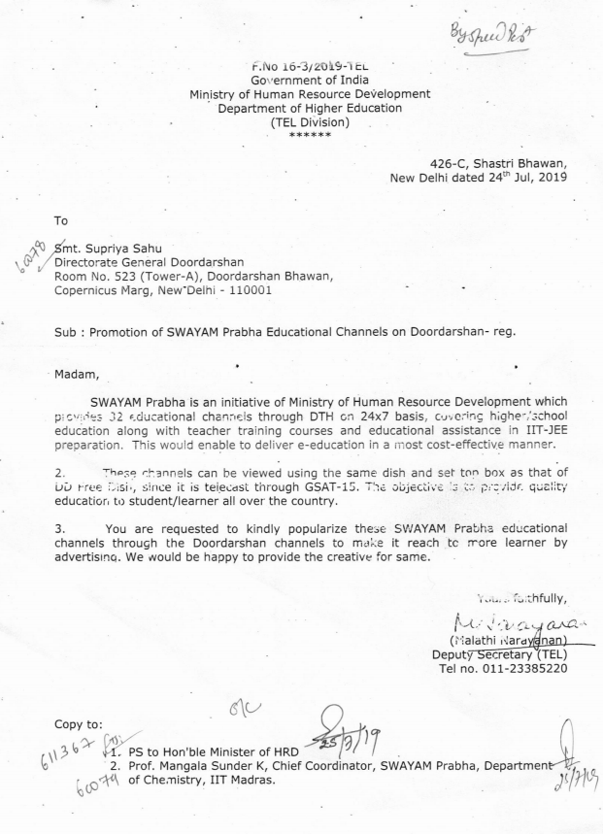

Agenda Item No. 3

Status Report on SWAYAM Courses

To be presented by Prof. Andrew Thangaraj, IIT Madras

Agenda Item No. 4

Presentation by NCs - Delivering Courses as a Package on SWAYAM and Review Report on Courses

1. Delivering Courses as a Package on SWAYAM:

Purport

Presentation by National Coordinators (NCs) for delivering of SWAYAM Courses as a package which shall make a part of certain Degree/ Diploma / Certificate Programme.

Background

In the 12th SWAYAM Board Meeting, Board emphasized the need of aligning the courses to the model curriculum and requested the NCs should offer courses in a packaged manner, which shall make a part of certain degree/ diploma /certificate programme. The packaged courses can also be delivered with partnership with some University / Institutions. These packaged courses will be good incentive for the learners and will serve as Micro - Masters / Diploma / Certificate program for learners.

2. Review Report on Courses:

Presentation to be made by individual NCs to include the following points:

- No. of courses offered in July 2019 Semester with current status.
- Course wise Details: Enrollments, Course Start - End Date, No. of Videos, No. of Assignments, No. of Tests, Effectiveness of Discussion Forum
- Factors on which delivery of the courses are monitored.
- The NCs should try to offer courses in a packaged manner, which shall make a part of certain degree / diploma programme.
- Action Plan for January 2020 Courses.
- Any other views / comments / suggestions

Agenda Item No. 5

Approval of the Recommendations of three-member Committee headed by Retired Judge of the High Court in the matter of M/s CtrlS Datacenters Ltd., Hyderabad for non-compliance of agreement to migrate all SWAYAM applications and services on SWAYAM Platform for taking appropriate action by AICTE.

Purport

The Objective of this Note is to seek the approval of the Board on the Recommendations of three-member Committee headed by Retired Judge of the High Court in the matter of M/s CtrlS Datacenters Ltd., Hyderabad for non-compliance of agreement to migrate all SWAYAM applications and services on SWAYAM Platform for taking appropriate action by AICTE.

Background

M/s CtrlS Datacenter Ltd., Hyderabad was selected through open tender (awarded on 12th May, 2017) as MSP/Cloud Service Provider (CSP) at a total cost of Rs.16, 48, 88,888/-(Rupees Sixteen Crore Forty Eight Lakh Eighty Eight Thousand Eight Hundred Eighty Eight only) (exclusive of Taxes) for a period of three years for providing cloud services/ managed services for SWAYAM Platform.

As per the Agreement, M/s CtrlS was mandated to migrate all SWAYAM application and services successfully on to their cloud environment and demonstrate the same to AICTE on or before 12th August, 2017 and the Operations were supposed to begin within 5 months from letter of intent. However, M/s CtrlS failed to meet the timelines of the agreement/contract for integration of PaaS services with SWAYAM Platform. Hence, MHRD constituted an Expert Committee on 14.12.2017 for evaluation and assessment of integration of PaaS/ Cloud services and deployment of SWAYAM platform through M/s CtrlS. The Expert Committee gave its final report dated 14th January, 2019 mentioning that reasons given by M/s CtrlS for the delay in migration beyond April 2018 were unjustifiable and unacceptable. Accordingly, the Expert Committee recommended that the contract with M/s CtrlS be terminated as per the provisions of the agreement.

In view of the Expert Committee Recommendation, the matter was referred to Standing Counsel of AICTE and on the basis of legal opinion given, AICTE issued a “Show Cause Notice” dated 07.02.2019 to M/s CtrlS. The Company failed to give any substantive and tenable explanation. A Committee headed by Justice (Retd.) N.L. Tibrewal Retired Judge of the High Court along with two Experts having the profound knowledge on the subject was constituted by AICTE to examine and analyze the explanation given to the Show Cause Notice and to give its recommendation.

The Justice Committee held Meetings with Expert committee and also held interaction with the members of M/s CtrlS to arrive at a final conclusion. The Committee after examining the entire matter gave its recommendations after its final Meeting held on 7th August, 2019 which is enclosed herewith. (Annexure II)

Recommendation:

The Justice Committee in its report, inter-alia, has recommended that AICTE may terminate the contract with M/s CtrlS and also forfeit the Performance Bank Guarantee (PBG) as the company has failed to fulfill its obligation and, as such, committed breach of contract/agreement dated 12th May, 2017.

Approval Sought:
The SWAYAM Board is may kindly approve the recommendations of the Justice Committee for taking appropriate action by AICTE in the matter.

Annexure II

Dated: 7th August, 2019

FINAL REPORT OF THE THREE MEMBER COMMITTEE IN THE MATTER RELATING TO THE AGREEMENT/CONTRACT DATED 12-05-2017ENTERED BETWEEN AICTE & M/S CTRLS DATACENTERS LTD., HYDERABAD

The Competent Authority of AICTE approved the constitution of a Three Member Committee headed by Retired Judge of the High Court vide letter No. 40-28/AICTE/SWAYAM/Ctrls Datacenter/2017, dated 22nd March, 2019to examine and analyze the reply of M/s CtrlS to the Show Cause Notice issued by AICTE for non-compliance of timelines of the Agreement for Migration of Cloud Services on SWAYAM Platform and submit its report with recommendations. The Justice Committee was constituted asunder:

- Justice N.L. Tibrewal, Retired Judge, High Court - Chairman
- Prof. Yogesh Singh, Vice Chancellor, DTU, Delhi- Member
- Prof. Satish Chand, Professor, JNU, New Delhi – Member

Factual Background

The Ministry of Human Resource Development, Govt. of India, Department of Higher Education, New Delhi decided to have one of the World’s best SWAYAM Platform through All India Council for Technical Education (AICTE), New Delhi for hosting Massive Open Online Courses (MOOCs).

Initially the Azure Cloud Services for SWAYAM Platform were availed through NBA at a monthly average cost of Rs. 48.33 Lakh till February, 2018 when the Azure Cloud Services were availed through M/s. Embee Software Pvt. Ltd. for smooth functioning of SWAYAM Platform as more than 2609949 learners/students (as on 7th Feb., 2018) had enrolled themselves on the SWAYAM Portal. Therefore, in order to get own cloud service provider for hosting MOOCs on SWAYAM Platform, AICTE floated e-Tender. M/s. CtrlS Datacenter Ltd., Hyderabad (hereinafter referred as M/s. CtrlS) was selected as the successful L-1 bidder for MSP/CSP at a total cost of Rs.16,48,88,888/- (Rupees Sixteen Crore Forty Eight Lakh Eighty Eight Thousand Eight Hundred Eighty Eight only) (exclusive of Taxes) for a period of three years on the basis of Technical & Financial e-Bid Evaluation through Government e-Procurement System on Central Public Procurement Portal (CPPP) vide e-Bid Tender ID 2017_AICTE-168252_1 on 25.01.2017 and an Agreement to this effect was entered between AICTE and M/s CtrlS on 12th May, 2017. Further, in compliance to the terms & conditions of LOI, M/s. CtrlS submitted PBG of INR 82,44,445/- (Rupees Eighty Two Lakh Forty Four Thousand Four Hundred Forty Five only) issued by Allahabad Bank dated 12.06.2017 in favour of AICTE valid upto 11.09.2020. As per the Agreement, M/s CtrlS was mandated to migrate all SWAYAM application and services successfully on to their cloud environment and demonstrate the same to AICTE on or before 12th August, 2017 i.e. within 3 months of letter of intent and the Operations were supposed to begin within 5 months from letter of intent. M/s CtrlS failed to meet the timelines of the agreement/contract for integration of PaaS services with SWAYAM Platform. Hence, MHRD constituted an Expert Committee on 14.12.2017 for evaluation and assessment of development of integration of PaaS/Cloud services and deployment of SWAYAM Phase III through M/s CtrlS.

The Expert Committee gave its final report dated 14th January, 2019 mentioning that reasons given by M/s CtrlS for the delay in migration beyond April 2018 were unjustifiable and unacceptable. The Expert Committee also recommended that continuing further development and deployment of SWAYAM 1.0 Phase III through M/s CtrlS would be a significant waste of public resources. Accordingly, the Expert Committee recommended that the contract with M/s CtrlS be terminated as per the provisions of the agreement.

The entire matter was referred to Standing Counsel of AICTE and on the basis of his legal opinion, AICTE issued a “Show Cause Notice” dated 07.02.2019 to M/s CtrlS. However, M/s Ctrls failed to give any substantive and tenable explanation to the various points raised in the Show Cause Notice for their failure to meet the timelines for migration of application and integration of PaaS Services with SWAYAM Platform in breach of terms & conditions of the Agreement dated 12.05.2017.

In this backdrop, this Committee was constituted by the Competent Authority of AICTE. The terms of reference are mentioned in the Office Memorandum dated 22-03-2019.

The committee had its meetings on 03.04.2019 & 08-05-2019 and deliberated the matter minutely after perusing the entire records and the correspondence between the parties. The Committee also decided to hear the company in the interest of justice. Hence, it was directed to give notice to the bidder company i.e. M/s. CtrlS to appear before the Committee to present its case on05-06-2019.
The representatives of the company appeared before the committee on 05-06-2019 andthey were heard at length. Since they could not offer any valid explanation for their non-compliance of the project, they were asked to submit their final proposal for arriving at an amicable settlement in the matter, if possible. To this, they sought more time. Accordingly, the committee gave them 10 days’ time to submit their proposal.
The company submitted its proposal vide communication dated 14-06-2019 wherein it made a demand of Rs.2,22,40,600/- and return of Performance Bank Guarantee (PBG) amounting to Rs.82,44,445/-.
The Committee re-examined the entire record and correspondence which took place between parties. After going through the same, the Committee is satisfied that M/s. CtrlS was provided full support and all relevant information. The Committee is also satisfied that the company failed to complete the project and,as such, committed breach of the contract. The company was paid Rs.1,94,06,563.20 during the period in the hope that it would complete the project successfully. This project was of National Importance in which more than 40 lakhs of learners/ students had already enrolled. The fact that the company did some work is irrelevant and not useful unless the project is completed.
The committee also noted that on account of non-compliance of the agreement by the company, AICTE had to incur an average monthly expenditure of Rs. 42.95 lakhs towards Azure Cloud Services for smooth functioning of SWAYAM Platform which is a very prestigious National project of MHRD, Govt. of India with several lakhs of learners.

The Committee, therefore, observes and recommends as under:
- The Company i.e. M/s. CtrlS has failed to migrate all SWAYAM application and services successfully on to their cloud environment. Accordingly, the company failed to fulfil its obligation and, as such, committed breach of contract/agreement dated 12-05-2017.

- The Company was provided full support and all relevant information for knowledge transfer in the beginning and also from time to time. The objections raised by the company in its reply to the Show Cause Notice are, therefore, after thought and without any basis.

- The AICTE, therefore, may terminate the contract and also forfeit the Performance Bank Guarantee (PBG) of Rs.82,44,445/- furnished by the company.

- The proposal given by the company for demand of Rs.2,22,40,600/- in such circumstances is unacceptable as being unjustified.

- AICTE is also entitled to take action for recovery of Rs.1,94,06,563/- paid to the company as such payment and doing some work in between by it becomes irrelevant unless the project is completed to make use of the same by AICTE.

(Prof. Satish Chand) (Prof. Yogesh Singh) (Justice N. L. Tibrewal)

Agenda Item No. 6

AICTE - Creation of Online Courses on “Human Excellence” by Vivekananda Institute of Human Excellence, Ramakrishna Math, Hyderabad

Purport

The Objective of this Note is to seek the approval of the Board for Creation of Online Courses on “Human Excellence” by Vivekananda Institute of Human Excellence, Ramakrishna Math, Hyderabad.

Background

Vivekananda Institute of Human Excellence (VIHE), Ramakrishna Math, Hyderabad apprising that their Institute has approached two decades (2000-2019) of imparting training to Lakhs of people including students, professionals and entrepreneurs etc. Now the Institute would like to offer some structured courses for higher education in areas subsuming Indian Culture and Values with Life Skills highlighting the brilliant formulations of Swami Vivekananda by creating online credit courses for 1st and 2nd year of B.Tech students as per the following Course Structure:

- The course of this nature would be spread over 4 Semesters (1st and 2nd year of B.Tech) which will be beneficial and transformative for the students.

- The course will be structured as follows:
-- 3/4 credits per semester
-- 45/60 hours of instruction/ interaction per semester
-- first three semesters course work and fourth semester project work
-- testing, grading and evaluation as per the existing norms for other subjects
-- credit transfer facility in universities whose students opt for the course.

The course syllabus and material will be prepared by VIHE and where possible training and instruction will also be undertaken by VIHE.

In this connection, VIHE has submitted that, if the entire 4 semesters package of Course is made available online through SWAYAM portal, it will have a wider reach. For this, VIHE needs to be permitted to prepare and execute the online courses with the financial assistance of MHRD.

Since the courses proposed by VIHE, Ramakrishna Math, Hyderabad will help the future generation of Engineers to equip with Indian Culture, Values with Life Skills and Human Excellence in addition to their Technical Abilities, the proposal of VIHE could be considered with financial support like any other credit course(s) offered under SWAYAM. Further, the courses of this nature may be considered either as Self-Paced Courses (or) Credit Courses as per the SWAYAM MOOCs Guidelines.

Approval Sought

Board may kindly consider the above proposal for Creation of Online Courses on “Human Excellence” by Vivekananda Institute of Human Excellence, Ramakrishna Math, Hyderabad.

Agenda Item No. 7

LSC - Proposal for Creating MOOC relating to Logistics Courses in SWAYAM Portal

Purport

The Objective of this Note is to seek the approval of the Board on the proposal of Logistics Skill Council (LSC) for Creating MOOC relating to Logistics Courses in SWAYAM Portal.

Background

Logistics Sector Skill Council (LSC) with the active support of Ministry of Human Resource Development and Ministry of Skill Development & Entrepreneurship has designed curriculum for apprenticeship-based BBA Degree Programme in Logistics. The Degree Programme has been launched in 18 institutions across the country in the current Academic Year 2019-2020. About 500 Students have joined the programme in these institutions.

In addition to the core courses on Logistics, the programme is also populated with one MOOC Courses in each Even Semester of the programme. LSC has scheduled a total of 6 MOOC Courses, of which students would register 3 Courses. Copy of the proposal is enclosed at Annexure III

LSC would deliver the above 6 Courses in MOOC Format and assess the students. The Grades awarded to students would be incorporated in the Grade Sheets issued by Collaborating Institutions with relevant credits.

Two Courses “Warehouse Automation” and “Best Practices in Transportation” are listed in the II Semester under MOOC Format. The II Semester Classes commence by the middle of December 2019 for the current academic year.

LSC has requested MHRD to kindly approve inclusion of these two courses in SWAYAM Platform and sanction the required grant for the same.

Approval Sought

Board may kindly consider the above proposal of LSC and provide financial assistance for Two Courses as requested.

Annexure III

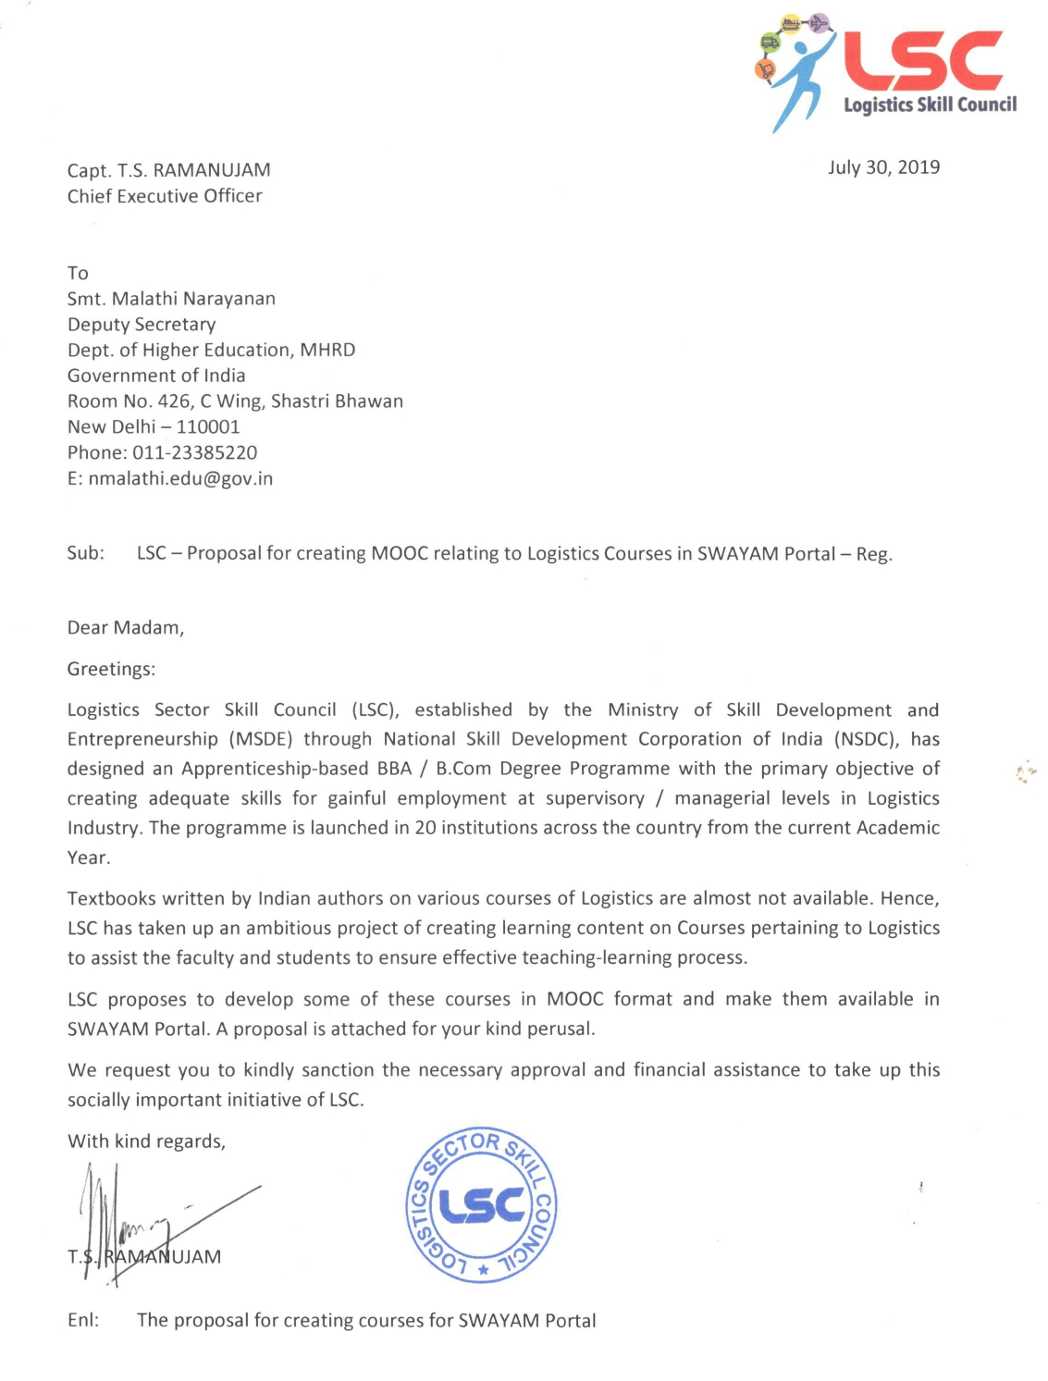

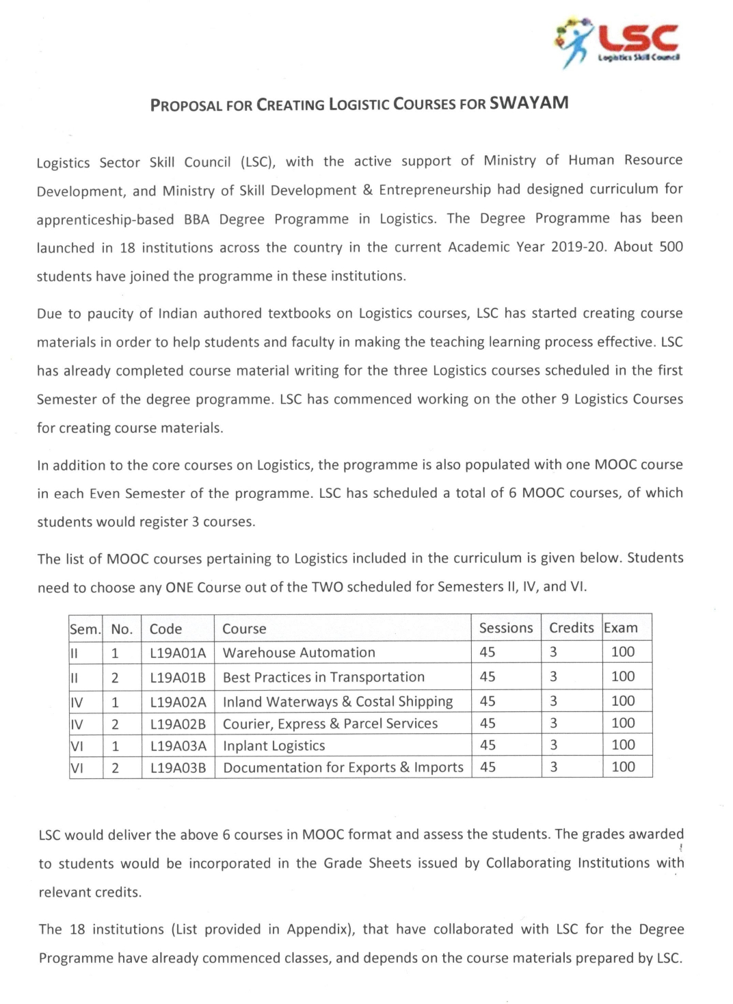

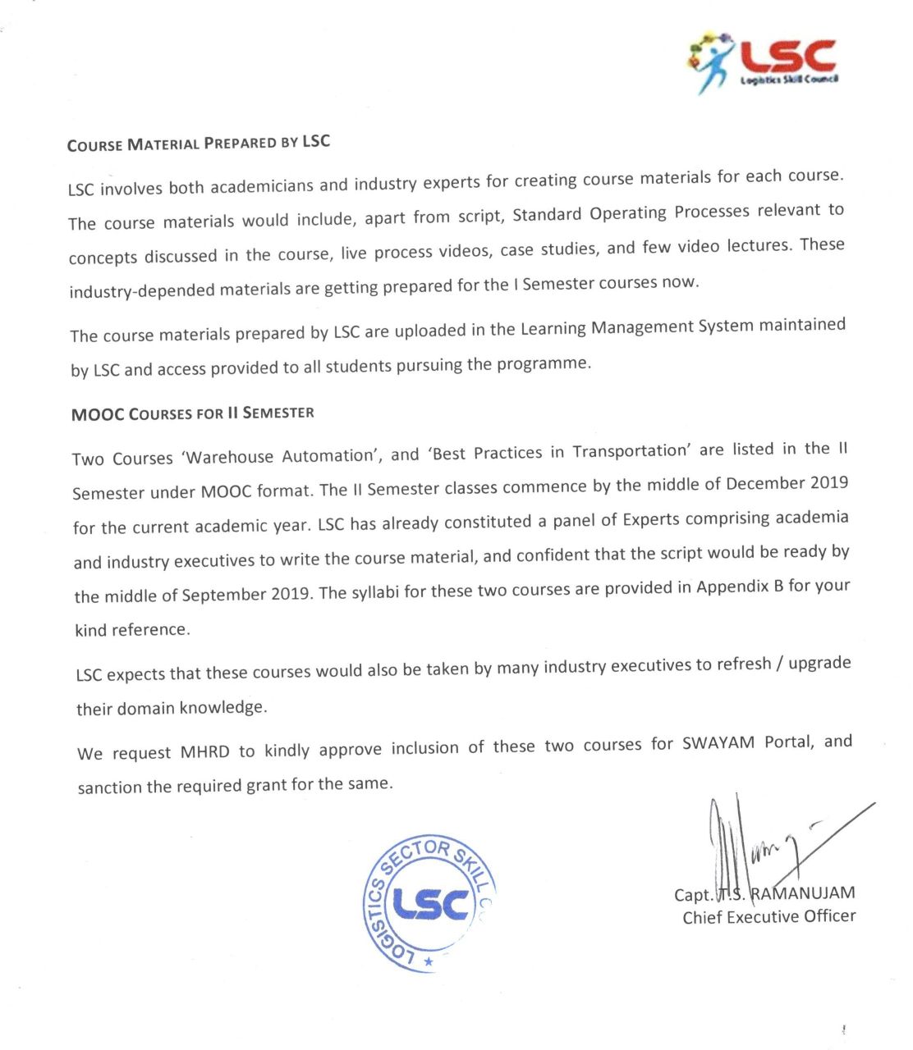

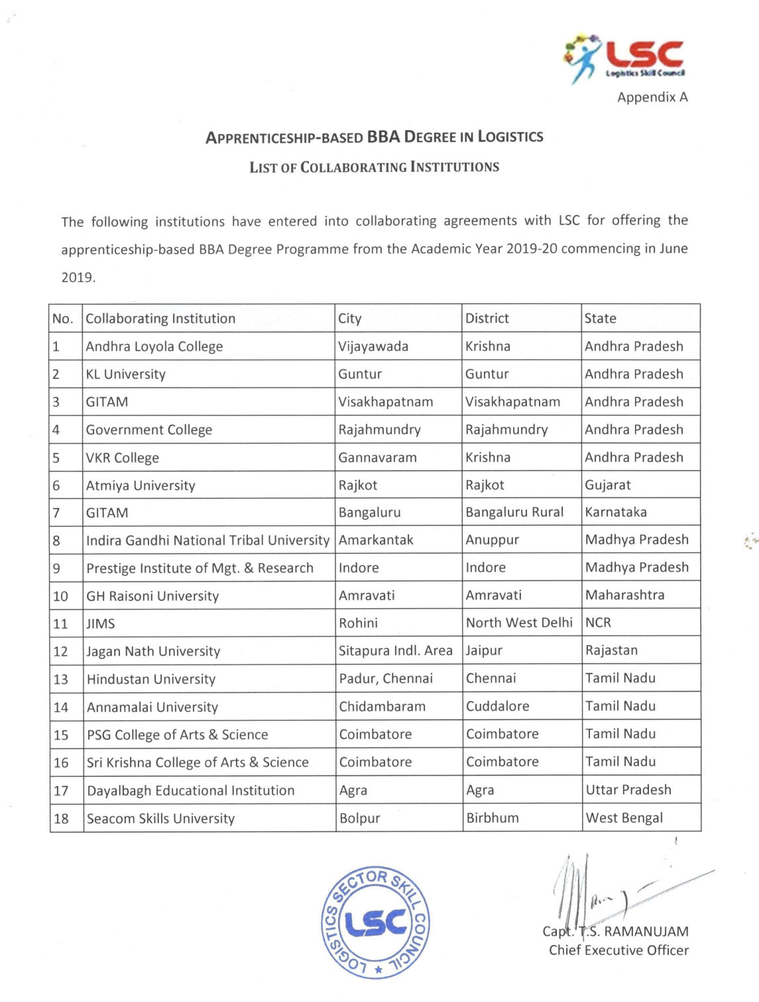

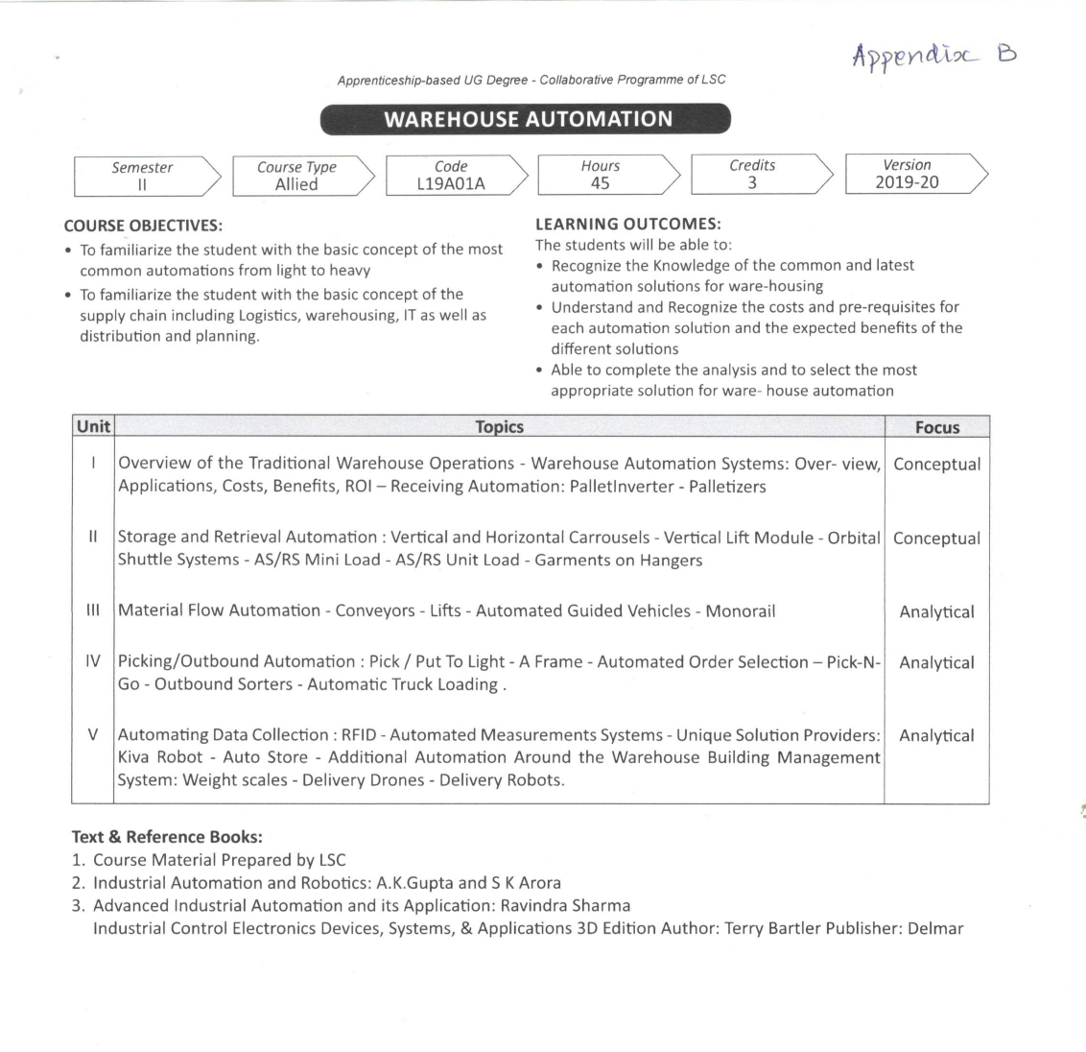

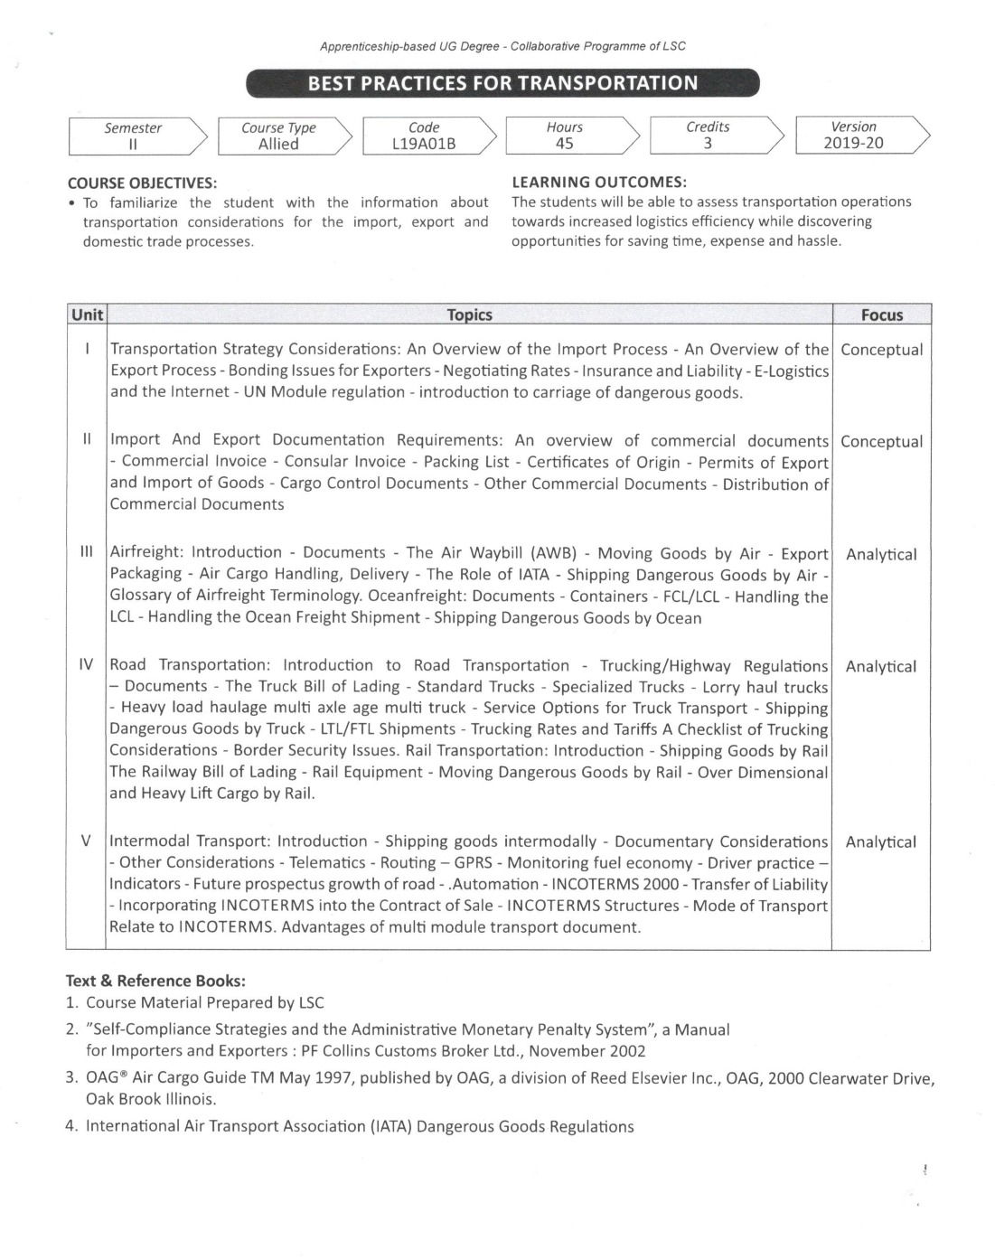

Agenda Item No. 8

NC / CC Guidelines for Running of SWAYAM Courses

Purport

The Objective of this Note is to take the approval of the Board for the submit the “NC / CC Guidelines for Running of SWAYAM Courses” for consideration.

Background

The SWAYAM Examination was successfully organized in December 2018 and May 2019 for the courses delivered in two semesters i.e. July 2018 and January 2019.

The learning and experience gathered in organizing these Examinations are compiled in the “NC / CC Guidelines for Running of SWAYAM Courses”. The same is enclosed at Annexure IV.

Approval Sought

The SWAYAM Board is requested to kindly approve the “NC / CC Guidelines for Running of SWAYAM Courses” for circulation.

Annexure IV

NC / CC Guidelines for Running of SWAYAM Courses

Integration with Conventional Education is one of the key features of SWAYAM. The necessary regulations for credit transfer have been brought out by UGC / AICTE for the same. In order to make it happen it is essential to synchronise the SWAYAM courses with the semester followed in universities/colleges. The SWAYAM Board has finalised the following schedule for the SWAYAM courses.
 | January  Semester | July  Semester
Course Start Date | 1- 31 January | 1 – 31 July
Course Enrolment End Date | 28 February | 31 August
Course End Date | 30 April | 31 October
Examination Date | Second Saturday and Sunday - May  (Two slots on each day) | Second Saturday and Sunday - November  (Two slots on each day)

The Students while enrolling for a course would like to know the final examination schedule of the course. This would help the students choose the courses in such a way that the examinations do not clash. The NCs would have to coordinate with the CCs and decide the examination slots for all the courses offered during the semester in such a way that a student can easily enroll in upto four courses and appear in their examinations.

1. CCs while uploading a course on SWAYAM Portal should provide the following information. While deciding the dates, the CCs should ensure that they are within the ranges prescribed above. Also please see the notes below:
• Course Start Date
• Course Enrolment End Date
• Course End Date
• Final Examination Date
• Examination slot
• Language of Instruction
• Duration of course
• Mode of exam: CBT or Pen & Paper
• Details and mode of internal assessment

Notes:

(i) The internal assessments may involve marks for weekly assignments, tests, participation in discussion forums etc
(ii) In Computer Based Test (CBT) all the questions would be answered by the student in Computer only.
(iii) In Pen & Paper Exam, the student needs to write all the answers, including the answers for objective questions, in answer sheets provided
(iv) Exam for January session will be held on 2nd Saturday and Sunday of May in following slots:
a. Slot1 - Morning session and Slot2 - Afternoon session on Saturday
b. Slot3 - Morning session and Slot4 - Afternoon session on Sunday

(v) Exam for July session will be held on 2nd Saturday and Sunday of November in following slots:
a. Slot1 - Morning session and Slot2 - Afternoon session on Saturday
b. Slot3 - Morning session and Slot4 - Afternoon session on Sunday

2. Guidelines for preparation of question papers
- The Questions should be clear. There should be no ambiguity in the multiple answers provided (in the case of CBT).
- Avoid repetition of questions in the question paper
- In case of CBT, Clearly specify the type of questions: Multiple Choice Question (MCQ), Multiple Select Question (MSQ), Short Answer (SA), Long Answer (LA) etc.
- The question paper should be set in such a way that neither it should be too short (i.e taking very less time to answer) nor too long (i.e. unable to complete)
- The CC should get the question paper peer reviewed before finalising it. NC should ensure that this is complied.

- Duration of Examination:
  - 3 Hours (9 am to 12.00 noon and 2.00 pm to 5.00 pm)

- . Maximum marks in each question paper
1. CBT – 100 Marks
2. Pen & Paper – 100 Marks

- Questions should be set as per the difficulty level given below
1. 40% - Easy
2. 40% - Moderate
3. 20% - Difficult
- Question paper should contain following information
- Course Code
- Course Title
- Examination date
- Examination slot
- Mode of Examination : CBT or Pen & Paper
- Duration of Examination in minutes
- Total no. of questions to be answered
- Clearly specify If choice is available (applicable in Pen & Paper exam only)
- Clearly specify the marks against each question
3. NCs/CCs should ensure that 2 sets of question paper along with Answer Keys for each course should be shared with NTA (as per NTA guidelines) two months prior to the examination date.

4. Examination Day

- Representatives from each NC should be available at NTA, Noida and details of representatives should be shared with NTA with copy to MHRD
- CC should be available on phone and should keep a copy of question paper ready for any query which may arise during the examination.
5. Evaluation of Paper
- 70% (min) for Final examination
- 30% (max) for internal assessment

6. Pass Criteria
- 40% or more
7. Information related to the Course in Exam Slots
- NCs should share the courses list in different exam slots (template already shared with NCs) to MHRD immediately after uploading of course on SWAYAM portal.
8. Uploading of Marks and Certificates on SWAYAM Portal
NCs ensure that uploading of marks and certificates must be completed within two weeks after the declaration of the examination result.

Agenda Item No. 9

NIOS – Hosting “D.El.Ed. Course for Elementary Teachers” material on SWAYAM as self paced Teacher Refresher Course

Purport

The Objective of this Note is to seek the approval of the Board for Hosting “D.El.Ed. Course for Elementary Teachers” material on SWAYAM as self paced Teacher Refresher Course.

Background

As per the notification of NCTE Right of Children to Free and Compulsory Education Act 2009 (35 of 2009) effective from 1st April, 2010, it is imperative that all teachers teaching at the elementary level, if not trained, shall have to acquire training qualification within a period of five years. After five years, it was observed that the teachers were still teaching in Primary schools without the essential training/qualification.
In order to give a last chance to the untrained in-service elementary teachers, an amendment to the section 23(2) of RTE Act was passed on 10th August 2017 by the Parliament of India and It was made mandatory for the untrained in-service elementary teachers to complete the training by 31st March, 2019.
The National Institute of Open Schooling (NIOS) was identified by MHRD as the nodal agency for the training of these teachers. The Diploma in Elementary Education Programme through Open and Distance Learning (ODL) mode has been designed and developed by NIOS duly approved by NCTE for the untrained in-service teachers at the elementary level.
The NIOS offered this D.El.Ed. Programme through online mode using ICT for the effective implementation. It was paperless Programme. All activities related to trainee teachers were done through online mode. Separate dashboard was developed for the Teachers and Study Centre Coordinators for all activities. Dashboard for State Coordinator/State Nodal Officers was provided for its effective monitoring. The entire teaching learning materials in 10 languages were developed and video lectures offered through SWAYAM portal, which is a MOOC platform initiated by MHRD. The 2000 videos developed for the D.El.Ed. were uploaded onto the SWAYAM portal by the Course coordinators. Trainee teachers were registered and enrolled onto SWAYAM for free access to these learning materials including the video lectures and interacted with the Course Coordinators in the Discussion Forum. NIOS has telecast quality video lectures on each and every chapter of D.El.Ed. through SWAYAM Prabha DTH Channel no 32 named Vagda with Live & interactive programme along with channel 25 which broadcasted video lectures in Regional languages. D.El.Ed. Mobile App was also developed by NIOS for learning support.
The NIOS produced and hosted 1009 video lectures in Hindi/English and 750 in Bangla/ Assamese apart from 381 Live Programme. The experts from more than 70 Universities across India were invited in the production of these quality videos. The video programmes were proved to be the most useful materials for the trainee teachers and complemented by Hon’ble Minister of HRD as well as many Teacher institutions across country.

NIOS has successfully completed all the activities related to the D.El.Ed. programme including the final examination within the scheduled duration by 31st March 2019. The final result has also been prepared and was declared by the Hon’ble HRM on 22nd May 2019. About 88% Teachers have successfully completed the course.
The recommendations of the NIOS SWAYAM and SWAYAM PRABHA Academic Advisory Committee (AAC) in its meeting held on 20th May, 2019 is as under
“Re-run of the successfully completed D.El.Ed courses for Elementary Teachers untrained in-service teachers on SWAYAM as non-credit Teacher Refresher Course.”
“Since the National resources have been used in production of the quality D.El.Ed. video materials and a large scale efforts were put in for the training of the untrained in-service teachers, the NIOS may approach to all the SCERTs/ DIETs /teachers training institutions to make use of these quality video available online through SWAYAM platform. ”
In view of the above, it is requested that the quality content may also be utilised by all the teacher education institutions as the reference material for capacity building of their teachers. The courses on SWAYAM is offered free of cost through the portal www.swayam.gov.in

Approval Sought

Approval of the Board is sought for Hosting “D.El.Ed. Course for Elementary Teachers” material on SWAYAM as self paced Teacher Refresher Course.

Agenda Item No. 10

NIOS - Integration of NIOS Student Portal with SWAYAM 2.0 Portal through Web Services for Single Registration

Purport

Integration of NIOS Student Portal with SWAYAM 2.0 Portal through Web Services for Single Registration.

Background

NIOS offers 100% online admission to its learners for Secondary (10th) & Sr. Secondary (12th) through its portal www.nios.ac.in (sdmis.nios.ac.in). In order to make optimal use of SWAYAM portal it is proposed to integrate NIOS Student Portal (sdmis.nios.ac.in) with SWAYAM portal. This means that whenever the student gets registered on NIOS Student Portal, the student will get registered on the SWAYAM portal automatically using the Web Service. This will ease out the registration process for NIOS learners on SWAYAM and on the basis of the single registration the student will be registered on SWAYAM Portal also.

NIOS will create a Web Service to push the registration details from NIOS Student Portal to SWAYAM portal. In turn SWAYAM portal will register the student on its portal with the same credentials shared by NIOS Web Service. This will help the students registered in NIOS to login on the SWAYAM portal using the same credentials created on NIOS Student Portal. NIOS will give a direct link from the Student Dashboard on NIOS Student portal to login into the SWAYAM portal for consuming the course including videos on SWAYAM Portal. This way the students will be directly enroll on SWAYAM with the single registration and get the optimum benefits of the SWAYAM.

The matter was discussed with Prof. Andrew Thangaraj, IIT Madras during the 23 - 25th April, 2019 SWAYAM 2.0 Workshop and again on 1st May Review meeting under the Chairmanship of Joint Secretary. Prof. Andrew Thangaraj was of the opinion that technically it is possible for such integration.

Approval Sought

Approval of the Board is sought for the integration NIOS Student Portal with SWAYAM 2.0 Portal through Web Services for Single Registration.

Agenda Item No. 11

Extension of Contract of M/s Embee Software Pvt. Ltd. for M/s Azure Cloud Services for SWAYAM MOOCs Platform from 8th August, 2019 till 31st December, 2019 - Information Agenda

The Joint Committee of SPC in its 30th Meeting held on 13.12.2017 had decided that AICTE may take necessary steps to invite a short term offline Tender to select L-1 vendor to provide Azure Based Cloud Services to SWAYAM till the CSP vendor viz. M/s CtrlS Datacentre successfully migrates the application to the new environment. In compliance to this decision, M/s Embee Software Pvt. Ltd. was selected for providing Azure Cloud Services for SWAYAM Platform for a period of Six Months from 8th February, 2018 to 7th August, 2018 which was subsequently extended for further six months from 08.08.2018 to 07.02.2019 with the approval of SWAYAM Board in its 5th Meeting held on 11th June, 2018.

The SWAYAM Board in its 11th Meeting held on 11th February, 2019 approved the further extension of contract of M/s Embee Software Pvt. Ltd. for another six months i.e. from 08.02.2019 to 07.08.2019 on the existing terms and conditions with provision for termination of services anytime by giving one month notice for providing Azure Cloud Services for SWAYAM MOOCs Platform.

During the SWAYAM Review Meeting held on 28th June, 2019 at MHRD under the Chairmanship of Joint Secretary (TEL), it was reported by IIT Madras that Cloud Tender is done and stated that now Cloud is to be Google for all NPTEL as well as other NCs Courses. IIT Madras was requested to intimate AICTE well in advance for discontinuation of Azure Cloud as a substantive amount is being paid for the Azure Cloud charges. The contract was to expire on 7th August, 2019.

In view of Para 13 of the minutes of the SWAYAM Review Meeting held on 28.6.2019, the matter was taken up with Prof. Andrew Thangaraj, IIT Madras by AICTE vide letter dated 10th July, 2019 (Annexure-V) for sending a formal communication to AICTE for discontinuation of contract of Azure Cloud Services for SWAYAM through M/s Embee Software Pvt. Ltd. w.e.f. 8th August, 2019.

Prof. Andrew vide his e-mail dated 16.07.2019 has requested AICTE to continue the Azure Cloud Services through M/s Embee Software Pvt. Ltd. till December, 2019. It has further been stated by Prof. Andrew that this will help with a smooth transition because migration is yet to be completed fully and a few courses are still running on the old SWAYAM 1.0 Portal. (Annexure VI)

Extension of M/s Azure Cloud Services has been approved by the Competent Authority at AICTE after receipt of a communication from Prof. Andrew vide his email dated 16.07.2019 for extension of Azure Cloud Services through M/s Embee Software Pvt. Ltd for smooth transition and migration of data/courses from SWAYAM 1.0 to SWAYAM 2.0

Submitted for Information

The information is submitted to SWAYAM Board regarding the Extension of the Contract of M/s Embee Software Pvt. Ltd. for providing M/s Azure Cloud Services from 8th August, 2019 till 31st December, 2019 on the existing terms & conditions with provision for termination of services anytime by giving one month notice for providing Azure Cloud Services for SWAYAM MOOCs Platform.

Annexure V

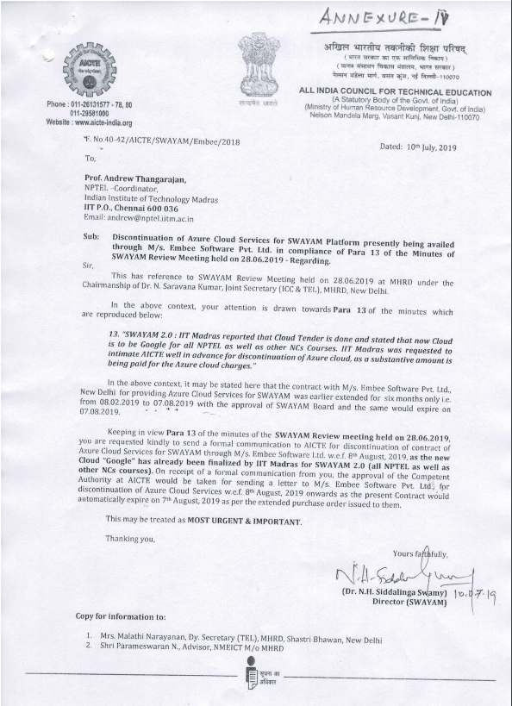

Annexure VI

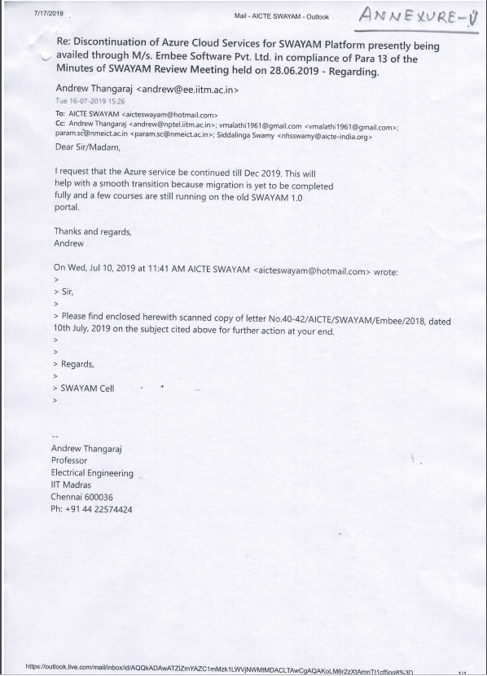

Agenda Item No. 12

Extension of Contract of Bulk SMS Gateway and e-Mail Services through M/s Netcore Solutions Pvt. Ltd., New Delhi from 01.04.2019 to 31.03.2020 - Information Agenda

The Joint Committee of SPC in its 14th Meeting held on 24th August, 2016 had approved the contract of Bulk SMS Gateway and Email Services for SWAYAM Project to M/s. Netcore Solutions Pvt. New Delhi, an empanelled Agency of D.A.V.P. @ Rs.2.75 paisa per SMS+ Service Tax and 0.95 paisa per e-mail+ Service Tax from 12.08.2016 to 31.03.2017 which was subsequently extended upto 31.03.2018 with the approval of the Joint Committee in its 26th Meeting held on 24th May, 2017.

On expiry of the contract of M/s. Netcore Solutions Pvt. Ltd. on 31.03.2018, an agenda note was submitted to SWAYAM Board in its 9th Meeting held on 12.11.2018 for approval of the further extension of the contract upto 31.03.2019. The SWAYAM Board considered the Agenda and observed as under:

“AICTE being the Implementing Agency for this, they shall take appropriate decision at their level following the relevant Rules and Regulations and report the action for information of Board.”

Accordingly, the contract of email services was extended upto 31.03.2019 with the approval of Competent Authority at AICTE. SWAYAM MOOCs Platform is receiving e-mail services at support@swayam.gov.in through M/s. Netcore Solutions Pvt. Ltd. These e-mail services are very essential for feedback and reply to the learners/students pertaining to online courses. Hence, keeping in view the need of email services for SWAYAM (SWAYAM 1.0 as well as SWAYAM-2.0) the matter was submitted to the Competent Authority for extension of contract for a further period of one year i.e. from 01.04.2019 to 31.03.2020. The Competent Authority at AICTE has approved extension of contract of Bulk SMS Gateway and E-Mail Services being provided by M/s. Netcore Solutions Pvt. Ltd., New Delhi upto 31st March, 2020 on the existing terms & conditions with provision for termination of services anytime by giving one month’s notice till an alternate e-mail service provider is finalised by NPTEL/IIT Madras for SWAYAM 2.0. It may be mentioned here that the monthly bill for email services being received from M/s. Netcore Solutions Pvt. Ltd. is less than Rs.5,000/- per month and annual financial implication is approx. Rs.60,000/- only.

Similar extension of Azure Cloud Services has been approved by the Competent Authority at AICTE after receipt of a communication from Prof. Andrew vide his email dated 16.07.2019 for extension of Azure Cloud Services through M/s. Embee Software Pvt. Ltd for smooth transition and migration of data/courses from SWAYAM 1.0 to SWAYAM 2.0 since a few courses are still running on the old SWAYAM 1.0 portal. An Information Agenda to this effect has already been sent to MHRD for information of SWAYAM Board in its next meeting.

Submitted For Information
The above extension of Bulk SMS Gateway and E-Mail Services in favour of M/s Netcore Solutions Pvt. Ltd., New Delhi from 01.04.2019 to 31.03.2020 is reported to SWAYAM Board for information.

Agenda Item No. 13

Allocation of SWAYAM Prabha Channel to AICTE

Purport

The Objective of this Note is to seek the approval of the Board for Allocating SWAYAM Prabha Channel to AICTE.

Background

AICTE has requested MHRD to allocate one DTH Channel from the SWAYAM Prabha Portfolio to AICTE for promoting programs related to student innovation, startup, and entrepreneurship apart from core subjects of technical education. A copy of the letter is annexed at Annexure VII.

AICTE in coordination with MIC will jointly work for the conceptualization of the programs along with external agencies to ensure that the content on this channel is state-of-the-art and on par with current needs.

All the expenses related to program conceptualization and program development will be taken care by AICTE from its own funds.

Approval Sought

Approval of the SWAYAM Board is sought for allocating SWAYAM Prabha Channel to AICTE.

Annexure VII

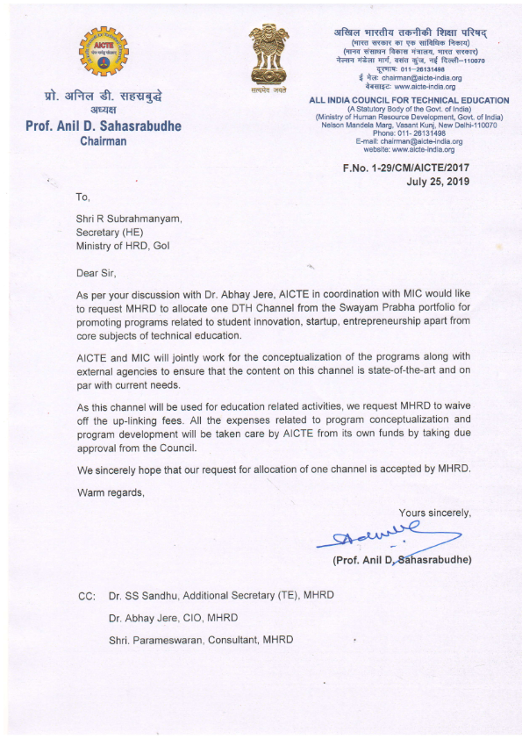

Thank You

