Agenda Papers

18th Meeting
SWAYAM BOARD

09th December 2019

Ministry of Human
Resource Development
Shastri Bhawan
New Delhi - 110001

AGENDA
18th Meeting of the SWAYAM Board

S. No. | Agenda Items | Page No.
1 | Agenda Item No. 1  Confirmation of Minutes of 17th SWAYAM Board Meeting | 2 - 3
2 | Agenda Item No. 2  Action Taken Report | 4 - 8
3 | Agenda Item No. 3  Status Report on SWAYAM Courses (by IIT Madras) & Status Report on SWAYAM Examination’s Result November, 2019 | 9
4 | Agenda Item No. 4  Review Report by NCs: 1. On Low Registration on Final Examination of SWAYAM Courses, 2. Review of SWAYAM Courses, 3. Local Chapter Activity by UGC | 10
5 | Agenda Item No. 5  Permission to Publish e-Content in the form of a Book / Other Distribution Material for Commercial Purpose | 11
6 | Agenda Item No. 6  Extension of SWAYAM and SWAYAM Prabha Projects beyond March, 2020 | 12
7 | Agenda Item No. 7  Pass Criteria for SWAYAM Courses | 13
8 | Agenda Item No. 8  Mandating / Encouraging Participation of all Universities to offer / accept SWAYAM Courses for Credit Transfer | 14
9 | Agenda Item No. 9  Proposal for a Pilot Project for Strengthening Uptake and Adoption of MOOCs and SWAYAM Prabha TV Channels amongst the students and faculty members of the University - By JAMIA MILLIA ISLAMIA | 15 - 23
10 | Agenda Item No. 10  Conduct of Yoga Programme Examinations by Swami Vivekananda Yoga Aunsandhana Samsthana (S-VYASA) on 29th & 30th December, 2019 at Bengaluru and proposal from S-VYASA for Re-running of Yoga Courses on SWAYAM Platform - By AICTE, New Delhi | 24 - 26
11 | Any other item with the permission of Chair

Agenda Item No. 1

Confirmation of Minutes of the 17th SWAYAM Board Meeting held on 11.11.2019

Minutes

The 17th Meeting of the SWAYAM Board was held under the Chairmanship of Shri R. Subrahmanyam, Secretary (HE), M/o HRD on 11.11.2019.
2. Confirmation of Minutes of the 16th SWAYAM Board Meeting: SWAYAM Board Confirmed the minutes of 16th SWAYAM Board meeting.

After detailed discussions the following decisions were arrived at:

3. National Coordinator for PG Non Engineering courses: Secretary (HE), MHRD requested UGC to support the CEC adequately in order to perform all activities pertaining to PG Non Engineering Courses. He emphasize on proper handholding to CEC and to avoid any vacuum / gap in the system in the absence of UGC. UGC will make a suitable arrangement and work plan to strengthen CEC to take as NC for Non-Engineering PG courses. Till such time adequate support systems are established UGC will continue to be NC.

4. SWAYAM Local Chapters: All the local chapters of UGC and NPTEL will be called as SWAYAM Local Chapters. UGC will perform all Local Chapters related activities as they are having access to all Universities. As per SWAYAM Board mandate the UGC should have to run SWAYAM Local Chapters. UGC should place proper SWAYAM Coordinator and Mentors for the Local Chapters.

5. SWAYAM Examination: Secretary (HE), MHRD requested to integrate the examination process of both Non Engineering and Engineering Courses (NPTEL) in a single cycle with common dates.

The Board also appointed an expert committee on Examination under the chairmanship of Prof. Anil D. Sahasrabudhe, AICTE with members including Prof. Andrew Thangaraj of NPTEL, Prof. P. D. Jose, IIM Bangalore, UGC Representative, MHRD as Convener. The Examination expert committee will come up with a proper examination process and implementation policy for conducting SWAYAM Exams before the next SWAYAM Board meeting.

6. SWAYAM Status: IIT Madras presented that there are total 123,54,849 Enrollments on 2867 SWAYAM Courses (SWAYAM 1.0 - 1,00,14,128 enrollments in 2213 courses, SWAYAM 2.0 - 23,40,711enrollments in 654 courses of July 2019 Semester).

7. SWAYAM Examination Status: SWAYAM Examinations were conducted for 174 courses in 124 cities across India. The total numbers of candidates registered were 22133, in which 20,088 appeared i.e. 90.76 % attendance.

Board requested all NCs to take action for the courses where registrations in final examination were very less and the CCs to be informed of the poor turnout. NCs to examine and take a call and come up with solutions. Each NC is to come up with a report on how to improve.

Board requested IIM Bangalore to conduct a Learner Survey for the SWAYAM Courses and the expenses will be made through SWAYAM.

8. Orchestration of Online Programmes by Universities through SWAYAM: UGC is requested to communicate the list of Universities with Programme details to SWAYAM team at IIT Madras. IIT Madras should clarify the process to all Universities with LOI and also conduct another workshop to clarify doubts of the Universities.

SWAYAM Board approved the proposal to enable the creation of the second vertical of SWAYAM for Online courses and also the Universities will pay the 15% of the fees collected to the SWAYAM Scheme and from this the payment to the llT Madras will be done. A letter from MHRD will be issued to all Universities for paying 15% of the fees to SWAYAM Scheme.

9. Translation of SWAYAM Courses: On viewing Demonstration of the translated course, The SWAYAM Board requested IIT Madras to do Academic Review of the translated courses as the translation in certain regional fonts is not correct. Board requested the IIT Madras to redo the same course again and showcase the translation in upcoming Board meeting.

10. List of January 2020 Courses: SWAYAM Board approved the list of 549 courses submitted by NCs to run in January 2020 Semester.

SWAYAM Board also reiterated the following guidelines while offering SWAYAM Courses which are to be kept in consideration.

(a) Repurposing of courses are not to be encouraged. (b) The courses that are chosen for re-run should have at least 500 enrolments in the earlier run. (c) The course should have the approval of Academic Council. (d) One faculty should not handle more than two courses as Course Coordinator, at a time. (e) Start dates of all the courses should be within 15 days of start of the Semester, so that exams can be planned at the same time.(f) All NCs must strictly follow the timelines of the SWAYAM Schedule as per O.M. dated 06.06.2019.

11. Social Media Strategy: Board requested M/s EdCIL (India) Ltd. to prepare a Social Media strategy for publicizing 549 courses of January 2019 Semesters and share to MHRD in a week. The Social Media plan is devised in a way to attract and reach large number of possible learners across prominent Social Media platforms like Facebook, Twitter, lnstagram etc. M/s EdCIL (India) Ltd. may also propagate the SWAYAM using My GoV and a meeting in next week should be planned with the CEO of MY Gov by M/s EdCIL (India) Ltd.

The meeting ended with thanks to the Chair.

******

Agenda Item No. 2

Action Taken Note on the Points decided in the 17th SWAYAM Board Meeting held on
11th November, 2019

S.No. | Items | Action Taken Note
1 | Awareness Creation & Publicity  A. Local Chapters activity  Secretary (HE) requested UGC to make a action plan for running successful Local Chapters and also identify at least 1000 local chapters from Progressive Institutions by their NIRF rankings, Participation on SWAYAM, Colleges with >= 10,000 students by the next meeting.  The UGC regional Office will be engaged to follow up regularly and a proper target will also be allocated to them.  In the upcoming SWAYAM Board meetings there should be a standard Agenda to be included regularly showcasing 10 best Local Chapters on basis of Enrollments, Sensitizing activities etc.  SWAYAM Workshops / Capacity Building Workshop:  B. Social Media Strategy:  Board requested M/s EdCIL (India) Ltd. to prepare a Social Media strategy for publicizing 549 Courses of January 2019 Semesters and share to MHRD in a week. M/s EdCIL (India) Ltd. may also propagate the SWAYAM using My GoV and a meeting in next week should be planned with the CEO of MY Gov by M/s EdCIL (India) Ltd. | UGC has conducted a meeting of all ROs on 05.12.2019 and shared with them:-  1. The list of Colleges with >= 10,000 students (from AISHE)  2. The Universities (63) which figure in top 100 NIRF ranking and still not accepting the SWAYAM courses for Credit Transfer as per the UGC Regulation 2016.  3. The list of Upcoming Courses for January, 2020 semester UG & PG  4. List of SWAYAM Coordinator and Mentors from their respective States  5. Guidelines for Local Chapters for Adoption, Awareness and promotion of SWAYAM Courses were shared with ROs clearly indicating the target for enrollment and exam registration to be monitored every fortnight.  6. ROs were requested to hold workshops for SWAYAM Local Chapters.  7. All ROs are requested to share the same to their respective SWAYAM Coordinator and Mentors.  8. List of January 2020 courses to be shared with AIU and CEC to be published in the AIU News and CEC Newsletter respectively.  - UGC to write a letter to top 100 NIRF Universities regarding accepting SWAYAM Courses for Credit Transfer.  - UGC is in process to revamp the existing UGC MOOCs Portal and a dedicated dynamic page for SWAYAM Local Chapters will be created soon and link will be provided on SWAYAM 2.0 Portal.  Presentation by UGC at Agenda Item No. 4  UGC: Propose to hold Workshop in North-East & Kerala after the parliament session.  NPTEL: Posters and course booklet sent to 3000 Local Chapters. Workshops done in Patna, Ranchi, Bagalkot and Gulbarga, Tezpur  CEC:  - 3rd National Media Conclave, in Association with Utkal University and Institute of Media Studies on 21st to 23rd November 2019 at Bhubaneswar.  - A one-day National Seminar was conducted in National Law University, Delhi on “Bridging Educational Divides through MOOCs and OERs” on 23rd November 2019.  IIM Bangalore:  - Conducted 3 FDP on blended Learning in 2019  - Plan to conduct 3 FDPs about blended learning in 2020.  NCERT: has initiated Local Chapter for Schools MOOCs and to start with, five schools have been visited within Delhi circle. A total of 760 students and 38 teachers from five schools have attended the programme.  This activity will be expanded at National Level and in Kendriya Vidyalayas, Navodya Vidyalayas and CBSE affiliated schools for scale enrolment. Apart from this, official letters were sent to SCERTs, SIEs, and School Boards for awareness and publicity of SWAYAM courses.  NIOS: Indian Institute of Teacher Education (IITE), Gandhi Nagar, Gujarat, on 13th & 14th November, 2019, for Faculty and School Teachers  M/s EdCIL (India) Ltd.: Shared the media plan till November 2020 for the assigned budgets, taking into account the past performance. The plan captures the social media growth projected till next year.
2 | National Coordinator for PG Non Engineering Courses:  Secretary (HE), MHRD emphasize on proper handholding to CEC and to avoid any vacuum / gap in the system in the absence of UGC. UGC will make a suitable arrangement and work plan to strengthen CEC to take as NC for Non-Engineering PG courses. Till such time adequate support systems are established UGC will continue to be NC. | CEC: raised that for the added responsibility for PG MOOCs no support and finances has been provided to CEC on this count.  UGC:  - A meeting has been conducted with Joint Director CEC & his MOOCs Team with UGC officials on 04.12.2019 at UGC.  - Letter written from UGC to CCs of January 2020 Courses
3 | SWAYAM Examination:  The Board also appointed an expert committee on Examination under the chairmanship of Prof. Anil D. Sahasrabudhe with members including Prof. Andrew Thangaraj of NPTEL, Prof. P. D. Jose IIM Bangalore, UGC Representative, MHRD as Convener. The Examination expert committee will come up with a proper examination process and implementation policy for conducting SWAYAM Exams before the next SWAYAM Board meeting.  Board requested all NCs to take action for the courses where registrations in final examination were very less and the CCs to be informed of the poor turnout. NCs to examine and take a call and come up with solutions. Each NC is to come up with a report on how to improve.  Board requested IIM Bangalore to conduct a Learner Survey for the SWAYAM Courses and the expenses will be made through SWAYAM. | MHRD vide O.M. dated 28.11.2019 Constituted the Committee and a meeting has been held on 04.12.2019.  Agenda Item No. 4  Presentation and Report by each NC  IIM Bangalore: Work in progress
4 | Orchestration of Online Programmes by Universities through SWAYAM:  - IIT Madras will create a separate vertical (the 2nd vertical) in SWAYAM.  - IIT Madras should clarify the process to all Universities with LOI and also conduct another workshop to clarify doubts of the Universities.  - The Universities will pay the 15% of the fees collected to the SWAYAM Scheme and from this the payment to the IIT Madras will be done. A letter from MHRD will be issued to all Universities for paying 15% of the fees to SWAYAM Scheme. | IIT Madras:  - IIT Madras created a total of 139 courses in the Staging server, 134 of these has been shared with the universities (Detailed list given in the table attached below)  - The regular sync-up calls with Persistent Team is scheduled on every Thursday and we have had 7 sync-up calls till now  - All the tickets related to development are being tracked using the VSTS system  - Out of 12 tickets that we raised in November Sprint, 8 have been closed.  - IIT Madras will be closing the remaining 2 along with 9 more new tickets raised by December to ensure that the portal will be ready for use in January 1st week (assuming that the approved funds would be available prior to this for setting up the production portal.  - IIT Madras will also be setting up a tutorial/workshop for universities during December 2nd or 3rd week (based on availability of portal development team) for clarifying the doubts/issues that university is having about the portal.  Staging environment has been brought up which the universities have been given access to. Funds have been requested for the same and once received, the production environment will be brought up.  IIT Madras: IIT Madras is in touch with all the universities who are uploading videos for the online degree programmes. If the need arises, we will conduct another workshop.
5 | Credit Transfer:  Board requested IIT Madras to assess the total number of students who have got the benefit of credit transfer and also to capture the data of students going to benefit from credit transfer in future. | IIT Madras: As per the exam form: July, 2019  Credit transfer from NPTEL - 61644  Other NCs - 15053  Information is also being directly collected from the Universities through a Portal created by INFLIBNET
6 | Translation:  - Board requested IIT Madras to share the time-frame for the translation project and also inform the number of courses will be made available as scrolling text / subtitle on SWAYAM in January 2020.  - On viewing Demonstration of the translated course, The SWAYAM Board requested IIT Madras to do Academic Review of the translated courses as the translation in certain regional fonts is not correct. Board requested the IIT Madras to redo the same course again and showcase the translation in upcoming Board meeting. | IIT Madras:  IIT Madras is focusing on 20 different courses of Jan 2020 for translation and we will complete the same in as many languages as is possible.  January 2020 completed: 45 course-language combinations out of 160  Time frame: 6 months per language per course  IIT Madras:  IIT Madras has verified it. There seems to be some dependency of the browser on the system used and we are looking into it.  The quality of translation in different languages has been validated using “Bleu score”, which is a globally accepted metric, to check the match of 1/2/3/4 contiguous words between an expert translation and the actual person translating the same content. Prof. Prathap will present more on this.
7 | January 2020 Semester Courses On SWAYAM:  SWAYAM Board approved the list of 549 Courses submitted by NCs to run in January 2019 Semester. | NC Committed Status of Upload  NPTEL 373 388 (added 15 New)  CEC PG 40 23  CEC UG 59 61 (Dropped 3 &  added 5 New)  IIM Bangalore 25 25  IGNOU 23 16  NITTTR 29 7  Total 549 520
8 | Separate Partition for School Education Courses in SWAYAM: Board also requested IIT Madras to present in the next Board Meeting, the time schedule for the same. | IIT Madras: Meeting with NIOS and NCERT is being planned to discuss all the parameters. Meeting scheduled for 09.12.2019 Forenoon.
9 | Review Report of running courses by NCs and activity plan | All NCs (Included as Agenda Item No. 4)
10 | Addressing Gap areas in Engineering and Non-Engineering programmes:  The Board decided that all the NCs would on priority identify the gap areas in all programmes and identify people who can fill the gap by offering courses in SWAYAM. The Board decided to monitor this very seriously from the next Board meeting. | NPTEL: Gap courses have been identified and circulated to all institutes to identify faculty and get created.  CEC for UG & PG: Gap Area Assessment has been completed in following 8 Subjects and identified subject experts to develop identified courses to fill gap area Subjects 1. Geography, 2. History, 3. Commerce, 4. Mathematics, 5. Physics, 6. Chemistry, 7. Botany, 8. Zoology
11 | Diploma/ Certificate/ Degree Programmes for African Students under eVBAB Project of MEA:  IIM Bangalore, NPTEL and IGNOU were requested to convey the details of such programmes along with the starting date in the next 2 days to MHRD, so that it could be conveyed to JS (WA), MEA. | Details from NPTEL, NITTTR Chennai and IIM Bangalore conveyed to MEA.
12 | Issue of Certificate: It was decided that the process should be automated. This should be completed before November 2019 examinations. IIT Madras requested to coordinate the same. | IIT Madras:  The functionality as was available on SWAYAM 1.0 has been implemented on SWAYAM 2.0 except for marksheet.
13 | Compliance to SWAYAM Schedule (O.M. dated 6/6/2019). SWAYAM 2.0 should ensure that the course enrolment date cannot be changed by the CC/NC beyond the prescribed date as per the schedule. IIT Madras was requested to ensure this | IIT Madras:  Will be done
14 | SWAYAM 2.0 Status:  - Status on Migration (from SWAYAM1 to SWAYAM 2)  - Regarding migration of courses from SWAYAM 1.0 to SWAYAM 2.0, Prof Andrew agreed that the detailed steps would be shared with all NCs. | Status to be presented by IIT Madras  SWAYAM 1.0 has been decommissioned  Data from SWAYAM 1.0 has been saved and backed up. Migration is underway for course content and certificates to SWAYAM 2.0 and will be done as per plan shared in email earlier.  SWAYAM 1.0 is shut down as of 30th November, 2019

Agenda Item No. 3

Status Report on SWAYAM

To be presented by Prof. Andrew Thangaraj, IIT Madras

Status Report on SWAYAM Examination’s Result November 2019

The Result of the SWAYAM Examination has been declared on 05th December, 2019

Courses | CBT /  Pen & Paper | Course Enrollment | Exam Registration | Present | Pass | Cities / Centers
174 | 144 / 30 | 5,23,292 | 22,133 (4.22%) | 20,088 (90.76%) | 15,546 (77.39%) | 124 / 160

24 Students took the Exam at Accra, Ghana

Agenda Item No. 4

Review Report on SWAYAM Courses and Activities

Presentation and Review to be made by individual NCs to include the following points:

1. Review Report on SWAYAM Examination for July 2019 Courses: NCs to give presentation and report on low registrations in final examination in their courses.

2. Review Report on Courses:

- No. of courses offered in July 2019 Semester with current status.
- Course wise Details: Enrollments, Course Start - End Date, No. of Videos, No. of Assignments, No. of Tests, Effectiveness of Discussion Forum
- Factors on which delivery of the courses are monitored.
- The NCs should try to offer courses in a packaged manner, which shall make a part of certain degree / diploma programme.
- Action Plan for January 2020 Courses.
- Any other views / comments / suggestions

3. Local Chapter Activity:
- Presentation by UGC on 10 best Local Chapters on basis of Enrollments, Sensitizing activities etc.

Agenda Item No. 5

Permission to Publish e-Content in the form of a Book / Other Distribution Material for Commercial Purpose

Purport

The Objective of this Note is to accord Permission to one of the Course Coordinators who has sought Publish e-Content in the form of a Book / other distribution material for commercial purpose.
Background

As per the MHRD’s Guidelines for “Developing Online Courses for SWAYAM” dated 1st June, 2017, Point No. 9 (d) Under Heading INTELLECTUAL PROPERTY RIGHTS / COPYRIGHTHANDLING, it is mentioned that:

“9. d) The CC shall be given explicit permission for creating books and other distribution materials ever for commercial purposes with the explicit undertaking that contents published in SWAYAM shall remain there.”
One of the Course Coordinator of SWAYAM has sought permission to Publish e-Content in the form of a Book / other distribution material for commercial purpose (details given below).

She has also confirmed that the Content shall continue to be available in SWAYAM.

Course Title: Mathematical Economics; CC: Sikha Ahmad; Host University: Doon University

Credit: 4: Date of first run: 15th July, 2019 - 31st October, 2019

Approval Sought

The Board is requested to kindly accord Permission to the course coordinators for Publishing
e-Content of her course in the form of a Book / other distribution material for commercial purpose.

Agenda Item No. 6

Extension of SWAYAM and SWAYAM Prabha Projects beyond March, 2020

Purport

The Objective of this Note is to seek permission to convey to the PIs / NCs that the SWAYAM and SWAYAM Prabha Projects would be continued beyond March 2020.

Background

As per the SFC the SWAYAM and SWAYAM Prabha projects are from April 2017 to 31st March 2020.The various stakeholders, in this case National Coordinators and Channel Coordinators, have engaged staff in these projects. They have requested for an assurance regarding continuation of SWAYAM and SWAYAM Prabha Projects beyond March 2020 so that the Staff could be retained.

Decision Sought

The Board is requested to kindly accord permission to convey to the PIs / NCs that the SWAYAM and SWAYAM Prabha Projects would be continued beyond March 2020.

Agenda Item No. 7

Pass Criteria for SWAYAM Courses

Purport

The Objective of this Note is to decide the passing criteria for SWAYAM Courses.

Background

In the SWAYAM Courses there are Two Parts in the Evaluation i.e. Internal Assessment during the Course and Final Proctored Examination. The Weightage of these as per the UGC Norms are:

Final Proctored Examination: 70% (minimum), Internal Assessment: 30% (maximum)

The students scoring 40% and more (Separately in Final Examination and Internal Assessment) are recognized as successful and issued certificate.

There are requests received from NCs to fix pass criteria for SWAYAM Examinations as 40% or above of total marks taking both Internal and Final Examination together.

Decision Sought

The Board is requested to kindly decide the pass criteria for SWAYAM Courses as 40% or above of total marks taking internal and final examination together.

Agenda Item No. 8

Mandating / Encouraging Participation of all Universities to offer / accept SWAYAM Courses for Credit Transfer

Purport

The Objective of this Note is to ensure the active participation of all Universities by contributing courses on SWAYAM and by accepting SWAYAM Courses for Credit Transfer.

Background

With the objective popularizing Online Education among students and Universities, the framework for transfer of credits has been put in place by AICTE vide Regulation No. 332 dated: 17.08.2016 and UGC vide Regulation No. 295 dated: 19.07.2016.

Para 4.3: “All the Institutions shall, within 4 weeks from the date of notification by SWAYAM, consider through their Competent Authority the online learning courses being offered through the SWAYAM platform; and keeping in view their academic requirements, decide up on the courses which it shall permit for credit transfer.

Provided that an Institution can only allow up to 20% of the total courses being offered in a particular program in a Semester through the online learning courses provided through SWAYAM platform.”

Even through, a number of efforts have been made to increase the participation of the Universities to increase the Credit Transfer of SWAYAM Courses, the same has not been very effective so far. It is proposed that all the Central and State Universities be Mandated or encouraged to offer at least 20% of their Courses in SWAYAM and also to accept Credit Transfer for 20% from the SWAYAM Courses.

Decision Sought

The Board is requested to kindly mandate all Central and State Universities to offer and / or accept 20% courses on SWAYAM.

Agenda Item No.9

Proposal for a Pilot Project for Strengthening Uptake and Adoption of MOOCs and SWAYAM Prabha TV Channels amongst the students and faculty members of the University
- By JAMIA MILLIA ISLAMIA

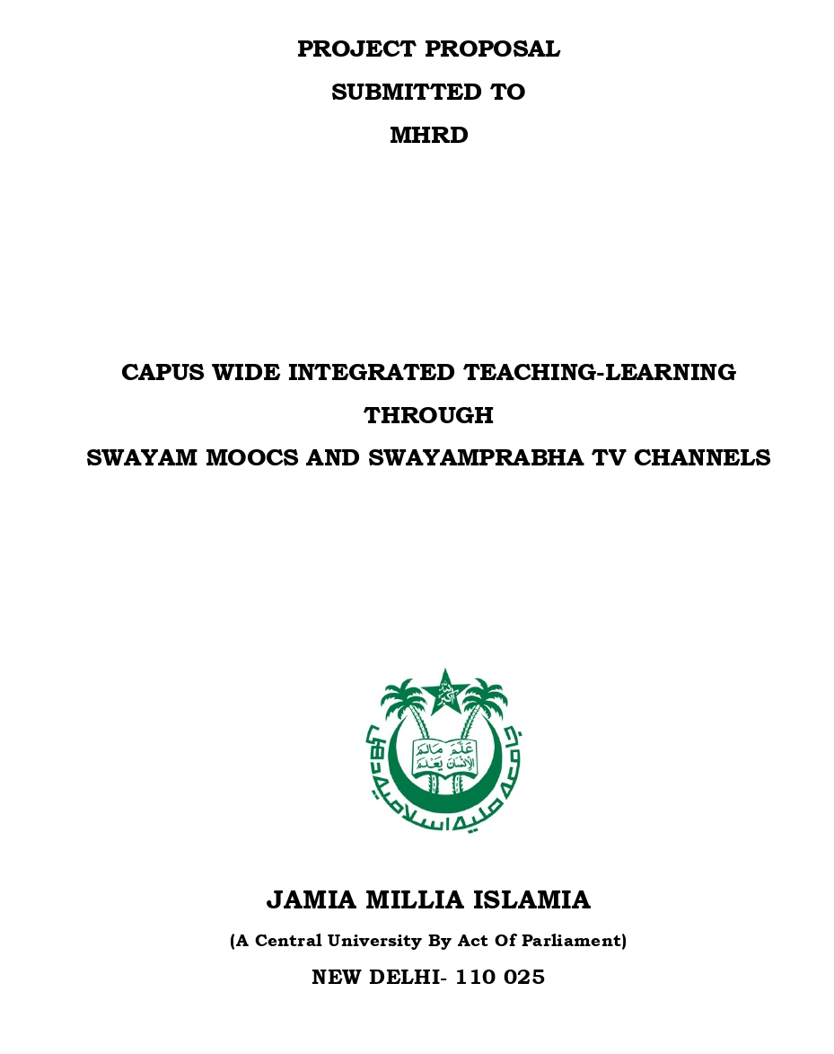

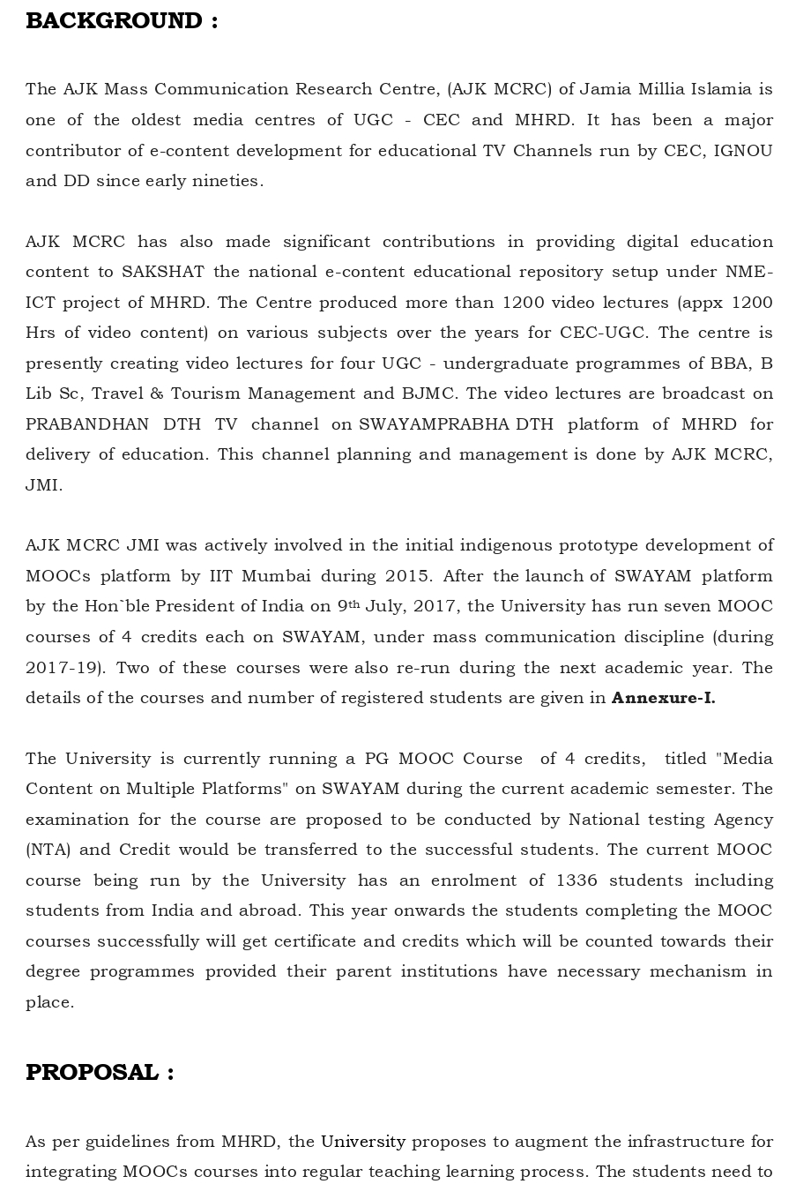

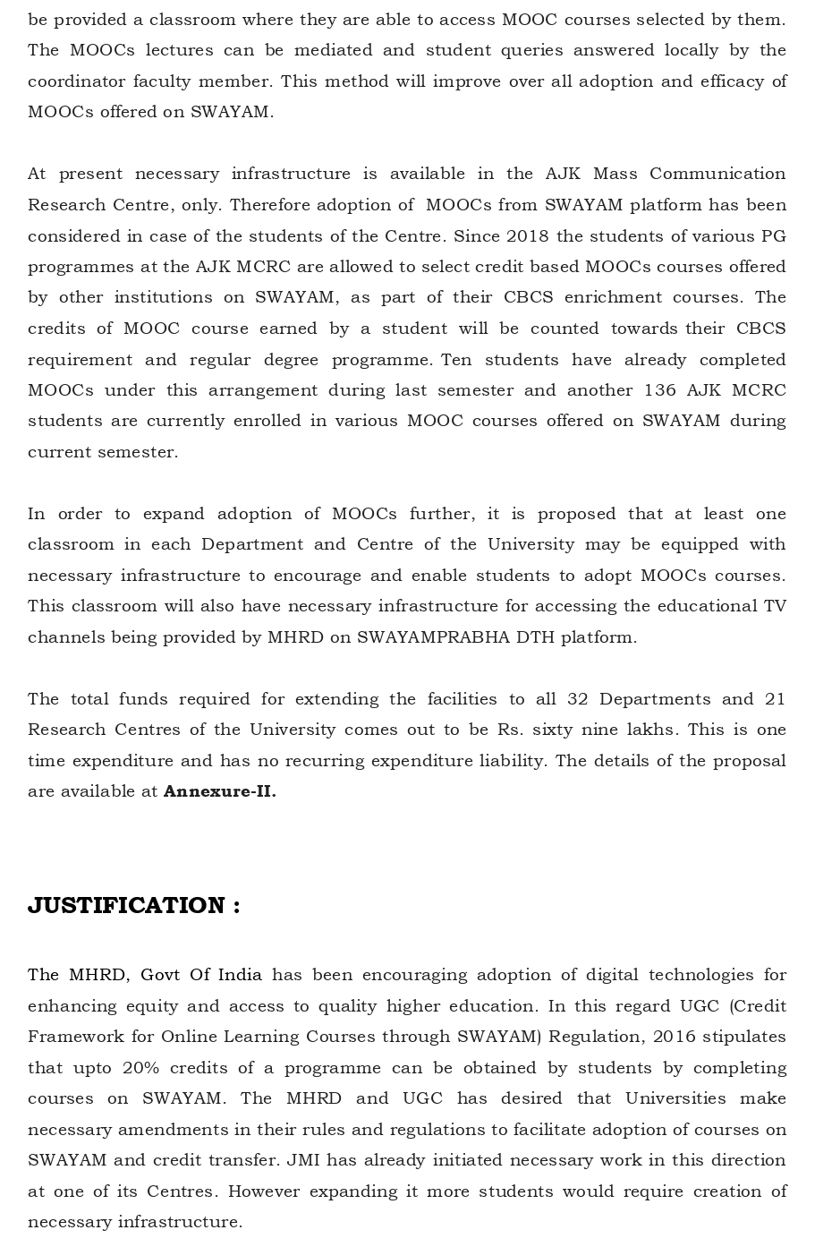

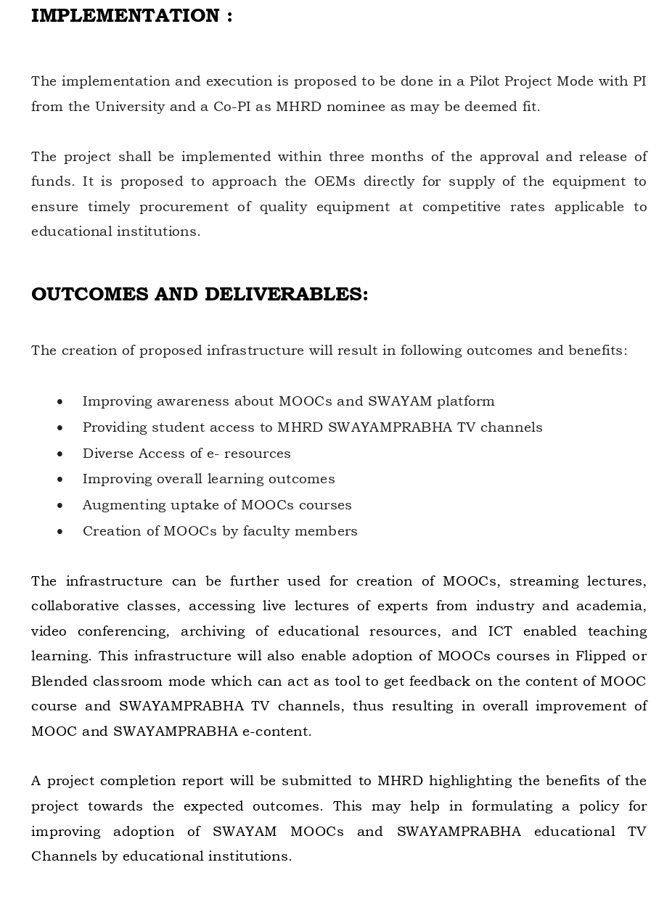

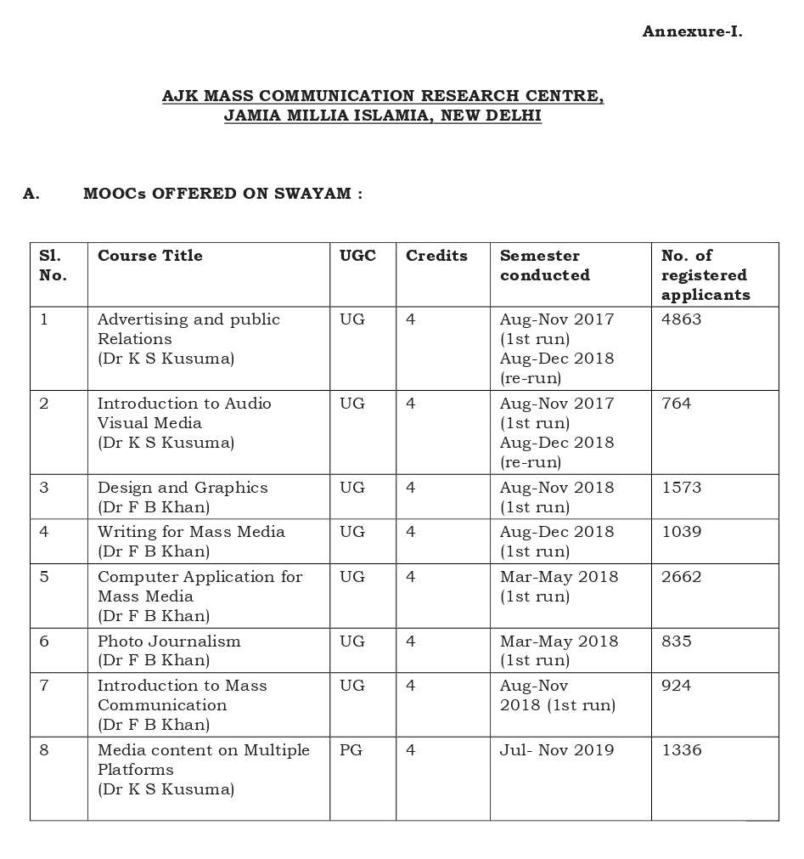

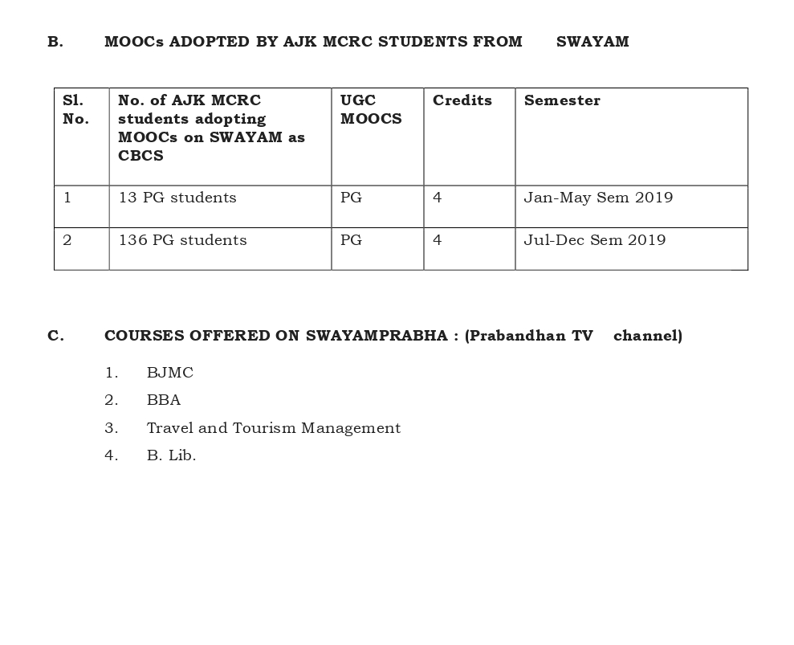

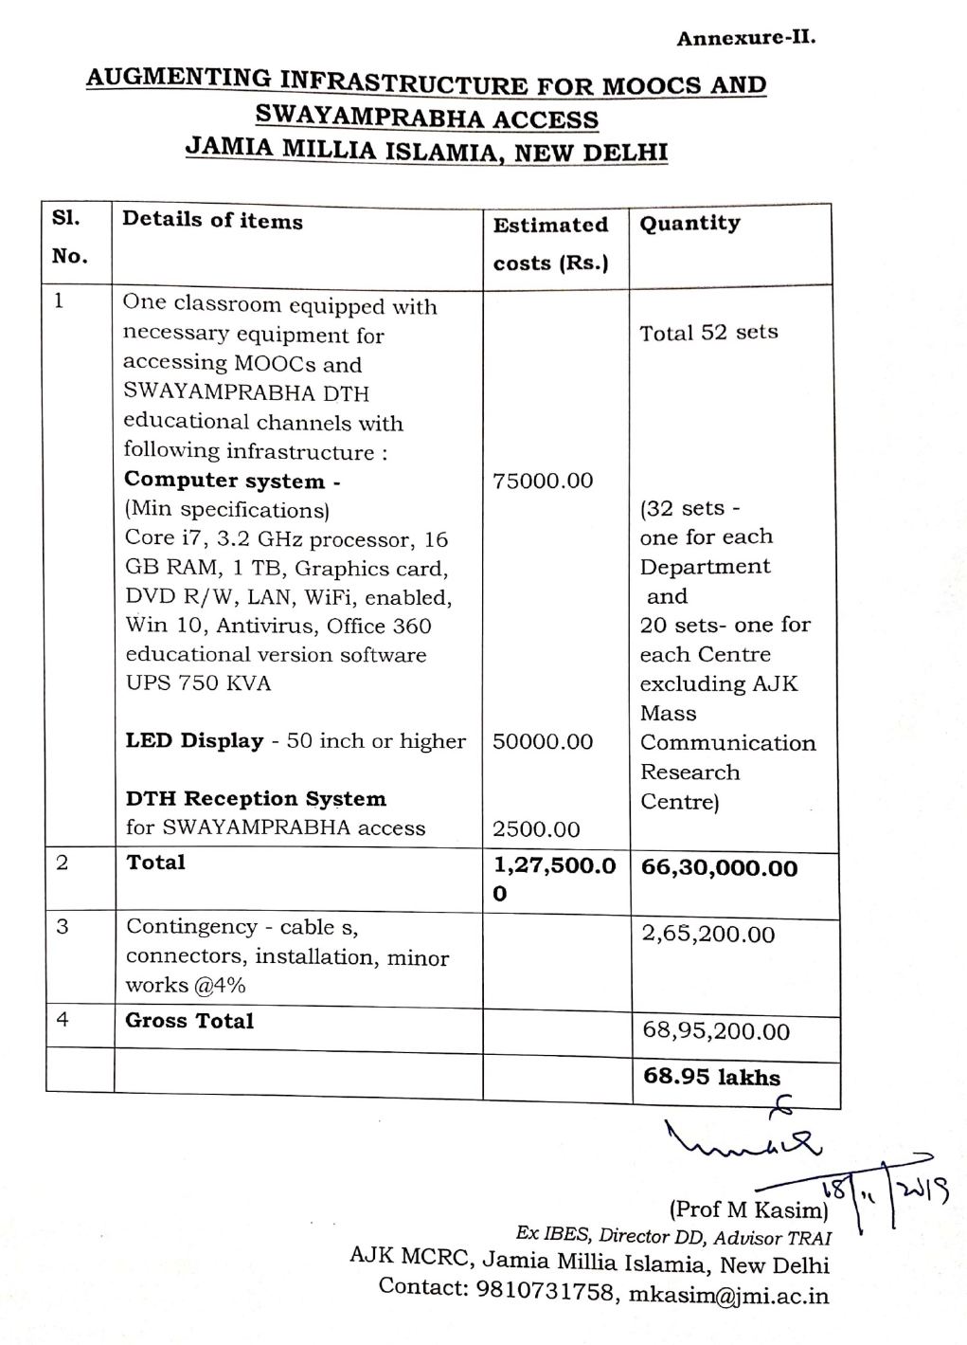

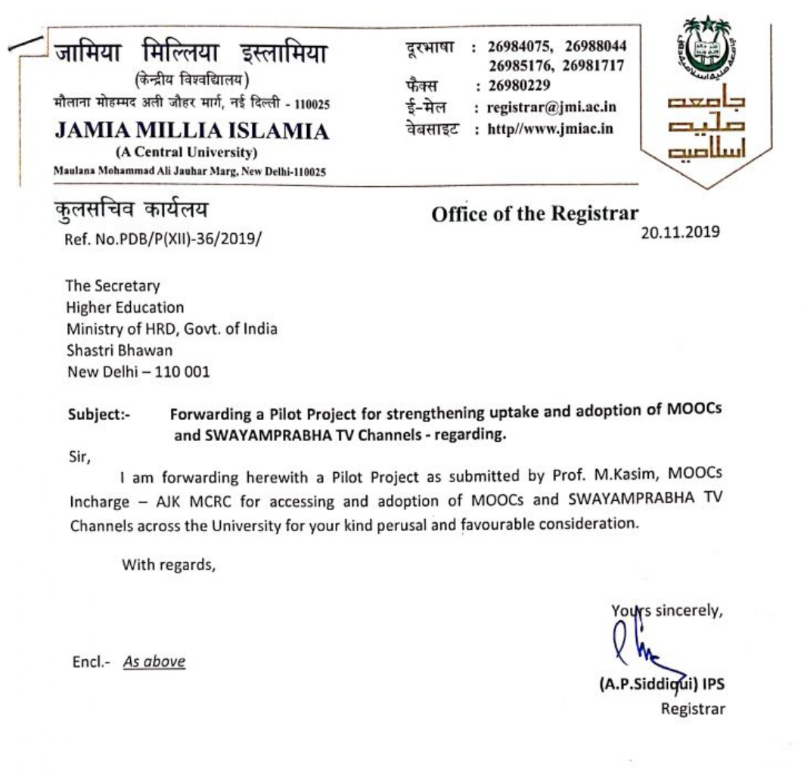

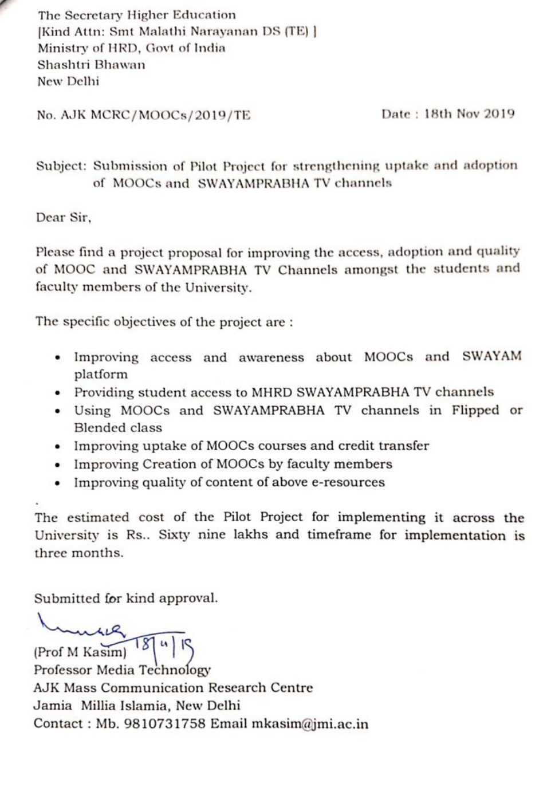

Agenda Item No. 10

Conduct of Yoga Programme Examinations by Swami Vivekananda Yoga Aunsandhana Samsthana (S-VYASA) on 29th & 30th December, 2019 at Bengaluru and proposal from
S-VYASA for Re-running of Yoga Courses on SWAYAM Platform
- By AICTE, New Delhi

Swami Vivekananda Yoga Anusandhana Samsthana (S-VYASA), Bangalore has created the following Four Online Yoga Courses, as Credit Courses, for SWAYAM:
- Introduction to Yoga and Applications of Yoga
- Yoga Practices 1
- Yoga Practices 2
- Yoga Practices 3
The Registrar, S-VYASA vide his e-mail dated 28th November, 2019 has informed that they propose to conduct the final examinations in respect of the above Yoga courses as per the following Model/Schedule:

S.No. | Name of the Yoga Course | Date of Examination | Time
1. | Introduction to Yoga and Applications of Yoga | 29-12-2019 | 9.30 am to 12.30 pm
2. | Yoga Practices 1/2/3 | 29-12-2019 | 2.30 am to 5.30 pm
3. | Yoga Practices 1/2/3 | 30-12-2019 | 7.00 am to 5.30 pm
4. | Yoga Practice 1/2/3 | 30-12-2019 | 9.30 am to 5.30 pm

Examination Venue: Prashanti Kutiram Campus, Jigani, Bengaluru

AICTE has been requested to forward this message to all the Students that “All the 4 Courses Examination for completing YIC Programme will be held on 29th and 30th December, 2019 (Sunday and Monday) at the above Examination Venue.

S-VYASA has further informed that they can organise examinations in other Centres also, like Agartala, Guwahati, Kolkata, Delhi, Bhopal, Pune, Hyderabad and Bangalore provided AICTE-SWAYAM can help them with more than 30 students per course.

Examination Fee for Practical Courses

For practice-based Courses including Yoga Practices 1, Yoga Practices 2 and Yoga Practices 3 Courses, S-VYASA has proposed examination fee @ Rs.2000/- per student per course. This will include:

- Assessment using the EIGHT Step Methodology for Asanas
- Assessment of Kriyas, Pranayama, Meditation, Bandhas and Mudras

Minimum qualification of Examiner:

A Qualified and Certified Post-graduate degree holder in Yoga (approved by S-VYASA)

Number of Examiners – 2 (Two) for 30 Candidates

Examination Fee for Theory Courses including Introduction to Yoga and Applications of Yoga

For Theory Courses including Introduction to Yoga and Applications of Yoga, the examination fees per student for the Course has been proposed @ Rs. 1000/-

Number of Invigilators: 1 (One) for 30 Students.

It may be mentioned here that an Agenda Note on Conduct of “Yoga Programmes” Examinations by S-VYASA, Bangalore was earlier submitted in 10th Meeting of SWAYAM Board held on 12th December, 2018 wherein the SWAYAM Board after discussion had decided the following regarding conduct of Examinations by S-VYASA:
- The examination fee would be collected through the Platform by AICTE
- The NCs would organise the examination
- The NCs would incur the expenditure for conducting the examination from the funds provided to them under the SWAYAM project
The above decision was conveyed to S-VYASA for taking further action in the matter to conduct the Examinations and to send their proposal to AICTE. S-VYASA vide their e-mail dated 28th November, 2019 has agreed for collection of Examination Fee through SWAYAM Platform by AICTE but they have requested to pass on the Fees to S-VYASA.

For organising the Examination by NC, it has been mentioned by S-VYASA that since they have developed the Yoga Courses, only S-VYASA nominated/qualified centers should conduct these Examinations. For this effort, the examination fees should be paid to S-VYASA. Further, it is stated by S-VYASA that there would be additional costs for Yoga Examinations to be held as part of the Yoga Courses being offered on the SWAYAM. Hence, the costs have been calculated as Rs.2000.00 per candidate per Course.

Proposal for Re-Running the Yoga Courses on SWAYAM Platform

S-VYASA has given their consent to re-run the Yoga Courses developed by them on SWAYAM Platform. S-VYASA has sought confirmation on payment of Rs.1.00 Lakh to be paid for Course delivery to the Course Coordinator per each re-run.

In view of the above, SWAYAM Board may kindly consider and approve the following:

- To approve conduct of Yoga Examinations by S-VYASA itself in place of NC in respect of all Four Yoga Courses on 29th & 30th December, 2019 (Sunday & Monday) in Prashanti Kutiram, S-VYASA University Campus, Jigani, Bengalure.

- To approve Examination Fee @ Rs.2000/- per student per course for practice-based Courses viz. Yoga Practice 1, 2 and 3 Courses as proposed by S-VYASA.

- To approve Examination Fee @ Rs. 1000/- per student per course for Theory Courses i.e. Introduction to Yoga and Applications of Yoga.

- Payment of Examination Fee to S-VYASA collected from Students of Yoga through SWAYAM Platform as requested by S-VYASA vide their e-mail dated 28th November, 2019.

- To consider payment of Rs.1.00 Lakh to be paid for Course delivery to the Course Coordinator per each Re-run.

Thank You

