Agenda Papers

2nd Meeting
SWAYAM BOARD

12th March, 2018

Ministry of Human
Resource Development
Shastri Bhawan
New Delhi - 110001

AGENDA
2nd Meeting of the SWAYAM Board

S. No. | Agenda Items | Page No.
1 | Agenda Item No. 1  Action Taken Report & Status Report | 2 - 3
2 | Agenda Item No. 2:  Payment of Honorarium for delivery of SWAYAM Courses | 4–6
3 | Agenda Item No. 3:  Conduct of Examination for Credit Transfer / Certificate Courses | 7 – 8
4 | Agenda Item No. 4:  Proposal to Conduct Term End Examination for MOOCs on SWAYAM Platform by IGNOU | 9– 12
5 | Agenda Item No. 5:  Proposal for Identifying an Application Service Provider (ASP) for SWAYAM | 13 - 16
6 | Agenda Item No. 6:  SWAYAM 2.0 | 17 – 23
7 | Agenda Item No. 7:  Partnership between edX and SWAYAM | 24 - 25
8 | Agenda Item No. 8:  Procurement of High Power Amplifiers for SWAYAM Prabha | 26 – 29
9 | Agenda Item No. 9:  Any other issue with the permission of Chair

Agenda Item No. 1

Action Taken Report of 1st SWAYAM Board meeting held on 14th November, 2017

S. No. | Action Item | Remarks
1 | Recommendation on EXAM fee and Exam framework by committee -Chairman UGC, Chairman AICTE, IIM Bangalore and NPTEL | The Committee has submitted its recommendation which is part of the Agenda of 2nd SWAYAM Board Meeting.
2 | Recommendation on Payment of Honorarium by Committee -Chairman AICTE and UGC | The Committee has submitted its recommendation which is part of the Agenda of 2nd SWAYAM Board Meeting.
3 | Setting up Local Chapters and Guidelines on Local Chapters | Orientation Workshop of forming Local Chapters in Universities held on 2nd February, 2018 by UGC. 120+ Universities attended the event.
4 | Awareness creation and publicity | Meeting held with AICTE and UGC on 5th January, 2018. UGC will prepare Radio Jingles and 3 TVC along with posters and hoardings. AICTE will come up with plan on Social Media Campaign.
5 | Seamless integration of learners of NPTEL and SWAYAM. | Expert Committee has submitted its recommendation on SWAYAM 2.0 which is part of the Agenda of 2nd SWAYAM Board Meeting.
6 | Translation of NIOS D.El.Ed. Courses | O.M. with Direction to expedite the process has been issued to NIOS.
7 | Approval of SWAYAM courses by the Central Universities. | Status to be reported by UGC
8 | Development of SWAYAM Prabha mobile app | Mobile app has been launched
9 | Providing 1 Gbps NKN connectivity to 11 EMRCs | Request for feasibility and financial proposal has been sent to NKN

Status Report

Status of SWAYAM Courses As On 08thMarch, 2018
Total Number of Courses Listed on SWAYAM : | 1011
Past Courses listed on SWAYAM : | 641
Current Courses listed on SWAYAM : | 319
Upcoming Courses listed on SWAYAM : | 51

National Coordinator-wise Distribution of Courses As On 08thMarch, 2018
 | Past Courses | Current Courses | Upcoming Courses | Total Courses | Total Student Enrollment
NPTEL (UG & PG Engineering) | 380 | 281 | 50 | 711 | 292629
UGC (PG Non Engineering) | 115 | 0 | 0 | 115 | 75031
CEC (UG Non Engineering) | 76 | 2 | 0 | 78 | 75517
IIM B (Management) | 10 | 6 | 1 | 17 | 40686
IGNOU (Certificate & Diploma Courses) | 14 | 0 | 0 | 14 | 16691
NCERT (School 9th to 12th) | 15 | 5 | 0 | 20 | 26290
NIOS (Open School 9th to 12th ) | 31 | 19 | 0 | 50 | 2447789
AICTE (Foreign Universities) | 0 | 6 | 0 | 6 | 20335
NITTTR (Teacher Training) | 0 | 0 | 0 | 0 | 0
Total | 641 | 319 | 51 | 1011 | 2994968

Registration & Enrollment Status As On 08thMarch, 2018
Total number of Registration on SWAYAM Platform | 1951008
Total number of Enrollment on SWAYAM Courses | 2994968
Enrollment in NIOS DElEd Courses 501 | 837306
Enrollment in NIOS DElEd Courses 502 | 705418
Enrollment in NIOS DElEd Courses 503 | 693558
Enrollment in NIOS DElEd Courses 504 | 135371
Enrollment in NIOS DElEd Courses 505 | 39090

Agenda Item No. 2
Payment of Honorarium for delivery of SWAYAM Courses
Purport
The objective of this Note is to seek the approval of the Board for the recommendations of the Committee setup to suggest norms for Payment of Honorarium for delivery of SWAYAM Courses.
Background
SWAYAM Board in its 1st meeting held on 14th November, 2017 formed a sub-committee consisting of Chairman UGC and Chairman, AICTE to examine the issue regarding payment of Honorarium for delivery of SWAYAM Courses and come up with their recommendations.
The Committee has submitted its report which is attached.
Recommendations

- The honorarium should be Rs. 20,000/- per credit (10 hrs TLM) for enrollments less than 500. So for a 40 Hours Course, it would be Rs. 80,000/- (maximum).

- The honorarium should be Rs. 25,000/- per credit for enrollments equal to or greater than 500. So for a 40 Hours Course, it would be Rs. 1,00,000/- (maximum).

- The payment towards teaching assistant should be of Rs. 20,000/- for every 500 students enrolled for a 40 Hours credit / certificate courses subject to a maximum of 5 Teaching Assistants for any course.

- For the Niche Courses, the concerned AAC would be empowered to modify the norms subject to the maximum cap mentioned above

Approval Sought
Approval of the Board is sought for the above recommendations of the Committee.

Report of the Committee regarding Payment of Honorarium for delivery of SWAYAM Courses

Background
SWAYAM Board in its 1st meeting held on 14th November, 2017 formed a sub-committee consisting of Chairman UGC and Chairman, AICTE to examine the issue regarding payment of Honorarium for delivery of SWAYAM Courses and come up with their recommendations. On their behalf, Chairman UGC nominated Additional Secretary and Chairman AICTE nominated Director (SWAYAM).

Observations and Analysis
- One course duration in SWAYAM is of 40 Hours of Teaching Learning Material (TLM) and the duration is taken as approximately 12 weeks.

- As per the norms used in the SFC, maximum honorarium for delivery of one course is Rs. 1 Lakh and for teaching assistant is Rs. 20,000/-.

- The honorarium and payment to teaching assistant are applicable for only credit transfer/ certificate courses.

- Every National Coordinator (NC) has an Academic Advisory Council (AAC) consisting of experienced Academicians for assisting the NC to take various decisions regarding SWAYAM-MOOCs Courses.

- The factors that determine the efforts that need to be put in for delivering the MOOCs Course are:

(i) No. of Credits. One credit could be consider and equivalent to 10 Hours of TLM so a 40 Hours SWAYAM Course taken to be of four credits.
(ii) Enrollment. There could be two slabs - less than 500 Enrollments and equal to or greater than 500 Enrollments. Here Enrollment would mean the students who are actually appearing in the examinations for credit transfer / certificate courses.
(iii) First Run or Re-run of the course. The effort required for every run of the course is approximately the same and one need not to differentiate based on this factor. However, whether a course to be re-run or not would be decided by the AAC depending upon the popularity of the course.
(iv) Area/ Discipline of the course - Technical, Management, Science and Social Science. There could be differences based on the area/ discipline. This should be left to the decision of the concerned AAC.

- The committee after deliberations have arrived at the following recommendations:

Recommendations

- The honorarium should be Rs. 20,000/- per credit for enrollments less than 500. So for a 40 Hours Course, it would be Rs. 80,000/- (maximum).

- The honorarium should be Rs. 25,000 per credit for enrollments equal to or greater than 500. So for a 40 Hours Course, it would be Rs. 1,00,000/- (maximum).

- The payment towards teaching assistant should be of Rs. 20,000/- for every 500 students enrolled for a 40 Hours credit / certificate courses subject to a maximum of 5 Teaching Assistant for any course.

- For the Niche Courses, the concerned AAC would be empowered to modify the norms subject to the maximum cap mentioned above.

Shri Parameswaran N. Dr. Manpreet Singh Manna
Sr. Consultant, M/o HRD Director, SWAYAM, AICTE

Dr. (Mrs.) Pankaj Mittal
Additional Secretary, UGC

Agenda Item No. 3

Conduct of Examination for Credit Transfer / Certificate Courses

Purport

The objective of this Note is to seek the approval of the Board for the recommendations of the Committee setup to suggest norms for Conduct of Examination for Credit Transfer / Certificate Courses.

Background

SWAYAM Board in its 1st meeting held on 14th November, 2017 formed a group consisting of Chairman UGC, Chairman AICTE, IIM Bangalore and NPTEL to come up with recommendations regarding conduct of examination for Credit Transfer/ Certificate Courses.
The Committee has submitted its report which is attached.

Recommendations

- IGNOU may be requested to submit a proposal for conducting the examinations for SWAYAM courses. This could be used by UGC, CEC and IGNOU as of now.
- As NPTEL and IIM Bangalore are conducting examinations themselves for their courses, they may be permitted to continue the same as of now

Approval Sought

Approval of the Board is sought for the above recommendations of the Committee.

Report of the Committee regarding Conduct of Examination for Credit Transfer / Certificate Courses

Background

- SWAYAM Board in its 1st meeting held on 14th November, 2017 formed a group consisting of Chairman UGC, Chairman AICTE, IIM Bangalore and NPTEL to come up with recommendations regarding conduct of examination for Credit Transfer/ Certificate Courses. On their behalf, Chairman UGC nominated Additional Secretary and Chairman AICTE nominated Director (SWAYAM).

- NPTEL and IIM Bangalore are already conducting the online examinations on their own through an outside agency. Apart from them UGC, CEC, IGNOU, NCERT, NIOS, AICTE, NITTTR has not conducted any examination under SWAYAM.

- It was observed that, IGNOU with their strong network of 56 Regional Centres and 3000 Study Centres is conducting exams for over 5 Lakhs students twice in a year during June and December. IGNOU is one of the main stakeholders in SWAYAM and could be requested to take up the responsibility of conducting the examinations for SWAYAM courses.

- As on date, AICTE and NCERT do not have any Credit/ Certificate Courses, NIOS has their own scheme of examinations and NITTTR Courses are not yet ready.

- The committee after deliberations have arrived at the following recommendations;

Recommendations

- IGNOU may be requested to submit a proposal for conducting the examinations for SWAYAM courses. This could be used by UGC, CEC and IGNOU as of now.

- As NPTEL and IIM Bangalore are conducting examinations themselves for their courses, they may be permitted to continue the same as of now.

Dr. (Mrs.) Pankaj Mittal Prof. P. D. Jose
Additional Secretary, UGC Chairperson (MOOCs Initiatives)
IIM Bangalore

Prof. Andrew Thangaraj Dr. Manpreet Singh Manna
NPTEL Coordinator Director, SWAYAM, AICTE
IIT Madras

Agenda Item No. 4
Proposal to Conduct Term End Examination for MOOCs on SWAYAM Platform by Indira Gandhi National Open University (IGNOU)

Purport

The objective of this Note is to seek the approval of the Board for the proposal of Indira Gandhi National Open University (IGNOU) to conduct Examination for MOOCs on SWAYAM Platform.

Background

M/o HRD had requested IGNOU to submit a proposal for conducting the examinations for SWAYAM Courses. IGNOU has submitted a proposal which is attached.

Key Points in the Proposal

1. IGNOU would conduct the examination through its Exam Centers numbering around 1000.

2. The Exams would be conducted in June and December every year.

3. The Exams would be paper and pen exam.

4. The approximate Financial Implications are Rs. 750/- to 1,000/- per person and service charges of Rs. 10 Lakhs per exam cycle. The Charges would come down once the number of people taking the examination increases.

5. The detailed steps in organizing the examination have been mentioned in the proposal.

Approval Sought

Approval of the Board is sought for the proposal of IGNOU to conduct the examination for SWAYAM Courses.

Proposal to Conduct Term End Examination for MOOCs on SWAYAM Platform by Indira Gandhi National Open University (IGNOU)
IGNOU has received request from the MHRD for conduct of examination for SWAYAM Courses using its existing examination system.
IGNOU conducts term end examinations (TEE) for around 2500 courses covering 18 to 20 days in 900-1000 Exam Centres. 6 Lakhs students appear for term end examination in each cycle with 22-25 Lakhs student-sittings per each cycle (approx 4 courses by each student). The conduct of examination and evaluation activities is decentralized using IGNOU’s Network of 67 Regional Centres and 5 Regional Evaluation Centres (REC) covering five zones under the supervision of the Student Evaluation Division at IGNOU Head Quarters.
For conducting the SWAYAM Examination the following procedural and financial guidelines are proposed for consideration and approval:
I. Procedural Guidelines
A. Steps involved in conduct of Examination:
S. No. | Task | Responsibility | Remarks / Required Action
1 | Question Paper Setting | Course Coordinator | 2 sets of question papers to be prepared by the Course Coordinator
2 | Moderation of Question Paper | Course Coordinator | Course coordinator will take the responsibility of getting them moderated by a panel of 2 to 3 subject experts.
3 | Dispatch of Moderated Question Paper to IGNOU for Printing | Course Coordinator | Moderated questions Paper in a sealed envelope should be sent of Registrar, SED, IGNOU at least 3 months in advance for printing
4 | Scheduling and Date Sheet preparation | IGNOU | Based on the number of courses offered for examination the date sheet will be prepared and uploaded on SWAYAM Portal
5 | Question Paper Printing | IGNOU | Depending on the no. of students registered for exam, the print run of the question paper will be decided and printed.
6 | Dispatching of question papers and Blank Answer Scripts to Exam Centers | IGNOU | Depending on the allotment of the courses to each exam centre, the question papers and blank answer scripts will be dispatched. (Atleast one examination centre per state will be identified by IGNOU)
7 | Conduct of Examination | IGNOU | Will be conducted along with IGNOU exams in the month of June and December (preferably during the last 10 days in June and December)
8 | Dispatch of Answer Scripts from Exam Centres to Regional Evaluation Center of IGNOU | Exam Centre of IGNOU | As per IGNOU procedure
9 | Sending of Answer scripts to Evaluators | Regional Evaluation Centre (REC), IGNOU | For each course the course coordinator concerned will prepare list of evaluators and share it with IGNOU.  RECs will dispatch the answer scripts to the evaluators drawn by the Course Coordinator.
10 | Return of the evaluated answer scripts and the Award List by insured Speed Post to RECs, IGNOU | Evaluator | As per IGNOU procedure
11 | Uploading of award list to SWAYAM portal | RECs, IGNOU | RECs will be uploading the award sheet on the SWAYAM portal within a week.
12 | Issue of Certificates | Host Institution | Once result is declared, the concerned course coordinator will coordinate with the host institution for issue of Course Completion Certificate in the format decided by SWAYAM.

B. Additional Guidelines:
1. Online Examination Form will be made available on the SWAYAM Portal for each course with online exam fee payment facility.
2. Hall Tickets will be generated online on SWAYAM Portal. The student has to take the print-out of the same and produced in the Exam Centre along with a Government valid Photo-ID for verification.
3. On pilot basis, exams will be scheduled and conducted along with IGNOU examination cycles in June and December every year. Once the volume of exam forms submitted increases, the process will be scaled-up and handled independent of IGNOUs exam cycles.
4. All answer scripts will be preserved for 2 years as per IGNOU norms.
5. Re-evaluation facility and on-demand photocopy of the answer script will be provided as per IGNOU payment norms.
6. The SWAYAM Portal should provide the interface for examination (exam registration to certification) with the special provision for IGNOU to upload datesheet, award list etc.
7. For International Students special provision may be made in the respective Embassies as per requirement.
8. Payment to Exam Centres, evaluators etc. will be made by IGNOU as per IGNOU norms.

C. Timelines:
S. No. | Task | Time
1 | Announcement of Examination | In the months of February for June Examination and August for December Examination
2 | Filling up of Examination Form | 30th April for June Examination and 31st October for December Examination
3 | Paper Setting and Moderation | 31st March for June Examination and 30th September for December Examination
4 | Conduct of Examination | 21st – 30thJune and 21st – 31stDecember (except on Sunday’s and Government / Gazetted Holidays)
5 | Evaluation by the Evaluator | 15 – 20 Days depending upon the No. of Answer Scripts.
6 | Declaration of Results | 15thAugust for June exam and 15th February for December Exam

II. Financial Requirements:
1. Examination fee per course will be around Rs.750/- to Rs. 1,000/- depending on the course requirements. Exam fee collected through SWAYAM portal will be transferred to IGNOU account for conduct of examination.
2. Examination Service Charges of Rs. 10 Lakhs per exam cycle (in addition to the exam fee) for overall management of the examination activities.

Agenda Item No. 5

Proposal for Identifying an Application Service Provider (ASP) for SWAYAM

Purport

The objective of this Note is to seek the approval of the Board for the proposal of IIT Madras for Identifying an Application Service Provider (ASP) for SWAYAM.

Background

1. The current contract with M/s Microsoft for support of the SWAYAM Platform is up to 17.06.2018. It has been discussed on earlier occasions the need for selection of an Application Service Provider who would take over from M/s Microsoft the support services for SWAYAM Platform.

2. It was decided by the Joint Committee of SPC in its meeting held on 23rd February 2018, that the project of selection of Application Service Provider (ASP) of SWAYAM Platform should be entrusted to IIT Madras. Prof. Andrew Thangaraj was advised to submit a proposal in this regard at the earliest mentioning therein the Scope, Time Frame, Costs, Deliverables and the Resources required for the same. A proposal has been submitted by IIT Madras which is enclosed herewith.

Key Features of proposal

1. The Principal Investigator of the project would be Prof. Andrew Thangaraj, IIT Madras and the Co-Investigator would be Prof. S. Sudarshan, IIT Bombay, Prof. G. Phanikumar, IIT Madras and Prof. Prathap Haridoss, IIT Madras.

2. The task of the Application Service Provider (ASP) (for both web and mobile) will be to maintain the SWAYAM Code, including fixing bugs as they are found, provide feature additions to satisfy user requirements and ensure further development of the MOOC application, and most importantly, in cooperation with the Cloud Service Provider (CSP), keep the application/ deployment up and running with service-level guarantees. This requires a team of .NET Developers, who are highly experienced in cloud deployments at very large scale.

3. The estimated overall Budget is as follows:

Item | Year 1 (Lakhs) | Year 2 (Lakhs) | Year 3 (Lakhs) | Total (Lakhs)
Application Service Provider | 420 + 75.60 (GST) | 420 + 75.60 (GST) | 420 + 75.60 (GST) | 1260 + 226.80 (GST)
Travel | 20 | 10 | 10 | 40
Contingency / Consumables | 20 | 10 | 10 | 40
Total (Lakhs) | 535.60 | 515.60 | 515.60 | 1566.80

Approval Sought

The approval of the Board is sought for the proposal for Identifying an Application Service Provider (ASP) for SWAYAM and incurring the expenditure of Rs. 15.67 Crores over three years.

Proposal for Identifying an Application Service Provider for SWAYAM

Principal investigator: Prof. Andrew Thangaraj, IIT Madras
Co-investigator: Prof. S. Sudarshan, IIT Bombay
Co-investigator: Prof. G. Phanikumar, IIT Madras
Co-investigator: Prof. Prathap Haridoss, IIT Madras

Background
swayam.gov.in is the Ministry of HRD's MOOC portal designed to serve students/learners in India from high school level to post-graduate level by offering online courses, whose content comprises video lectures, quizzes, assignments and reading material with a discussion forum that aids interaction between the Instructor and the learners. There are plans to target more than 1 Crore students by August 15th, 2018, and make the portal a premier destination for all learners.

The entire application (backend, and web/mobile frontend), implemented primarily on .NET, was designed/developed by Microsoft and is currently deployed on the Microsoft proprietary Azure cloud. Microsoft has been managing the deployment and the application so far. The Microsoft team is due to exit the project within the next 4 months.

For the long term, a cloud service provider (CSP) has been contracted to host the application, who is currently porting the application out of Azure and into the CSP’s infrastructure.

The next immediate requirement is that of an Application Service Provider (ASP) (for both web and mobile), whose task will be to maintain the SWAYAM Code, including fixing bugs as they are found, provide feature additions to satisfy user requirements and ensure further development of the MOOC application, and, most importantly, in cooperation with the CSP, keep the application/deployment up and running with service-level guarantees. This requires a team of .NET developers, who are highly experienced in cloud deployments at very large scale.

Methodology

The first step is to study and understand the SWAYAM application and its deployment. The investigators have the advantage of having been part of the expert committee that evaluated the current SWAYAM application. Therefore, they have a good starting point. However, the detailed architecture of the application needs to be studied to fully understand all the complexities and implementation issues. After this study, the investigators will arrive at a suitable composition for the team that is needed for providing all the services required from an ASP.

The next task is to identify the ASP. Given the time criticality and scale of the task of the ASP, an appropriate organisation with suitable experience and expertise needs to be identified in a time-bound manner. The basic process to be used for identifying the organisation will be in accordance with the financial and purchase procedures followed at IIT Madras. Options include an open tender on a QCBS basis, and nomination via reputed public sector undertakings such as CDAC, or TCIL. Note that sourcing manpower via organizations that supply skilled manpower is not desirable, since it does not match the ASP model, where the ASP takes complete responsibility for the running of the service.

The final task is to identify suitable procedures for managing the ASP and working with the ASP. Suitable mechanisms will be developed for bug fixes and feature additions on the portal. The portal is used by several stakeholders.

(1) The National Coordinators of SWAYAM: They offer courses on SWAYAM.
(2) The students or learners: They consume the content.
(3) Administrators: They monitor the activity.

All of the stakeholders will have feedback on improvements and bugs. A systematic and simple procedure for identifying and prioritising the bug fixes and feature additions is important. A suitable online mechanism will be evolved for this purpose.

Timeline (3 Years Proposal)

Task | Time (W: week) | Remarks
Study SWAYAM and identify team composition | W1 | Go through documentation  Discuss with experts in academia/industry
Form committee at IIT Madras to recommend procedure to identify ASP | W1 | Academic experts  Administrative input
Implement the procedure | W2 - W10 | Time critical task.  Aggressive timing if we follow open tender route.
Appoint the ASP and issue the work order | W11 | Order to be issued for 3 years  Risk of delay if there are any issues with open tender
Monitor the work of the ASP | W12 - | Monitor/manage the ASP’s work
Evolve mechanisms for working with ASP | W12 - W36 | Six month window to establish joint operations

Budget

ASP: For an application of this scale and the requirement of high quality, based on inputs from reputed organisations and based on the expertise of the investigators, a tentative budgetary estimate is an average cost of Rs. 3.5 Lakhs per person per month in the ASP’s team. Assuming a tentative team size of 10, the expected cost of the ASP will be about Rs. 35 Lakhs per month, which amounts to a total of Rs. 420 Lakhs per year plus applicable GST at 18%.

Travel: The 4 coordinators will need to travel to meet with different organisations, and to MHRD in Delhi. Once an ASP is identified, regular meetings are needed to monitor progress. A sum of Rs. 20 Lakhs is budgeted for travel and meetings in the first year and Rs. 10 Lakhs is budgeted for subsequent years.

Contingency/Consumable Costs: Contingency and consumable costs for managing the entire process is budgeted at Rs. 20 Lakhs for the first year and Rs. 10 Lakhs is budgeted for subsequent years.

The overall budget is as follows:
(All costs are in Lakhs)
Item | Year 1 (Lakhs) | Year 2 (Lakhs) | Year 3 (Lakhs) | Total (Lakhs)
Application Service Provider | 420  + 75.6 (GST) | 420  + 75.6 (GST) | 420  + 75.6 (GST) | 1260  + 226.8 (GST)
Travel | 20 | 10 | 10 | 40
Contingency / Consumables | 20 | 10 | 10 | 40
Total (Lakhs) | 535.6 | 515.6 | 515.6 | 1566.8

Agenda Item No.6

SWAYAM 2.0

Purport

The objective of this Note is to place before the Board the recommendations of the Expert Committee on SWAYAM 2.0.

Background

1. The following Expert constituted by the M/o HRD requested to make recommendations on the next version of SWAYAM, named SWAYAM 2.0:

(i) Prof. Andrew Thangaraj, IIT Madras
(ii) Prof. Huzur Saran, IIT Delhi
(iii) Prof. Prathap Haridoss, IIT Madras
(iv) Prof. S. Sudarshan, IIT Bombay
(v) Shri N. Parameswaran N., Senior Consultant (NMEICT), M/o HRD

2. The committee had their deliberations and has arrived at the recommendations for architecture of SWAYAM 2.0. The report also covers the limitations of the current approach, portal management, enhancement and National Coordinator Workflow. Copy of the recommendations is attached.

Key Features of recommendations:

1. All the courses and learner information (enrollment, marks etc.) would be centrally maintained at SWAYAM Master Platform. The Dash Board and all other information available in the SWAYAM Master Platform would be combined information from all the MOOC Platforms connected to the Master Platform.

2. The student interaction would only be through SWAYAM Master Platform. The student would be able to enroll for courses in any MOOC Platform connected to the SWAYAM Master Platform including a mix of courses across the different platforms. The existence of multiple MOOC Platforms would be seamless to the students.

3. The Data Storage (i.e. Courses) in all the MOOC Platform would reside within India.

Decision Sought

The Board is requested to accept the recommendations of the Expert Committee on SWAYAM 2.0. If accepted, the Committee may be requested to submit a detailed implementation plan to the Board.

Recommendations for SWAYAM 2.0

The following committee was constituted by the MHRD to make recommendations on the next version of SWAYAM, named SWAYAM 2.0.

1. Prof. Andrew Thangaraj, IIT Madras
2. Prof. Huzur Saran, IIT Delhi
3. Prof. Prathap Haridoss, IIT Madras
4. Prof. S. Sudarshan, IIT Bombay
5. Shri. N. Parameswaran, Senior Consultant, MHRD

All members have electronically expressed their consent for the recommendations made in this document.

Overview of Changes

The proposed recommendations for SWAYAM primarily build on and extend the definitions set by SWAYAM 1. The extensions are consistent with the core philosophy of SWAYAM 1 and not in any fundamental manner in conflict with broad parameters of SWAYAM 1. The main extensions are as listed below:

SWAYAM 1

1. Single portal for seamless experience
2. All code to be owned by Government of India
3. Single cloud deployment to be hosted inside India

SWAYAM 2

1. Single master portal for seamless experience
2. All proprietary code developed to be owned by Govt of India. Open source applications are possible as well.
3. Single cloud or multiple cloud deployments used, to be hosted in India

The overall architecture of SWAYAM 2.0 is given as a simple diagram next.

Architecture of SWAYAM V.2
SWAYAM MASTER PLATFORM

STUDENTS

OTHER MOOC PLATFORMS

MANAGEMENT MOOC PLATFORM
NPTEL MOOC PLATFORM

SWAYAM MOOC PLATFORM

Users: Users: Users:
Users: Users: Users:

AICTE All NPTEL Courses All Management
UGC Coordinated by Courses Coordinated
IGNOU IIT Madras by IIM Bangalore
CEC
NIOS
NCERT

Key Features:

1. All the courses and learner information (enrollment, marks etc.) would be centrally maintained at SWAYAM Master Platform. The Dash Board and all other information available in the SWAYAM Master Platform would be combined information from all the MOOC Platforms connected to the Master Platform.

2. The student interaction would only be through SWAYAM Master Platform. The student would be able to enroll for courses in any MOOC Platform connected to the SWAYAM Master Platform including a mix of courses across the different platforms. The existence of multiple MOOC Platforms would be seamless to the students.

3. The Data Storage (i.e. courses) in all the MOOC Platform would reside within India.

Structure
The vision of SWAYAM is to have a common Massive Open Online Courses (MOOCs) platform for a wide variety of users from school, colleges, universities, industry and many other domains. In the current version SWAYAM 1.0, several feature limitations have been observed by course coordinators and pointed out by national coordinators. Often one feature requirement contradicts another. In summary, our observation is that one size MOOC portal does not fit all of the users and is not an effective solution for a national MOOCs portal.
Limitations of Current Approach

The current SWAYAM approach assumes a single underlying platform for a very large variety of courses; by trying to be a jack of all trades, it runs the risk of being master of none. In contrast there are already several widely used MOOC platforms that provide a variety of features required for specific courses.

As an example, many MOOC courses require automatic grading of assignments. The exact manner in which an assignment is graded varies widely; it could range from executing user submitted programs to check for correct output, to Artificial Intelligence (AI) systems that analyze a submission for grammar and cohesiveness and assign a score. The resource requirements of these grading techniques can vary widely. Running user programs on a single national level MOOC server could cause serious performance problems. It is better to run courses with such requirements on MOOC systems that have already been designed to support automated grading techniques, and to run these on smaller servers to limit the effect of any performance problems that could arise.

Further, instructors may have already created MOOC courses on different platforms, such as IITBx or MITx or course builder, which offer features that they need for their course, and may be now offering the course on SWAYAM. They would be unable or unwilling to port the course to a new platform with significantly lesser features. Since it is important to attract high quality faculty and teachers to offer courses on SWAYAM, it is good to offer flexibility and ease of use.

Finally, it is important for SWAYAM to provide a way for its learners to seamlessly go to a different platform for a specific course, while supporting a single entry point for users. Moreover, the ability to take courses in a variety of platforms should not result in fragmentation of user information that is stored for the long term. It is important that information about student achievements, such as marks/grades, e-portfolios containing project reports, program code, design files, etc, should be stored centrally, and can be shared by the student with recruiters and such, to demonstrate their learning achievements.

Proposed Architecture

We propose a common SWAYAM master portal, which leads to individual MOOCs sites at the backend. The current SWAYAM version 1 will continue to live, as one of the backend MOOCS.

Master Portal

The master portal is the main SWAYAM portal with the swayam.gov.in URL. All users will land at this common page and access everything from one common place. The main functions of the master portal are as follows:

● Manages user authentication and registration
○ Optionally, unique identity management

● Single sign-on for all courses

● Maintains dashboards for all types of users

● Keeps all long-term records for each user across all courses
○ Students: Marks/grades/transcripts
○ Faculty: Courses taught, number of students, ratings etc.
○ National Coordinators: Number of courses, enrolments, ratings etc.

● Credit transfer
○ Handled centrally through the master portal

● Standards based interfaces to allow user data to be returned from MOOCs portals to master portal
○ E.g. LTI: Learning Tools Interoperability standards

● High quality search features to help users find relevant courses

● User types and rich course metadata to determine course relevance

● Ranking of courses is important
○ Course rating (by user type etc.), ratings of individual faculty and institutions

● Funding
○ The main expenditure will be development, maintenance of the master portal along with monthly cloud usage charges

● Organisation
○ Short term: A quick and effective short-term plan needs to be worked out for initiating the master portal. It is crucial to identify entities that have experience and expertise in building and maintaining large-scale application deployments on cloud.
○ Long term: A suitable organisation needs to take charge of the maintenance of the portal including application service and management of feature additions.

Multiple MOOCs Portals at the backend

● Accept single sign-on user authentication from master portal
● Should be a transparent experience for users
● Can be built on any technology
○ The current SWAYAM 1.0 portal, Course builder, Open edX, etc
● Compliance with a common method such as Learning Tools Interoperability (LTI) for maintaining synchronized data with the master portal
● Individual MOOC portals can be customized to target audience

Mobile Apps

Each MOOC Platform comes with its own Mobile App. The SWAYAM 2.0 mobile master app should be able to hand off to another MOOC App in a seamless manner when the user navigates to a course hosted on that MOOC Platform, if the user has installed that app, or should just direct the user to the MOOC website. In either case, the SWAYAM master app should support single sign on (as long as the other MOOC supports authentication from the master portal) so the users need not authenticate themselves again.

MOOCs Portal Management

Individual organisations and national coordinators have expertise in different MOOCs portals. A few of them are as follows:

- Course Builder - NPTEL
  - With several added features
- Open edX - IITB, IIMB
  - With Blended MOOCs features added by IITB
- The current SWAYAM 1.0 portal - AICTE

Considerable research and development has gone into MOOCs portals over the past decade. Further, several companies and other organisations in India are into education technology. The benefits of all the new developments can be passed on to users of SWAYAM through the deployment of multiple MOOC portals. The number of backend MOOC portals can grow in the future based on interest from organisations.

Individual organisations, who have expertise, should be tasked to maintain MOOC portal deployment and manage features. The recommended modality for portal management is as follows:

- Cloud hosting
  - The entire deployment should be on cloud with suitable scalability
  - There must be clear data privacy and ownership agreements in place
  - The cloud hosting must be inside India
  - Private clouds are an option; for example, the IITBx MOOC is hosted on a private cloud at IIT Bombay

- Funding: A suitable funding mechanism needs to be evolved for the support of development and cloud charges of the different MOOC platforms.

- Course coordinators can run their courses on any of the platforms depending on the national coordinator through which the course is being offered.

- There may be further MOOC platforms that are not funded from SWAYAM, e.g. MIT edX. SWAYAM will in general only link to courses on platforms that are non-commercial, and free to the student for learning purposes; platforms may however charge for certification.

- Dealing with system problems: Failures are a part of life, and any issues that students see in any of the platforms will reflect back on SWAYAM. Thus, SWAYAM will insist on a reasonable quality of service from the platform; quality of service should be monitored using automated systems, and SWAYAM may drop platforms that do not meet minimum standards.
A centralized trouble reporting system needs to be implemented by the master portal. MOOC platform maintainers must use this system to learn about and fix problems. Phone support may be considered for high priority issues, with restricted circulation of phone numbers to avoid phones getting swamped.

- Code Repository

  - The code repository should be maintained by a national coordinator
  - Similar to all software, the code itself will be a mix of open source components, which clearly cannot be owned by the national coordinator, and feature additions made by the national coordinator.
  - The national coordinator needs to develop a suitable policy of ownership and licensing for the feature additions

Enhancements to MOOCs Portals
The MOOC portals must continue to evolve and their features need to be enhanced over time. Also, the MOOC portals might have to interface with multiple tools developed independently so as to benefit the learners and provide them hands-on experience. For instance, integration with virtual labs is an interesting possibility going forward.

A suitable model for sharing code and data with education technology researchers who desire to make enhancements to the MOOC portals need to be evolved. A suitable project-based or course-based funding model needs to be evolved for supporting the development of enhancements as well. The cloud hosting requirements of such researchers could be supported on a common platform to facilitate ease of development.

National Coordinators Workflow

Several features in the current SWAYAM portal are actually part of workflow for national coordinators (NCs) - course proposals, examinations etc. Ideally, the workflow of NCs should be separated from the MOOCs portal. The reason is that the workflow is often tweaked and changed by NCs independently and according to their requirements. It is inconvenient to expect the nodal agency maintaining the master portal to be responsible for NC workflow development and changes.

NPTEL, being the largest contributor to SWAYAM, has developed several web applications for NC workflow. These include applications for the following:

- Course proposal
- Student/course data portal
- Local chapter portal
- Exam registration
- Question paper management
- Certificate generation

NPTEL can make the entire workflow suite available to all national coordinators. NPTEL’s workflow suite has been developed and deployed in the standard LAMP architecture, which is easy to deploy and maintain by individual NCs.

The NC workflow application need not be hosted on cloud. It is best if individual NCs have a small coding team to maintain their own workflow on local installations.

Agenda Item No. 7

Partnership between edX and SWAYAM

Purport

The objective of this Note is to place before the Board the developments regarding the Partnership between edX and SWAYAM.

Background

1. CEO, M/s edX Corp. had discussions with M/o HRD and has expressed their desire for partnership with SWAYAM. Some of the best courses available on SWAYAM could be made available on edX Platform. The SWAYAM users would be able to access edX Courses seamlessly.

2. M/s edX Corp. has forwarded the terms and conditions of the agreement to be signed with them. The same is enclosed herewith.

Key Features of proposal

1. Annual maintenance fee of US $1,00,000.

2. Can host upto 30 courses with no additional fee.

3. Revenue share - 60% to edX.

4. Training for four Institution Designees.

5. One Hour Course Team Support for each course.

Guidance Sought

The Board is requested to kindly guide the future course of action to be taken on the matter.

MEMBER PARTICIPATION AGREEMENT
Cover Sheet

Parties: | [SWAYAM], a [jurisdiction of organization and type of entity], with a principal place of business of [Institution address](“Institution”)  edX Inc., a Massachusetts nonprofit corporation, with a principal place of business of 141 Portland Street, 9th Floor, Cambridge, MA 02139 (“edX”)
Effective Date: | [DATE], 201__
Membership Fee: | US $250,000 - WAIVED
Annual Maintenance Fees: | US $100,000 each year of the Term
Initial Term: | 2 years
Hosting: | InstitutionX Courses² on the edX Site: up to 30 per year with no additional fee. All InstitutionX Courses offered on the edX Site shall be MOOCs unless otherwise agreed by the Parties.A “MOOC” is a massive open online course offered and available to any and all interested learners at no cost to the end-user except for any fees associated with the issuance of verified certificates of achievement or other fee-based course features agreed upon by the Parties.  On-campus use of InstitutionX Courses on Edge Site: up to 10 per year with no additional fee.
Course Minimum: | Institution must offer 4 distinct InstitutionX Courses on the edX Site each year of the Term (the “Course Minimum”).  For purposes of clarity, a repeat InstitutionX Course shall not be considered a distinct InstitutionX Course for purposes of satisfying the Course Minimum.
Revenue Share: | 60% of Revenue to edX and 40% of Revenue to Institution
edX Studio: | Free access for Institution designees to the edX-hosted version of Studio, edX’s course authoring software.
Training: | Training for 4 Institution designees as outlined in the attached terms and conditions³.
Learner Support: | Processing of unlimited support tickets in English with respect to InstitutionX Courses on the edX Site.
Course Team Support: | 1 hour of support from an edXservices representativefor eachInstitutionX Course offered on the edX Site.
Assessment Data: | EdX will provide Institution with full access to the Assessment Data that edX collects with respect to students enrolled in InstitutionX Courses.
Marketing: | Marketing support as set forth on Schedule A to the attached terms and conditions.

Effective Date : Effective date to be as of 1st or 15th of month to facilitate tracking by finance team.
InstitutionX Courses^{2 :} : All courses must meet edX course guidelines, structure and should be of high quality from top university partners on Swayam Platform. The courses will be branded as SwayamX courses on the edX site. Training³ : Expectation is thatedX will trainSwayamteam as reflected in this agreement,and that Swayam will train/support the universities with which it partners whose content will be hosted on edX under the Swayam name – i.e., a train-the-trainer approach

Agenda Item No.8

Procurement of High Power Amplifiers for SWAYAM Prabha

Purport

The objective of this Note is to seek the approval of the Board for the procurement of High Power Amplifier for uplinking of the SWAYAM Prabha DTH Channels at BISAG, Gandhinagar, Gujarat.

Background

1. The 32 SWAYAM Prabha DTH Channels are uplinked from BISAG, Gandhinagar, Gujarat. The equipments required for uplinking were procured by M/o HRD through M/s ECIL.

2. The High Power Amplifier (HPA) set up is tailor made for every installation, is imported and takes time for supply. At the time of commissioning of SWAYAM Prabha, due to shortage of time the HPA available at BISAG was used.

3. The ECIL and BISAG Team in their study report had recommended that a 2.4 KW HPA be used for uplinking the SWAYAM Prabha Channels. Director, BISAG vide his letter dated 12.10.2017 has highlighted the need for urgent procurement of the HPA. Copy of the letter along with the study report is enclosed.

4. The approximate cost of 2.4 KW HPA is Rs. 3.5 Crores.

Approval Sought

Approval of the Board is sought for procurement of 2.4 KW HPA costing approx. Rs. 3.5 Crores, for uplinking of SWAYAM Prabha Channels, through M/s ECIL Hyderabad.

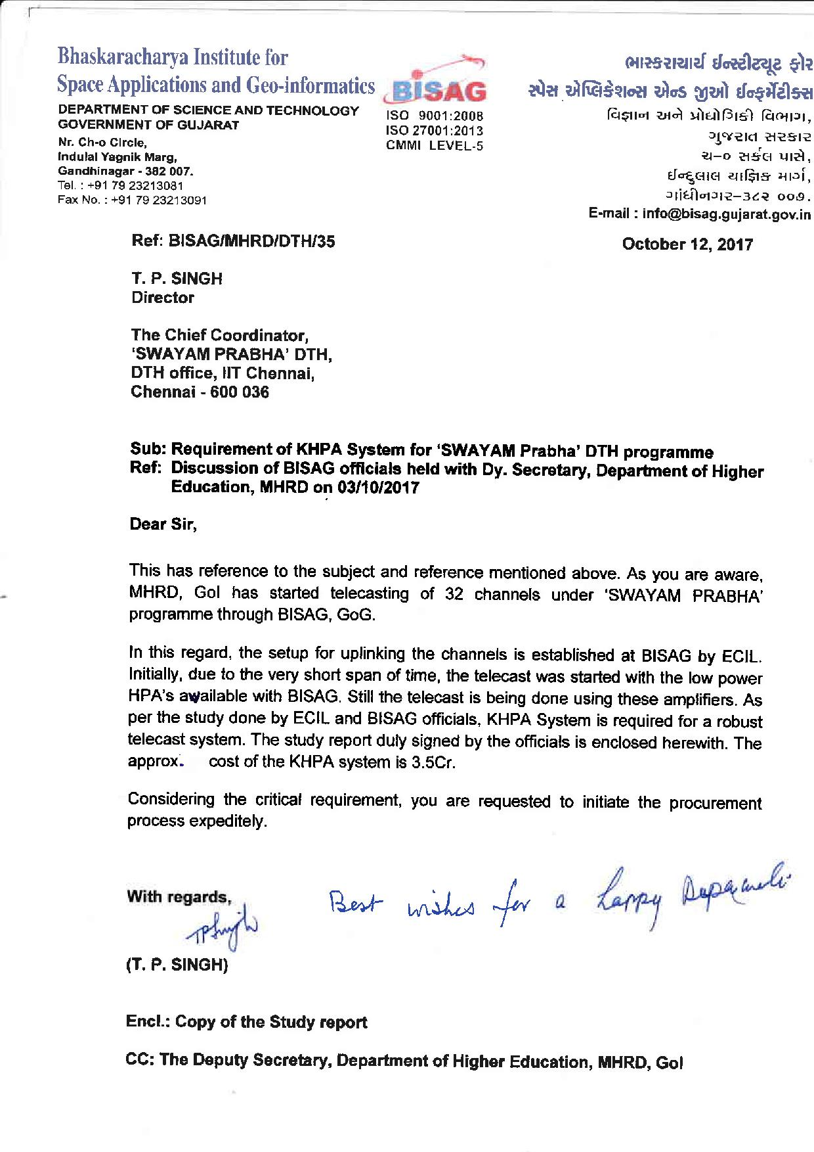

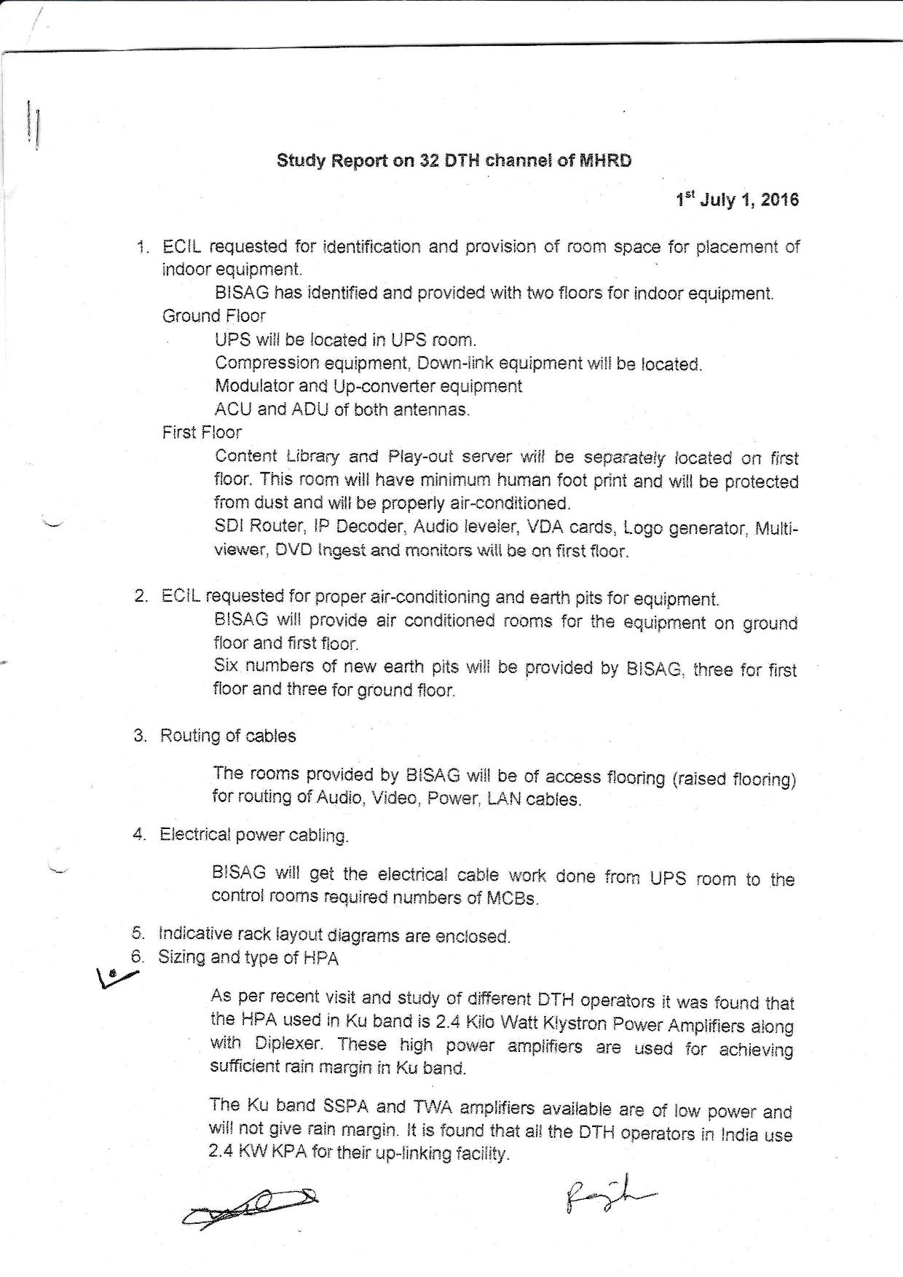
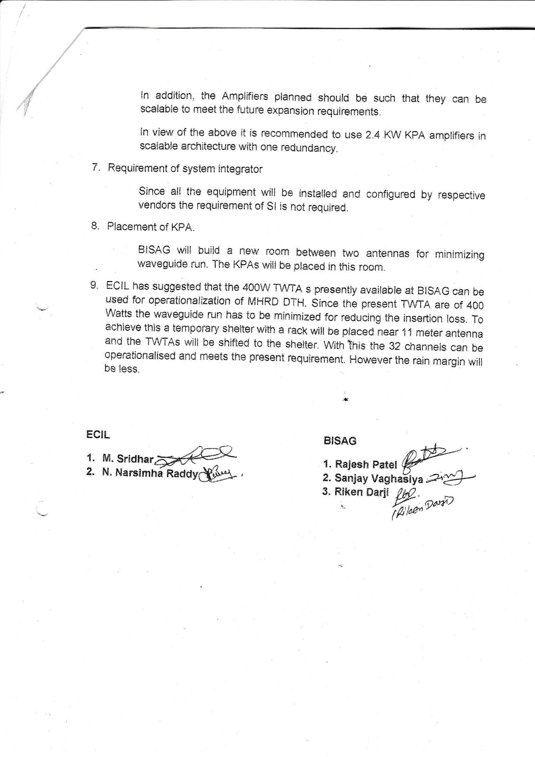

Thank You

.

