**Agenda Papers**

**4th Meeting**

**SWAYAM BOARD**

**07th May, 2018**

**Ministry of Human**

**Resource Development**

**Shastri Bhawan**

**New Delhi - 110001**

**AGENDA**

**04th Meeting of the SWAYAM Board**

|  |  |  |
| --- | --- | --- |
| **S. No.** | **Agenda Items** | **Page No.** |
| 1 | **Agenda Item No. 1**  Confirmation of Minutes of 3rd SWAYAM Board Meeting | 2 - 4 |
| 2 | **Agenda Item No. 2**  Action Taken Report | 5 - 7 |
| 3 | **Agenda Item No. 3**  Status Report provided by NC’s | 8 - 9 |
| 4 | **Agenda Item No. 4**  Facilitating Course Coordinators to offer courses to the students from other Universities / Institutions | 10 |
| 5 | **Agenda Item No. 5**  Releasing of funds for SWAYAM Local Chapters | 11 - 14 |
| 6 | **Agenda Item No. 6**  Translation and subtitling of SWAYAM Courses | 15 – 33 |
| 7 | **Agenda Item No. 7**  Guidelines on IPR, Copyrights and Plagiarism for CCs | 34 - 37 |
| 8 | **Agenda Item No. 8**  Workshop of E-9 Ministerial Meeting on ICT in Education | 38 - 41 |
| 9 | **Agenda Item No. 9**  Presentation on **How to Improve Enrollment in SWAYAM Courses** by IIM Bangalore |  |
| 10 | **Agenda Item No. 10**  Any other issue with the permission of Chair |  |

**Agenda Item No. 1**

**Confirmation of Minutes of the 3rd SWAYAM Board Meeting held on 09.04.2018**

**Minutes**

The 3rd Meeting of the SWAYAM Board was held under the Chairmanship of Shri R. Subrahmanyam, Secretary (HE), M/o HRD on 09.04.2018 at 11.00 A.M.

2. JS (TEL) initiated the meeting by going over the action taken on the decisions of 2nd SWAYAM Board meeting held on 12.03.2018.

**Agenda Item No. 1 - The** Minutes of 2nd SWAYAM Board meeting has been taken as confirmed as there was no observation.

**Agenda Item No. 2 -** Following decisions were taken on the action points:-

* **Local Chapters:** After hearing UGC and other NCs, the suggestion of NPTEL to   
  re-designate NPTEL local chapters as NPTEL SWAYAM local chapters was accepted. After discussion it emerged that all the Regional Offices of all the NCs could be tapped to reach out to maximum universities/colleges/institutions, to formulate local chapters. Secretary (HE) also suggested that a standard format be designed detailing a to-do-list and work flow of local chapters, which could be shared with all the institutions by the NCs. UGC and AICTE have agreed to organise Regional Workshops to bring in the awareness about the SWAYAM portal. NPTEL has been requested to share their existing ‘local chapter’ mandate. UGC and AICTE to take lead in this activity enthusing local chapters. All the Regional Offices of each NC should mobilize at least 10 local chapters.
* **Awareness Creation & Publicity**: UGC made a presentation of the 3 TVCs, 3 Radio jingles and sample posters. After seeing the TVCs and hearing the Jingles, it was decided to push it through Social Media. On 10.04.2018 there is a Workshop on “Social Media- Use and Effect” in AICTE auditorium which would also be addressed by Hon’ble HRM wherein these videos would be tweeted through HRM handle after its release. This is to be re-tweeted by all, for effective social media coverage. The Radio Jingles to be pushed through FM which the UGC would take up through DAVP. Between 15.04.2018 to 01.06.2018 the campaign should be intensified through Social Media in an intermeshing manner. Secretary (HE) suggested that the posters be de-cluttered and redone by 15.04.2018 after showing to UGC & AICTE which should be displayed across institutions by 01.05.2018. The soft copy of the publicity materials may also be shared with Institutions for better utilization. AICTE to expedite the social media campaign through the selected partner M/s. Goldmine Advertising Ltd.
* **Translation of NIOS D.El.Ed. Courses**: The progress was noted and Secretary (HE) directed that the progress should be reported to HRM, for his perusal.
* **Alignment of courses to curriculum:-** Status of SWAYAM courses alongwith their credits for July 2018 semester ( 1st Semester of the year ) of the NCs as below has been reviewed :-
* UGC : 44 courses (29 Re-pur+15 Re-run)
* CEC : 78 courses
* NPTEL : 262 courses (153 new + 109 Re-run)
* IIM – B : 4 courses
* IGNOU : 11 courses
* NCERT : 20 courses (8 new + 12 Re-run)
* NIOS : 35 courses (16 new + 19 Re-run)
* NITTTR : 15 courses (15 new)
* AICTE : 9 courses (self paced)

Secretary (HE) directed that details of courses, introduction, credit, name of the faculty, start & end date, assessment may be called from each course coordinator latest by 15.04.2018. For this purpose, a standard format may be designed and circulated. The alignment of courses for credit approval was discussed in detail and decided that the universities will take the decision but the UGC & AICTE must ensure that the course details are shared with all the institutions and placed before the respective academic council in the period between 1st May, 2018 and 30th June, 2018.

The Board has desired that UGC / AICTE should inform the Institutions that all the SWAYAM courses are approved duly by an Expert Committee, to ensure the quality of the courses. This is expected to help the Institutions to take a decision with regard to allowing credit transfer to courses through SWAYAM.

Registration for all courses must open on 01.05.2018. All Course Coordinators must tweet about their courses and it should be re-tweeted from all official handles. This is to bring in a significant digital impact about the availability of the courses through SWAYAM.

* **Conduct of examination:** Status noted.
* **Application Service Provider (ASP) for SWAYAM:** Status given by IIT Madras was noted. The new ASP finalisation is expected to be completed before the next Board meeting. Approximate time that would be needed for a new ASP for knowledge transfer was assessed. It was decided by the Board that since the contract with Microsoft is likely to end in mid-June 2018, their contract may be extended by 2 more months. i.e. upto July-Mid-August, 2018 to enable the new ASP to take over.
* **SWAYAM 2.0**: Status noted and final report to be placed in the next SWAYAM Board meeting.
* **Procurement of High Power Amplifiers for SP:** Prof. Mangala Sunder acknowledged that the funds have been received and a letter from MHRD is needed for further release. It is being processed.
* **Project Proposal on AI-based Learning System for Higher Education (ALSHE)**:- Prof. P D Jose has acknowledged the receipt of funds and stated that a Brainstorming session is scheduled in May, 2018.

**Agenda Item No. 3 -** The status of SWAYAM Courses is summarized below:

* Total Courses : 1031
* Active Courses : 232
* Courses Completed : 745
* Upcoming Courses : 54
* Students Registered : 19,85,320
* Students Enrolled : 31,64,839

Secretary (HE) directed the SWAYAM Cell to ensure that the change in status should be reported in every monthly meeting, comparing it with earlier status.

**Agenda Item No. 4 – Credit Framework through SWAYAM for diploma students.**

It was decided that CP, AICTE may decide as the provision already exists in notification. AICTE agreed to clarify the provisions to all the Institutions.

**Agenda Item No. 5 -** Following decisions taken:-

1. Inter-university centre for MOOCs - It was decided that UGC & CEC to interact and come to a decision which may be reported in the next SWAYAM Board meeting.
2. Videos of eminent faculty on upcoming topics - it was accepted and SWAYAM Prabha rates for creation of videos would apply.
3. Issue regarding fee for examination - It was felt by all members that a small fee for the exam was totally justified as lot of work goes in preparation and assessment of exam. The course should remain anyway completely free.
4. Finalization of courses by all NCs by 15.04.2018 – Already decided at (iv) of Agenda No.2.
5. EoI of MOOCs proposals – Private Universities – All such proposals received from private institutions should be dealt by AICTE. So, all NCs should transfer such proposals to AICTE.
6. Rolling advertisements for online proposals to develop MOOCs – Accepted.

**Items for information of SWAYAM Board**

1. Guidelines on IPR, Copyrights and Plagiarism for CCs - UGC. It is decided to circulate to all NCs and would be discussed in next meeting.
2. The recommendation of Academic Advisory Council of UGC on approval of one week content of course by SMEG prior to the final approval of development of course, has been accepted and approved.

**Agenda Item No.6 - Status of SWAYAM Prabha Channels –** Prof. Mangala Sunder made a presentation on the status of the 33 channels of SWAYAM Prabha. Secretary (HE) desired that every NC must ensure that they have access to DTH channels. After discussion, the point that came out was that the SP Channels needed publicity and this would be also taken care of by UGC.

The meeting ended with vote of thanks to the Chair.

**Agenda Item No. 2**

**Action Taken on the decisions of the 3rd SWAYAM Board meeting held on 9th April, 2018**

|  |  |  |
| --- | --- | --- |
| **S. No.** | **Action Points** | **Action Taken Note (ATN)** |
| 1 | **Local Chapters:**  NPTEL to re-designate NPTEL local chapters as **NPTEL SWAYAM** local chapters  A **standard format** be designed detailing a to-do-list and work flow of local chapters, which could be shared with all the institutions by the NCs.  UGC and AICTE have agreed to **organise Regional Workshops** to bring in the awareness about the SWAYAM portal  All the **Regional Offices** of each NC should mobilize at least **10 local chapters.** | Will be done this week.  **NPTEL SWAYAM** - format is already in place.  **UGC** Official visited IIT, Chennai on 19th & 20th April, 2018 to get an insight into the working of NPTEL Local Chapters and has written letters to Joint Secretary of Regional Office of UGC for the promotion of SWAYAM and also to reach out to maximum colleges and provide the details of SWAYAM Mentors to UGC.  **UGC** is organising a one day orientation workshop for Course Coordinators (Fresh & repurposed) on the development of MOOCs, on 10th May, 2018 at 9:30 am in the UGC, Main office New Delhi.  **AICTE:** Letters are being issued to all AICTE approved Institutes / Autonomous Institutions for establishment of Local Chapters of SWAYAM and conduct of Regional Workshops in different Institutes to bring awareness about the SWAYAM Portal. Matter is also being taken up with Principals of all CBSE/CBSE affiliated Schools/ Navodaya Vidyalayas/ Kendriya Vidyalayas apprising them about the development of “SWAYAM” Platform by MHRD and requesting all Students.  **CEC** have shared the list of 47 Local chapters and other (17) are in process.  **NIOS** is in the process of mobilizing its 22 Regional Centres for Local Chapters. NIOS had organized a SWAYAM Workshop on 23rd April 2018 at G.D. Goenka University, Gurugram, Haryana and Upcoming workshop at JMI and The Maharaja Sayajirao University of Baroda.  **NCERT** has started 6 Local Chapters in five Regional Institutes of Education (RIEs) and PSSCIVE. |
| 2 | **Awareness Creation & publicity.**  The advt. campaign shall begin by 15th April. From 15.04.2018 to 01.06.2018 the campaign should be intensified through Social Media in an intermeshing manner  **Posters** be de-cluttered and redone by 15.04.2018 after showing to UGC & AICTE which should be displayed across institutions by 01.05.2018.  **AICTE** to expedite the **social media** campaign through the selected partner M/s. Goldmine Advertising Ltd. | **UGC:**  The 3 TVCs and 3 Radio jingles has been launched by MoS M/o HRD in the Workshop on "Social Media- Use and Effect" held on 10.04.2018 in AICTE auditorium.  The TVCs and Radio Jingles have been uploaded on the UGC and the UGC MOOCs website and SWAYAM coordinators have been requested to provide links of these TVCs and Jingles on their universities website.  UGC has requested DAVP to submit the media plan for radio jingles in 10 languages (including Hindi) to be broadcast in the period of a month starting from 1.06.2018 to 1.07.2018, in pan India approach. DAVP is also requested to submit the budget indicating the rates charged for the above purpose.  Poster have been redesigned as per the feedback received in the 3rd SWAYAM Board meeting and placed for approval from the SWAYAM Board  **AICTE:** The proposal has been submitted before the Competent Authority for approval regarding issue of Work Order in favour of M/s. Goldmine Advertising Ltd, would start from the second week of May, 2018. |
| 3 | **Translation of NIOS D.El.Ed. Courses:** | **NIOS :**  1. The Study Materials of D.El.Ed have been translated in Regional Languages besides Hindi & English and are available on NIOS D.El.Ed portal & can be access through mobile application also.  2. The video program have been translated in Assamese, Bangla & Telugu are being telecast on SWAYAM Prabha Channel 25.  3. The video programme production in Odia is under process. |
| 4 | **Align the courses to the Academic Curriculum :**  Details of courses, introduction, credit, name of the faculty, start & end date, assessment may be called from each course coordinator latest by **15.04.2018**.  The UGC & AICTE must ensure that the course details are shared with all the institutions and placed before the respective academic council in the period between **1st May, 2018 and 30th June, 2018.**  Registration for all courses must open on 01.05.2018. | **UGC:**  UGC in its communication to VCs of all Universities shared the consolidated list of course received from UGC, AICTE, NPTEL, CEC, IIM-B, NIOS , NITTTR-Chennai in the requisite format with a copy to UGC SWAYAM Coordinators and UGC regional offices.  **AICTE:** The institutes will be informed that online courses would be taken on SWAYAM Portal only after the same are approved by SEMG to ensure the quality of courses.  4th May, 2018 status shows NPTEL, NITTTR,I GNOU, CEC placed their courses for July 2018 semester. |
| 5 | **Conduct of Examination** for Credit Transfer / Certificate Courses: | **IGNOU:** Request from NCs awaited |
| 6 | **Application Service**  The new ASP finalisation is expected to be completed before the next Board meeting.  It was decided by the Board that since the contract with Microsoft is likely to end in mid-June 2018, their contract may be extended by 2 more months. i.e. upto July-Mid-August, 2018 to enable the new ASP to take over. | **IIT Madras:**  Two bids have been received. Technical demo is scheduled for 7 May after which the Financial bid will be opened.    **AICTE:** The contract of M/s. MCIPL has been extended by another two months i.e. from 18-06-2018 to 17-8-2018. Letter to this effect has already been issued to M/s. MCIPL on 24th April, 2018. |
| 7 | **SWAYAM 2.0 status**  Final report to be placed in the next SWAYAM Board meeting. | **IIT Madras:** Under preparation. Will be updated in the SWAYAM Board meeting to be held in June, 2018. |
| 8 | Procurement of High Power Amplifiers for SWAYAM Prabha | **Chief Coordinator IIT Madras:** |
| 9 | **Project Proposal on Al-based Learning System for Higher Education (ALSHE):** Brainstorming session is scheduled in May, 2018. | **IIM Bangalore:** Workshop tentatively planned during 3rd week of May 2018. |
| 10 | **Inter-university centre for MOOCs** | **UGC:** Action is being taken  **CEC:** Feels that there is no need to create a separate center and the CEC may strengthen to perform additional jobs. |

**Agenda Item No. 3**

**Status of SWAYAM Courses**

|  |  |
| --- | --- |
| **Status of SWAYAM Courses as per SWAYAM Portal (as on 4th May, 2018))** | |
| Total Number of Courses Listed on SWAYAM : | **1334** |
| Past Courses (i.e already run) | **833** |
| Current Courses being run | **146** |
| Upcoming Courses (i.e. scheduled to run on a later date) | **356** |

|  |  |  |  |  |  |
| --- | --- | --- | --- | --- | --- |
| **NC wise Distribution of Courses (as on 4th May, 2018)** | | | | | |
|  | **Past courses** | **Current Courses** | **Upcoming Courses** | **Total Courses** | **Total Student Enrollment** |
| UGC (PG Non Engineering) | 115 | 0 | 0 | 115 | 75031 |
| NIOS (Open School 9th to 12th ) | 31 | 19 | 0 | 50 | 2630471 |
| NPTEL (UG & PG Engineering) | 560 | 101 | 310 | 971 | 318311 |
| NITTTR (Teacher Training) | 3 | 3 | 4 | 10 | 5089 |
| NCERT (School 9th to 12th) | 19 | 1 | 0 | 20 | 27048 |
| IGNOU (Certificate & Diploma Courses) | 14 | 0 | 9 | 23 | 16732 |
| IIM B (Management) | 14 | 5 | 0 | 19 | 45150 |
| CEC (UG Non Engineering) | 77 | 10 | 33 | 120 | 80887 |
| AICTE (Foreign Universities) | 0 | 6 | 0 | 6 | 24147 |
|  | **833** | **145** | **356** | **1334** | **3222866** |

|  |  |
| --- | --- |
| **Registration & Enrollment Status (as on 4th May, 2018)** | |
| Total number of Registration on SWAYAM Platform | 2006048 |
| Total number of Enrollment on SWAYAM Courses | 3222866 |
| Enrollment in NIOS DElEd Courses 501 | 867019 |
| Enrollment in NIOS DElEd Courses 502 | 731201 |
| Enrollment in NIOS DElEd Courses 503 | 719003 |
| Enrollment in NIOS DElEd Courses 504 | 176313 |
| Enrollment in NIOS DElEd Courses 505 | 97140 |

|  |  |  |  |
| --- | --- | --- | --- |
| **Top 10 Certificate / Credit Courses Enrollment-wise (as on 4th May, 2018)** | | | |
| **S.No.** | **Course Name** | **Institute Name** | **Enrollment** |
| 1 | 2018:Fundamentals Of Combustion - I | IIT Kanpur - NPTEL | 17796 |
| 2 | A Study Guide In Organic Retrosynthesis: Problem Solving Approach | IIT Kharagpur - NPTEL | 16068 |
| 3 | Applications of Molecular Symmetry and Group theory | Delhi University - UGC | 16000 |
| 4 | Artificial Intelligence-I | Gujarat University - UGC | 8375 |
| 5 | Communication Technologies in Education | Mumbai University - UGC | 7605 |
| 6 | Computer Programming | IIT Bombay - NPTEL | 7368 |
| 7 | Strategy and the Sustainable Enterprise | IIM Bangalore | 7295 |
| 8 | Advanced Fluid Mechanics | IIT Kharagpur - NPTEL | 7192 |
| 9 | Introduction to Strategic Management | IIM Bangalore | 5657 |
| 10 | Predictive Analytics | IIM Bangalore | 5410 |

**Status Report by NCs for the 4th SWAYAM Board meeting to be held on 7th May, 2018**

|  |  |  |  |  |  |  |
| --- | --- | --- | --- | --- | --- | --- |
| **National**  **Coordinator**  **Name** | **Total no. of courses produced till date**  **(Also indicate within bracket the credit courses among them.)** | **Total no. of courses delivered through SWAYAM (a+b) - Breakup  (a) First Run  (b) Re Run** | **No. of courses that are currently in production** | **Date of holding the last Academic Advisory Council (AAC) meeting  (a) No. of courses examined (b) No. of Courses approved** | **No. of courses in which exams have been conducted for Credit Transfer / Certificates** | **No. of Universities that have approved credit transfer.** |
| **UGC** | 60 | 120 | 87 (46 New + 29 Repur. + 12 Invited) | 26th March, 2018 (2nd Meeting) | 7 | 62 University |
| **CEC** | 87 Credit Courses | 78  (a) 55  (b) 23 | 252  (150 Repurpose + 102 Fresh) | 19th March, 2018  23rd March, 2018  159 Examined  102 Approved | - | 15 University |
| **NPTEL** | 482 | 740  (a) 482 First Run  (b) 258 Rerun | 156 courses | 07th Oct, 2017 | 514 upto January, 2018  226 in April, 2018 | 26 institutions |
| **IIM B** | 19 (All Credit) | 19  (a) 16 First Run  (b) 03 Rerun | 7 | AAC not held  Planned in June - July 2018 | 14 | - |
| **IGNOU** | 11 | 21  (a) 11 First Run  (b) 10 Rerun | 44  (31 IGNOU, 13 Other Univ.) | Held on 18th April, 2018  (a) No. of courses examined: 32 (b) No. of Courses approved: 24 (in principle) | - | - |
| **NCERT** | 20 | 16  (a) 12 First Run  (b) 4 Rerun | 24 | 23rd March 2018 (2nd meeting)  20 Courses examined  4 Proposals examined  20 Courses approved  2 Proposals approved | - | - |
| **AICTE** | 6 | 6 | 5 | 20th March 2018  10 examined  2 approved |  |  |
| **NITTTR** | 3 (All are credit  courses) | 0 | 34 | 6th December 2017  43 Examined  35 Approved | - | - |
| **NIOS** | 19 (All Credit) | Total 36  (a) 5 First Run  (b) 31 Re Run | Total 28  16 in 2017-18  12 in 2018-19 | 30th January, 2018  47 Examined  47 Approved | 14 for Secondary Course | - |

**Agenda Item No. 4**

**Facilitating Course Coordinators to offer courses to the students from other Universities / Institutions**

**Purport**

The Objective of this Note is to seek the approval of the Board for amending the guidelines for developing online course for SWAYAM so that the course coordinators can offer their courses, conduct the examination and convey the credit directly to the students from other Universities / Institutions.

**Background**

According to the guidelines for developing online course for SWAYAM dated 01.06.2017

*“The Course Coordinator while submitting the expression of interest (EoI) shall also submit an undertaking from a Host University / Institution conveying its willingness to offer the course for credit, conduct examination, assessment, evaluation, issue certificates and transfer the credits to the students of the Parent University / Institution as per the UGC/ AICTE / any other Regulatory Body Regulations issues for the purpose”*.

The UGC / AICTE Regulations dated July / August, 2016 on Credit Framework for Online Learning Courses through SWAYAM also reflect the above.

It is seen that the Host Universities are not keen to take up this responsibility of running the online courses for other Universities / Institutions. With the result the course coordinator who is otherwise willing to offer the course is not able to do so since the Host University is not extending its support. This is affecting the uptake of the SWAYAM Courses by the students.

**Proposal**

It is proposed that once the Academic Advisory Council (AAC) attached to the National Coordinator approves a course proposed by Course Coordinator (CC), the CC should be able to run the course, conduct the examination and give the credits to other Universities / Institutions directly. In a way, the CC works like an extended faculty of Parent University / Institution for this course. Before offering the course, the CC should take the no objection letter from the University / Institution that he belongs, so that the Institution is aware about the same.

The guidelines for developing online course for SWAYAM dated 01.06.2017 would need to be amended to incorporate the above proposal. Also the UGC / AICTE Regulations would have to be amended.

**Approval Sought**

**The Board is requested to kindly approve the above proposal to facilitate course coordinators to offer their courses, conduct the examination and convey the credit directly to the students from other Universities / Institutions. Also to amend the guidelines dated 01.06.2017 and UGC / AICTE Regulation to reflect this change.**

**Agenda Item No. 5**

**Releasing of funds for SWAYAM Local Chapters**

**Purport**

The Objective of this Note is to seek the approval of the Board for Releasing of funds for SWAYAM Local Chapters coordinated by IIT Madras and UGC.

**Background**

It has been the experience of NPTEL that the Local Chapters in the Educational Institutions across the country play a major role in spreading the awareness about the online courses and making it more popular. NPTEL has around 1,600 Local Chapters as on date. NPTEL has been requesting for funding to run the local chapters. A proposal in this regard is attached at **Annexure I**.

The SWAYAM Board has requested UGC to create local chapters for the non-technical courses so that more awareness can be created about these courses. This work has been taken up by UGC earnestly.

The Standing Finance Committee (SFC) has allocated Rs. 2 Crores towards Local Chapters for the F.Y. 2018-2019.

**Proposal**

It is proposed that a sum of Rs. 50 Lakhs to NPTEL and Rs. 10 Lakhs to UGC may be released for running the local chapters. NPTEL / UGC would obtain the approval of AAC for incurring expenditure on local chapters. The funding for other National Coordinators would be taken up once this activity is taken up by them.

**Approval Sought**

**The Board is requested to kindly approve the above proposal to release a sum of  
Rs. 50 Lakhs to NPTEL (IIT Madras) and Rs. 10 Lakhs to UGC for running of Local Chapters.**

**Annexure I**

**Proposal from NPTEL for Local Chapters**

**NPTEL Local Chapters**

NPTEL initiated the forming of Local Chapters in colleges in April 2015 with the aim of creating a formal partnership with them to exchange information, suggestions and feedback regarding the MOOCs being offered and to have a direct connect with the audience.

The only requirement to establish a Local Chapter is a letter from the Head of the Institution expressing interest to do so along with details of the person who would function as the Single Point of Contact (SPOC) for the Local Chapter.

In the period of 3 years (April 2015-April 2018), 1680+ local chapters have been added, which are spread all across India. 2 Local Chapters have been established in Ethiopia too.

# **Interaction with SPOCs**

The NPTEL team is in contact with the SPOCs throughout the year.

## New SPOCs

We give them a detailed document on all features available for them and also give them accounts on 2 portals - onlineourses.nptel.ac.in and on nptel.ac.in/LocalChapter.

## 4 Months ahead of the course run:

1. The tentative timelines are published and SPOCs are asked for feedback.
2. The tentative list of courses to be offered the next semester is also published and suggestions regarding addition of any other courses are invited.
3. The syllabus of all the courses is shared with them - for approval within the college/University as adopted for internal marks, activity points or credit transfer
4. Explore the avenues of adopting the courses for credit and implement the same through the Board of studies/Academic Council
5. The SPOC sits with faculty members of various departments and helps decide on the courses that are best for their students based on the mathematical difficulty, the pre-requisites and based on experience if someone has taken it before.

**3 Months ahead of course run:**

1. NPTEL office sends the hard copies of the posters to SPOCs to be put up at prominent places within the campus
2. NPTEL sends emails that can be used by the SPOCs to urge students to enroll to courses

**2 Months ahead of course run:**

1. NPTEL asks the SPOCs to request for exam centre in their city with tentative numbers to be booked with the exam partner.
2. SPOC can dynamically monitor the enrollments - coursewise.
3. He/she can designate faculty members who are mentors for every course.
4. SPOC conducts awareness workshops and meetings within the campus to motivate students and faculty to enroll. Photographs received from several colleges posted on our website is proof of this.

**During the course run:**

1. The SPOC makes arrangements within the college for either lab facilities for students to access the material online or downloads the content and puts it on the local system for access.
2. The SPOC monitors the progress of the students in the course - by checking on the assignment submission and marks obtained.
3. If fee waivers are available with NPTEL in case any company has sponsored the same through CSR, then the SPOCs also submit this data to NPTEL with proof for the request.

**Exam related**

1. If the college management agrees and the SPOC is willing, students can register to the exam form and can pay via the SPOC instead of doing an online payment directly. This is to overcome the issue of students not probably having a bank account or access to online payment methods.
2. SPOC also monitors the exam registration details and motivates the candidates from his/her college to register for the exam.
3. SPOC ensures that details entered by candidates are accurate and the mapping to the college etc. are properly done.
4. NPTEL in turn provides the SPOC with the hall tickets of all candidates registered so that they can also help out the candidates if required.
5. Many SPOCs make arrangements for transport of candidates (such as the college bus or accompanying them in case students from the hostels are taking up exams) in case the exam centre is not near the college.

**Exam results**

1. Once the course results are declared, NPTEL shares the assignment scores and final exam scores as is with the SPOC who can use this internally as per their college norms.
2. The e-certificates are also shared with the SPOC who can again use them as required.
3. A survey on the general experience, the pain points, suggestions and recommendations are invited from them.

**Refund of fee waiver**

If NPTEL does have the funds to provide fee waiver, the refund is also passed on to the students via the SPOC who disburses it to them.

**Interaction with SPOC**

1. We have a common email group with SPOCs of all college in it - to exchange and share views.
2. We have an announcement feature on the portal where all the important events and reminders are posted.
3. There is a calendar with spoc tasks and deadlines marked that helps them keep at it.
4. There is a dedicated team of staff members who handle the SPOCs aiding and guiding them at every step.
5. Once every 6 months, we have an in person meeting with the SPOCs that is organized region wise.
6. The NPTEL team interacts with them through phone calls and one-one emails also, which is sometimes more than even 100-150 a day.

## SPOC Forum: Apart from course related information

1. NPTEL informs the SPOCs of any contest happening anywhere that students can participate in and benefit from.
2. NPTEL organizes workshops by industry professionals to which students of LCs are invited - by going through the SPOC.
3. NPTEL also shares with the SPOCs the ways in which different Universities and colleges are adopting MOOC courses to give them inputs on deciding on the best way for their students, best practices are shared, etc.
4. It has become a forum for them also to share news about the happenings in their colleges and about the seminars and symposiums that happen.

**Other Assistance NPTEL gets from SPOCs**

1. SPOCs are now helping with verifying technical content in regional languages for the translated transcripts. They are also leading us to other resources who can help with the same.
2. They help organize NPTEL awareness workshops by coordinating with nearby colleges and making all the logistic arrangements for the same.

**Recognition for the SPOCs**

The Local Chapters are being rated based on performance every semester and the top 100 Local Chapters and active Local Chapters are recognized and felicitated and so are the SPOCs. Currently this is only in the form of certificates and there is NO financial incentive attached.

All the above activities are done by the SPOCs without any expectation from NPTEL, which require quite a bit of his/her time and effort every week and which are over and above the regular duties they carry on within the college.

**Proposal**

In view of the above, NPTEL proposes the following reward scheme:

Assuming that NPTEL has 2000 Local Chapters soon, we propose a budget of Rs 10000/- (Rupees ten thousand only) for SPOC of each Local Chapter for a year, which comes to a total of **Rs 2 crores per year** for the NPTEL Local Chapters.

The norms for distributing this among the SPOCs and the amount to be given to each will be based on the guidelines laid down by the NPTEL Programme Implementation Committee (PIC).

**Agenda Item No. 6**

**Translation and subtitling of SWAYAM Courses**

**Purport**

The Objective of this Note is to seek the approval of the Board for Translation and subtitling of SWAYAM Courses by IIT Madras and C-DAC / IIIT Hyderabad.

**Background**

It is envisaged in SWAYAM that the courses would be translated and subtitled in the local languages. As per the SFC Note 100 Courses are to be translated during this financial year (2018-2019) and an amount of Rs. 15 Crores has been allocated for the same.

IIT Madras and C-DAC / IIIT Hyderabad have submitted proposals for translation of SWAYAM Courses. These proposals are attached at **Annexure II**.

**Proposals**

**Proposal submitted by IIT Madras:**

**The overall budget for the one year is expected to be as follows:**

|  |  |  |
| --- | --- | --- |
| **Items** | **Details** | **Cost (INR)** |
| Transcription and Translation of **MOOCs content** | 40 courses of 40 hours at Rs 50,250/= per hour | 8,04,00,000 |
| Equipment | Server and computers for office staff | 1,20,00,000 |
| Manpower | Office and project management team  1 senior project officers and 8 project associates  Approximately Rs 5 Lakhs per person per year | 45,00,000 |
| Workshops | One per language, Rs 10,000 per participant for 100 participants in each language. | 80,00,000 |
| Travel | For meetings as well as to disseminate information | 10,00,000 |
| Consumables | Office spares and consumables | 10,00,000 |
| Honorarium | Rs 2.5 Lakhs per coordinator per year | 10,00,000 |
| **Total** |  | **10,79,00,000** |

**Proposal submitted by C-DAC / IIIT Hyderabad :**

|  |  |  |  |  |  |
| --- | --- | --- | --- | --- | --- |
| **Cost Estimation for 25 Courses into 10 Languages (A)** | | | | | |
|  | Cost of 1 course (in Rs.) | Total  Courses | No. of Languages | | Total Cost |
| **Transcription** | 36000 | 25 | 1 | | 9,00,000 |
| **Translation** | 273600 | 25 | 10 | | 6,84,00,000 |
| **Subtitling** | 60000 | 25 | 11 | | 1,65,00,000 |
| **Sub Total (A)** | | | | **8,58,00,000**  **(Rs. Eight Crore Fifty Eight Lakhs only)** | |

*Transcription validation cost is considered only for source language that is English.

|  |  |  |  |  |
| --- | --- | --- | --- | --- |
| **Customization & Management Cost (B)** | | | | |
|  | No of managers | Cost per Month  (in Rs.) | Period  (in months) | Cost in Rupees |
| Project Management | 5 | 120000 | 18 | 10800000 |
| LPMF Customization (One time setup cost) | | | | 15,00,000 |
| LPMF Hosting & Maintain Charges  (Yearly Cost 50 lacs) | | | 18 | 75,00,000 |
| Training and Workshop | | |  | 10,00,000 |
| Travel | | |  | 15,00,000 |
| Contingency | | |  | 10,00,000 |
|  |  |  | **Sub Total (B)** | 2,33,00,000 |
|  |  |  | **Total (A+B)** | 10,91,00,000 |
| **Project Overheads (10%)** | | | | 1,09,10,000 |
| **Grand Total for translation of 25 Courses into 10 Languages** | | | **12,00,10,000**  **(Rs. Twelve Crore Ten Thousand only)** | |

**Project Duration: 18 months**

**Approval Sought**

**The Board is requested to kindly approve the above proposals received from IIT Madras and CDAC and allocate 40 Courses to IIT Madras and 25 Courses to CDAC / IIIT Hyderabad.**

**Annexure II**

**Translation and subtitling of Higher Education MOOCs Video Lectures in Indian languages**

**A proposal**

**Submitted to MHRD**

**PIs:**

**Dr. Prathap Haridoss, Dr. Andrew Thangaraj,**

**Dr. Rajesh Kumar, and Dr. Abhijit P. Deshpande**

**IIT Madras**

**Executive Summary:**

As part of the activities of SWAYAM, it is proposed to enhance the utility and reach of higher educational MOOCs content, by translating the same into Indian languages and using the translation to generate subtitles in Indian languages. For technical education, the content produced by NPTEL will serve as a starting point for this process

Based on maximizing the reach, it is presently proposed that 40 courses will be translated into 8 languages. The courses selected will cover important core courses across all engineering disciplines, as well as courses in popular demand by the student community.

**Details of the Proposal:**

|  |  |  |  |  |
| --- | --- | --- | --- | --- |
|  | **PI - 1** | **PI - 2** | **PI - 3** | **PI - 4** |
| **Name** | Dr. Prathap Haridoss | Dr. Andrew Thangaraj | Dr. Rajesh Kumar | Dr. Abhijit P. Deshpande |
| **Designation** | Professor | Professor | Associate Professor | Professor |
| **Organisation** | IIT Madras | IIT Madras | IIT Madras | IIT Madras |
| **Postal Address** | (Dept. of MME)  Second floor, Central Library, IIT Madras, Chennai 600036 | (Dept. of EE)  Second floor, Central Library,IIT Madras, Chennai 600036 | Dept. of Humanities and Social Sciences, IIT Madras, Chennai 600036 | Dept. of Chemical Engineering, IIT Madras, Chennai 600036 |
| **City** | Chennai | Chennai | Chennai | Chennai |
| **State** | Tamil Nadu | Tamil Nadu | Tamil Nadu | Tamil Nadu |
| **Fax** | 044-22570545 | 044-22570545 | 044-22570545 | 044-22570545 |
| **Email** | prathap@iitm.ac.in | andrew@iitm.ac.in | rajesh@iitm.ac.in | abhijit@iitm.ac.in |
| **Mobile** | 9444468235 | 9940489032 | 9498073782 | 9444802401 |
| **Project Category** | E-Content Development | ------- | ------- | -------- |

**Names & Designation of Principle Researchers in the major areas and list of publications during last 5 years based on work done in the Department:**

Dr. Prathap Haridoss (IIT Madras), Dr. Andrew Thangaraj (IIT Madras), Dr. Rajesh Kumar (IIT Madras) and Dr. Abhijit P. Deshpande (IIT Madras); The CV of the Principal Investigators is attached at the end of this document.

**Principal Investigator Details:**

1. **Dr. Prathap Haridoss** is a Professor and has been in the Department of Metallurgical and Materials Engineering**,** Indian Institute of Technology Madras since 2003. For the past five years he has been developing online and distance education pedagogies and coursework and paradigms, and has been an active coordinator of NPTEL Phases II and III for the past three years. He is also a content creator for NPTEL Phases II and III. He is one of the coordinators for the NPTEL MOOC initiative. More details are in the CV attached. His areas of research interests include Carbon Nanotubes, Fuel Cells, Semiconducting Nanomaterials and Recycling Printed Circuit Boards.

**2) Dr. Andrew Thangaraj** is a Professor and has been in the Department of Electrical Engineering at the Indian Institute of Technology, Madras since 2004. His areas of research interest are Coding Theory, Information-theoretic Security and Information Theory. For the past five years he has been interested in online and distance education pedagogies and paradigms, and has been an active coordinator of NPTEL Phases II and III for the past five years. He has been heading the NPTEL Massive Open Online Courses (NPTEL MOOC) for the past four years. He is also a content creator for NPTEL Phases II and III. More details are in the CV attached.

3. **Dr. Rajesh Kumar** is an Associate Professor in the Department of Humanities and Social Sciences. He is an active contributor to the NPTEL MOOC program and his research interests include Natural Language Syntax/Structure of South Asian Languages, Language in Education and Language Teaching/Sociolinguistics and Language in Human Cognition.

4. **Dr. Abhijit P Deshpande** is a Professor and has been in the Department of Chemical Engineering since 1996. His areas of interest include Polymers and composites, Rheology, and Ionic polymers. He has been involved in efforts to increase the reach of science to children.

**Summary of the project:**

The SWAYAM initiative of the Ministry of Human Resource Development, Government of India, requires online courses to be made available to citizens of our country. The present proposal aims to make high quality educational content available to the public with subtitles in Indian languages so that a larger section of the citizens can benefit from the same.

NPTEL has the largest single repository of online video course material for engineering in the world, and is the most accessed educational channel on YouTube, having been accessed more than 195 million times. NPTEL is used by students in engineering colleges in India, by working professionals to refresh their knowledge or learn about another field of engineering, and by teachers and instructors in various colleges in India to enhance their understanding of specific topics as well as to improve their teaching methodologies.

Associated with the NPTEL project, a Text Transcription project has also been carried out in which the text transcript of each of the video lectures has been generated, which has been used to subtitle the videos in English.

In India, a significant number of students go through their schooling in their native language, and they may find it difficult to adjust to instructions in English in engineering colleges, which they enter immediately after native language learning for 12 years. They may also find it difficult to fully benefit from the quality engineering education material freely available to them through NPTEL.

Therefore this proposal aims to generate subtitles and metadata for the NPTEL videos in Indian languages. Since the grammar structure of Indian languages is different from that of English, automated software cannot be used for generating the subtitles. Translation to a limited extent is possible using machine tools but the bulk of content generation in local languages has to be done manually.

NPTEL videos with subtitles in Indian languages will also have the additional benefit of helping the students improve their English skills, since they will hear the instructor speak in English, and will be able to see the subtitles in their native language. This proposal therefore aims to increase the reach of NPTEL content to students who are more comfortable with instruction in other Indian languages, while simultaneously helping them improve their English skills. In addition, a large enough metadata can be created in Indian languages that can be used to search content. The process addresses cognitive skills which might be native to the learner and to help him or her with enhancement of communication skills through constant and persistent training by listening to spoken English.

**Objective:**

The SWAYAM initiative of the Ministry of Human Resource Development, Government of India, requires online courses to be made available to citizens of our country. The objective of this project is to make high quality educational content in MOOCs format, presently generated through NPTEL, available to the public with subtitles in Indian languages so that a larger section of the citizens can benefit from the same.

**Methodology:**

To begin with, the project will focus on a total of 40 video courses. Translation of these courses will be carried out in 8 languages (Hindi, Bengali, Telugu, Marathi, Tamil, Kannada, Gujarati, and Malayalam). Preliminary trials will also be attempted in the remaining official Indian languages. The process will involve:

* Manual translation from English to the Indian language.
* Use of technical terms to the extent already listed in the State approved high school science texts and
* Check for technical as well as accuracy.

**Justification, importance of the project:**

Online content and online courses can greatly enhance the educational opportunities of citizens in our country. High quality educational content with subtitles in Indian languages can further enhance the reach of such efforts in our country.

In India, there are millions of students who are keen on registering for professional education, but who may be hampered in their learning due to their insufficient grasp of the English language. This language barrier can greatly limit their learning capabilities. Their lack of English language skills is largely due to their lack of adequate opportunities for learning the same. In addition, a significant fraction of school students may also go through their schooling in their native language and hence find it difficult to adjust to instructions in English in engineering colleges. They may also find it difficult to fully benefit from the quality engineering education material freely available to them through NPTEL since there are assumptions on student preparedness in many of these courses. In the Indian online education context, NPTEL has made a significant contribution in the country’s effort towards affordable, high-quality, online education for all. To increase the reach and utility of the NPTEL online course content to even larger numbers of students in India,it is necessary to make the content accessible to students who have undergone education in Indian languages. It is also necessary to make them comfortable with technical content in English. Both of these goals can be met by providing subtitles to NPTEL content in Indian languages, which is the focus of the present proposal.

**Details of the work already done by Principal Investigator in this area**

In this proposal, it is proposed that subtitles will be generated for the NPTEL videos in 8 of the official Indian languages. Trial samples will also be attempted in the remaining official languages. A trial has already been initiated by the Prinicipal Investigators by taking a sample NPTEL video and generating its subtitles in Indian languages. These subtitles were generated by technically capable volunteers who took up the English transcript and generated a sentence by sentence equivalent in Indian languages. This NPTEL video is now available on YouTube with subtitles in several Indian languages. Screenshots of this activity are shown below. Subsequently, a professional agency has been used to generate subtitles for a couple of lectures of a highly accessed NPTEL course in several Indian languages.

English Gujarati

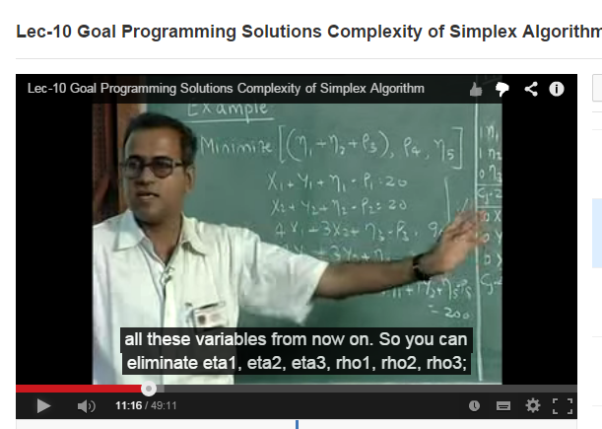 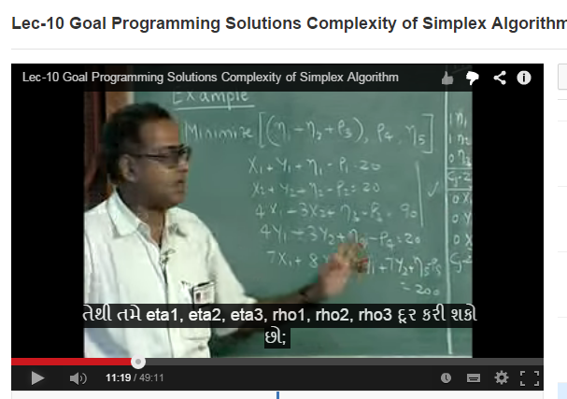

**Marathi Oriya**

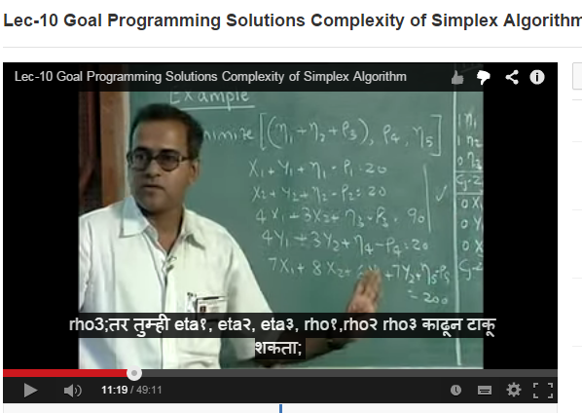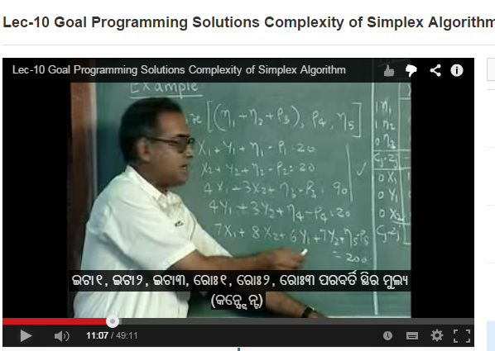

**Telugu Hindi**

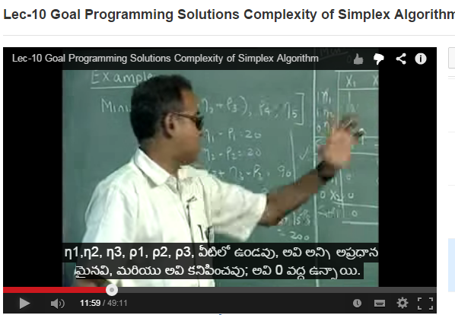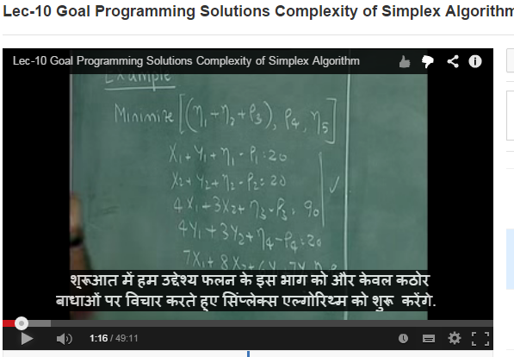

Shown below are screen-shots of Lecture 19 of the video course ‘Pre-stressed Concrete Structures’ (IIT Madras) with subtitles in English and Tamil.

**English**

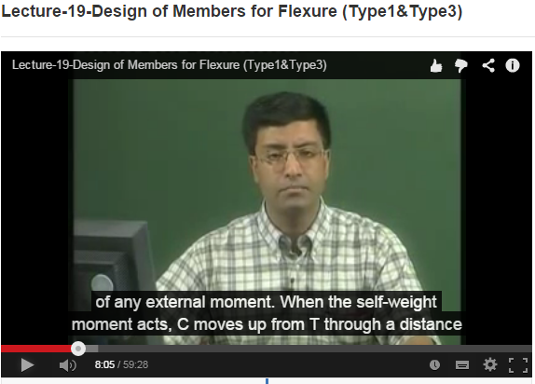

**Tamil**

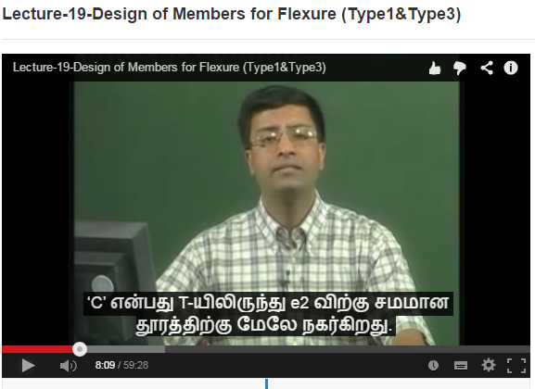

**Costing per hour of Transcription and Translation of MOOCs courses**

|  |  |  |
| --- | --- | --- |
| **Costing for 1 hr of video content** | **INR** | **Vendors** |
| Transcribing MOOCs course into English | 2950 | 1. Desi Crew Solutions 2. Bow & Bann Technology Solutions 3. Crescendo Transcription Pvt. Ltd 4. Mayflower Language Services (P) Ltd. (identified by floating an open tender) |
| Verification of the transcript | 1500 | Done by the SME |
| Subtitling the video | 200 | Currently done in-house; Can be tendered out |
| Verification of subtitles | NA | Crowd sourcing is being explored |
| **Total (for English alone)** | **4650** |  |
|  |  |  |
| **Translation of MOOCs courses into 8 languages: Hindi, Tamil,Malayalam,Kannada,Telugu,Marathi,Bengali, and Gujarati** |  |  |
| Translation into each of the 8 above Indian languages | 3500 | Desi Crew Solutions (identified by floating an open tender) |
| Verification of the translation in each language | 2000 | Experts to be identified |
| Subtitling for each language | 200 | Currently done in-house; Can be tendered out |
| Verification of subtitles | NA | Crowd sourcing is being explored |
| **Total for one language** | **5700** |  |
| Cost for translation into 8 common Indian languages | Rs 45600/- |  |
| **Cost for English Transcription as well as translation into 8 common Indian languages, per hour** | **Rs 50250/=** |  |

The above represents the costing per hour for generating English Transcript as well as translation into 8 common Indian Languages.

For an initial duration of one year, it is anticipated that this can be successfully carried out across 40 courses of approximately 40 hours each. If the duration of specific courses is different from this, correspondingly the number of courses will be adjusted to deliver 1600 hours of transcribed and translated content.

**The overall budget for the one year is therefore expected to be as follows:**

|  |  |  |
| --- | --- | --- |
| **Items** | **Details** | **Cost (INR)** |
| Transcription and Translation of **MOOCs content** | 40 courses of 40 hours at Rs 50,250/= per hour | 8,04,00,000 |
| Equipment | Server and computers for office staff | 1,20,00,000 |
| Manpower | Office and project management team  1 senior project officers and 8 project associates  Approximately Rs 5 Lakhs per person per year | 45,00,000 |
| Workshops | One per language, Rs 10,000 per participant for 100 participants in each language. | 80,00,000 |
| Travel | For meetings as well as to disseminate information | 10,00,000 |
| Consumables | Office spares and consumables | 10,00,000 |
| Honorarium | Rs 2.5 Lakhs per coordinator per year | 10,00,000 |
| **Total** |  | **10,79,00,000** |

This project is a human intensive project in content creation of the best kind in the whole world in a manner that can be accessed to users in Indian languages. Automatic translation software will result in high numbers of errors due to the different grammar structures of Indian languages. This project requires significant time, effort, and involvement from the coordinators, and these honoraria are with respect to these efforts.

#### Management of Deliverables & IPR etc.

All learning materials developed on this project will be released as Open Education Resource (OER) Creative Commons By Attribution ShareAlike (CC BY SA 4.0 India).

#### Social Impact:

Subtitling SWAYAM content in Indian languages will greatly increase the reach of the content. In particularly translation and subtitling of technical education content of SWAYAM, based on NPTEL **MOOCs content**, will enable students across the country to benefit from this content. Students who have learnt up to high school in Indian languages face significant challenges in learning technical content in English during the early years of their college studies. This greatly impacts their confidence and lowers their ability to do well in college and impacts their professional preparedness. Subtitling high quality technical content available in NPTEL, in Indian languages, has the potential to transform the educational experience that students will have access to. It will enable them to understand technical content more easily while also improving their English skills. The social impact of confident engineers with backgrounds in different Indian languages can be tremendous for all regions of the nation. This is the aspect that the present proposal aims to enable.

**Proposal for**

**“Language Translation of SWAYAM courses”**

Submitted to

**MHRD Jointly by**

**Centre for Development of Advanced Computing**

(A Scientific Society of Department of Electronics &Information Technology, Ministry of Communications and Information Technology, Govt. of India)

‘Anusandhan Bhawan’, C-56/1, Institutional Area, Sector - 62, NOIDA (UP) 201307

Tel.: +95 120 3063311-13 Fax: +95 120 3063317

Website: www.cdac.in

**International Institute of Information Technology, Hyderabad**

(A deemed University)

Gachibowli, Hyderabad, Telangana 500032

Tel.: +91-40-6653 1000, Fax : +91-40-6653 1413

Website: www.iiit.ac.in

**Date: 16th April, 2018**

**Language Translation of SWAYAM courses**

The scope of the project is to generate multi-lingual subtitled & transcripted versions of video lecture available through SWAYAM portal. This will involve transcribing the video with English text, translation of English text to Indian languages, sub-titling in English and Indian languages.

There are approximately 275 course lectures, each lecture having approx. 40 modules, each module having 30 min video. The initial scope of the project is for 25 courses.

CDAC shall be delivering the content in the following 10 Indian Languages:

Hindi, Bengali, Telugu, Marathi, Tamil, Urdu, Gujarati, Kannada, Malayalam, Oriya

The work will involve the following;

• The transcription validation of text of English videos

• Translation and validation of transcript English text into 10 Indian Language text

• Subtitling and validation of English videos into English and 10 Indian Languages

The complete process will be managed through Localization Project Management Framework (LPMF)

**Creation of Subtitles for videos lectures of SWAYAM courses using CDAC Portal:**

The process involves providing subtitles in different Indian languages to the videos lectures from SWAYAM courses received from MHRD. The various stake holders involved in the process are:

a) Project Investigator

b) Time spotter

c) Translator

d) Validator & Previewer

e) LPMF and Swayam interface manager

The above stake holders will be provided with a “login ID” and “password “for the portal with access to their corresponding Dashboards. Relevant course material will be available to them through the portal.

**Work flow:**

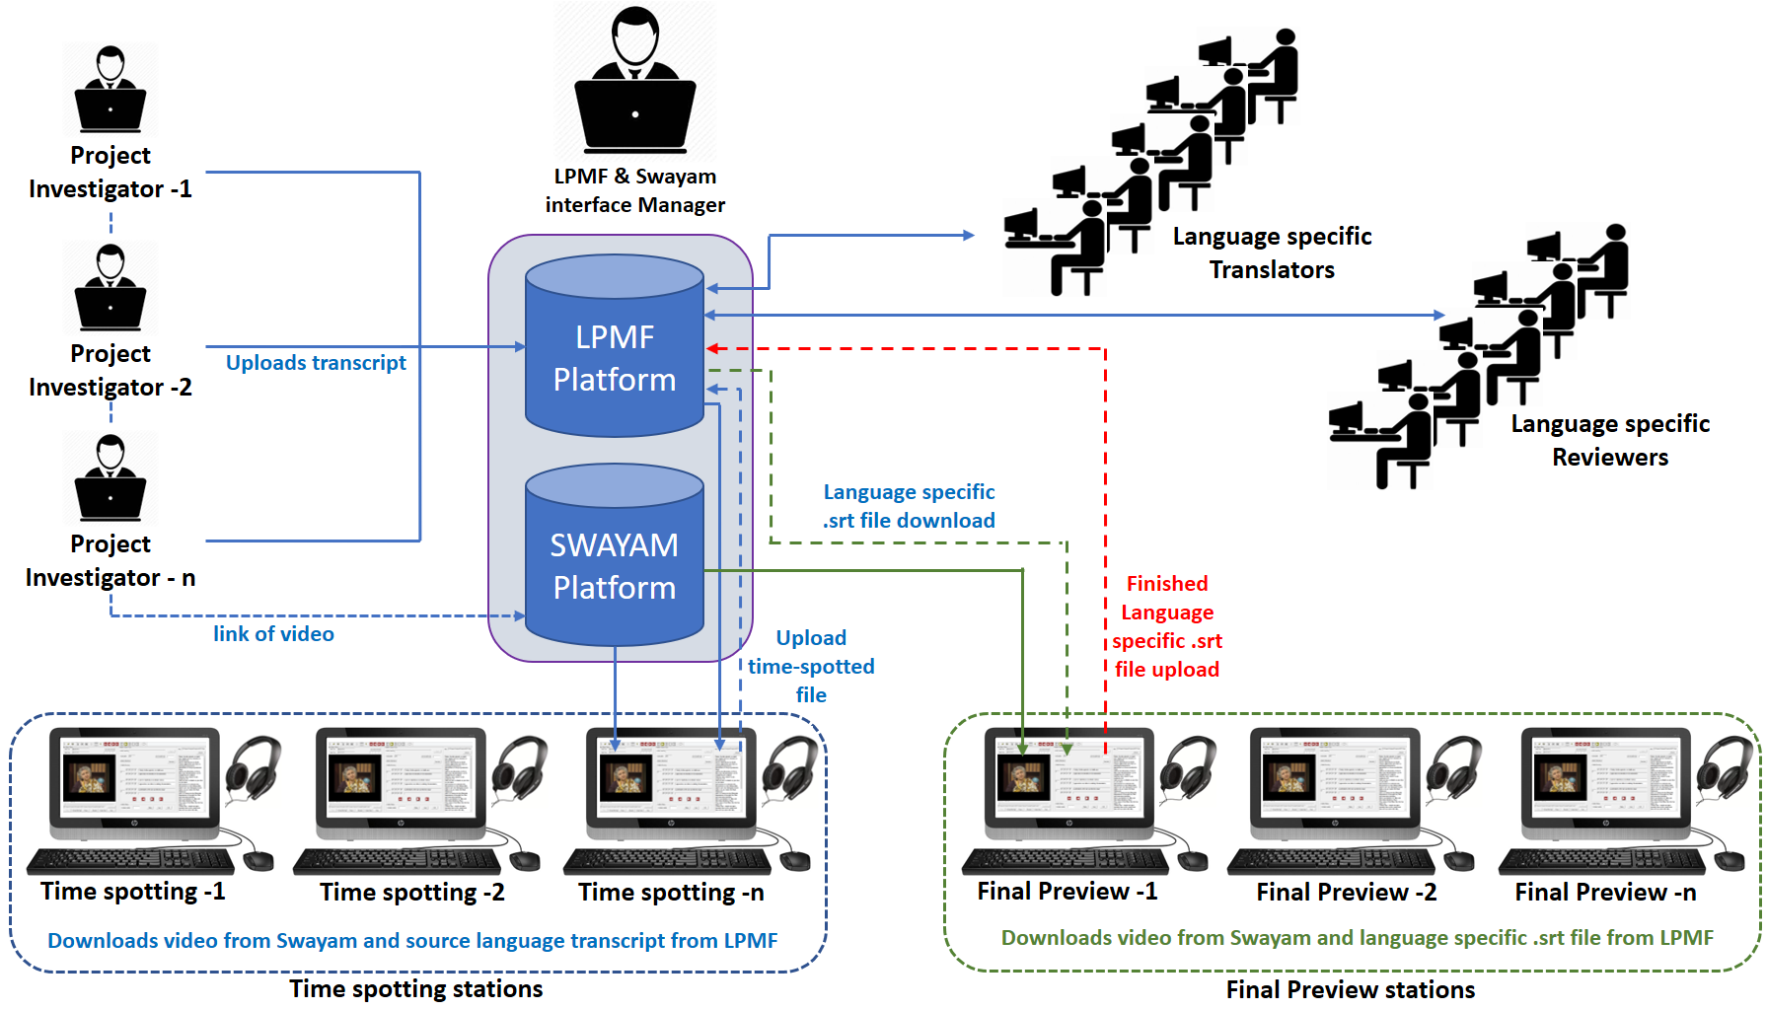

The steps involved in the process for creation of subtitles for a selected course video are described below.

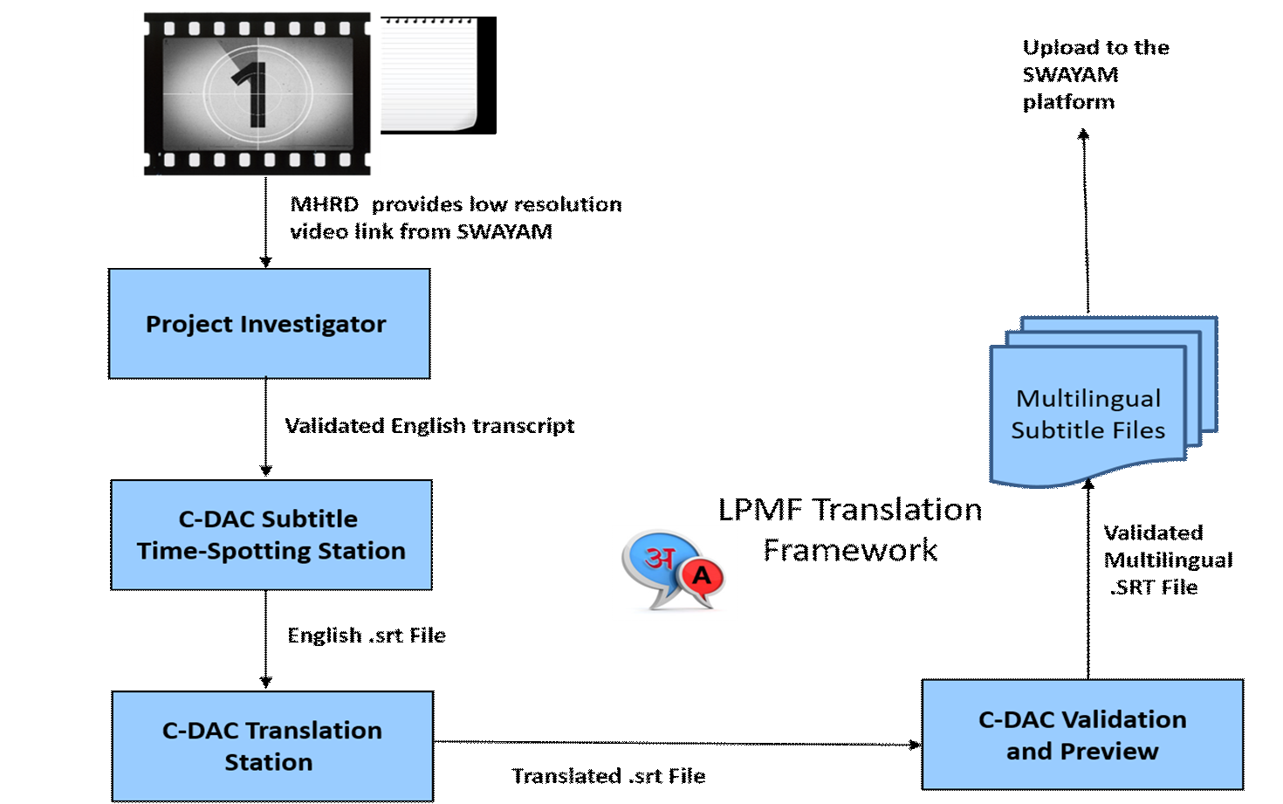

**Work flow Diagram**

**Step 1: Transcription**

The Project Investigator (PI) Dashboard will have the link to the video on SWAYAM portal. PI will create and upload transcript in English of the corresponding videos onto the Portal.

**Step 2: Time Spotting:**

Time spotter’s dashboard will have the following:

(a) Low res video - preferably in MP4 / AVI format and downloaded from the SWAYAM portal or through secondary media like DVD, hard disk etc.

(b) Transcript uploaded by the PI

(c) Downloaded Subtitle creation station – a desktop based application for creation of .srt file (one time download)

Time spotting process will involve the following steps.

**Step i)**: Importing the video file and transcripted text in the Creation software.

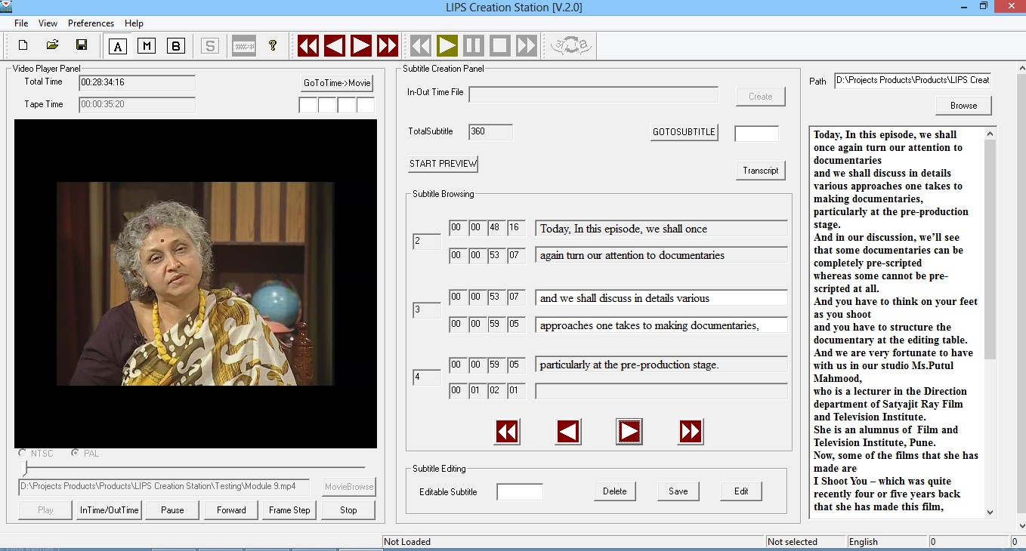

**Step ii):** Time Spotting:

The time-spotting for the video is done by listening to the audio and clicking the “InTimeOutTime” button at the start and end of the dialogue. Transcripted text is manually copied to the software to create the subtitles. The Time-code and subtitle text is visible in the Subtitle Browsing space.

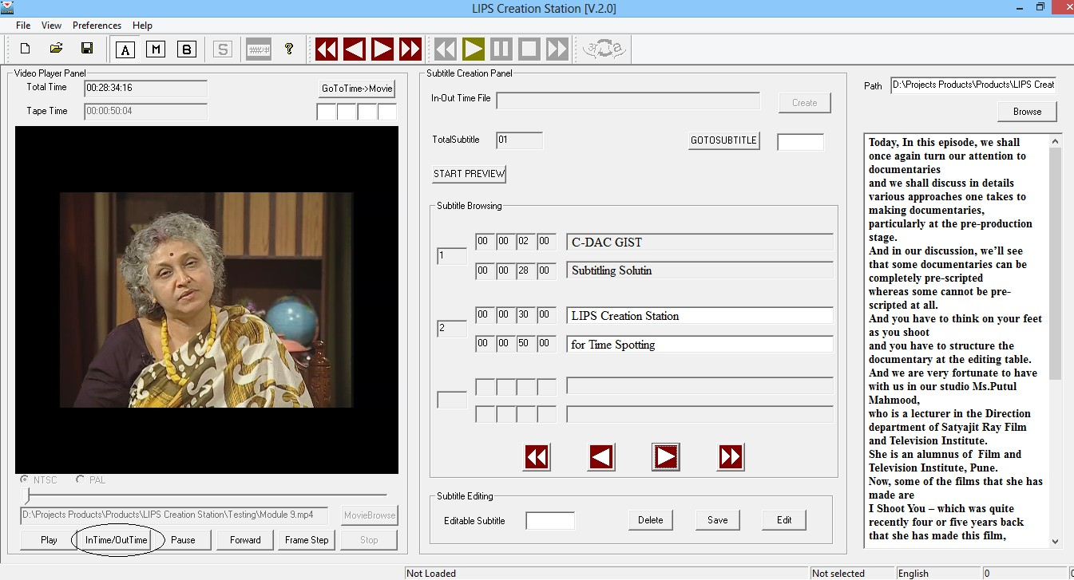

**Step iii)**: Time-code validation

The Timecode validation indicates the manual errors in spotting the “InTime” and

“OutTime”. Few errors are shown in the diagram above.

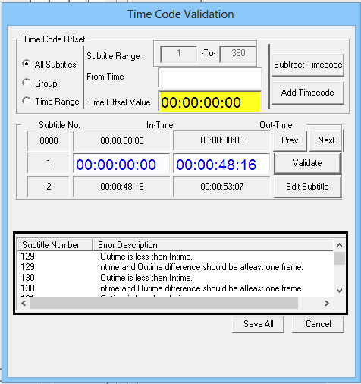

**Step iv)**: Subtitle Preview

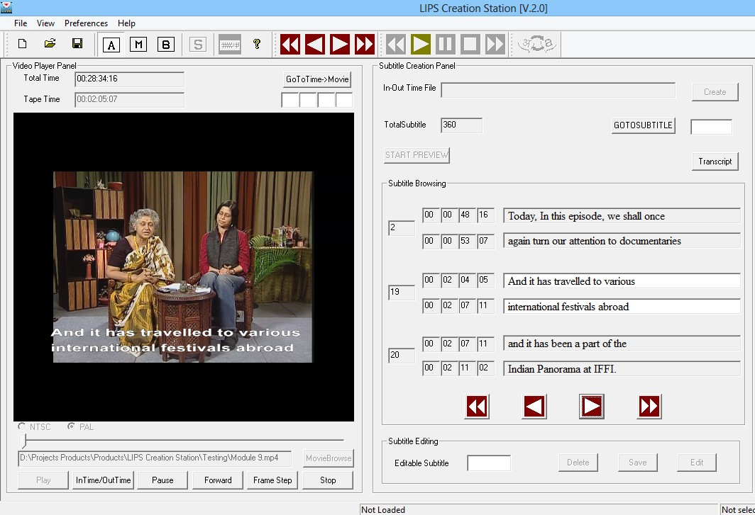

The software provides a facility to preview the software output (with the video and subtitles)

for visibilit y and placement of the subtitles.

**Step vi)**:Master .srt file (English) with Time-code and subtitles

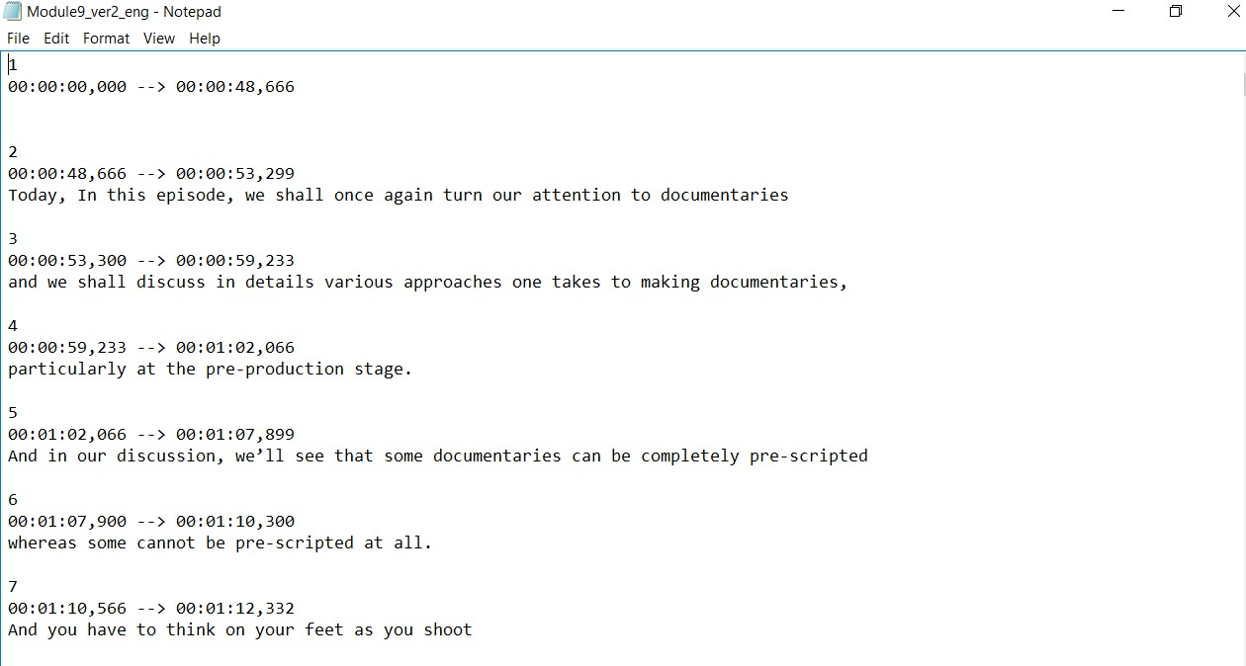

The Final output of the Subtitle Creation Station is a Master .srt file with Time-code and subtitles. This file will be an input to the LPMF framework for translation in Indian languages.

LPMF and SWAYAM interface manager will monitor the status and send Notification / Reminder to the Time spotter and also notify the translator accordingly.

**Step 3: Translation**

Translator’s dashboard will have the downloaded .srt file in English from the portal. Translator translates the .srt file in English (source language) into target language using LPMF (MT suggestions) and uploads the corresponding .srt file to the portal.

Please find below few screen shots depicting the same.

**1. Open SRT in browser:**

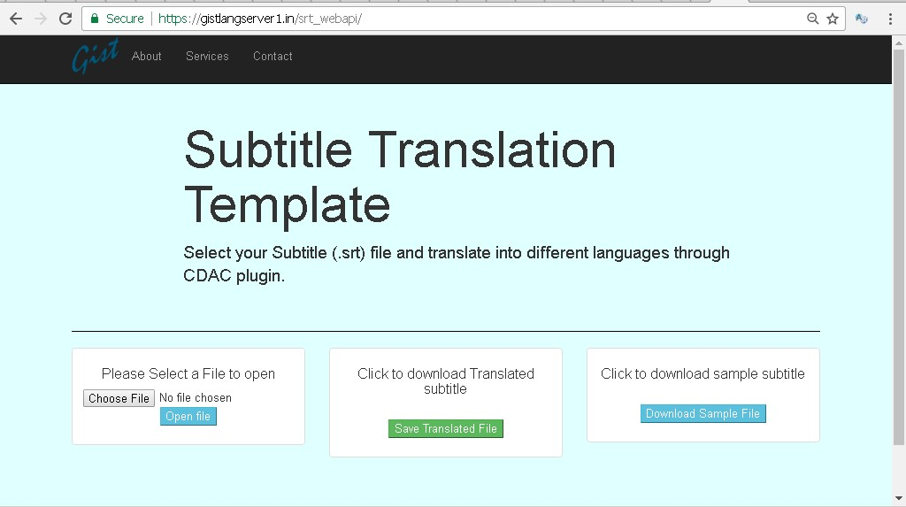

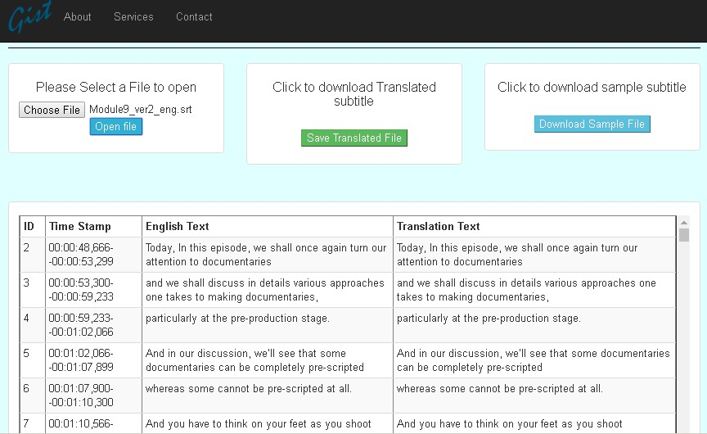

**2. Convert using Gotranslate**

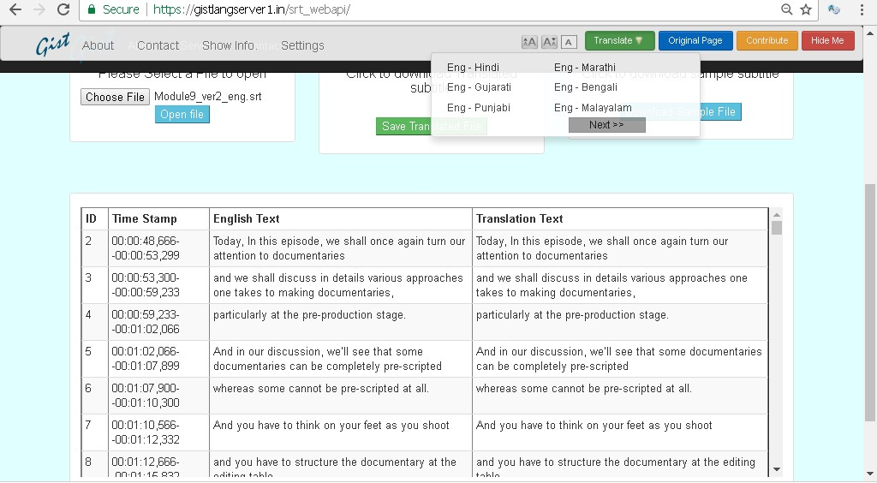

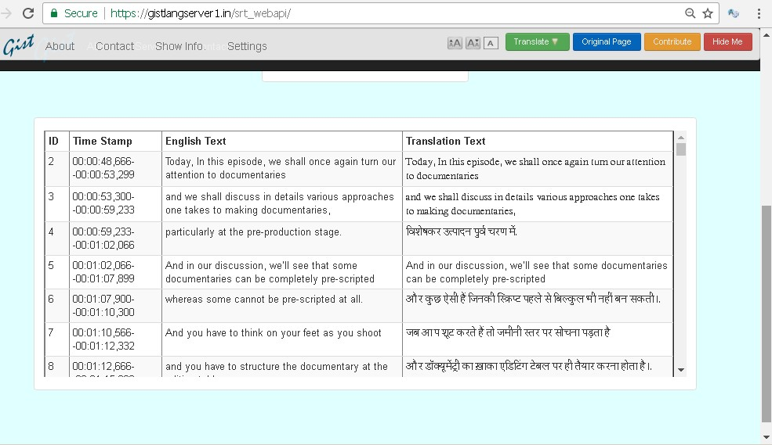

**3. Login:**

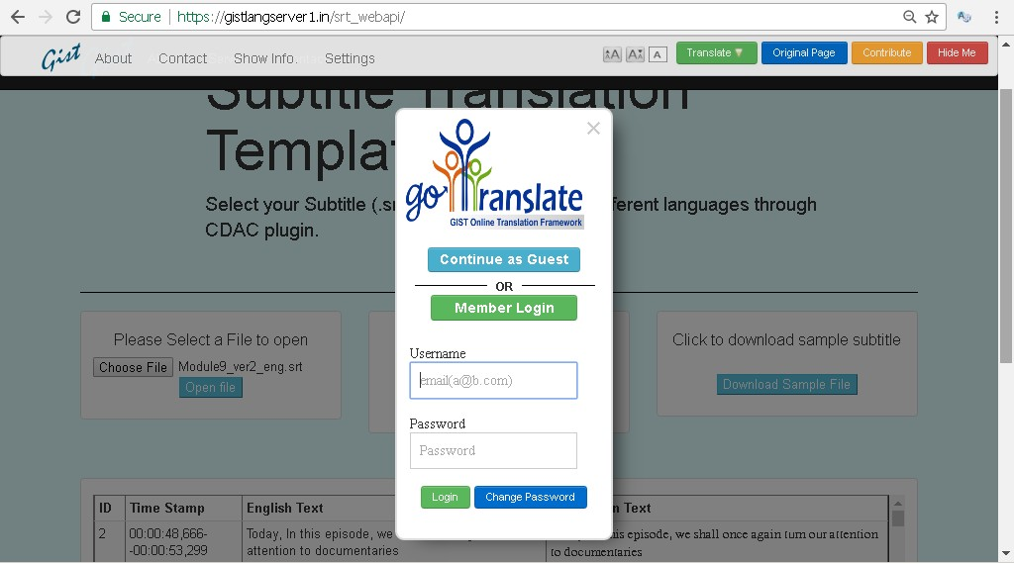

**Workbench Settings:**

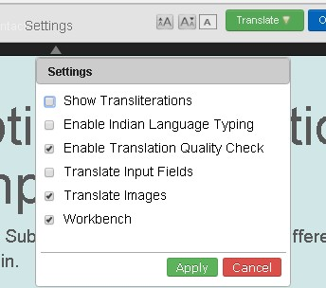

**Contribute by directly typing:**

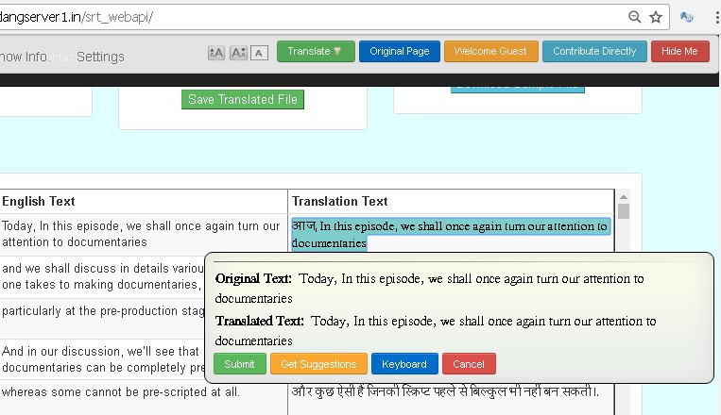

**Machine Translation options and virtual keyboard:**

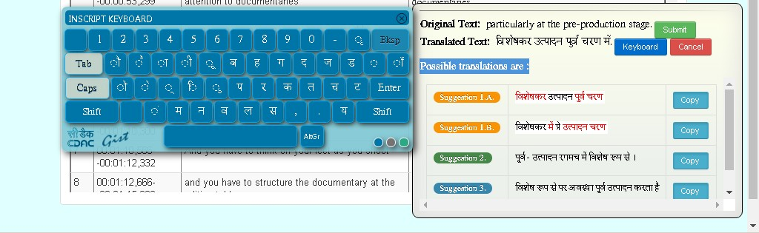

LPMF and Swayam interface manager will monitor the status and send Notification / Reminder to the Translator and also notify the Validator accordingly.

**Step 4: Validation and Subtitle Preview:**

Validator’s dashboard will have the following:

a. Downloaded low res video from the SWAYAM portal

b. Downloaded Preview station (one time download)

c. .srt file of target language as shown below

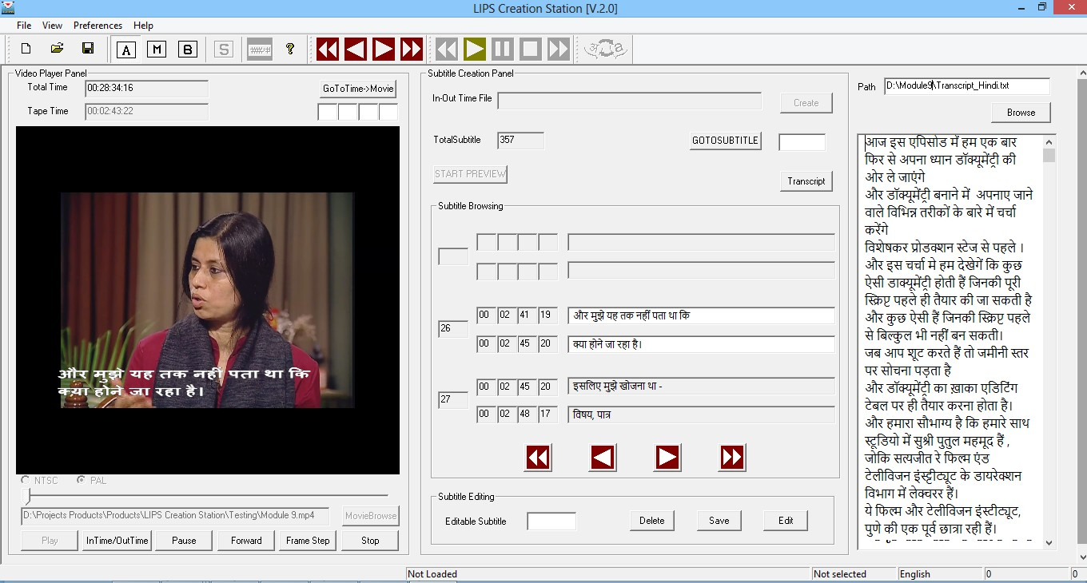

Validator previews the video with the subtitles on the preview windows while the subtitles text is displayed on the side pane. The validator can correct/modify the .srt file content by pausing the video and making changes to the .srt file for the corresponding time-code. The validated .srt files are then sent to the LPMF and SWAYAM interface manager.

LPMF and SWAYAM interface manager will bundle the .srt files in different languages and upload it to the SWAYAM platform.

**Assumptions for Estimation of Cost:**

The following table shows the cost estimation for transcription, translation and subtitling of 1 course into 1 language taking into consideration the following assumptions;

• One course consists of 40 lectures, having of total duration of 20 hours

• One course of 20 hrs have approx 1,44,000 words (approx. 120 words/min)

• The actual cost will be charged as per actual duration and volume of text content in the course.

• The technical terms would be transliterated in translated version

|  |  |  |  |
| --- | --- | --- | --- |
| **Cost Estimation for 1 Course For English to 1 Indian Language (Hindi)** | | | |
| **Number of Course** |  | 1 |  |
| **Modules / lectures** |  | 40 |  |
| **Duration of 1 course in hrs** | 30 min / lect | 20 |  |
| **Words per course** | 120 word/min | 144000 |  |
|  |  |  |  |
| **Transcription cost** | Transcription will be provided by MHRD | | |
| **Transcription validation cost** | Rs.30 per min | 36000 |  |
| **Total Transcription Cost in Rs.** | | | 36,000 |
|  |  |  |  |
| **Translation cost** | Rs 1.00 per word | 144000 |  |
| **Translation Proofing & Typing cost** | Rs.0.40 per word | 57600 |  |
| **Translation validation cost** | Rs.0.50 per word | 72000 |  |
| **Total Translation Cost in Rs.** | | | 2,73,600 |
| **Subtitling cost** | Rs.30 per min | 36000 |  |
| **Subtitling validation cost** | Rs.20 per min | 24000 |  |
| **Total Subtitling Cost in Rs.** | | | 60,000 |
| **Total in Rs.** | 3,69,600  **Rs. Three Lac Sixty Nine Thousand Six Hundred only)** | | |

|  |  |  |  |  |
| --- | --- | --- | --- | --- |
| **Cost Estimation for 25 Courses into 10 Languages (A)** | | | | |
|  | Cost of 1 course (in Rs.) | Total  Courses | No. of Languages | Total Cost |
| **Transcription** | 36000 | 25 | 1 | 9,00,000 |
| **Translation** | 273600 | 25 | 10 | 6,84,00,000 |
| **Subtitling** | 60000 | 25 | 11 | 1,65,00,000 |
| **Sub Total (A)** | | **8,58,00,000**  **(Rs. Eight Crore Fifty Eight lac only)** | | |

*Transcription validation cost is considered only for source language that is English.

|  |  |  |  |  |  |
| --- | --- | --- | --- | --- | --- |
| **Customization & Management Cost (B)** | | | | | |
|  | No of managers | | Cost per Month  (in Rs.) | Period  (in months) | Cost in Rupees |
| Project Management | 5 | | 120000 | 18 | 10800000 |
| LPMF Customization (One time setup cost) | | | | | 15,00,000 |
| LPMF Hosting & Maintain Charges  (Yearly Cost 50 lacs) | | | | 18 | 75,00,000 |
| Training and Workshop | | | |  | 10,00,000 |
| Travel | | | |  | 15,00,000 |
| Contingency | | | |  | 10,00,000 |
|  |  |  | | **Sub Total (B)** | 2,33,00,000 |
|  |  |  | | **Total (A+B)** | 10,91,00,000 |
| **Project Overheads (10%)** | | | | | 1,09,10,000 |
| **Grand Total for translation of 25 Courses into 10 Languages** | | | | **12,00,10,000**  **(Rs. Twelve Crore Ten Thousand only)** | |

Project Duration: **18 Months**

Payment Terms and Conditions

|  |  |  |
| --- | --- | --- |
| **S. No.** | **Payment Terms** | **Amount** |
| 1 | Transcription Validation  (English) | 40% in advance (for assigned lectures) + 40% after completion of 60% of the assigned lectures + 20% after completion of remaining assigned lectures |
|  | Translation | 40% in advance (for assigned lectures) + 40% after completion of 60% of the assigned lectures + 20% after completion of remaining assigned lectures |
|  | Subtitling | 40% in advance (for assigned lectures) + 40% after completion of 60% of the assigned lectures + 20% after completion of remaining assigned lectures |
|  | LPMF Customization | 40% in advance + 40% after 6 months + 20% on completion |
|  | LPMF hosting & maintenance | 40% in advance + 60% after completion of the year |
|  | Project Management | 40% in advance + 40% after completion of First year + 20% after completion of assigned work |
|  | Training and Workshops | 40% in advance + 40% after completion of First year + 20% after completion of assigned work |
|  | Travel and Contingency | 40% in advance + 40% after completion of First year + 20% after completion of assigned work |
| 2 | The above prices are **exclusive** of any taxes applicable. The GST or other taxes as applicable at the time of billing would be charged extra. | |
| 3 | The above offer is valid for 90 days from the date of this offer. Any further extension is subject to confirmation from CDAC, Noida in writing only. | |

**Agenda Item No. 7**

**Guidelines on IPR, Copyrights and Plagiarism for CCs**

**Purport**

The Objective of this Note is to seek the approval of the Board for the “Guidelines on IPR, Copyrights and Plagiarism” for development of courses by CCs for SWAYAM.

**Background**

In the 3rd SWAYAM Board meeting, “Guidelines on IPR, Copyrights and Plagiarism” for CCs was part of Agenda No. 5. It was decided to discuss these guidelines in next board meeting. The guidelines are enclosed as **Annexure- III**.

**Approval Sought**

The Board is requested to approve the **“**Guidelines on IPR, Copyrights and Plagiarism” for CCs which would be complied by the CCs while creating SWAYAM Courses.

**Annexure-III**

**Best Practices for Copyright Compliance and Plagiarism Control**

**Guidelines for MOOC Co-coordinators and Content Developers**

**Context**

Copyright law in India has certain important educational use exceptions that are aimed at safeguarding the broader interests of the society with regard to access to knowledge, while protecting the legitimate rights of copyright holders. The scope of different educational use related exceptions under Indian copyright law have been interpreted by different courts in India. Two of the most recent decisions in this regard are the decisions of the Single Bench and the Division Bench of Delhi High Court in *The Chancellor, Masters & Scholars of University of Oxford & others v. Rameshwari Photocopy Services & others* (often referred to as “Delhi University Photocopy shop case”). In this case, the court had to analyse in detail the scope of Sec. 52(1) (j) of the Copyright Act, 1957, which talks about the reproduction of any copyrighted work by a teacher or a pupil in the course of instruction. The judges have given a liberal interpretation of the provision, taking into consideration the educational requirements of the country as well as socio-economic realities, and held that the inclusion of copyrighted work in a course pack is permitted aslong as the same is **justified by the purpose of the course pack.** In other words, as long as the inclusion of a copyrighted work is necessary for instructional use by the teacher to the class, the act may fall within the scope of the exception provision.

While India is yet to see any litigation on the application of these exception provisions for MOOCs, we see no reason why the same principles shouldn’t be applicable to MOOCs, particularly because India is currently viewing MOOCs as an important channel for making education accessible for millions of economically poor people in the country. While recognising and acknowledging the applicability of educational use related exceptions for MOOCs also, we suggest the following best practices to help you in avoiding unwarranted controversies and litigations –

*A Note Prepared at National Law University, Delhi

**1. Use self-created contents**

As far as possible, use only contents that were created by you or contents wherein copyrights are owned by your institution and you have the permission to use them. One may use materials created by others, only if your course really requires inclusion of those materials from a pedagogical perspective.

**2. Use materials in the public domain**

Anyone is free to use materials available in the public domain. There are many ways in which works enter the public domain. The most common is the expiry of copyright protection (for example, for literary and artistic works, the term of copyright protection in India is Authors life time + 60 years. One can use those materials after the expiry of the copyright term without any fear about copyright infringement). In some cases, the courts might also rule that no copyright protection is available for that subject matter. In all such cases, the work is considered to be in public domain and you are free to use them for any purpose without fear of copyright infringement. Please DO NOT be under the impression that all materials available on internet are in public domain and one has to carefully verify the copyright status of the material before reaching the conclusion that the work is in public domain.

**3. Use contents licensed under an open license (for example, Creative Commons)**

Many a times, creators and artists release their works under different kinds of open licenses that permit different types of uses. One may use such works, depending on the uses permitted by the copyright holder under the specific license. For example, many works are today available under the Creative Commons Licenses. As you may notice from the creative commons website (<https://creativecommons.org/share-your-work/licensing-types-examples/licensing-examples/>), there are six different categories of creative commons licenses and one may incorporate the work in a MOOC depending on the kind of creative commons license used by the copyright holder. Many of them only require attribution (works released under CC-BY license) and they can be incorporated in your MOOC by giving appropriate attribution to the creator of that work. Since Creative Commons uses different symbols for easily conveying the kind of uses permitted, it is relatively easy to use the works that are released under creative commons license. Some of the creators also release works under CC0 license and they are works in public domain.

**(i) Some of the useful websites for finding open access materials**

**Images**

On Google Images, one can search for open access images using the filter on Usage Rights. To access this feature, please go to Tools/ Usage Rights. We recommend using only images which are labelled for reuse with modifications.

Some of the other platforms providing images under open licenses are –

<https://commons.wikimedia.org/wiki/Main_Page>

[www.pixabay.com](http://www.pixabay.com)

[www.pexels.com](http://www.pexels.com)

<https://www.metmuseum.org/about-the-met/policies-and-documents/image-resources>

[www.flickr.com](http://www.flickr.com) (Please select an appropriate license from the tab on licenses)

**Text**

Over the last couple of years, many journals have started providing open access to articles. So always try to search for an open access version of the article or any other material you want to include as part of course.

Some of the useful platforms providing access to open access books are -

<https://www.hathitrust.org/>

<http://www.gutenberg.org/>

<https://open.umn.edu/opentextbooks/>

<https://openlibrary.org/>

**Videos**

You may use videos released under open licenses like Creative Commons licenses, but use them only in accordance with the terms of license.

You may also provide links to videos uploaded by copyright holders on platforms like YouTube ([www.youtube.com](http://www.youtube.com)) and use them in accordance with the license conditions.

**4. Use of copyrighted materials which are not available under any open license**

**(a) Try to take permission from the copyright holder**

Many copyright holders might be willing to allow the use of their works for educational purposes. So you may contact the copyright holder directly and seek their written permission for inclusion of their materials.

**(b) Provide the links to the copyrighted materials**

Wherever possible, provide hyperlinks to the content, instead of directly incorporating the copyrighted work in to the course material. Please make sure that the hyper linking is done only to legitimate contents and not to any illegally copied contents.

**(c) Use as minimum as possible**

Wherever you have to use copyrighted materials which are not available under any open license, use as minimum as possible, so that the courts would be more inclined to rule in favour of fair dealing or consider the use as *de minimize,* in the event of a dispute. Once again, we reemphasize that such contents should be taken only from legitimate sources.

**5. Other general guidelines**

**Providing appropriate attribution to original creators**

Under all circumstances, you must provide appropriate attribution to the creators of the contents used in any of the other materials you developed as part of the course. In case it is not possible to provide attribution at the exact place where you have used the work, you must at least provide attribution at the end part of your content (for example, on the last slide or at the end of the video).

**Avoiding Plagiarism**

As academics, it is our ethical duty to be cautious against plagiarism. Since not all instances of plagiarism may be intentional, and since plagiarism can also happen subconsciously, we strongly recommend you to use one of the anti-plagiarism software like Turnitin, before finalizing the contents of your course. We also recommend you to get the contents reviewed by your peers, so that the probabilities of plagiarism can be reduced.

**Use institutional mechanisms to address IPR related queries**

Please consult the IP experts in your university or recommended IP practitioners in your city if you have any queries or doubts regarding the possibility of including any specific contents to your course materials.

**Share your contents also under an open license**

This MOOC initiative is part of a broad global open access movement to make knowledge accessible for everyone. Hence we strongly encourage you also to share all the contents you create (including photos and graphs you may have created for your course) under suitable open licenses, so that more people can use them for different purposes. As beneficiaries of different materials made available under open licenses, it is our ethical duty to share the materials we create.

**Agenda Item No. 8**

**Workshop on “ICT in Education” for the UNESCO E-9 Countries**

**Purport**

The objective of this Note is to seek in principle approval for holding a Workshop on “ICT in Education” for the UNESCO E-9 Countries.

**Background**

Launched in 1993, the E-9 Initiative is a networking platform to share experiences in educational policy, exchange best practices and monitor progress. The E-9 countries - the People's Republic of Bangladesh, the Federative Republic of Brazil, the People’s Republic of China, the Arab Republic of Egypt, the Republic of India, the Republic of Indonesia, the United Mexican States, the Federal Republic of Nigeria and the Islamic Republic of Pakistan– are home to over half of the world’s population, two-thirds of the world’s illiterate adults and nearly one-half of the world’s out-of-school children and youth.

The Eleventh E-9 Ministerial Meeting was held in Dhaka, Bangladesh from 5th to 7th February, 2017. The Meeting, hosted by the Government of Bangladesh, was the first E-9 Ministerial meeting since the adoption of the 2030 Agenda for Sustainable Development and the Education 2030 Framework for Action.

India highlighted that there is need to Harnessing the potential of ICTs for expanding access to education, improving the quality of teaching-learning process, improving the quality of teacher development programs, strengthening educational planning and management, and improving monitoring systems.

It was also proposed that joint efforts by E-9 countries is required for sharing and dissemination of knowledge between the nine countries including the publication of an E-9 Newsletter and the creation of a mechanism for dissemination of policy analysis and research results on specific themes of common interest such as education for sustainable development; transition of youth from education and training to the world of work; use of ICTs for education, and innovative teaching-learning practices.

The DHAKA Declaration states that E-9 should promote cross-fertilization of good practice through exchange programs, scholarships, internships, as well as virtual ICT-enabled learning programs. It was also decided to hold regular meetings of experts and E-9 focal points (at least one per year), in addition to the Ministerial Meetings held once in two years, to discuss technical issues relating to a particular theme or SDG4 targets. Copy of the declaration is attached at **Annexure IV**.

**Approval Sought**

**The Board is requested to accord in principle approval for holding a Workshop on “ICT in Education” for the UNESCO E-9 Countries at New Delhi during November / December, 2018.**

**Annexure-IV**

** **

**E-9 Ministerial Meeting on Education 2030**

**Inclusive and Equitable Quality Education and Lifelong Learning by 2030:**

**Challenges and Opportunities for E-9 countries**

**DHAKA DECLARATION**

We, the Ministers of Education and heads of delegations of the E-9 countries in attendance - the People’s Republic of Bangladesh, the Federative Republic of Brazil, the People’s Republic of China, the Arab Republic of Egypt, the Republic of India, the Republic of Indonesia, the Federal Republic of Nigeria and the Islamic Republic of Pakistan - extend our warm appreciation to the Islamic Republic of Pakistan as the out-going Chair and the People’s Republic of Bangladesh for hosting this Ministerial Meeting on Education 2030 and assuming the role of the E-9 Chair.

Having met in Dhaka, Bangladesh, from 5 to 7 February 2017 to discuss the education challenges and opportunities for E-9 countries in the context of a fast-evolving global development landscape, to further enhance our cooperation in ensuring the unfinished Education for All agenda, and to address the national education challenges to achieve by 2030 the country- specific goals and targets set in the context of SDG4,

Reaffirming our endorsement of the vision, principles, and targets laid out under SDG4 within ‘The 2030 Agenda for Sustainable Development’ and the ‘Education 2030 Framework for Action’,

Noting that the overarching goal which seeks to ‘ensure equitable and inclusive quality education and lifelong learning for all by 2030’ reflects the aspiration and commitment of each of our countries for national education development by 2030,

Given the diversity that characterizes our countries in a global context of increasing inequality, tension, and division, we affirm the role of the E-9 partnership in advancing human solidarity, respect for human rights and human dignity,

Acknowledging that the E-9 countries together are home to over half of the world’s population, over half of the world’s out-of-school children, and two thirds of the world’s non-literate youth and adults, we share, not only common challenges, but also opportunities for joint action and progress on a large scale,

Recognizing the continued relevance of the E-9 initiative and its important role in advancing the Education 2030 agenda, as stated in the 2014 Islamabad Declaration,

Hereby, in reaffirming the E-9 Initiative, we declare our commitment to:

1. Advance SDG4 and corresponding targets set within ‘The 2030 Agenda for Sustainable Development’ and the ‘Education 2030 Framework for Action’ which serve as the overall guiding framework for education development and enhancing lifelong learning opportunities in the coming few years.

2. Initiate actions to formulate country-specific targets within the broader scope of the SDG4, taking into account past gains and achievements in the education sector, emerging national development priorities, availability of resources and institutional capacities; align national education legislation, policy priorities and planning processes with SDG4 targets and commitments; and build capacity at the national and sub national levels, as appropriate, for monitoring progress towards SDG4 and other SDGs as relevant.

3. Promote greater relevance, visibility and impact of our cooperation and contribute meaningfully to the efforts aimed at advancing and monitoring progress towards the SDGs.

4. Strengthen the E-9 partnership by putting in place a robust mechanism for promoting joint programmes / projects/activities involving the following, and coordinated and led by a designated E-9 country:

4.1 Cross-country study visits hosted by E-9 countries and exchange of experience of successful interventions relating to each of the SDG4 targets;

4.2 Collaborative research of mutual benefit to all E-9 countries, to generate knowledge in areas of common interests and on educational challenges specific to high-population countries that help inform and support education policy formulation, implementation and monitoring & evaluation;

4.3 Sharing information and knowledge among various stakeholders of E-9 countries, including through the publication of an E-9 Newsletter, seminars/conferences and other modalities for dissemination of policy analysis and research results on specific themes of common interest;

4.4 Promote cross-fertilization of good practice through exchange programmes, scholarships, internships, as well as virtual ICT-enabled learning programmes;

4.5 Regular meetings of experts and E-9 focal points (at least one per year), in addition to the Ministerial Meetings held once in two years, to discuss technical issues relating to a particular theme or SDG4 targets;

4.6 Policy dialogues involving education authorities, universities, civil society, and other stakeholders in E-9 countries and within regional platforms to evolve appropriate policy responses and programmatic interventions required to facilitate achievement of education sector development goals and targets set by E-9 countries, including through non-formal approaches;

4.7 Assessment and analysis of education developments in each E-9 country and preparation ofE-9 specific biennial Education Monitoring Reports facilitated by the E-9 Secretariat in collaboration with the Global Education Monitoring Report and disseminate them through publications and national conferences to facilitate the formulation of policy responses and programmatic interventions required for achieving the education development goals and targets;

4.8 Joint advocacy by the E-9 countries for promoting the adoption of effective education policies/practices and for influencing global education policies, including through regional platforms, and ensuring that these policies reflect common educational concerns and priorities of the nine countries;

4.9 Enhance multilateral and bilateral cooperation among E-9 countries through programmes which integrate economic development and education initiatives.

*5.* Put in place mechanisms to increase government funding for education, enhance its efficient use, and facilitate mobilization of domestic resources from both public and private sources. We strongly recommend reaching the internationally recognized bench marks of at least 4 to6 percent of gross domestic product and/or at least 15 to 20 percent of total public expenditure allocated to education, in line with the 2015 Incheon Declaration. This may include identifying alternative funding sources and the possibility of tapping into existing resources that might be available within the nine countries for funding joint projects among the E-9 countries.

6. Mobilize international and external financing from traditional and emerging public and private sources and engage more actively with global processes and mechanisms in order to ensure that education is prioritized within global financing processes including by the multilateral financial institutions.

7. Institute measures to develop inclusive and responsive education systems to address the challenges we face from natural disasters, climate change, conflict, and other crises, based on our common experience in ensuring risk reduction in and through education.

8. Engage with the development of global indicators through participation in the Inter-Agency and Expert Group on SDG Indicators (IAEG), and the Technical Cooperation Group (TCG) and the Global Alliance for Monitoring Learning (GAML), and other processes on data and monitoring coordinated by the UNESCO Institute for Statistics (UIS).

Finally, as a unique partnership of peoples in the E-9 countries, we reaffirm our commitment to devote our energy, resources and creativity to fulfilling the Education 2030 targets and commitments in our respective countries and for the world.

We urge UNESCO to enhance its role in coordination, facilitation, and follow-up of the implementation of commitments with Ministries of Education of the E-9 countries.

Done in English language, on 6th of February, 2017, in Dhaka, Bangladesh

**Thank You**