Agenda Papers

5thMeeting
SWAYAM BOARD

11thJune 2018

Ministry of Human
Resource Development
Shastri Bhawan
New Delhi - 110001

AGENDA
05thMeeting of the SWAYAM Board

S. No. | Agenda Items | Page No.
1 | Agenda Item No. 1  Confirmation of Minutes of 4th SWAYAM Board Meeting | 2 - 5
2 | Agenda Item No. 2  Action Taken Report | 6 - 8
3 | Agenda Item No. 3  Status Report provided by NCs | 9 - 10
4 | Agenda Item No. 4  Local Chapter Guidelines - UGC, NPTEL | 11 - 31
5 | Agenda Item No. 5  Proposal from NPTEL and IISER Pune, for workshop course on principles of organic chemistry laboratory | 32 - 34
6 | Agenda Item No. 6  Points raised by UGC | 35
7 | Agenda Item No. 7  Status of SWAYAM Prabha Channels | 36 - 37
8 | Agenda Item No. 8  Presentation by CEC on –“CEC SWAYAM Prabha Channels”
9 | Agenda Item No. 9  Any other issue with the permission of Chair

Agenda Item No. 1
Confirmation ofMinutes of the 4thSWAYAM Board Meeting held on 07.05.2018

Minutes

The 4th Meeting of the SWAYAM Board was held under the Chairmanship of Shri R. Subrahmanyam, Secretary (HE), M/o HRD on 07.05.2018.

2. The status of SWAYAM Courses that was placed before the Board is summarized below:
- Total Courses : 1335
- Active Courses : 146
- Courses Completed : 833
- Upcoming Courses : 356
- Students Registered : 20,06,048
- Students Enrolled for courses : 32,22,866

National Coordinator Report on SWAYAM Courses
National  Coordinator  Name | Total no. of courses produced till date  (Also indicate within bracket the credit courses among them.) | Total no. of courses delivered through SWAYAM (a+b) -  Breakup  (a) First Run  (b) Re Run | No. of courses that are currently in production | Date of holding the last Academic Advisory Council (AAC) meeting  (a) No. of courses examined  (b) No. of Courses approved | No. of courses in which exams have been conducted for Credit Transfer / Certificates | No. of Universities that have approved credit transfer
UGC | 60 | 120 | 87 (46 New ,29 Repurposed, 12 Invited to be called) | 26th March 2018 (2nd meeting) | 7 | 62 Univ.
CEC | 87 Credit Courses | 78  (a) 55  (b) 23 | 252 (150 Repurpose + 102 New) | 19th March, 2018  23rd March, 2018  159 Examined  102 Approved | Nil | 15 Univ.
NPTEL | 482 | 740  (a) 482 First Run  (b) 258 Rerun | 156 (to be offered in July 2018 – new courses) | 07th Oct,2017 | 514 upto January, 2018  226 in April, 2018 | 26 institutions
IIM B | 19 (All Credit) | 19  (a) 16 First Run  (b) 03 Rerun | 7 | AAC not held  Planned in June - July 2018 | 14 | -
IGNOU | 11 | 21  (a) 11 First Run  (b) 10 Rerun | 44  (31 IGNOU,13 Other Univ.) | 18th April, 2018 | - | -
NCERT | 20 | 16  (a) 12 First Run  (b) 4 Rerun | 24 Courses | 23rd March 2018(2nd meeting)  20 Courses examined  4 Proposals examined  20 Courses approved  2 Proposals approved | - | N/A
AICTE | 6 | 6 | 5 | 20th March 2018  10 examined  2 approved | - | -
NITTTR | 3 (All are credit  courses) | 0 | 34 | 6th December 2017  43 Examined  35 Approved | - | -
NIOS | 19 | 36 | 28 | 30th January, 2018  47 Examined  47 Approved | 14 Secondary | -

3. Discussion on Action Taken and Status Report:

(i) Local Chapters: It was decided in the last SWAYAM Board meeting to re-designate NPTEL local chapters as SWAYAM-NPTEL local chapters. Similarly UGC local chapters would be known as SWAYAM-UGC local chapters. The local chapters would create awareness and popularize all the SWAYAM courses of all National Coordinators and not restrict themselves to one set of courses. Also it was decided that there should not be any overlap between the local chapters of different National Coordinators. This should be ensured by the National Coordinators while creating local chapters. MHRD would issue a letter to the Local chapters highlighting their role. This letter would be sent by MHRD to the National coordinators (NPTEL, UGC and CEC) who would in turn circulate it to the local chapters and accordingly enter into MoU. The new MoU would specifically mention the local chapters as the concerned SWAYAM local chapters (e.g. SWAYAM UGC, SWYAM NPTEL) and would bear the stamp of SWAYAM in the certificates issued too.

(ii) It is felt that local chapters should be in a position to operationalise their activities under SWAYAM, on their own. Funding support can be provided for organizing Orientation Workshops for local chapters. Also, financial incentives to best performing local chapters can also be thought of. NPTEL and UGC would prepare a detailed guidelines for financing and working of Local Chapters and provide to MHRD, to place it before SWAYAM Board for approval.

(iii) Awareness Creation & Publicity: After detailed discussions, it was decided to do channelise the entire publicity campaign from 1st June 2018 to 30th June 2018 through DAVP, to have more impact. UGC and AICTE would prepare the Social Media Plan and get the approval from MHRD on time. UGC has already created the TVCs, Radio Jingles and Posters. AICTE has been asked to ensure the timely preparation of all creatives.

(iv) List of courses (for July, 2018 Semester): All NCs were requested to ensure that they publish the July 2018 semester courses on SWAYAM immediately. UGC through their Regional centers will take up with the Universities for approving these courses in their Academic Councils.

(v) Application Service Provider (ASP) for SWAYAM: IIT Madras reported that technical evaluation of the ASP is taking place on 7th May 2018. AICTE informed that the Microsoft has been granted two months extension upto 17th August, 2018.

(vi) SWAYAM 2.0: IIT Madras would be making the proposal in the June 2018 monthly meeting.

(vii) Procurement of High Power Amplifiers: Chief Coordinator SWAYAM Prabha informed that the work is in progress.

4. Facilitating Course Coordinators to offer courses to the students from other Universities / Institutions:
After detailed deliberations, it was decided that:
- The MOOC version of all such courses which are already being offered in the host institution, would not need further approval by the concerned University Academic Council (AC) before hosting.

However, if any new course, which is not already approved by the AC of the university, is proposed to be offered under SWAYAM, the same shall be duly approved by the AC specifying the credits available, the modalities for evaluation etc.
- The Course Coordinator, thereupon, is authorised to run the course, and also conduct evaluation either directly, or through a third party, after which the candidates would be awarded marks.

- In order to ensure that the evaluation is standardised, the National Coordinator, in consultation with stakeholder Universities, will prescribe the detailed guidelines for evaluation and setting of question paper.

- The Course Coordinator, based on the detailed guidelines prescribed by the National Coordinator, will set the examination paper, run the exam and will convey the marks directly to the Controller of Examinations of the parent Institute of the learners.

- The Controller of Examination of the Parent University (where the SWAYAM learner is enrolled) will accept the marks provided by the CC and would incorporate in the mark sheet of the student.

Changes should be made in the SWAYAM guidelines to this effect and communicated to all institutions.

5. Releasing of funds for SWAYAM Local Chapters: It was decided that the guidelines for release of funds to the Local chapters would be approved first and the funds would be released accordingly.

6. Translation and subtitling of SWAYAM Courses: Among the two proposals from IIT Madras and CDAC/IIIT Hyderabad, the Board approved the proposal of IIT Madras since it was much lower in cost. It was decided to give to IIT Madras video content of 1600 hours (i.e. top 40 SWAYAM courses of 40 hours) for translation. Meanwhile CDAC would be requested to match the prices of IIT Madras proposal. In case CDAC is able to match the prices they would also be given courses for translation.
7. Guidelines on IPR, Copyrights and Plagiarism for CCs:
All the National coordinators would go through the guidelines and send their comments to MHRD in 15 days.
8. Workshop on ICT in Education for the UNSECO E-9 countries
The proposal was approved and it was desired to showcase the ICT initiatives in Higher and School Education. It was also felt that the workshop could be held at IIT Madras or IIM Bangalore or NITTTR Chennai, to facilitate the field visits to showcase ICT initiatives.
9. Presentation by IIM Bangalore: The Secretary (HE) complimented Prof P.D. Jose IIM Bangalore for the comprehensive presentation and bringing out many important points that needs to be addressed. It was decided to circulate the presentation to all National Coordinators. The points mentioned in the presentation could be discussed in detail in the next Board meeting.
10. Examination and Fees reimbursement: It was decided that for the first year (From July 2018 semester) the fees of examination will be reimbursed only to those students who register on SWAYAM, take the course work and register for examination through the SWAYAM platform. The reimbursement would be limited to a maximum of upto Rs.1100.

Agenda Item No. 2

Action Taken on the decisions of the 4th SWAYAM Board Meeting held on 7th May, 2018

S. No. | Action Points | Action Taken Note
1 | Local Chapters:  MHRD would issue a letter to the Local chapters highlighting their role. This letter would be sent by MHRD to the National coordinators (NPTEL, UGC and CEC) who would in turn circulate it to the local chapters and accordingly enter into MoU.  NPTEL and UGC would prepare a detailed guidelines for financing and working of Local Chapters and provide to MHRD, to place it before SWAYAM Board for approval. | MHRD has issued letters to NPTEL and UGC for circulation to local chapters.  UGC: UGC has issued letters regarding SWAYAM - UGC Local Chapters to all UGC SWAYAM Coordinators from Universities and UGC SWAYAM mentors from Colleges with a copy to Regional Heads of UGC.  NPTEL: The letter has been sent by email to all SWAYAM-NPTEL Local chapters and also posted on the website.  UGC: Has submitted Guidelines for SWAYAM UGC Local Chapters.  NPTEL: Proposal for allocating funds to NCs towards Local Chapters and the document showcasing NPTEL’s work with Local Chapters has been submitted.
2 | Awareness Creation & publicity.  It was decided to do channelize the entire publicity campaign from 1st June, 2018 to 30th June, 2018 through DAVP, to have more impact.  UGC and AICTE would prepare the Social Media Plan and get the approval from MHRD on time. | NPTEL: NPTEL has created booklet containing information about the 270 NPTEL-SWAYAM Courses along with posters for the same. This has been dispatched to 1700 Local Chapter Colleges. Campaigns are being run on social media also for publicizing the courses.  NIOS: Provided link of SWAYAM TVC &amp; Jingles on NIOS portal www.nios.ac.in. Two workshops proposed in June and July.  NITTTR: In the Engineering college and Polytechnic faculty development programme, sensitization about SWAYAM courses is provided. Since Dec 2017, more than 1000 faculty members have been exposed to the SWAYAM MOOC.  UGC & AICTE: Work in progress
3 | List of courses (for July 2018 semester):  All NCs were requested to ensure that they publish the July 2018 semester courses on SWAYAM immediately.  UGC through their Regional centers will take up with the Universities for approving these courses in their Academic Councils. | Committed in 2nd SB Actual uploaded  UGC : 44 Courses 17 Courses  CEC : 78 Courses 90 Courses  NPTEL: 262 Courses 270 Courses  IIM B: 4 Courses 5 courses  IGNOU: 11 Courses 12 Courses  NCERT: 20 Courses 20 Courses  NIOS: 35 Courses 20 Courses  NITTTR: 15 Courses 4 Courses  AICTE: 9 Self Paced Courses 6 Courses  UGC has issued letters in this regard to all Regional Heads of UGC to nominate SWAYAM Mentors in colleges to act as a Single Point of Contact (SPOC).
4 | Application Service Provider  IIT Madras reported that technical evaluation of the ASP is taking place on 7th May 2018.  AICTE informed that the Microsoft has been granted two months extension upto 17th August, 2018. | IIT Madras: The Technical and Financial Bids were opened and a company has been tentatively selected as the ASP for SWAYAM @ Rs 25 Lakhs/month. Funds of Rs 2,86,75,000/- have been received and Rs.23.50 Lakhs is yet to be received from MHRD. The PO for the same will be issued soon.  AICTE:  - M/s. MCIPL in their response stated that “We have took cognizance of the same and applied in system for higher level approvals since providing resource for 2 months is not a standard package”.  SWAYAM Board may kindly consider extension of M/s. MCIPL for further two months (Total four months) from 18-06-2018 to 17-10-2018) for providing Support for Azure based SWAYAM Solution under Capacity-based Resourcing Model for SWAYAM. However, as per Purchase Order, their services can be terminated any time by giving one-month notice.  - M/s. CtrlS Data Centre has not completed the Phase-3 deployment for migration of Cloud Service on new environment so far. Also Microsoft would be working only on Azure cloud.  The contract in favour of M/s. Embee Software Ltd. for Azure cloud is upto 07thAugust, 2018.  The SWAYAM Board may kindly consider extension of contract for another six months with a clause of termination of service anytime by giving one month notice.
5 | SWAYAM 2.0 status  IIT Madras would be making the proposal in the June 2018 monthly meeting. | IIT Madras: This will be updated in July meeting.
6 | Facilitating Course Coordinators to offer courses to the students from other Universities / institutions:  Changes should be made in the SWAYAM guidelines to this effect and communicated to all institutions. | Amendment / Addition to the Guidelines for developing Online Courses for SWAYAM is put up for approval and issuance.
7 | Translation and subtitling of SWAYAM Courses:  It was decided to give to IIT Madras video content of 1600 hours (i.e. top 40 SWAYAM courses of 40 hours) for translation. | IIT Madras has been requested to submit the proposal for release of funds.
8 | Guidelines on lPR, Copyrights and Plagiarism for CCs:  All the National coordinators would go through the guidelines and send their comments to MHRD in 15 days. | NPTEL Distributes all its content under CC-BY-SA (Creative Commons by Distribution Share Alike) License.  NPTEL relies on the policies of the participating institutes for handling plagiarism.  NIOS: Guidelines seems to be complete in all respect and it covers all necessary & relevant points related to IPR, Copyright & Plagiarism.  IGNOU: The guidelines need to be interlinked with the NMEICT Open Licensing Policy Guidelines.  NITTTR: Based on the SWAYAM guidelines, we have prepared an abridged version of guidebook to facilitate the course coordinators with respect to Copyright, Plagiarism and content layout preparation.
9 | Workshop on ICT in Education for the UNSECO E-9 Countries | Work in progress.

Agenda Item No. 3
Status of SWAYAM Courses

Status of SWAYAM Courses As On 07.06.2018
Total Number of Courses Listed on SWAYAM : | 1473
Past Courses listed on SWAYAM : | 840
Current Courses listed on SWAYAM : | 159
Upcoming Courses listed on SWAYAM : | 474

NC wise Distribution of Courses As On 07.06.2018
 | Past courses | Current Courses | Upcoming Courses | Total Courses | Total Student Enrollment
UGC (PG Non Engineering) | 115 | 0 | 16 | 131 | 76123
NIOS (Open School 9th to 12th ) | 32 | 19 | 27 | 78 | 2748530
NPTEL (UG & PG Engineering) | 560 | 101 | 320 | 981 | 331144
NITTTR (Teacher Training) | 3 | 0 | 4 | 7 | 177
NCERT (School 9th to 12th) | 19 | 20 | 0 | 39 | 32362
IGNOU (Certificate & Diploma Courses) | 14 | 0 | 11 | 25 | 19898
IIM B (Management) | 14 | 9 | 2 | 25 | 47110
CEC (UG Non Engineering) | 83 | 4 | 94 | 181 | 89188
AICTE (Foreign Universities) | 0 | 6 | 0 | 6 | 27937
 | 840 | 159 | 474 | 1473 | 3372469

Registration & Enrollment Status As On 07.06.2018
Total number of Registration on SWAYAM Platform | 2057719
Total number of Enrollment on SWAYAM Courses | 3372469
Enrollment in NIOS DElEd Courses 501 | 882409
Enrollment in NIOS DElEd Courses 502 | 744450
Enrollment in NIOS DElEd Courses 503 | 731832
Enrollment in NIOS DElEd Courses 504 | 212777
Enrollment in NIOS DElEd Courses 505 | 126816

Top 10 Certificate / Credit Courses Enrollment-wise As On 07.06.2018
S. No. | Course Name | Institute Name | Enrollment
1 | 2018:Fundamentals Of Combustion - I | IIT Kanpur - NPTEL | 17796
2 | A Study Guide In Organic Retrosyn thesis: Problem Solving Approach | IIT Kharagpur - NPTEL | 16068
3 | Applications of Molecular Symmetry and Group theory | Delhi University - UGC | 16000
4 | Artificial Intelligence-I | Gujarat University- UGC | 8375
5 | Communication Technologies in Education | Mumbai University- UGC | 7605
6 | Computer Programming | IIT Bombay - NPTEL | 7368
7 | Strategy and the Sustainable Enterprise | IIM Bangalore | 7295
8 | Advanced Fluid Mechanics | IIT Kharagpur- NPTEL | 7192
9 | Introduction to Strategic Management | IIM Bangalore | 5657
10 | Predictive Analytics | IIM Bangalore | 5410

Status Report by NCs for the 5thSWAYAM Board Meeting to be held on 11th June, 2018
National  Coordinator  Name | Total no. of courses produced till date  (Also indicate within bracket the credit courses among them.) | Total no. of courses delivered through SWAYAM (a+b) -  Breakup  (a) First Run  (b) Re Run | No. of courses that are currently in production | Date of holding the last Academic Advisory Council (AAC) meeting  (a) No. of courses examined  (b) No. of Courses approved | No. of courses in which exams have been conducted for Credit Transfer / Certificates | No. of Universities that have approved credit transfer.
UGC | 60 | 120 | 86* (45 New + 29 Repur. + 12 Invited) | 2nd Meeting held on 26.03.2018  3rd Meeting Scheduled for 13.06.2018 | 7 | 65 University
CEC | 160Credit Courses (87) | 77  (a) 54  (b) 23 | 130 (50 Repurpose + 80 Fresh) | 19th March, 2018  23rd March, 2018  159 Examined  102 Approved | - | 15 University
NPTEL | 482 | 740  (a) 482 First Run  (b) 258 Rerun | 156 (to be offered in July 2018 – new courses) | 07th Oct, 2017 | 740 upto April, 2018 | 26 Institutions
IIM B | 26 (All Credit) | 26  (a) 17 First Run  (b) 09 Rerun | 7 | AAC not held  Planned in June - July 2018 | 14 | -
IGNOU | 11 | 22  (a) 11 First Run  (b) 11 Rerun | 44  (31 IGNOU, 13 Other Univ.) | Held on 18th April, 2018  (a) No. of courses examined: 32  (b) No. of Courses approved: 24 (in principle) | - | -
NCERT | 20 | 24  (a) 8 First Run  (b) 16 Rerun | 24 | 23rd March 2018 (2nd meeting)  20 Courses examined  4 Proposals examined  20 Courses approved  2 Proposals approved | - | -
AICTE | 6 | 6 | 6 (5)  *43 upcoming | 20th March 2018  Next meeting on 08.06.2018
NITTTR | 3 (All are credit  courses) | 0 | 34 | 6th December 2017  43 Examined  35 Approved | - | -
NIOS | 39 All Credit (19) | Total 39  (a) 21 First Run  (b) 18 Re Run | 8  For Jan 2019 | 30th January, 2018  52 Examined  52 Approved | 17  (14 Sec+3 DElEd | -

Agenda Item No. 4

Local Chapters Guidelines -UGC& NPTEL
Purport
The Objective of this Note is to place the Guidelines for working of Local Chapters received from UGC and NPTEL before board for approval.
Background
In the 4th SWAYAM Board meeting, it was decided that NPTEL and UGC would prepare a detailed guidelines for financing and working of Local Chapters and place it before SWAYAM Board for approval.
Proposal
UGC& NPTEL has submitted the guidelines for working of Local Chapters, attached at ANNEXUREI.
- UGC proposes incentives Like: For SWAYAM Coordinator/Mentor which enroll maximum number of learners from their institution would get due recognition on the SWAYAM platform.
- The Local Chapters comprising of SWAYAM Coordinators and Mentors will serve as SWAYAM brand ambassadors for creating awareness and popularization of SWAYAM courses on SWAYAM.
- NPTEL proposes that Local Chapters that have Enrollments of at least 10 (across courses) and Exam registration of at least 1 candidate can be deemed to be functional and Rs 10,000/- (Rupees ten thousand only) can be claimed from MHRD towards the same.

Decision Sought
The Board is requested to kindly give its directions on the matter.

Annexure I

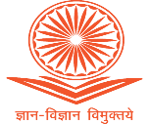
University Grants Commission

Guidelines for SWAYAM UGC Local Chapters

Genesis
With the aim of providing access to the best quality learning resources across the country, the project ‘Study Webs of Active Learning for Young Aspiring Minds’ (SWAYAM) of the Government of India was initiated in 2016. SWAYAM provides an integrated platform for online courses, using information and communication technology (ICT) from High School till higher education including skill & teacher training sector courses to ensure that every student benefits from learning through SWAYAM. Massive Open Online Courses (MOOCs) and e-content (video and text) are hosted on this robust IT platform. The MOOCs courses on the SWAYAM platform will benefit lifelong learners, students, teachers, homemakers and researchers to learn on anytime, anywhere basis for acquiring knowledge and skills. SWAYAM would allow students and teachers to practice different approaches of learning including innovation in teaching, by optimally using the resources and time on hand. This e-resource can also be used for revising teaching pedagogy to the flipped class room model. SWAYAM would also help the students and teachers to update their knowledge and skills especially for those located in rural/backward/remote areas and would successfully bridge the digital divide and would help the nation move towards an information-rich society.

Study Webs of Active Learning for Young Aspiring Minds (SWAYAM)
SWAYAM provides an integrated platform for online courses, using information and communication technology (ICT) and covering courses from high School to post-graduate subjects including skill sector courses to ensure that every student benefits from learning material through ICT. The SWAYAM offers:
- One-stop web and mobile based interactive e-content for all courses from high school to university level;
- High quality learning experience using multimedia on anytime, anywhere basis;
- State-of-the-art system that allows easy access, monitoring and certification;
- Peer group interaction and discussion forum to clarify doubts; and
- Hybrid model of delivery that adds to the quality of classroom teaching.

National MOOCs Co-ordinators indentified by MHRD for Various Sectors
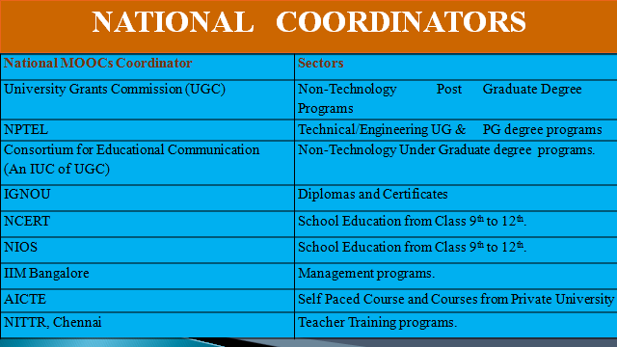
Massive Open Online Courses (MOOCs) on SWAYAM
In “MOOCs” or Massive Open Online Courses, the word massive means that there is no limit on the number of learners who can enroll in the course. Open means that there are no mandatory requirements for the learner to enroll in this course. These courses are fully online and delivered through internet.
These are highly multimedia enriched, interactive, online courses which offer a unique opportunity to the learners to learn these courses as per their convenience. The basic philosophy of MOOCs is 3A's i.e., Anyone, Anywhere, Anytime.
All MOOCs of the various types developed under the aegis of MHRD by the various National Coordinators (UGC, CEC, IGNOU, NPTEL, etc.) shall be hosted on the web platform called “SWAYAM”.
Some of the salient features of SWAYAM are:
- Facilitates learning from peers across different institutes of India
- Open to everyone
- Enhances skills (apart from course- curriculum)
- Free of Cost
- Offers choice among different elective courses
- Allows credit transfer
- Provides an affordable alternative to formal education
- Improves access to education from School to Higher Education
- Facilitates Sustainable Development Goals

UGC Regulation, 2016
The UGC has issued UGC (Credit Framework for Online Learning Courses through SWAYAM) Regulation, 2016. These shall apply to all universities established or incorporated by or under a Central Act, a Provincial Act, or a State/Union Territory Act and all institutions recognized by or affiliated to such Universities and all institutions deemed to be universities under Section 3 of the UGC Act, 1956. These shall further apply to the transfer of credits of such students who are enrolled as regular/part-time students in any educational institution in India.

Accordingly, all the Institutions shall, within 4 weeks from the date of notification by SWAYAM, consider through their Competent Authority the online learning courses being offered through the SWAYAM platform; and keeping in view their academic requirements, decide upon the courses which it shall permit for credit transfer.
An Institution can only allow up to 20% of the total courses being offered in a particular program in a Semester through the online learning courses provided through SWAYAM platform.

Promotion of Massive Open Online Courses (MOOCs)
SWAYAM is one of the flagship programmes of MHRD which is upgrading the learning environment of the country while providing opportunities for online learning. Good quality courses from school till postgraduate level will be hosted on the SWAYAM platform for the benefit of the general public. Therefore, it becomes pertinent to ensure that such activities reach to each and every learner located at each and every corner in the country. The following initiatives have been taken by the UGC to promote MOOCs on SWAYAM which in turn will be used by the local chapters to promote SWAYAM in their own and in affiliating institutions.
- The UGC has identified selected universities and colleges to act as Local Chapters (LC) to help UGC in adopting and promoting MOOCs courses in the universities. SWAYAM Coordinators have been nominated by the universities and SWAYAM Mentors have been nominated by the Colleges. The Local Chapters have to work as a link between the UGC and the learners and to act as single point of contact for the UGC/CEC. The SWAYAM Coordinators in the universities will in turn engage SWAYAM Mentors in the colleges affiliated with the university to adopt and promote the concept in colleges as well. The local chapters would be required to form an active community ofonline learners who would be sharing experiences about digital learning in real time.
- The Local chapters would be contact points and facilitators for all National Coordinators
- In addition to identifying local chapters, the UGC has also developed TV Commercials, Radio Jingles and Posters in 10 different regional languages to for promotion of SWAYAM. These TVCs, Jingles and Posters are available on the UGC website and the local chapters would be expected to disseminate the TVCs and Jingles to the learners through various media like university/college website, social media platforms like WhatsApp, Face Book, Twitter, Seminars, and Workshops etc. All the local chapters would be required to register themselves on a dedicated portal for local chapters (ugcmoocs.inflibnet.ac.in).

Roles and Responsibilities of Local Chapters
Capacity Building of Local Chapters:
- UGC will be conducting orientation programmes for the local chapters in which the training will be provided on SWAYAM). The objective of training will be focused on
- SWAYAM initiatives;
- understanding of credit transfer through SWAYAM;
- hands-on practical learning on the SWAYAM platform;
- Roles and responsibilities of LC;
- Incentives to Local Chapters
- Profile creation on UGC-MOOC (ugcmoocs.inflibnet.ac.in) platform.
- Similar workshops will be organised by SWAYAM Coordinators and Mentors in their Universities &affiliated colleges.

Awareness & Promotion:

- The SWAYAM Coordinator/Mentor should see the TVCs, Jingles and Posters and understand the concept.
- As soon as the list of courses is released every semester by the SWAYAM, in May and October, the SWAYAM Coordinator/Mentor should assist the university/college in selecting the appropriate courses for its educational institutions and students.
- The SWAYAM Coordinator/Mentor should popularize the concept of SWAYAM to the students of the university/college through various mediums which could include holding workshops, Nukkad Natak, forwarding TVCs and Radio Jingles through WhatsApp, placing them on the university website, pasting posters on the SWAYAM at all Strategic Locations / Notice boards of the universities/colleges e.g. hostels, classrooms, library, academic areas and common areas.
- The SWAYAM Coordinator/Mentor should create a FaceBook page and a Twitter account of the SWAYAM courses of the university. The Twitter handle of all the universities/colleges shall necessarily follow the SWAYAM twitter handles of MHRD, UGC, CEC and NPTEL.
- The SWAYAM Coordinator/Mentor should regularly send tweets about the courses of their university and shall engage maximum number of followers from the faculty and students of the institution.
- SWAYAM Coordinator/Mentor should apprise the university administration about the amendments in the Acts, Statutes, and Ordinances required to adopt SWAYAM courses.
- UGC will provide TVCs, radio jingles and posters for SWAYAM awareness. These would be provided in 10 different regional languages to cater to area specific requirements. Press releases in the local media may also be issued by Local Chapters.
- SWAYAM Coordinators and Mentors may also identify Student Volunteers for SWAYAM awareness activities.

Handholding of Student learners:
  - The SWAYAM Coordinator/Mentor should facilitate the students in enrolling for the selected courses. He/she can also promote students in enrolling for other courses as well which will be in the supplementary learning mode.
  - The SWAYAM Coordinator/Mentor should work as a troubleshooter for any problem encountered by any learner of the SWAYAM Platform.
  - Liasoning work with the SWAYAM team at AICTE for exam schedule
  - Video recording of discussion for obtaining their feedback among learners in Institute
  - Upload activities (photo/video) while interaction with teacher or learners
  - The SWAYAM Coordinator/Mentor will provide technical help in guiding the students throughout the course including assistance in writing, quizzes, and submitting assignments and to appear for term end final examination.
  - SWAYAM Coordinators and Mentors may themselves enroll in MOOCs courses to get a first-hand experience of the SWAYAM experiment.
  - Local Chapters have to identify and suggest, as per their requirements new courses for development of MOOCs to the NC.
  - Local Chapters mentors may facilitate the evaluation, end-term exam and credit award of the students in their university. They may facilitate the inter-university transfer of credits.

Statistical Reports:
The Local Chapters would be compiling statistical information cum reports pertaining to SWAYAM courses in their respective Universities/Colleges
  - Conducting Survey and obtaining feedback from learners
  - Conducting Survey for in-demand courses for future development of courses
  - Ratio of student registered and appeared in exam, registration and successful completion of course, registration and drop out student, etc.

Role as a Bridge between UGC & Learners:
The Local Chapters would act as a single point of contact between the UGC and the SWAYAM Coordinators/Mentors.
  - Provide feedback (from end-user) details to UGC
  - Provide a list of in-demand courses to UGC
  - Liasoning work among different institutes for credit transfer
  - Liasoning work for registration on behalf of the University/Institutes
Adoption of MOOCs for Credit Transfer by Various Universities
(A Step by Step Guide)
Step-1: Make Amendments
The University through their Competent Authority (EC, AC, BOS), should make amendments in their Ordinances, Rules, Regulations to incorporate provisions for transfer of credits for MOOCs courses as per UGC Regulations.
Step-2: Select the Courses
The University shall select the courses to be permitted for credit transfer through SWAYAM. (e.g. courses in high demand for which faculty is not available, elective courses or for supplementing teaching-learning process) while ensuring that physical facilities like laboratories, computer facilities, library etc. required for the course are made available free to the students in adequate measure
Step-3: Designate Course Coordinator
The University must designate a Course Coordinator/facilitator to guide the students throughout the course and to facilitate/conduct the Lab/Practical sessions/examinations.
Step-4: Disseminate Information
The University/ College through their SWAYAM Coordinators and mentors of Local Chapters widely disseminate information about selected courses and motivate the students through faculty members, notice boards, student forums, workshops and university website etc.
Step-5: Course Registration
University to facilitate registration of students. Every student enrolled for the course in the University must register for the MOOCs course.

Step-6: Evaluation
The Host Institution shall evaluate the students registered for MOOCs courses based on discussion forums, quizzes, assignments, sessionals and final examinations. The University to assist Host Institution in conducting the final examination.
Step-7: Marks of the Students
The University shall incorporate the marks/grades communicated by the Host Institution in the final mark sheet of the student which counts for award of degree/diploma. However, the University shall evaluate the students for the practical/lab component and incorporate these marks/grades in the overall mark sheet of the student.
Step-8: Certificate
On receipt of MOOCs completion certificate from Host Institute, the University to give equivalent credit weight (up to 20%) for the credits earned through SWAYAM. No University shall refuse any student for credit mobility for courses earned through MOOCs.
Incentives for Local Chapters:
- The SWAYAM Coordinator/Mentor which enroll maximum number of learners from their institution would get due recognition on the SWAYAM platform.

- The Local Chapters comprising of SWAYAM Coordinators and Mentors will serve as SWAYAM brand ambassadors for creating awareness and popularization of SWAYAM courses on SWAYAM.

SWAYAM-NPTEL Local Chapters

The following are the steps for establishing a Local Chapter and for its functioning. More details are available in the Document.

1. Creation and acknowledgement of a Local Chapter

1.1 The Head of the institution on the Institute’s Letter head requests to establish a SWAYAM Local Chapter in the institute and also gives the contact details of the Single Point of Contact (SPOC) who will work with the NC for this activity.

1.2 The NC will send an acknowledgement letter for the same.

2. Communication channels of the Local Chapters with the NC

2.1 The NC should have means of communicating with the Local Chapters for various activities such as publicizing courses, inviting feedback and suggestions, etc. This should include an Email group and an Announcement group.
The number of emails sent and received can be a metric of the interaction along with public access to Announcements made.

2.2 The NC should meet with the Local Chapter coordinators at least once every semester to obtain suggestions and feedback and interact with them, with a view to better the processes involved. The details of the meeting should be made available.

3. Information to SPOCs about Enrollment and Registration
3.1 On the portal where online courses are offered, candidates from the Local Chapter should be able to choose their Local Chapter and affiliate themselves to it.

3.2 Enrollment data should be automatically be seen inside the login that the SPOC has on the portal.

3.3 Also, as candidates register for the exam, the SPOC should be able to view the details.

3.4 Marks procured in the final exam and the e-certificates should also be shared with SPOC inside his login.

4. Public portal to display Local Chapter Participation
The following data should be available on a portal that can be publicly accessed by anyone and the following should be verifiable:

4.1 List of all Local Chapters attached to an NC
4.2 The details of the SPOC within each Local Chapter page along with the data about the Number of candidates enrolled, registered and appeared for the exam - semester wise.
4.3 Any rating/ranking if applicable for the Local Chapters and given by the NCs.

5. Norms for claiming funds towards operating the Local Chapters:
5.1 The above mentioned points need to be available for verifying the data on the Local Chapters.
5.2 Local Chapters that have Enrollments of at least 10 (across courses) and Exam registration of at least 1 candidate can be deemed to be functional and Rs 10,000/- (Rupees ten thousand only) can be claimed from MHRD towards the same.

SWAYAM-NPTEL Local Chapters
This document has snapshots of NPTEL’s implementation of the various features listed in the criteria for identifying Local Chapters that are functioning and active through the courses too.

1. Creation and acknowledgement of a Local Chapter
1.1 Here are snapshots of a sample request letter from a college to establish an NPTEL Local Chapter and the acknowledgement letter.
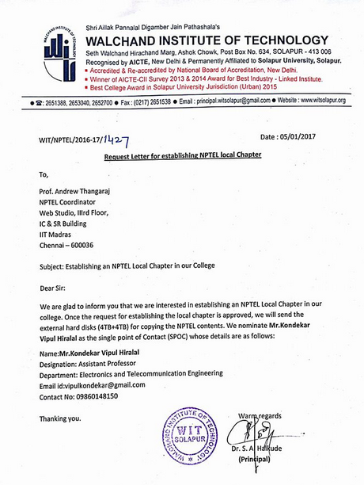

1.2 Seen below is NPTEL’s acknowledgement letter. This letter can be downloaded from within the SPOC login created when the Local Chapter is established.
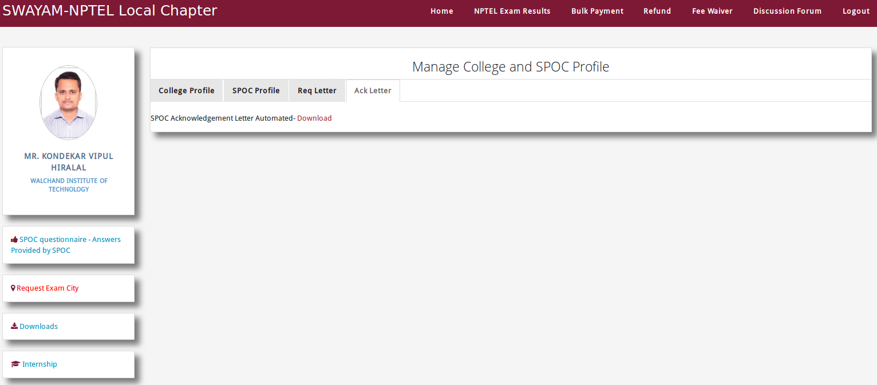

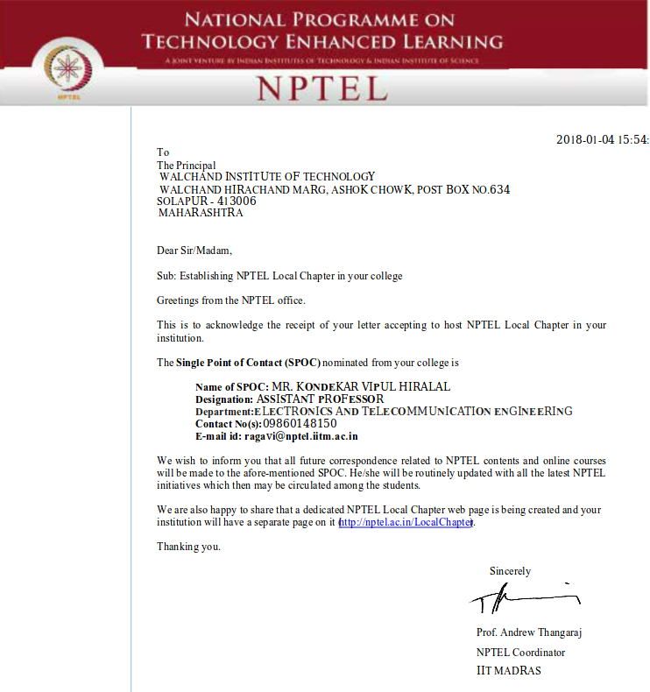

2. Communication channels of NPTEL Local Chapters with NPTEL offices
2.1 Here is the Snapshot of the Announcement forum available on the portal – for public viewing so that even if the SPOC misses emails, they can always check for important information here.

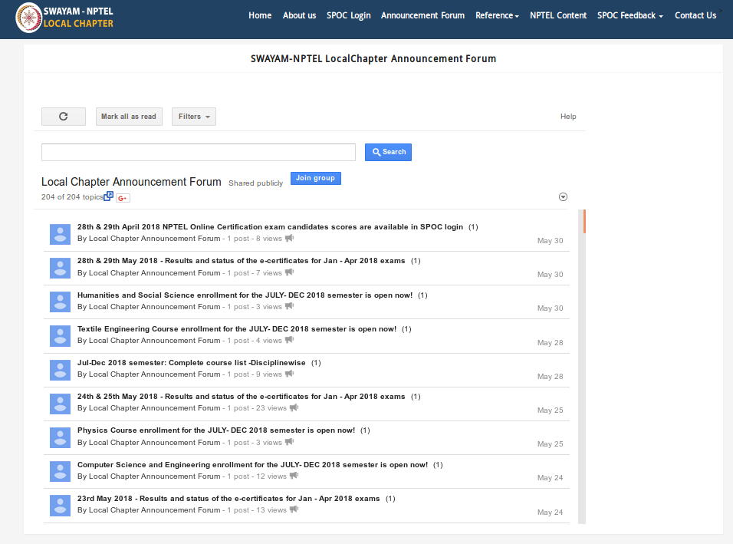
This is a snapshot of the Email group of SPOCs and sample correspondence with them.
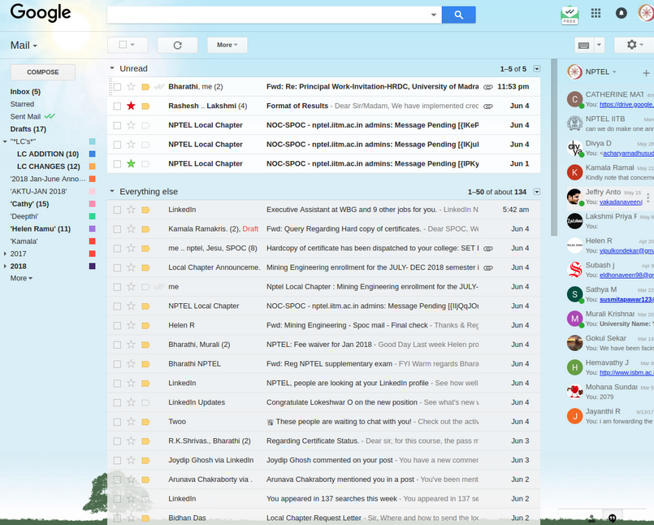

2.2 Snapshot of the felicitation function and SPOC interaction at IIT Madras. Similar events are held in the West zone, East zone and North zone also.
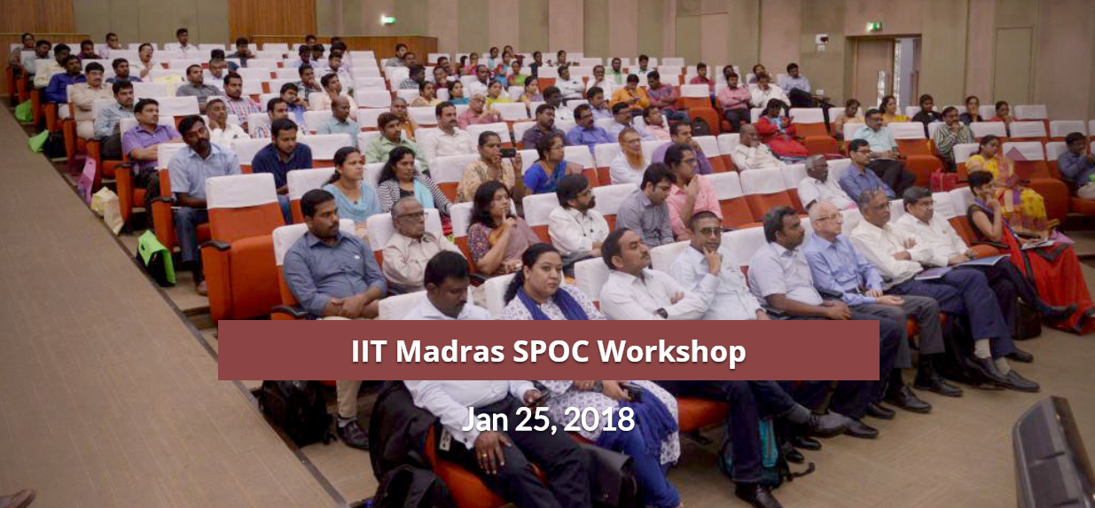

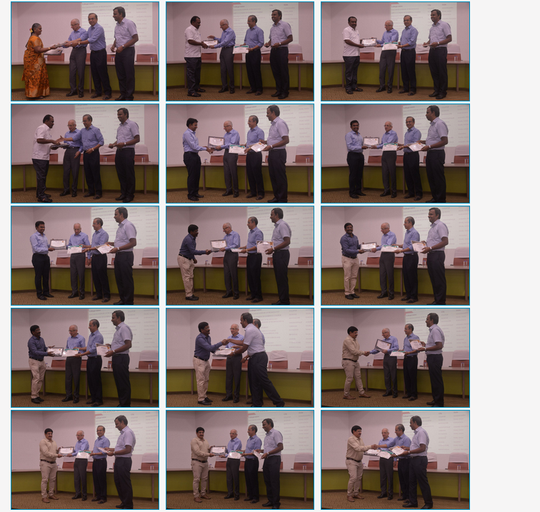

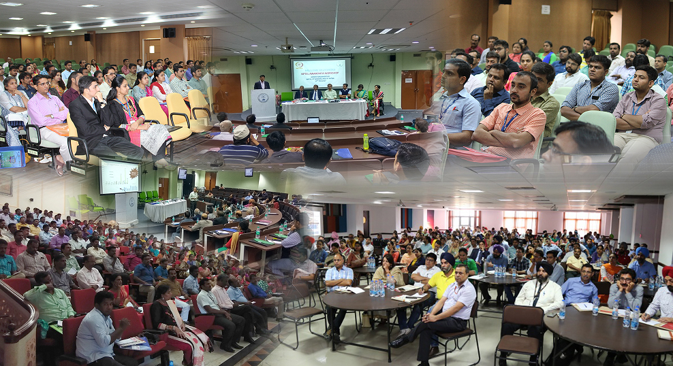

3. Information to SPOCs about Enrollment and Registration
3.1 On the portal where online courses are offered, candidates from the Local Chapter should be able to choose their Local Chapter and affiliate themselves to it and this data should be automatically be seen inside the login that the SPOC has on the portal. As seen below, this information about the LC is collected on the enrollment form.
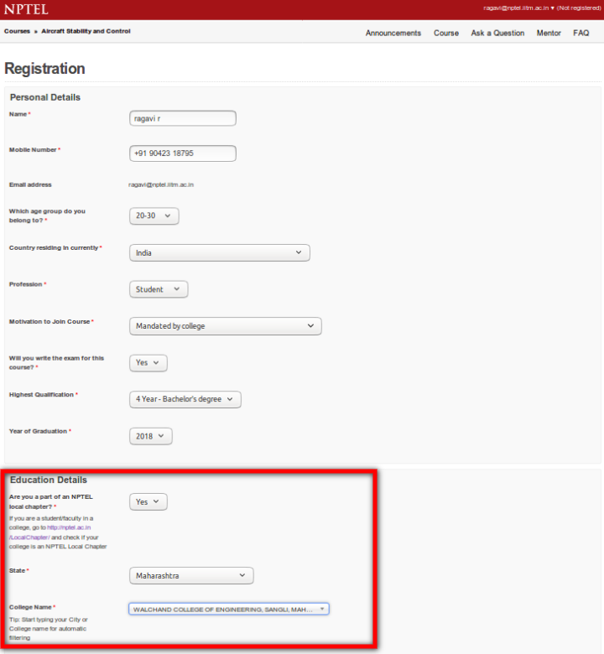

3.2 The SPOC has a login on the portal where the courses are offered where they can see the enrollment information – course wise and overall. Mentors can also be appointed here for various courses to help out the students.
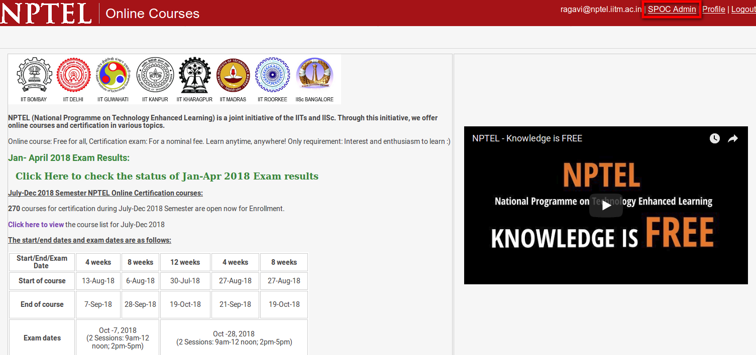

Number of candidates enrolled to various courses from a Local Chapter

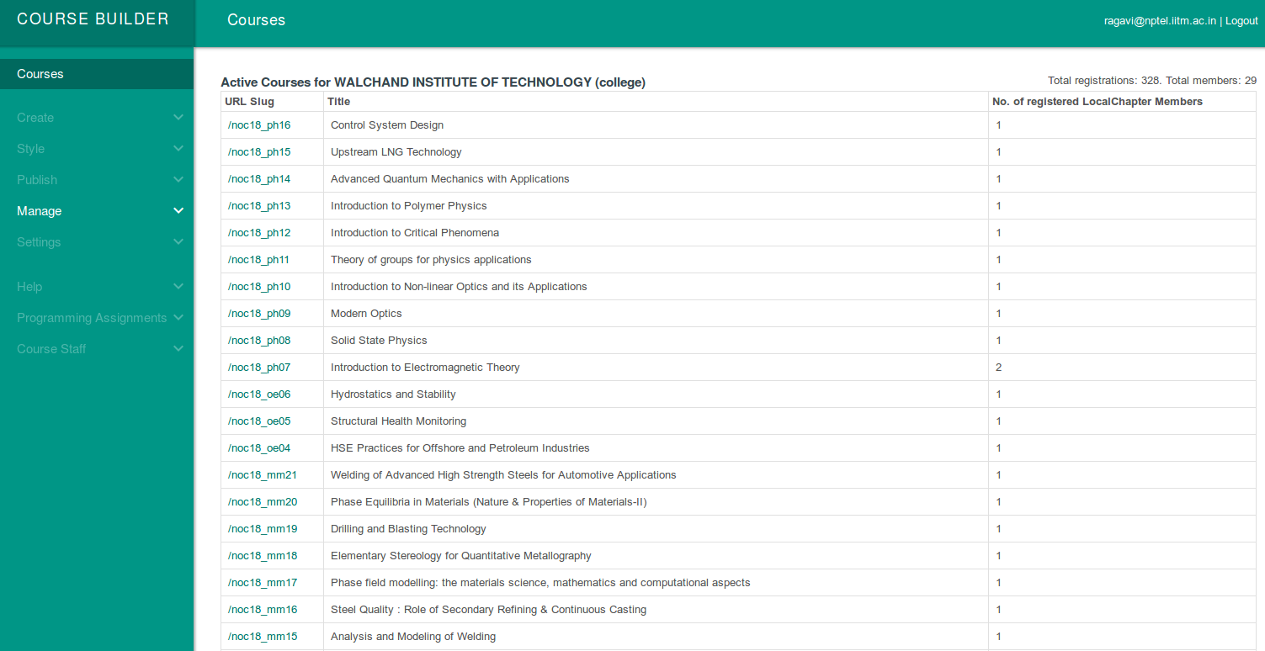

The next snapshot shows the details of candidates enrolled to a particular course from the Local Chapter.

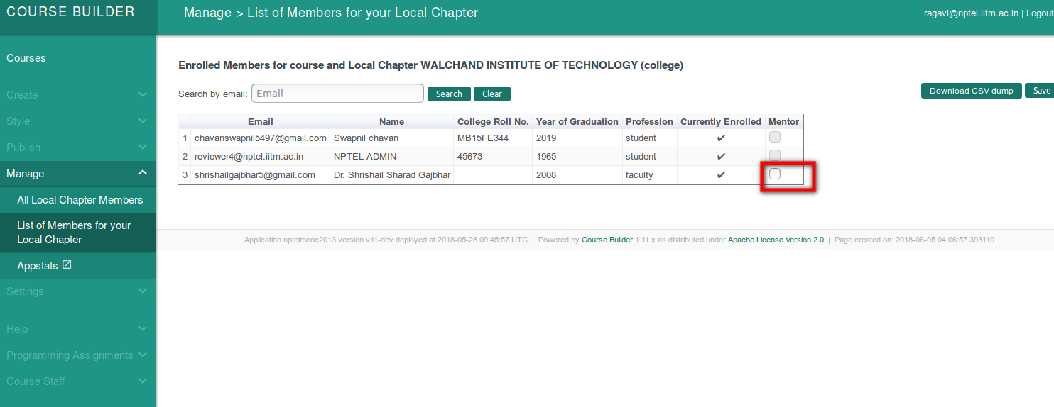

Enrollment details archived on the NPTEL Local Chapter portal within SPOC login

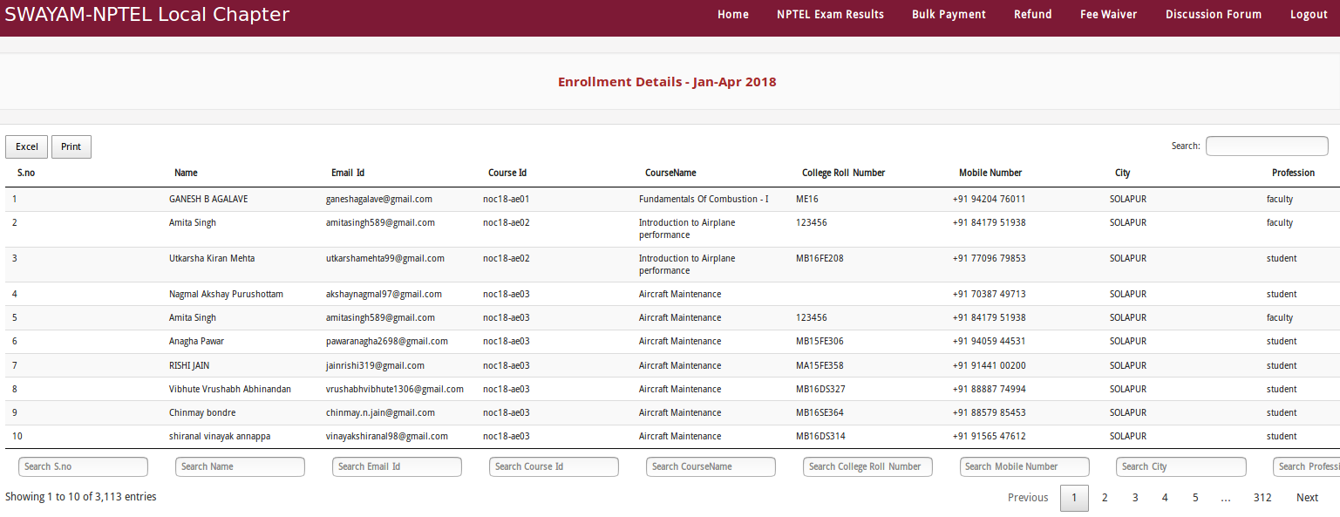

3.3 Details of candidates registering for the exam for various courses – from within a Local Chapter. This is visible within SPOC login dynamically.
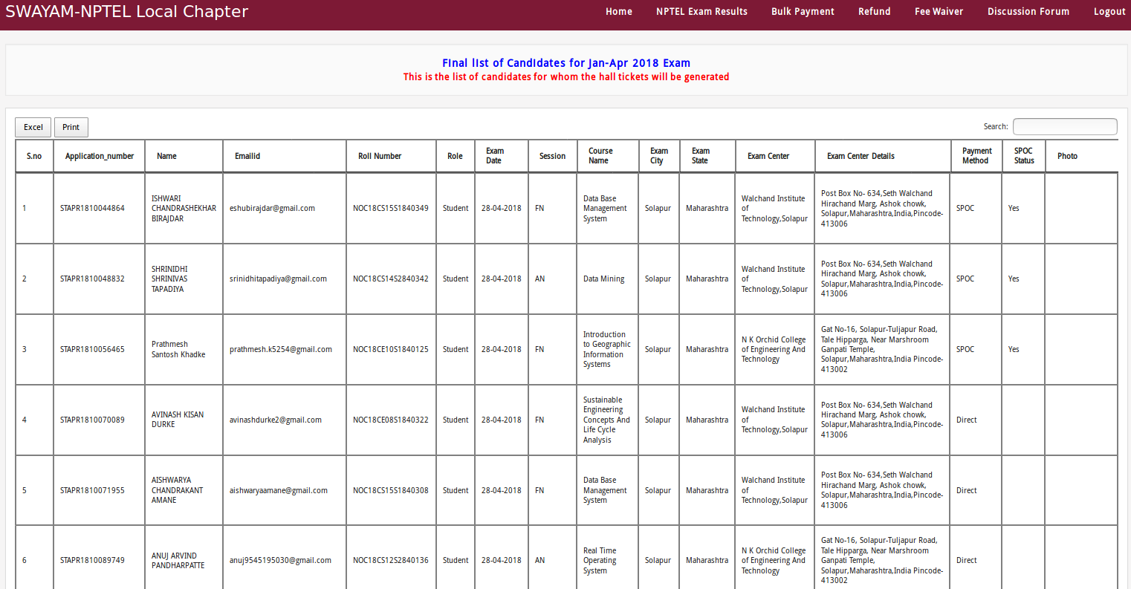
3.4 Marks procured in the final exam and the e-certificates as shared with SPOC inside his login.

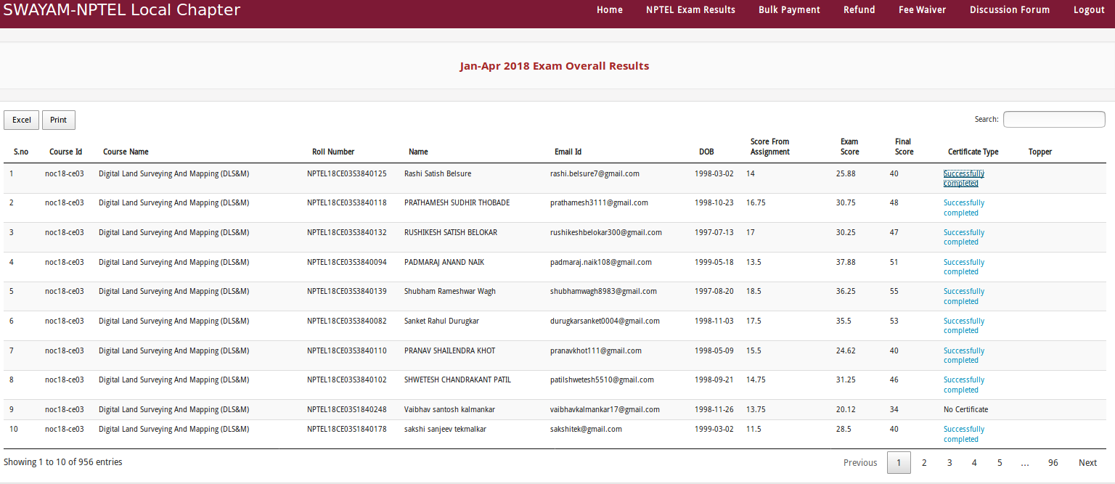

4. Public portal to display Local Chapter Participation
The following data should be available on a portal that can be publicly accessed by anyone and the following should be verifiable:
  - List of all Local Chapters attached to an NC
  - The details of the SPOC within each Local Chapter page along with the data about the Number of candidates enrolled, registered and appeared for the exam - semester wise.
  - Any rating/ranking if applicable for the Local Chapters and given by the NCs.

The portal for SWAYAM-NPTEL Local Chapters is nptel.ac.in/Local Chapter

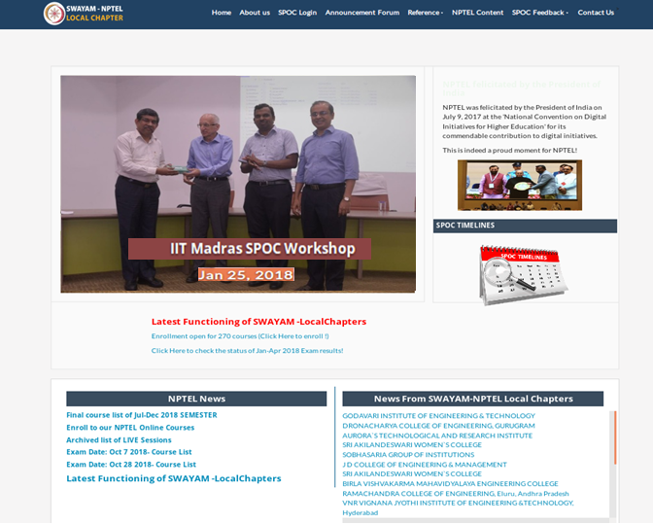

4.1 All the Local Chapters established so far are listed here.
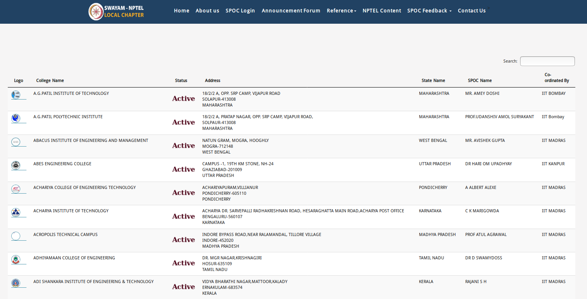

4.2 The statistics being showcased for a college on the portal – participating and rating, if applicable.
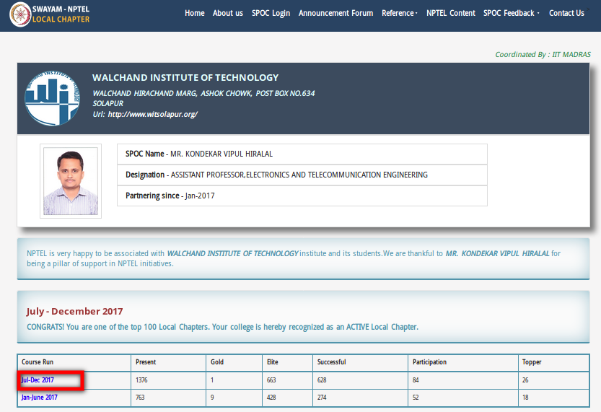

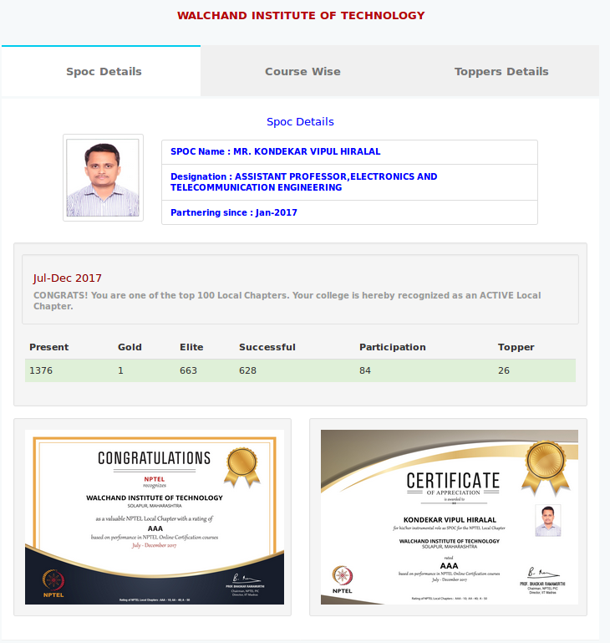

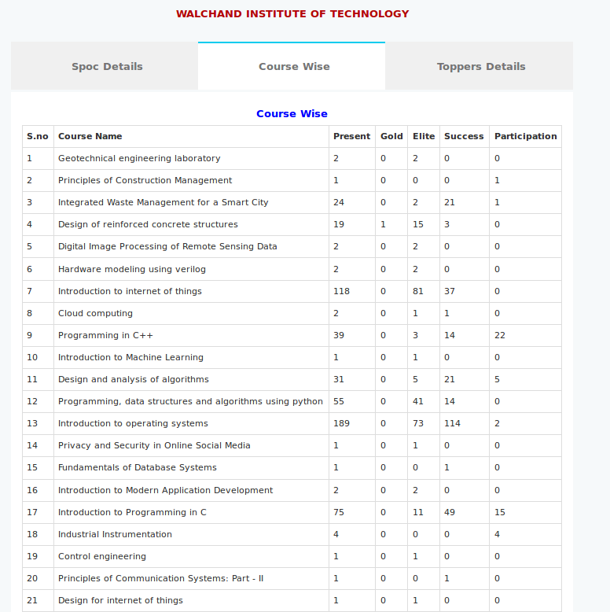

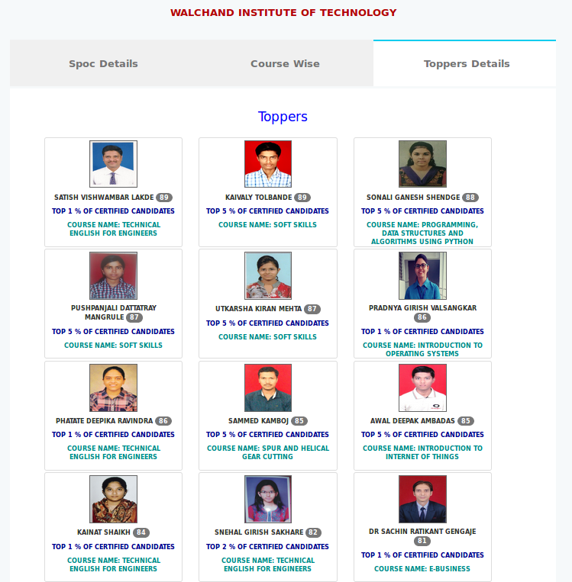

4.3 The rating of Local Chapters in the last semester is available.
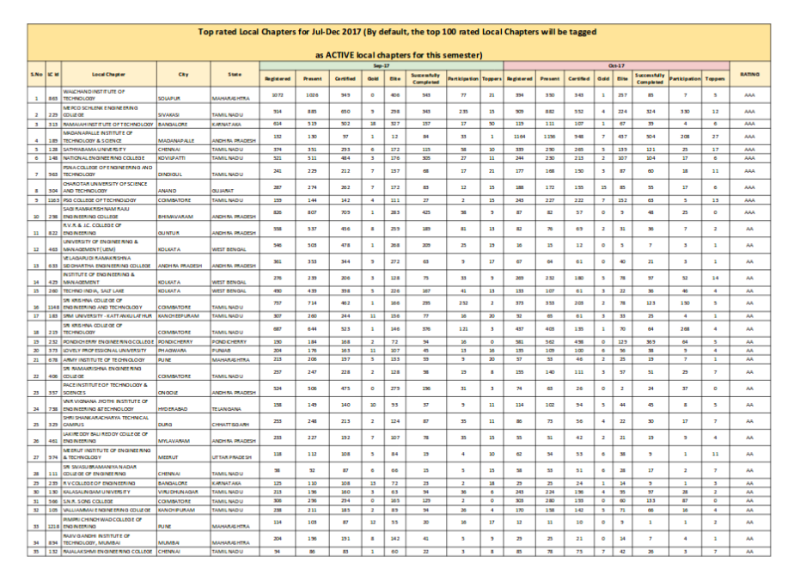

Agenda Item No. 5

Proposal from NPTEL and IISER Pune, for Workshop Course on Principles of Organic Chemistry Laboratory

Purport
The objective of this note is to seek approval of the Board for the combined proposal from NPTEL & IISER Pune, for workshop course on principles of organic chemistry laboratory.

Background
Experimental science plays an important role in science learning. Performing science experiments builds excitement amongst students and boosts conceptual understanding. Hands-on learning is a major component in learning but has received less attention.

Proposal
A proposal for 6 days residential workshop of 50 participants for a course on principles of organic chemistry laboratory by NPTEL & IISER is attached at ANNEXURE II. The workshop will be recorded and can be used in SWAYAM Courses. A budget of Rs.6,54,000/- is required for whole workshop.

Approval Sought
The Board is requested to kindly approve the above proposal of Rs. 6,54,000/- for Workshop Course on Principles of Organic Chemistry Laboratory.

Annexure II
Principles of Organic Chemistry Laboratory (Workshop Mode)

Preamble
Experimental science plays an important role in science learning. Performing science experiments builds excitement amongst students and boosts conceptual understanding. Experiments conducted with a research mindset benefit the students in ways other than just conveying the concepts. They build scientific temper, increasing the ability of critical and rational thinking. Lack of appropriate resources in communicating science in an effective pedagogical manner is a serious roadblock. Hands-on learning is a major component in learning but has received less attention.

Course Overview
We aim to offer a workshop course on principles of organic chemistry laboratory. This course will focus on important hands-on techniques in organic chemistry, as well as theoretical concepts behind the experiments. Each experiment is accompanied with an introduction to instrumentation techniques that will be used. Apart from direct learning gains stated above, students would learn research skills such as basics of experimental design, data interpretation, and documentation. We also aim to create a database of audiovisual materials suitable for the college students that will be shared with the participants. The course will focus on techniques such as synthesis, purification, separation, extraction and instrumentation techniques important for any organic chemist. Each experiment is accompanied with a pre-laboratory and a post laboratory task. These activities will be monitored and graded by the teaching assistants and feedback will be communicated with the participants in a timely manner. Students will attend theory classes, laboratory sessions each day. Instrumentation facility tours and discussion sessions will be conducted as a part of this course when required. Continuous evaluation components such as assignments and quizzes are a part of this workshop. A proctored final exam will be conducted at the end of the workshop and this grade may be used by NPTEL.

About us
IISER Pune is well equipped to support various chemistry education programs. Our teaching laboratories are equipped with state of the art facilities, which will act as an excellent venue for this workshop. Our expert faculty and staff will contribute towards content generation to boost the learning experience of participants. The participants will be hosted on campus for their stay and other arrangements.
Typical/Suggested Schedule
Course duration: 10th- 15th December, 2018 (Six Days)

Time | Activity
8.30 am- 9.30 am | Pre lab task and introductory lecture
9.30 am- 10 am | Tea break
10 am- 1 pm | Laboratory session
1 pm- 2 pm | Lunch break
2 pm- 3.30 pm | Post lab task, assignments and discussions
3.30 pm- 4 pm | Tea break
4 pm- 5 pm | Instrumentation facility tours, guest lectures etc

We believe that this course will be beneficial for participants willing to master the practical techniques in organic chemistry as well as learn basic experimental skills that may be useful for them in their careers.

Budget

S.No. | Activity | Cost | For 50 participants
1 | Accommodation, food etc. | Rs. 1000/day | Rs. 60,000
2 | Chemicals, consumables, glassware, etc.(one-time) | - | Rs. 1,00,000
3 | Chemicals, consumables, glassware, etc. (Recurring expenditure) | Rs. 3000 | Rs. 1,50,000
4 | Teaching assistants (Rs. 300 per hour and 8 hour/ day; one TA for 5 participants) | Rs. 2400/day and Rs. 14,400/ workshop | Rs. 1,44,000
5 | Video Coverage (3 hours) | Rs. 5000/day | Rs. 30,000
6 | Editing, post-production etc. for 18 hours of video recording | Rs. 10,000/day | Rs. 60,000
7 | Lecture Rooms | Rs. 5000/day | Rs. 60,000
8 | Stationery, misc. costs | Rs. 1000/person | Rs. 50,000
Total |  |  | Rs. 6,54,000

Agenda Item No. 6

Points raised by UGC

- Issue of student failing in MOOCs Examination:

The following queries have been raised by the university SWAYAM Coordinators:

- If the student fails in the exam, how and when will he/ she reappear in the exam?
- How many attempts can be given to him/her for clearing the exam?
- Since every year new courses shall be floated on SWAYAM, how will these failed students be able to take admission in the same course, if the course is not re-run.?

- Decision on Skill development Course :-

- With respect to Course :- credit/non-credit
- With respect to funding :-
As many eminent professors have retired from the university, involving them with the university w.r.t. funding is a tough job. Board may identify a body which will fund these eminent professors

- Decision on MOOCs proposal received from Colleges

- Budget for Broadcast of SWAYAM Radio Jingles on FM radio pan India in 10 languages from the period of 1.05.2018 to 1.06.2018

- Whether Foreign Faculty willing to offer MOOCs courses or Video lecture on SWAYAM free of cost will be allowed?

- Creation of a Data cum Information Facilitation Centre at UGC (recommendation based on visit to NPTEL , IIT-M, by NC, UGC)
Request to MHRD to partially fund the setting up the data centre.

- Request of the UGC Course Coordinator for assigning one Extra Credit for the Course “academic writing” if learner publishes a paper in web of science or Scopus indexed journal or publish an OER in Wikipedia or creative commons or OER commons with acknowledgment to the UGC MOOC

Currently the Course is of 3 Credit and Course Coordinator have requested UGC to provide permission to add 1 more credit to the course if :-
- the learner passes the Exam will qualify for 3 credits.
- If the learner passes the term end exam and submits a proof of publishing a paper in Web of Science or Scopus Indexed Journal or publish an OER in Wikipedia or creative commons or OER commons with acknowledgment to the UGC MOOC
- shall be given an additional one credit and in total 4 credits.
- CC may be assigned to approve the additional credit.
- this kind of additional credit policy is existing in PCI syllabus of M. Pharmacy syllabi of third semester. So this can be implemented for all the disciplines.
- This will increase India's contribution in OER by the vital trigger of UGC.

Agenda Item No. 7

Status of SWAYAM Prabha Channels

Status of Content Generation for SWAYAM Prabha Channels
CH. NO. | Channel  Name | Channel  Coordinator | Total contents  uploaded till Mar-18 (in hours) | Content created during last financial year (2017-18)  (in hours) | Target for current financial year  (2018-19)  (in hours) | Content created till date during this financial year  (2018-19)  (in hours)
1 | Language and Literature | Prof. K. Venkat Reddy  Director , EMRC EFLU (CEC) | 331 | 185 | 200 | 50
2 | History, Culture & Philosophy | Mr. Nageshwar Nath  Joint Director (HW), CEC | 750 | 200 | 200 | 50
3 | Social and behavioral science | Prof. Akhil Ranjan Garg  Director, EMRC Jodhpur (CEC) | 950 | 376 | 1360 | 144
4 | Education and Home Science | Mr. Nageshwar Nath  Joint Director (HW), CEC | 1513 | 693 | 84 | 5
5 | Information, Communication and Management Studies | Prof. Iftekar Ahmed, Director, MCRC, Jamia (CEC) | Content available  =1,500 hours  (1,000 hrs.+  500 hrs ) | Montage, Channel Video | 100 | 0
6 | Law and Legal Studies | Dr. Gurmeet Singh Maan, Director , EMRC Patiala (CEC) | 1401 | 0 | 120 | 16
7 | Economics, Commerce, Finance | Dr. B V Patel, Director EMRC Ahamdabad (CEC) | 598 | 0 | 160 | 0
8 | PHYSICAL AND EARTH SCIENCES | D Damodar Prasad,Director, EMMRC, University of Calicut (CEC) | 542 | 102 | 276 | 81
9 | Life Sciences | Dr. Salima Jan (CEC) | 780 | 0 | 100 | 0
10 | Applied Sciences | Prof. S. Gowri, Director, EMRC Chennai (CEC) | 859.5 | 395.5 | - | -
11 | Chemical Engineering, Chemistry and related Subjects | Prof. Sunando Das Gupta (NPTEL)
12 | Civil Engineering and related subjects | Prof. B. Bhattacharjee (NPTEL)
13 | Computer Science and Engineering | Prof. Anupam Basu (NPTEL)
14 | Electrical engineering, Electronics and CommunicationEngineering and related subjects | Prof. Shouri Chatterjee (NPTEL)
15 | Engineering Sciences and general subjects for engineering | Prof. K. Mangala Sunder (NPTEL)
16 | Humanities, Social Sciences &Management | Prof. Munmun Jha (NPTEL) | 1252 | 200 | 510 | 190
17 | Mechanical Engineering &related subjects | Prof. Shantanu Bhattacharya (NPTEL) | 1252 | 110 | 180 | 120
18 | Mathematics, Physics, Metallurgy and related subjects | Prof. T. S. Natarajan (NPTEL)
19 | IIT PAL Biology | Mr. Aditya Mittal | 120 | 120 | 0 | 0
20 | IIT PAL Chemistry | Mr. Ravi P Singh | 108 | 88 | 60
21 | IIT PAL Mathematics | Mr. Prof. Niladri Chatterjee | 177 | 3 | 32 | 19
22 | IIT PAL Physics | Prof. Pankaj Srivastava
23 | Liberal Arts and  Humanities | Prof. Anju SehgalGupta (IGNOU) | 128 | 76 | 1000 | 0
24 | Agriculture Vocational  and Allied Sciences  Krishi Gyan Vigyan | Prof. M.K. Salooja and  Dr. Praveen Kumar Jain  (IGNOU) | 220 | 100 (edited) | 1000 | 10
25 | Culture | Dr. Gaurav Singh (IGNOU)/NIOS | 42 | 16 | 400 | 43
26 | State Open Universities’ programs | Prof. P.K. Biswas (IGNOU) | 349 | 112 | 1000 | 0
27 | PANINI (Secondary Level) | Sh. S. K. Prasad (NIOS) | 127 | 127 | 400 | 7.5
28 | SHARDA (Sr. Secondary) | Dr. Sandhya Kumar (NIOS) | 92 | 92 | 2000 | 5
29 | QEEE 1 (Live classes in Engineering and Technology) | Prof. Ashok Jhunjhunwala
30 | NPTEL: Mathematics | Prof. Mangala Sunder (NPTEL) | 462 | 270 | 270
31 | Kishore Manch (School and Teacher Education) | Prof. A. Behera, Jt. Dir. CIET/NCERT | 384 | 60 | 72
32 | Teacher  Education- Vagda | Dr. Gaurav Singh (IGNOU/NIOS) | 250 | 230  (NIOS-210, IGNOU-20) | 300 | 60

Thank You

