Agenda Papers

7th Meeting
SWAYAM BOARD

13th August 2018

Ministry of Human
Resource Development
Shastri Bhawan
New Delhi - 110001

AGENDA
07th Meeting of the SWAYAM Board

S. No. | Agenda Items | Page No.
1 | Agenda Item No. 1  Confirmation of Minutes of 6th SWAYAM Board Meeting | 2 - 5
2 | Agenda Item No. 2  Action Taken Report | 6 - 8
3 | Agenda Item No. 3  Status Report provided by NCs | 9 - 10
4 | Agenda Item No. 4  Enrollment in July, 2018 Semester Courses | 11 - 12
5 | Agenda Item No. 5  Mapping of SWAYAM Courses to the model curriculum | 13
6 | Agenda Item No. 6  Proposal for developing SWAYAM Courses for Indian Languages | 14 – 17
7 | Agenda Item No. 7  Proposal for building Managerial Capability for SWAYAM Platform based Digital Education received from IIM Bangalore | 18 - 23
8 | Agenda Item No. 8  Presentation by IIT Madras on SWAYAM 2.0 and ASP | 24
9 | Agenda Item No. 9  Points suggested by UGC | 25
10 | Agenda Item No. 10  Any other issue with the permission of Chair

Agenda Item No. 1
Confirmation of Minutes of the 6th SWAYAM Board Meeting held on 09.07.2018

Minutes

The 6th Meeting of the SWAYAM Board was held under the Chairmanship of Shri R. Subrahmanyam, Secretary (HE), M/o HRD on 09.07.2018.

2. The status of SWAYAM Courses that was placed before the Board is summarized below:
- Total Courses : 1523
- Active Courses : 239
- Courses Completed : 843
- Upcoming Courses : 441
- Students Registered : 21,11,379
- Students Enrolled for courses : 34,71,953

National Coordinator Report on SWAYAM Courses

National  Coordinator  Name | Total no. of courses produced till date  (Also indicate within bracket the credit courses among them.) | Total no. of courses delivered through SWAYAM (a+b) -  Breakup  (a) First Run  (b) Re Run | No. of courses that are currently in production | Date of holding the last Academic Advisory Council (AAC) meeting  (a) No. of courses examined  (b) No. of Courses approved | No. of courses in which exams have been conducted for Credit Transfer / Certificates | No. of Universities that have approved credit transfer.
UGC | 60 | 120 | 87* (46 New + 29 Repur. + 12 Invited) | 2nd Meeting held on 26.03.2018  3rd Meeting Scheduled for 13.06.2018 | 7 | 65 University
CEC | 160Credit Courses | 77  (a) 54  (b) 23 | 130 (50 Repurpose + 80 Fresh) | 19th March, 2018  23rd March, 2018  159 Examined  102 Approved | - | 15 University
NPTEL | 482 | 740  (a) 482 First Run  (b) 258 Rerun | 156 (to be offered in July 2018 – new courses) | 07th Oct, 2017 | 740 upto April, 2018 | 26 Institutions
IIM B | 26 (All Credit) | 26  (a) 17 First Run  (b) 09 Rerun | 7 | AAC not held  Planned in August 2018 | 18 (14 ) | -
IGNOU | 14 (11) | 22  (a) 11 First Run  (b) 11 Rerun | 44  (31 IGNOU, 13 Other Univ.) | Held on 18th April, 2018  (a) No. of courses examined: 32  (b) No. of Courses approved: 24 (in principle) | - | -
NCERT | 20 | 24  (a) 8 First Run  (b) 16 Rerun | 24 | 23rd March 2018 (2nd meeting)  20 Courses examined  4 Proposals examined  20 Courses approved  2 Proposals approved | - | -
AICTE | 6 | 6 | 6  *43 upcoming | 20th March 2018  Next meeting on 08.06.2018
NITTTR | 8 (3)  (All are credit  courses) | 0 | 26 (34) | 6th December 2017  43 Examined  35 Approved | - | -
NIOS | 19 All Credit | Total 39  (a) 21 First Run  (b) 18 Re Run | 8  For Jan 2019 | 30th January, 2018  52 Examined  52 Approved | 17  (14 Sec + 3 D.El.Ed | -

3. Discussion on Action Taken and Status Report:

(i) Local Chapters: UGC and NPTEL informed the SWAYAM Board regarding activities of Local Chapters. SWAYAM Board emphasized that the focus should be on popularizing SWAYAM Courses and enrolling more students in SWAYAM.

(ii) Awareness Creation & Publicity: Secretary (HE), M/o HRD expressed his concern that none of the National Coordinators (NCs) are effectively using the Social Media to publicize the courses starting in July, 2018 Semester. He urged the NCs to step up the Social Media Campaign immediately. It was decided that all the National Coordinators would take necessary action regarding Social Media Campaign by 13.07.2018 and continue the campaign till 15.08.2018.

Each NC should have their own Social Media Campaign through verified accounts and designate a Single Point of Contact (SPOC) for Social media.

It was pointed out that during Study in India Campaign; M/s EdCIL (India) Ltd. had effectively used the Social Media. It was decided that JS (TEL & ICC), M/o HRD would chair a meeting of SPOCs from all NCs and M/s EdCIL (India) Ltd. (Mr. Nikhil) on 10th July, 2018 at 3:00 P.M. for finalizing the Strategy for Social Media Campaign.

UGC and CEC presented the recorded testimonials of students of SWAYAM Courses. The following suggestions were made by the members. Only the Video portion of SWAYAM Courses is getting covered in the testimonials. The other quadrants such as discussion forum and assessment are not highlighted. The back ground of many videos need improvement (proper framing is required). In case of languages other than Hindi and English, subtitling should be done.

(iii) Examination for SWAYAM: The Board in its 5th meeting held on 11.06.2018 had nominated Two Committees to deliberate on the different aspects related to conduct of examination and re-running of the courses. The Committee Members (Prof. P. D. Jose, IIM Bangalore, Prof. Pankaj Mittal, Additional Secretary, UGC, Prof. Prathap Haridoss, IIT Madras, Prof. Uma Kanjilal, IGNOU, Shri S. K. Prasad, Joint Director, NIOS and Shri Parameswaran N., Senior Consultant, NMEICT) met in MHRD on 09.07.2018 at 11 A.M. and discussed the issues in detail. The outcome was appraised to the Board as follows:-

(a) Recognizing the right of the student, there would be one re-examination for every course. The total exam time frame would be three months. The result of the 1st Exam would be declared within one month of the exam. The Re-examination would be conducted one month after declaration of result of 1st Exam. The students who have not cleared the 1st Exam or those who would like to improve the score can attend the re-examination. The Exam Fee for the Re-examination would be higher than the 1st Exam (recommended double). The Result of Re-examination would also be declared within one month of the exam. The total time frame from the date of 1st exam to the result of the Re-examination would be maximum of three months.

(b) Regarding the conduct of examination, ultimately it should be done in the digital mode. However, the same could be achieved only in a phased manner. For the courses for July, 2018 Semester, NPTEL, IIM Bangalore, NCERT, NIOS will continue to conduct examination as they are doing now. IGNOU would organize the examinations for UGC, CEC, IGNOU and NITTTR. Meanwhile, the Committee would take presentations from vendors who are specialized in conducting the examination using digital techniques and finalize a suitable methodology for January, 2019 courses.

The Board approved the above approach suggested by the Committee.

(iv) List of Courses (for July, 2018 Semester): The Current Status of Courses uploaded on SWAYAM was presented to the Board. Secretary (HE), M/o HRD pointed out the low figures of enrollment in July, 2018 Semester Courses. NCs should bring up the courses that have less than 500 Enrolments. Progress in enrollment should be regularly monitored by NCs and should take necessary step to popularize courses in starting days of launch.

The courses with low enrollment should be reported to the board and may be scrapped from SWAYAM portal.

It was noticed that the enrollment numbers as per the SWAYAM Portal and NPTEL Portal are different. The Board desired that the aspect of mirroring of NPTEL Data (like Registration, Enrollment etc.) on SWAYAM Portal should be examined on urgent basis and report in the next Board meeting.

e-Book Version of Courses was showcased by UGC. The Board cleared the same with some suggestions to highlight the course details

(v) Application Service Provider (ASP) for SWAYAM: IIT Madras and AICTE reported that knowledge transfer process between M/s Microsoft and M/s Persistant System has started.

(vi) SWAYAM 2.0: Secretary (HE), M/o HRD desired that the work on SWAYAM 2.0 should be expedited and requested IIT Madras to give a presentation on new architecture, features and implementation plan in the next Board meeting. Chairman, AICTE suggested that there should be a Brainstorming Session with all NCs before finalizing the additional features in SWAYAM 2.0.

4. Request from Government of Afghanistan for using SWAYAM Platform: The Board approved in-principle for proposal for permitting the Institutions under Afghanistan Government to upload courses on SWAYAM Platform and offer the courses to the learners / students in Afghanistan. It was felt that since the facility is being extended free of cost, there should be a time limit of 2 / 3 years specified in the MoU. Further, the proposal would require the approval of the Competent Authority.

AICTE was requested to make available a draft MoU.
The Members also felt that the Foreign Students who come through SWAYAM could be given Credit Transfer Facility in the Indian Universities. This would be an encouragement for students to come to India under the Study in India Programme.
5. Approval letter for courses to be offered by each NC and release of funds: The Board approved the proposal for issue of formal letter from MHRD confirming the courses to be run by an NC as well as the corresponding budget. In case, the total number of courses exceeds the number provided in the SFC, approval for the same will have to be obtained.
6. Fund Allocation to National Coordinators towards Local Chapters: The Board approved the proposal for release of funds for Local Chapters to the NCs in proportion to the number of courses offered by them.
7. To refund the 50% fee waiver extended to SC/ST Students and PwD Students: As per the SFC, the reimbursement of examination fee could be possible only for the Registrations done through SWAYAM. Mirroring of Data between SWAYAM and NPTEL Portals would solve the issue. The reimbursement would be limited to a maximum of Rs.1,100/-.
8. Points raised by UGC:
• ISTM and IEEE are allowed to run their courses on SWAYAM as Self Paced Courses and no financial support would be provided for these courses.

- The Board desired that a detailed proposal for revision of Budget Heads to be made for examination through IFD.

- No Experience Certificate would be given for Course Coordinators.

- The existing Feedback Mechanism of SWAYAM Portal was explained by AICTE.

NPTEL has raised the following issue regarding Re-exams:

The clause on re-exams (Clause No: 3(iii) (a)) is too stringent on the NCs, while we are still trying to establish and stabilize our operations. NPTEL faces a lot of issues in its exam process. On behalf of NPTEL, I request that this clause be removed from the current minutes. We need to have a wider debate involving the entire SWAYAM board in the August meeting to discuss this further.

Agenda Item No. 2

Action Taken on the decisions of the 6th SWAYAM Board Meeting held on 09th July, 2018

S.No | Action Points | ATN to be provided by:
1 | Local Chapters:  Activity happened / planned in Local Chapters to increase student enrollment in SWAYAM Courses. | UGC :  - Circulated the e-booklet to all NCs, Local Chapters and Course Coordinators and the same has also been distributed in the National Conference for all VCs and CFTIs held from 26th to 28th July, 2018.  - Compiled Video testimonial and made a film on SWAYAM.  - Shortly to organize a workshop for the Local Chapters.  CEC:  - Two-Day Workshop for Development and Delivery of MOOC for Course Coordinators on 23rd and 24th July 2018 at MCRC Jamia Milia Islamia.  - 6-Days Training/Workshop on digital Learning from 23rd to 28th July 2018.  - Two-Day Workshop for Development and Delivery of MOOC for Course Coordinators on 2nd and 3rd August, 2018 at EMRC Calicut.  - CEC Media centre at Srinagar has developed 4 Promo Films for SWAYAM Prabha Channels,  NPTEL: Current enrollment as of 6th August, 2018 was 11.62 Lakhs NPTEL is doing workshops at more places in the coming months and also conducted SPOC felicitation cum interaction workshops at Chennai, Mumbai, Delhi and Kolkata for the Local Chapters of the 4 zones. More than 600 college representatives attended the same and a lot of feedback was received.  NPTEL SWAYAM Local Chapters as of 8th August, 2018 - 1924  NIOS: had organized SWAYAM Workshop on 19th July, 2018 at Amity Institute of Education, Saket. Proposed workshop at Jamia Milia Islamia University, Delhi and The Maharaja Sayajiroa University of Baroda, Gujarat.  NCERT: formed six local chapters at RIEs-Ajmer, Bhopal, Bhubaneswar, Mysore, Shillong and PSSCIVE Bhopal
2 | Awareness Creation & publicity.  All the NCs to step up the Social Media campaign immediately. It was decided that all the National coordinators would take necessary action regarding Social Media Campaign by 13.07.2018 and continue the campaign till 15.08.2018.  Each NC should have their own social Media campaign through verified accounts and designate a Single Point of Contact (SPOC) for Social media'  It was pointed out that during Study in India Campaign, M/s EdCIL (India) Ltd, had effectively used the Social Media. It was decided that JS (TEL & lCC), M/o HRD would chair a meeting of SPOCs from all NCs and M/s EdCIL (India) Ltd. (Mr. Nikhil) on 10th July, 2O18 at 3:00 P.M. for finalizing the Strategy for Social Media Campaign. | UGC: Tweeting for all PG courses through account @ugc_india and the average impression (seen by user) of each tweet is more than 800 per tweet. Also in process for verification of its official twitter & FB A/c  IIM Bangalore: Prepared a Social Media Marketing Plan and adhering to that. The FB posts and Tweets are already running as per the plan.  CEC: Courses schedule along with course details for each month are being posted on CEC’s FB page and twitter handle.  NITTTR: All our courses launch details uploaded in the FB.  NCERT: NCERT has created poster (creative) for each course and shared on social media (Twitter, Facebook and WhatsApp)  NPTEL: Is running social media campaign.  AICTE: AICTE is using its Facebook and Twitter Handle for publicity of self-paced courses and other online courses on SWAYAM Platform.  NIOS: All course coordinators also created their Facebook & Twitter handle for individual publicity of their course.  IGNOU: IGNOU NC has created Face book account and Twitter account, promotional activities have been initiated.  UGC, CEC, NPTEL, AICTE, IGNOU, NCERT, NIOS, IIM B has designated SPOC for Social media campaign.  MHRD: Two Meetings, chaired by JS, were organized with NCs on 10th July & 2nd August, 2018. UGC, CEC, AICTE, IGNOU, NCERT and M/s EdCIL (India) Ltd attended the meeting. NCs were directed to first verify their social media accounts and share content and creative’s amongst them. As EdCIL is having experience in managing Social media campaign, it was decided that the Social Media campaign should be implemented in a centralized manner by M/s EdCIL (India) Ltd.
4 | List of courses (for July 2018 semester):  NCs should bring up the courses that have less than 500 Enrolments. Progress in enrollment should be regularly monitored by NCs. The courses with low enrollment should be reported to the board and may be scrapped from SWAYAM portal.  The Board desired that the aspect of mirroring of NPTEL Data (like Registration, Enrollment etc.) on SWAYAM Portal should be examined on urgent basis and report in the next Board meeting | Committed in 2nd SB Actual uploaded  UGC : 44 Courses 47 Courses  CEC : 78 Courses 116 Courses  NPTEL: 262 Courses 270 Courses  IIM B: 4 Courses 8 courses  IGNOU: 11 Courses 13 Courses  NCERT: 20 Courses 20 Courses  NIOS: 35 Courses 35 Courses  NITTTR: 15 Courses 2 Courses  AICTE: 9 Self Paced 6 Courses  Total : 478 courses 517 courses  NPTEL: NPTEL enrolment data is to be integrated currently in the SWAYAM share point dashboard. The ASP has made this change and it will be pushed into the production code in a few days.
5 | Application Service Provider  Information on related activities and status of knowledge transfer activities between Microsoft and Persistent. | AICTE: Knowledge transfer activities between M/s Micrsoft and M/s Persistent are continuing.  AICTE has extended the contract of M/s MCIPL towards Support for Azure based SWAYAM solution under capacity based Resourcing Model upto 17.10.2018. Similarly, AICTE has extended the contract of M/s Embee Software Pvt. Ltd. from 08.08.2018 to 07.02.2019, on the existing terms & conditions, with a clause that the services can be terminated by giving one month’s notice.  IIT Madras: Prof. Andrew Thangaraj would be making a presentation
6 | SWAYAM 2.0 status  Secretary (HE), M/o HRD desired that the work on SWAYAM 2.0 should be expedited and requested IIT Madras to give a presentation on new architecture, features and implementation plan in the next Board meeting. | IIT Madras: Prof. Andrew Thangaraj would be making a presentation.
7 | Request from Government of Afghanistan for using SWAYAM Platform:  The Board approved in-principle for proposal for permitting the institutions under Afghanistan Government to upload courses on SWAYAM Platform.  The proposal would require the approval of the Competent Authority. | MHRD: Draft MoU has been prepared and being send to MEA for approval.

Agenda Item No. 3
Status of SWAYAM Courses

Status of SWAYAM Courses As On 08.08.2018
Total Number of Courses Listed on SWAYAM : | 1543
Past Courses listed on SWAYAM : | 862
Current Courses listed on SWAYAM : | 537
Upcoming Courses listed on SWAYAM : | 144

NC wise Distribution of Courses As On 08.08.2018
 | Past courses | Current Courses | Upcoming Courses | Total Courses | Total Student Enrollment
UGC (PG Non Engineering) | 115 | 24 | 23 | 162 | 98828
NIOS (Open School 9th to 12th ) | 46 | 39 | 0 | 85 | 2813295
NPTEL (UG & PG Engineering) | 560 | 348 | 73 | 981 | 433591
NITTTR (Teacher Training) | 3 | 1 | 3 | 7 | 838
NCERT (School 9th to 12th) | 19 | 20 | 0 | 39 | 40361
IGNOU (Certificate & Diploma Courses) | 14 | 11 | 2 | 27 | 28284
IIM B (Management) | 19 | 8 | 0 | 27 | 52730
CEC (UG Non Engineering) | 86 | 74 | 43 | 203 | 134918
AICTE (Foreign Universities) | 0 | 12 | 0 | 12 | 37134
 | 862 | 537 | 144 | 1543 | 3639979

Registration & Enrollment Status As On 08.08.2018
Total number of Registration on SWAYAM Platform | 2250383
Total number of Enrollment on SWAYAM Courses | 3639979
Enrollment in NIOS DElEd Courses 501 | 884356
Enrollment in NIOS DElEd Courses 502 | 746056
Enrollment in NIOS DElEd Courses 503 | 733580
Enrollment in NIOS DElEd Courses 504 | 243539
Enrollment in NIOS DElEd Courses 505 | 143808

Top 15 Certificate / Credit Courses for July, 2018 Semester (Enrollment-wise) As On 08.08.2018
S.No. | Course Name | Institute Name | Enrollment
1 | D.El.Ed. 504: Learning Mathematics at Elementary Level | NIOS | 47774
2 | Fundamentals of Banking and Insurance | CEC | 2838
3 | July 2018: The Joy of Computing using Python | NPTEL | 2472
4 | July 2018: Introduction to Internet of Things | NPTEL | 2438
5 | Practical English: Learning and Teaching | NPTEL | 2409
6 | Project Planning and Control | NPTEL | 2237
7 | Organisation Behaviour | UGC | 2211
8 | July 2018: Basic Electrical Circuits | NPTEL | 1849
9 | July 2018: Computer Networks and Internet Protocol | NPTEL | 1825
10 | Introduction to Information Security - I | NPTEL | 1795
11 | NCERT Physics 01 - Class XI - 2018 | NCERT | 1784
12 | July 2018: Programming, data structures and algorithms using Python | NPTEL | 1780
13 | Principles of Marketing | CEC | 1759
14 | Indian Agricultural Development | IGNOU | 1715
15 | Financial Accounting | CEC | 1709

Status Report by NCs for the 7th SWAYAM Board Meeting to be held on 13.08.2018
National  Coordinator  Name | Total no. of courses produced till date  (Also indicate within bracket the credit courses among them.) | Total no. of courses delivered through SWAYAM (a+b) -  Breakup  (a) First Run  (b) Re Run | No. of courses that are currently in production | Date of holding the last Academic Advisory Council (AAC) meeting  (a) No. of courses examined  (b) No. of Courses approved | No. of courses in which exams have been conducted for Credit Transfer / Certificates | No. of Universities that have approved credit transfer.
UGC | 91 (60)  (49 course for  credit and 42 non-  credit) | FIRST RUN:-  July-Dec17-  Total 60 course  July-  Dec,18:-  31 Re-purp.  +16 Re-run | 59 (48 New + 11  Invited) | 3rd Meeting Scheduled for 13.06.2018 | 7 (During the  session July-Dec-17) | 66 (65) University
CEC | 160 Credit Courses | 192  (a) 54  (b) 23  (c)115 Courses are  being offered on SWAYAM (including 22  rerun courses) | 130 (50 Repurpose + 80 Fresh) | 19th March, 2018  23rd March, 2018  159 Examined  102 Approved | 1 Course.  (Exam for 3 more  Courses are  scheduled for  September, 2018) | 17 (15) University
NPTEL | 482 | 740  (a) 482 First Run  (b) 258 Rerun | 156 (to be offered in July 2018 - new courses) | 04th August, 2018 | 740 upto April, 2018 | 26 Institutions
IIM B | 26 (All Credit) | 26  (a) 17 First Run  (b) 09 Rerun | 7 | AAC not held  Planned in August, 2018 | 18 | -
IGNOU | 14 | 22  (a) 11 First Run  (b) 11 Rerun | 44  (31 IGNOU, 13 Other Univ.) | Held on 18th April, 2018  (a) No. of courses examined: 32  (b) No. of Courses approved: 24 (in principle) | - | -
NCERT | 20 | 24  (a) 8 First Run  (b) 16 Rerun | 24 | 23rd March 2018 (2nd meeting)  20 Courses examined  4 Proposals examined  20 Courses approved  2 Proposals approved | - | -
AICTE | 12 (6) | 12 | 12 | 20th March, 2018 | - | -
NITTTR | 16  (All are credit  courses) | 0 | 19 | 6th December, 2017  43 Examined  35 Approved | - | -
NIOS | 19 All Credit | Total 40  (a) 22 First Run  (b) 18 Re-run | 8  For January, 2019 | 30th January, 2018  52 Examined  52 Approved | 17  (14 Sec + 3 D.El.Ed. | -

Agenda Item No. 4

Enrollment in July, 2018 Semester Courses
Purport
The objective of this Note is to draw the kind attention of the Board on Courses with less Enrollments. Details of Courses with Enrollments are attached at Annexure I.

Background
In the last Board meeting it was decided that the enrollment in the SWAYAM courses should be monitored and the NCs should take necessary action to increase the enrollment in courses which have less than 500 enrollments. Also courses with very low enrollment should be removed from the platform

Attention Sought
It is requested that the Board may kindly take note of the enrollment in July 2018 semester courses enclosed.

Enrollment of July, 2018 Semester Courses 8th August, 2018
NC Name | Total Courses | Total Enrollments | Average Enrollments  per course | Courses Enroll. ≤ 500 | Courses Enroll. 500 < 1000 | Courses  Enroll. ≥ 1000
UGC | 47 | 23815 | 506 | 25 | 19 | 3
CEC | 116 | 49882 | 430 | 80 | 24 | 12
NPTEL | 320 | 91551 | 286 | 270 | 27 | 23
IIM B | 8 | 5811 | 726 | 2 | 4 | 2
IGNOU | 13 | 11593 | 891 | 3 | 5 | 5
NCERT | 20 | 13313 | 665 | 6 | 12 | 2
NIOS | 35 | 55576  7802 | 1587 (with D.El.Ed)  229 (without DElEd) | 31 | 2 | 2
NITTTR | 4 | 684 | 171 | 3 | 1 | 0
AICTE | 6 | 2839 | 473 | 4 | 2 | 0
 | 569 | 255064  207290 | 448 (including DElEd)  365 (excluding DElEd) | 424 | 96 | 49
NPTEL: Only 270 Courses in July, 2018 Semester, but 50 Courses mistakenly showing on portal.
NIOS: D.El.Ed. Course is included, majorly contributing 47774 to Enrollment Numbers.
NITTTR: 2 Courses mistakenly showing on portal. Requested all NCs to delete the unwanted mistakenly added courses after identifying them with the help of AICTE because students get enrolled to these courses also.
Annexure I

Comparison between 5th July, 2018 and 8th August, 2018
NC Name | Enroll.  5th July, 2018 | Enroll. 8th August ,2018 | Average Enroll. per Course: 5th July, 2018 | Average Enroll.  per course: 8th August, 2018
UGC | 5823 | 23815 | 129 | 506
CEC | 16886 | 49882 | 170 | 430
NPTEL | 31819 | 91551 | 99 | 286
IIM B | 3352 | 5811 | 419 | 726
IGNOU | 8088 | 11593 | 622 | 891
NCERT | 8633 | 13313 | 431 | 665
NIOS | 1840 | 7802  55576 | 54 | 1587 (including D.El.Ed)  229 (excluding D.El.Ed)
NITTTR | 464 | 684 | 77 | 171
AICTE | 338 | 2839 | 67 | 473
Total | 77243 | 207290 (excluding D.El.Ed)  255064 (including D.El.Ed) | 140 | 365  448

Courses with less Content Count
NC Name | Content Count < 10 | Courses started upto 13th Aug
UGC | 9 | 6
CEC | 44 | 8
NPTEL | 124 | 92
IIM B | 0 | 0
IGNOU | 4 | 3
NCERT | 0 | 0
NIOS | 3 | 3
NITTTR | 4 | 1
AICTE | 0 | 0
 | 188 | 113

Agenda Item No. 5
Mapping of SWAYAM Courses to the model curriculum
Purport
The objective of this Note is to request the Board to finalize the time frame for Mapping of SWAYAM Courses to the model curriculum.

Background
As per the Regulations, 2016 (Credit Framework for Online Learning Courses through SWAYAM) issued by UGC & AICTE, credit transfer up to 20% on the basis of MOOCs on SWAYAM is allowed. It has been seen that some Universities are unable to find / identify courses to their curriculum and in some areas unable to find courses through SWAYAM. In previous board meetings it was discussed and decided to align the courses to the academic Curriculum. The ultimate objective of SWAYAM is that , every course that is taught in the class should be available in SWAYAM.

Decision Sought
It is requested that the Board may kindly deliberate and fix the time frame for Mapping of SWAYAM Courses to the model curriculum.

Agenda Item No. 6

Proposal for Developing SWAYAM Courses for Indian Languages
Purport
The objective of this Note is to place before the SWAYAM Board a proposal received from Central Institute of Indian Languages (CIIL) for developing and running SWAYAM Courses for all Indian Languages.

Background
A proposal received from Central Institute of Indian Languages for running SWAYAM Courses for all Indian Languages has been received at MHRD. Copy of the same is attached at Annexure II.

Proposal
CIIL offers 10 Months Diploma Course at 7 Regional Centers in India to cater to the Implementation of the Three Languages Formula Policy of the Government of India. It has been mentioned that the response for these courses are have seen a decline now. One of the reasons is that the Authorities are unwilling to depute teachers for 10 months period. So CIIL is proposing to develop MOOC Courses following SWAYAM Guidelines and have requested for funding of the same as per SWAYAM Guidelines.
Also it has been requested that CIIL may be designated as National Coordinator to provide Certificate and Diploma Courses in Indian Languages.

Decision Sought
The Board is requested to kindly consider the above proposal of CIIL for designation as National Coordinator to provide Certificate and Diploma Courses in Indian Languages and funding of these courses as per SWAYAM Guidelines.

Annexure II

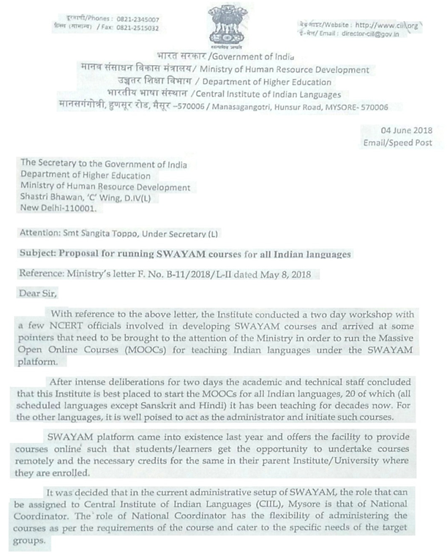

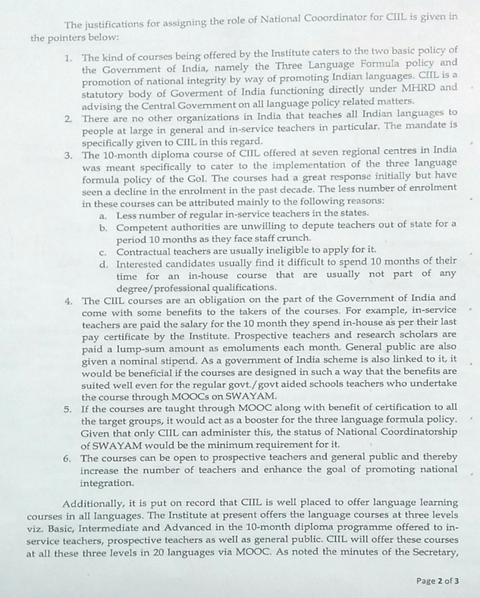

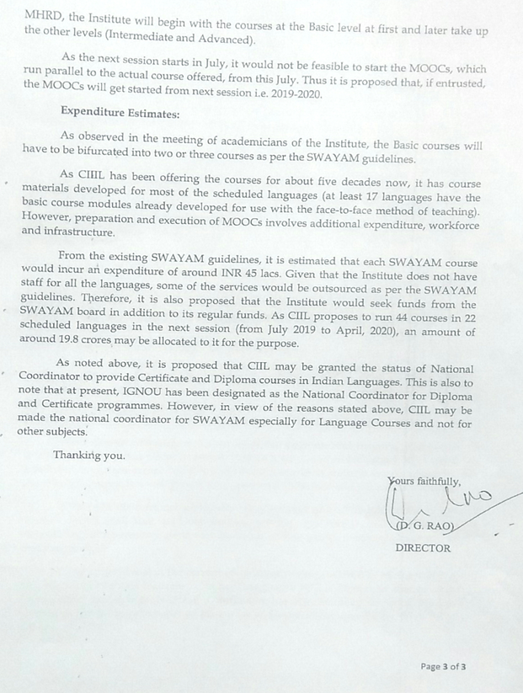

Agenda Item No. 7

Proposal for building Managerial Capability for SWAYAM Platform based Digital Education received from IIM Bangalore
Purport
The objective of this Note is to seek approval of the SWAYAM Board for the Proposal received from the IIM Bangalore for building Managerial Capability for SWAYAM Platform based Digital Education Copy of the proposal is attached at Annexure III.
Background
IIM Bangalore is one of the National Coordinators for SWAYAM and has been designated by the HRD Ministry to focus on the domain of Management. IIM Bangalore is targeting to have 20 courses on SWAYAM Platform in 2018 with proctored examination for each of the courses, to be conducted in the cities of Bangalore, Mumbai, Delhi and Kolkata.
Proposal
IIM Bangalore has placed proposal to engage with the Ministry of Human Resources Development (MHRD) to conduct a formal Pilot in 3 States of India to start with (Maharashtra, Goa and Karnataka). In each of these 3 States, IIM Bangalore proposes to engage with 10 Government First Grade Colleges each.
The following activities are expected to be part of the proposed pilot –
- MOOCs and SWAYAM introduction to colleges and registrations / course signups.
- Visits to colleges, follow ups on progress on MOOCs / SWAYAM by students and reporting on the same.
- Events in IIM Bangalore to engage with faculty.
- Blended teaching experiments by faculty with training.
- Have 50 faculties to take up 2 certifications each in each of the 3 States on MOOCs, and 100 students to take up 1 course examination in SWAYAM and MOOCs in each state.
- Collection of feedback from students and measurement.
- To work with MHRD and ensure end to end functioning of SWAYAM in collaboration with universities.
- To create a comprehensive study report as a result of the pilot exercise.

The financial budget for the above proposal is as below:
Cost Heads | Amount (INR)
Manpower Time | 84,00,000
Travel | 25,00,000
Certifications | 30,00,000
Communication / Stationary | 3,00,000
Overheads | 21,30,000
GST | 29,39,400
Overall Total | 1,92,69,400
Final Total ( Rounded off ) | 1,92,00,000

Approval Sought
The Board is requested to kindly approve the above proposal of the IIM Bangalore for building Managerial Capability for SWAYAM Platform based Digital Education.

Annexure III
Proposal for building Managerial Capability for SWAYAM Platform based Digital Education and Placement services in Government First Grade Colleges in Maharashtra, Goa and Karnataka.

IIM Bangalore has been promoting different concepts and tools in digital education that can make impact in the education space. MOOCs (Massive Open Online Courses) based digital education initiative is one of the programs that IIM Bangalore has been actively involved as a not for profit initiative. IIMBx is a platform started in August 2014 by IIM Bangalore with the aim of providing access to world-class education in management to every interested learner in India and across the world. IIM Bangalore believes in the disruptive power of technology and is committed to leveraging digital channel, so as to bring motto of radiant learning to reach out to young students living in rural areas.

IIM Bangalore is one of the National Coordinators for SWAYAM and has been designated by the HRD Ministry to focus on the domain of Management. IIM Bangalore is targeting to have 20 courses on SWAYAM platform in 2018 with proctored examination for each of the courses, to be conducted in the cities of Bangalore, Mumbai, Delhi and Kolkata.

The following are the IIM Bangalore’s other current programs apart from SWAYAM in this regard:

- IIMBx Academic Partnership Programme

IIMBx offers 30 MOOCs in core and elective management subjects aimed at the Post Graduate Level (PGDM/MBA - 2nd year students). These include courses on Banking and Finance, Entrepreneurship, Analytics, Economics, People management, Marketing Management, Strategy, Operations etc. Please visit our website at https://www.iimbx.edu.in/ to understand the benefits of this programme.

- IIMBx MBA Preparatory Programme

IIMBx offers an MBA Preparatory programme for B-schools and MBA colleges. IIMBxPrep is a preparatory programme aimed at equipping MBA students with basic understanding of Statistics, Accounting and Economics before joining a full-time PGDM/MBA programme. This bridge course is a package of 3 MOOCs - Statistics for Business, Introduction to Accounting and Managerial Economics. It is already being used at a few IIMs including IIM Bangalore.

- IIMBx Certificate Programme in Fundamentals of Business Management

IIMBx also offers "Fundamentals of Business Management", a certificate programme designed for students who are pursuing their under-graduate degrees (typically, B.Tech-2nd, 3rd & 4th year & BBA / B.Com- 2nd & 3rd year). Institutions/colleges can choose six out of eight core management courses and students are required to complete the six courses over a period of one year.

IIMBx MOOCs courses have about 5 Lakhs enrolments from across the globe from 190 countries. IIM Bangalore has trained 750 faculties from various institutes on blended teaching. Since its beginning in August 2014, 7500 students have achieved certifications across 27 different courses.

Whereas, in the past 4 months, IIM Bangalore has launched another program as a pilot “MOOCs Outreach Programme”, with the intention to take the MOOCs concepts of digital education to the hinterlands of the State Of Karnataka. IIM Bangalore believes that the benefits of digital open education should be made available to the rural and far off areas so that the rural students are not further deprived of quality education and to avoid the increase in gap of abilities between urban and rural students. The following are the highlights of the 3 month pilot study done so far.

- IIM Bangalore has reached out to about 20 first grade degree colleges and made an initial pitch on the MOOCs concepts.
- IIM Bangalore has made faculty and students aware of the benefits of MOOCs in about 16 colleges and able to achieve sample targeted registrations of students and faculty.
- A total of about 280 students and faculty across BCOM, BSC and BA, have so far been registered to various courses available in the open edx platform.
- Apart from course registrations, IIM Bangalore has also conducted “Faculty Connect Programs” at 2 First Grade Degree Colleges in Mysore. Concepts of digital learning and Blended Teaching have been introduced to the faculty and students in these colleges.
- A one day workshop on “E-Learning platforms and blended teaching concepts” was conducted at IIM Bangalore on the 21st of April, 2018. About 30 faculties from various first grade colleges in Kolar, Bangalore Rural, Tumkur took part in the workshop. (The summary of the workshop is enclosed herewith)

Encouraged by the response to these initiatives, IIM Bangalore now wishes to engage with the Ministry of Human Resources Development (MHRD) to conduct a formal Pilot in 3 states of India to start with (Maharashtra, Goa and Karnataka). In each of these 3 states, IIM Bangalore proposes to engage with 10 Government First Grade Colleges each. The objective of this pilot is to:-

- Arrive at definitive process and methodology for large scale roll outs of MOOCS / SWAYAM platforms.
- Analyze and study the pros and cons of running such courses through digital means.
- Study the benefits for Students and Faculty by taking feedback after the course and performance in certification evaluations.
- Introduce Faculty to the concepts of Blended Teaching and study the challenges in its actual implementation in practice.
- Impact of utilization of college digital resources – like computer lab, internet access, multimedia tools, Projector supported class rooms.

The following activities are expected to be part of the proposed pilot –
- MOOCs and SWAYAM introduction to colleges and registrations / course signups.
- Visits to colleges, follow ups on progress on MOOCs/SWAYAM by students and reporting on the same.
- Events in IIM Bangalore to engage with faculty.
- Blended teaching experiments by faculty with training.
- Have 50 faculties to take up 2 certifications each in each of the 3 States on MOOCs, and 100 students to take up 1 course examination in SWAYAM and MOOCs in each state.
- Collection of feedback from students and measurement.
- To work with MHRD and ensure end to end functioning of SWAYAM in collaboration with universities.
- To create a comprehensive study report as a result of the pilot exercise.

IIM Bangalore having so far funded the initial study internally, now seeks to partner with MHRD and is herewith projecting an amount of INR 1.92 Crore (includes costs under the head of Manpower effort, Travel, Communication, Certifications, Overheads and GST) as the expenditure to cover the operating costs for 1 year, for handling such a massive exercise involving about 10,000 students and 150 faculty to be covered as part of 30 colleges. It is to be noted that these 10 colleges in each state, will be geographically distributed and hence it will involve significant travel and co-ordination costs.

Cost Heads | Amount (INR)
Manpower Time | 84,00,000
Travel | 25,00,000
Certifications | 30,00,000
Communication / Stationary | 3,00,000
Overheads | 21,30,000
GST | 29,39,400
Overall Total | 1,92,69,400
Final Total ( Rounded off ) | 1,92,00,000

Workshop Summary
A full day workshop titled “E-Learning Platforms and Blended Teaching Concepts” was held in IIM Bangalore on the 21st of April, 2018. The participants of the workshop were the faculty of the First Grade Colleges mainly in the districts of Kolar , Rural Bangalore, Tumkur, Hassan. The objective of the workshop was twofold:-
- to arrive at effective means through which Students in First Grade Colleges can benefit from the
E-Learning Platforms (like MOOCs on edX platform)
- to introduce blended teaching in the pedagogy followed.
The above objectives were approached through introductory presentations, and team activity to brainstorm and come up with effective suggestions. The Workshop was designed as participatory exercise where in the teaching experience of the participant faculty was harnessed, with IIMB providing the platform for rich discussions. IIM Bangalore shared its learnings from its outreach programs concerning MOOCs and Blended Learning methodologies. This introduced the new dimension of the pedagogy to be imbibed.
Here are a few highlights / learnings from the workshop:
1. The Program was targeted towards Faculty from Government First Grade Colleges mostly from the districts of Kolar, Bangalore Rural, Tumkur, Hassan.

2. A few faculties from private degree colleges also made it to the program.

3. Total Faculty attended - 28, Government - 19, Private - 9

4. Gender of faculty attended: Male - 11, Female - 17

5. Feedback was collected from all members

6. The average feedback ratings against the different aspects are as follows:

(i) Did the workshop fulfill your expectations - 4.17/5 (avg)
(ii) How do you rate the presentations made - 4.21/5
(iii) Were the team activities effective - 4.21/5
(iv) Are you confident about the success of MOOCs program in your college - 3.53/5
(v) Overall workshop experience - 4.35/5
(vi) Usefulness of MOOCs for faculty and students - (Yes or No option) - 28 Yes's
(vii) Does the college have the facility for MOOCs - 10 Yes, 18 No.

7. From the above feedback it can be observed that relevance of MOOCs convincing, there is also concern about the readiness in College.

8. Here are some observations captured in the form of comments in feedback and also from the Team Activities.
(i) Issues with access to computers
(ii) Internet access
(iii) Maintenance of infrastructure
(iv) Institute level motivation and initiative
(v) Lack of awareness about options such as MOOCs
(vi) Teacher level interest and motivation
(vii) Strength of students in college (number)
(viii) Lack of basic computer knowledge among students
(ix) Faculty already overburdened.
(x) Optional nature of such programs results in a casual approach
(xi) No competitive spirit
(xii) Erratic Power Supply and UPS situation.
(xiii) Lack of job linkage results in lack of interest
(xiv) Some faculties are on the verge of retirement.
(xv) Some students also go to work, so they may not be interested
(xvi) For Blended Learning the challenges are - Student interest, complexity, benefits are not clear, consistency in execution, outdated curriculum, Lengthy process.

9. Here are some of the possible solutions suggested for the challenges as captured in the workshop
(i) A dedicated IT coordinator is required
(ii) Students should be filtered and those who are having a good background knowledge should be taken up for MOOCs,
(iii) Awareness should be spread through formation of a separate focused committee
(iv) Student focus group should be formed to handle the issue of tracking of progress
(v) In order to ensure consistency and make MOOCs long lasting, a separate policy should be initiated by DCE, GOK
(vi) To ensure that students do not drop out, introduce MOOCs subjects as Non Core paper for students
(vii) Explore KSWAN (Karnataka State Wide Area Network ) for solving the connectivity issue
(viii) To avoid drop outs, ensure academic cycle is taken into consideration
(ix) For any funding, consider Alumni groups

Couples of photos from the event are included below:
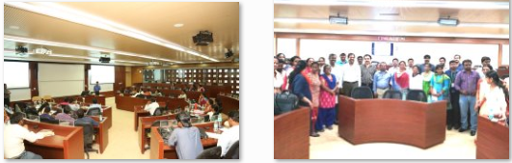

Agenda Item No. 8

Presentation by IIT Madras on SWAYAM 2.0 and ASP

Agenda Item No. 9

Point given by UGC
- MHRD is requested to provide on revision of budget heads for development of new MOOCs at the earliest decision

In the 6th SWAYAM Board MHRD was requested to add the following budget heads in the financial guideline of MHRD with financial assistance remaining the same.

• Secretarial Assistance
• Workshops / Meetings
• Contingency / Travelling / Office expenses / Hardware/ Software purchase
The Course Coordinators are not able to raise their UCs due to absence of the above Budget Heads. Accordingly, UGC is not in a position to release the 2nd Installment that is causing delay in development of MOOCs Courses

Thank You

