Agenda Papers

8th Meeting
SWAYAM BOARD

10th September 2018

Ministry of Human
Resource Development
Shastri Bhawan
New Delhi – 110001

AGENDA
08th Meeting of the SWAYAM Board

S. No. | Agenda Items | Page No.
1 | Agenda Item No. 1  Confirmation of Minutes of 7th SWAYAM Board Meeting | 2 - 6
2 | Agenda Item No. 2  Action Taken Report | 7 - 8
3 | Agenda Item No. 3  Status Report provided by NCs | 9 - 10
4 | Agenda Item No. 4  Enrollment in July, 2018 Semester Courses | 11 - 13
5 | Agenda Item No. 5  Presentation on ASP Transition and SWAYAM 2.0 by M/s Persistent Systems and IIT Madras | 14
6 | Agenda Item No. 6  Proposal from University of Hyderabad (Submitted by UGC) | 15 - 16
7 | Agenda Item No. 7  Proposal for Social Media Campaign by M/s EdCIL (India) Ltd. | 17 - 19
8 | Agenda Item No. 8  List of Courses on offer for January, 2019 Semester Courses | 20
9 | Agenda Item No. 9  Presentation on Status of AI in Education by IIM Bangalore | 21
10 | Agenda Item No. 10  Items raised by CEC and UGC | 22
11 | Agenda Item No. 11  Any other item with the permission of Chair

Agenda Item No. 1
Confirmation of Minutes of the 7th SWAYAM Board Meeting held on 13.08.2018

Minutes

The 7th Meeting of the SWAYAM Board was held under the Chairmanship of Shri R. Subrahmanyam, Secretary (HE), M/o HRD on 13.08.2018.

2. The status of SWAYAM Courses that was placed before the Board is summarized below:
- Total Courses : 1543
- Active Courses : 537
- Courses Completed : 862
- Upcoming Courses : 144
- Students Registered : 22,50,383
- Students Enrolled for courses : 36,39,979

National Coordinator Report on SWAYAM Courses

National  Coordinator  Name | Total no. of courses produced till date  (Also indicate within bracket the credit courses among them.) | Total no. of courses delivered through SWAYAM (a+b) -  Breakup  (a) First Run  (b) Re Run | No. of courses that are currently in production | Date of holding the last Academic Advisory Council (AAC) meeting  (a) No. of courses examined  (b) No. of Courses approved | No. of courses in which exams have been conducted for Credit Transfer / Certificates | No. of Universities that have approved credit transfer.
UGC | 91 (60)  (49 course for  credit and 42 non-  credit) | FIRST RUN:-  July-Dec17-  Total 60 course  July-  Dec,18:-  31 Re-purp.  +16 Re-run | 59 (48 New + 11  Invited) | 3rd Meeting Scheduled for 13.06.2018 | 7 (During the  session July-Dec-17) | 66 (65) University
CEC | 160 Credit Courses | 192  (a) 54  (b) 23  (c)115 Courses are  being offered on SWAYAM (including 22  rerun courses) | 130 (50 Repurpose + 80 Fresh) | 19th March, 2018  23rd March, 2018  159 Examined  102 Approved | 1 Course.  (Exam for 3 more  Courses are  scheduled for  September, 2018) | 17 (15) University
NPTEL | 482 | 740  (a) 482 First Run  (b) 258 Rerun | 156 (to be offered in July 2018 - new courses) | 04th August, 2018 | 740 upto April, 2018 | 26 Institutions
IIM B | 26 (All Credit) | 26  (a) 17 First Run  (b) 09 Rerun | 7 | AAC not held  Planned in August, 2018 | 18 | -
IGNOU | 14 | 22  (a) 11 First Run  (b) 11 Rerun | 44  (31 IGNOU, 13 Other Univ.) | Held on 18th April, 2018  (a) No. of courses examined: 32  (b) No. of Courses approved: 24 (in principle) | - | -
NCERT | 20 | 24  (a) 8 First Run  (b) 16 Rerun | 24 | 23rd March 2018 (2nd meeting)  20 Courses examined  4 Proposals examined  20 Courses approved  2 Proposals approved | - | -
AICTE | 12 (6) | 12 | 12 | 20th March, 2018 | - | -
NITTTR | 16  (All are credit  courses) | 0 | 19 | 6th December, 2017  43 Examined  35 Approved | - | -
NIOS | 19 All Credit | Total 40  (a) 22 First Run  (b) 18 Re-run | 8  For January, 2019 | 30th January, 2018  52 Examined  52 Approved | 17  (14 Sec + 3 D.El.Ed. | -
Enrollment of July, 2018 Semester Courses
NC Name | Total courses | Total Enrollment | Average Enrollment per Course | Courses Enroll  ≤ 500 | Courses Enroll  500 < 1000 | Courses  Enroll  ≥ 1000
UGC | 47 | 23815 | 506 | 25 | 19 | 3
CEC | 116 | 49882 | 430 | 80 | 24 | 12
SWAYAM + NPTEL | 270 | 1333530 | 4939 | 11 | 38 | 221
IIM B | 8 | 5811 | 726 | 2 | 4 | 2
IGNOU | 13 | 11593 | 891 | 3 | 5 | 5
NCERT | 20 | 13313 | 665 | 6 | 12 | 2
NIOS | 35 | 55576  7802 | 1587  (including D.El.Ed)  229  (excluding D.El.Ed) | 31 | 2 | 2
NITTTR | 4 | 684 | 171 | 3 | 1 | 0
AICTE | 6 | 2839 | 473 | 4 | 2 | 0
 | 519 | 14,97,043  14,49,269  1,15,739 | 2884 (including D.El.Ed.)  2792 (excluding D.El.Ed.)  464 (excluding NPTEL +  D.El.Ed.) | 165 | 107 | 247

Comparison between 5th July, 2018 and 8th August, 2018
NC Name | Enrollment  5th July, 2018 | Enrollment  8th August, 2018 | Average Enrollment per Course  5th July, 2018 | Average Enrollment per Course 8th August, 2018
UGC | 5823 | 23815 | 129 | 506
CEC | 16886 | 49882 | 170 | 430
SWAYAM + NPTEL | 475307 | 1333530 | 1766 | 4939
IIM B | 3352 | 5811 | 419 | 726
IGNOU | 8088 | 11593 | 622 | 891
NCERT | 8633 | 13313 | 431 | 665
NIOS | 1840 | 55576  7802 | 54 | 1587 (including DElEd)  229 (excluding DElEd)
NITTTR | 464 | 684 | 77 | 171
AICTE | 338 | 2839 | 67 | 473
Total | 5,20,731 | 14,97,043  (including DElEd)  14,49,269  (excluding DElEd)  1,15,739  (excluding NPTEL + DElEd) | 1043 | 2884  (including D.El.Ed.)  2792  (excluding D.El.Ed.)  464  (excluding NPTEL+ D.El.Ed)

3. Confirmation of 6th SWAYAM Board Minutes:

On the issue of Re-exam raised by the NPTEL, the Board clarified that wherever the NC is going to conduct two examinations for a SWAYAM Course, this clause can be treated as optional for the time being.

4. Discussion on Action Taken and Status Report:

- Local Chapters: UGC and NPTEL informed the SWAYAM Board regarding activities of Local Chapters. SWAYAM Board emphasized that the focus should be on popularizing SWAYAM Courses and enrolling more students in SWAYAM through the local chapters.

- Awareness Creation & Publicity: Board has directed that each NC must finalize a strategy for popularizing the SWAYAM courses under them. They are free to adopt different ways to popularize SWAYAM courses. If any of the working strategy regarding this, needs additional funding support, such proposal can be brought to board for approval.

Joint Secretary (TEL & ICC), M/o HRD mentioned that 106 Universities / Institutions have approved the SWAYAM courses for credit transfer and a letter from MHRD have been written to all these Universities/ Institutions to clearly identify the courses allowed for credit transfer and to get more students to SWAYAM courses from these Universities / Institutions. All of the Universities/ Institutions name who have approved SWAYAM Courses for credit transfer should be listed on SWAYAM. Respective NCs i.e. UGC, CEC and NPTEL should provide the list of Universities/ Institutions to AICTE for loading on the portal.

After discussions, it was realized that social media campaign under this programme is very weak. It was decided that EdCIL will manage the social media campaign in a centralized manner and also will take up the task of verification of social media accounts. CMD, EdCIL has mentioned the need to utilize the same model adopted for Study in India programme to make a significant impact in SWAYAM media campaign.

Board has directed UGC to complete the printing of posters latest by the end of month and send across to all Universities for placing them at prominent places in campuses. UGC may also send soft copies of all media materials to all Universities / Institutions.

- List of Courses (for July, 2018 Semester): The Current Status of Courses uploaded on SWAYAM was presented to the Board. Secretary (HE), M/o HRD asked NITTTR to upload their committed courses for July, 2018 Semester at the earliest and get their courses reviewed by Chairman AICTE.

- Application Service Provider (ASP) for SWAYAM: IIT Madras and AICTE reported that knowledge transfer process between M/s Microsoft and M/s Persistent System is in the process as per plan and M/s Persistent Systems may be able to take charge by end August 2018. IIT Madras has made a presentation on the status and SWAYAM Board has requested IIT Madras to provide the status on ASP in every Board meeting.

- SWAYAM 2.0: IIT Madras made a presentation on tactical and strategic approach of SWAYAM 2.0 and informed about some of the new features like Enrollment End Date , Embedding Discussion forum etc being taken up for SWAYAM 2.0. It was decided that all the NCs should inform IIT Madras regarding the expected features and requirements for SWAYAM2.0.

Board requested IIT Madras to give the consumption and billing pattern of cloud usage in every board meeting to review the cloud optimization.

Also in the next SWAYAM Board meeting M/s Persistent Systems should be requested to make a detailed presentation on ASP transition and SWAYAM 2.0

5. Enrollment in July, 2018 Semester Courses: SWAYAM Board has decided that all courses with less than 500 Enrollments should be get reviewed by a committee headed by AICTE Chairman along with representatives from the NCs. This meeting would be completed before the next SWAYAM Board meeting. On the recommendation of the committee the courses with less than 500 Enrollments would be considered to be deleted from the SWAYAM portal.
6. Mapping of SWAYAM Courses to the Model Curriculum: SWAYAM Board decided that mapping of SWAYAM Courses has to be done at University / Institution level.
SWAYAM Board directed AICTE and UGC to write a letter to 106 Universities / Institutions (who approved credit transfer) to map the SWAYAM courses to the model curriculum, immediately and latest by 31st August, 2018. Also it could be a good idea to get all these universities at one place and talk to them on various issues.
7. Proposal for Developing SWAYAM Courses for Indian Languages: The Board decided that CIIL should prepare one course on their own and submit it to UGC for review, for consideration of their proposal by Board.

8. Proposal for building Managerial Capability for SWAYAM Platform based Digital Education received from IIM Bangalore: Board decided that this need not be taken as separate proposal and may come through NC as part of their proposal to build awareness. NCs are expected to do such activities on their own.

9. Points raised by UGC:

The Board desired that a detailed proposal for revision of Budget Heads to be made for examination through IFD.

CEC informed that they have prepared the guidelines for preparation of Question paper and Evaluation. The same has been circulated to all Board members. It was decided that the comments of the NCs would be discussed in the next meeting

The next meeting of the SWAYAM Board would be held on 10th September, 2018.

Agenda Item No. 2

Action Taken Note on the Points decided in the 7th SWAYAM Board Meeting held on 13th August, 2018

S.No | Action Points | Action by
1 | Awareness Creation & publicity.  - All of the Universities/ Institutions name who have approved SWAYAM Courses for credit transfer should be listed on SWAYAM.  - Social Media Campaign work by M/s EdCIL (India) Ltd. in a centralized manner.  - UGC to complete the printing and distribution of posters latest by the end of month. | UGC has conducted one day Orientation workshop on Adoption, Promotion & Production of MOOCs on the SWAYAM platform on 31st August, 2018 at the Maulana Azad National Urdu University, Hyderabad. About 600 participants from Universities & colleges from southern states including Andhra Pradesh, Telangana, Tamil Nadu, Puducherry, and Andaman & Nicobar.  The State Government of Telangana has issued notification to promote SWAYAM by allowing all teachers to enroll for MOOCs on SWAYAM for capacity building.  NIOS organized Workshop on SWAYAM at Army Public School, Delhi Cantt. on 1st September, 2018, for Students and on 6th September, 2018 for School Teachers .  AICTE  M/s EdCIL (India) Ltd. has submitted a proposal for the Social Media Campaign. The same has been put up for approval at Agenda Item No. 7  UGC has allotted this work to NFDC, after no response received from DAVP.NFDC is in process of printing the paper, it is expected that by the end of September , 2018 the poster will be printed and dispatched to 865 universities in India.
2 | List of courses (for July 2018 semester):  - NITTTR to upload their committed courses for July, 2018 Semester at the earliest  - NITTTR to get their courses reviewed by Chairman AICTE. | NITTTR: One Course is running and six courses opened for registration. The remaining nine committed courses of four and Eight Weeks duration for the teachers will be launched during this semester.  NITTTR have submitted the course links to the Chairman/ Vice Chairman, AICTE, New Delhi
3 | Application Service Provider  - Knowledge Transfer process  - Presentation on status on ASP in every Board meeting. | Prof. Andrew Thangaraj from IIT Madras would be making a presentation.
4 | SWAYAM 2.0 Status  - All the NCs should inform IIT Madras regarding the expected features and requirements for SWAYAM2.0  - Consumption and billing pattern of cloud usage to review cloud optimization.  - Detailed presentation o ASP transition and SWAYAM2.0 | Following NCs submitted the feature requirements to NPTEL: UGC, CEC, IIM Bangalore, NCERT, NIOS  Prof. Andrew Thangaraj from IIT Madras would be making a presentation.  M/s Persistent Systems would be making a presentation.
5 | Enrollment in July, 2018 Semester Courses  Courses with less than 500 Enrollments should be get reviewed by a committee headed by AICTE Chairman along with representatives from the NCs. | The Review Committee headed by Chairman, AICTE, New Delhi, held on 5th September, 2018 and the recommendations made by the Committee are placed at Agenda Item No. 4.
6 | Mapping of SWAYAM Courses to the Model Curriculum  Board directed AICTE and UGC to write a letter to 106 Universities / Institutions (who approved credit transfer) to map the SWAYAM courses to the model curriculum, immediately and latest by 31st August. | UGC has issued a letter on 24th August, 2018 regarding mapping of the course with the academic programmes being run by the universities for which the credit transfers would be allowed to students to 89 Universities (who approved credit transfer).  AICTE :
7 | Guidelines for preparation of Question paper and Evaluation by CEC | No Comments received from any NC

Agenda Item No. 3

Status of SWAYAM Courses

Status of SWAYAM Courses As On 06.09.2018
Total Number of Courses Listed on SWAYAM : | 1551
Past Courses listed on SWAYAM : | 874
Current Courses listed on SWAYAM : | 643
Upcoming Courses listed on SWAYAM : | 34

NC wise Distribution of Courses As On 06.09.2018
 | Past courses | Current Courses | Upcoming Courses | Total Courses | Total Student Enrollment
UGC (PG Non Engineering) | 115 | 47 | 0 | 162 | 107924
NIOS (Open School 9th to 12th ) | 46 | 39 | 0 | 85 | 2826769
NPTEL (UG & PG Engineering) | 560 | 420 | 1 | 981 | 469823
NITTTR (Teacher Training) | 4 | 1 | 8 | 13 | 5728
NCERT (School 9th to 12th) | 19 | 20 | 0 | 39 | 48644
IGNOU (Certificate & Diploma Courses) | 14 | 11 | 2 | 27 | 31160
IIM B (Management) | 19 | 8 | 0 | 27 | 54759
CEC (UG Non Engineering) | 97 | 85 | 22 | 204 | 170499
AICTE (Foreign Universities) | 0 | 12 | 1 | 13 | 41777
 | 874 | 643 | 34 | 1551 | 3757083

Registration & Enrollment Status As On 06.09.2018
Total number of Registration on SWAYAM Platform | 2341812
Total number of Enrollment on SWAYAM Courses | 3757083
Enrollment in NIOS DElEd Courses 501 | 884946
Enrollment in NIOS DElEd Courses 502 | 746523
Enrollment in NIOS DElEd Courses 503 | 734050
Enrollment in NIOS DElEd Courses 504 | 249978
Enrollment in NIOS DElEd Courses 505 | 147413

Top 15 Certificate / Credit Courses for July, 2018 Semester (Enrollment-wise) As On 06.09.2018
S.No. | Course Name | Institute Name | Enrollment
1 | Business Planning And Project Management | CEC | 3885
2 | July 2018: Developing Soft Skills and Personality | NPTEL | 3496
3 | NCERT Physics 01 - Class XI - 2018 | NCERT | 3410
4 | Fundamentals of Banking and Insurance | CEC | 3279
5 | Practical English: Learning and Teaching | NPTEL | 2725
6 | July 2018: The Joy of Computing using Python | NPTEL | 2697
7 | July 2018: Introduction to Internet of Things | NPTEL | 2678
8 | Organisation Behaviour | UGC | 2571
9 | Principles of Marketing | CEC | 2532
10 | Project Planning and Control | NPTEL | 2386
11 | Artificial Intelligence | UGC | 2354
12 | Graphics and Animation Development | NITTTR | 2284
13 | Computer Fundamentals | CEC | 2177
14 | Basics of Photography | CEC | 2133
15 | Information Technology | CEC | 2109

Status Report by NCs for the 8th SWAYAM Board Meeting to be held on 10.09.2018
National  Coordinator  Name | Total no. of courses produced till date  (Also indicate within bracket the credit courses among them.) | Total no. of courses delivered through SWAYAM (a+b) -  Breakup  (a) First Run  (b) Re Run | No. of courses that are currently in production | Date of holding the last Academic Advisory Council (AAC) meeting  (a) No. of courses examined  (b) No. of Courses approved | No. of courses in which exams have been conducted for Credit Transfer / Certificates | No. of Universities that have approved credit transfer.
UGC | 91 (60)  (49 course for  credit and 42 non-  credit) | FIRST RUN:-  July-Dec17-  Total 60 course  July-  Dec,18:-  31 Re-purp.  +16 Re-run | 59 (48 New + 11  Invited) | 3rd Meeting13.06.2018 | 7 (During the  session July-Dec-17) | 63 University. Reduced to 63 from 66.
CEC | 162 (160) Credit Courses | 192  (a) 54  (b) 23  (c)115 Courses are  being offered on SWAYAM (including 22  rerun courses) | 130 (50 Repurpose + 80 Fresh) | 19th March, 2018  23rd March, 2018  159 Examined  80 (102) Approved | 1 Course.  (Exam for 3 more  Courses are  scheduled for  September, 2018) | 17 Univ.
NPTEL | 482 | 740  (a) 482 First Run  (b) 258 Rerun | 156 (to be offered in July 2018 - new courses) | 04th August, 2018 | 740 upto April, 2018 | 26 Institutions
IIM B | 26 (All Credit) | 26  (a) 17 First Run  (b) 09 Rerun | 7 | AAC not held  Planned in August, 2018 | 18 | -
IGNOU | 14 | 22  (a) 11 First Run  (b) 11 Rerun | 44  (31 IGNOU, 13 Other Univ.) | Held on 18th April, 2018  (a) No. of courses examined: 32  (b) No. of Courses approved: 24 (in principle) | - | -
NCERT | 20 | 24  (a) 8 First Run  (b) 16 Rerun | 24 | 23rd March 2018 (2nd meeting)  20 Courses examined  4 Proposals examined  20 Courses approved  2 Proposals approved | - | -
AICTE | 12 | 12 | 12 | 20th March, 2018 | - | -
NITTTR | 16  (All are credit  courses) | 1 Running  6 Opened for Registration | 19 | 6th December, 2017  43 Examined  35 Approved | - | -
NIOS | 19 All Credit | Total 40  (a) 22 First Run  (b) 18 Re-run | 8+3 =11  For January, 2019 | 30th January, 2018  10th August,2018  52 Examined  52+3=55 Approved | 17  (14 Sec + 3 D.El.Ed. | -

Agenda Item No. 4

Enrollment in July, 2018 Semester Courses
Enrollment of July, 2018 Semester Courses 6th September, 2018
NC Name | Total Courses | Total Enrollments | Average Enrollments  per course | Courses Enroll. ≤ 500 | Courses Enroll. 500 < 1000 | Courses  Enroll. ≥ 1000
UGC | 47 | 32913 | 700 | 20 | 21 | 6
CEC | 117 | 84904 | 725 | 57 | 34 | 26
NPTEL | 270 | 1468507 | 5438 | 7 | 33 | 230
IIM B | 8 | 7840 | 980 | 2 | 2 | 4
IGNOU | 13 | 14469 | 1113 | 1 | 4 | 8
NCERT | 20 | 21596 | 1079 | 5 | 7 | 8
NIOS | 34 | 9702 | 285 | 31 | 2 | 1
NITTTR | 10 | 5574 | 557 | 6 | 2 | 2
AICTE | 7 | 3965 | 566 | 3 | 4 | 0
 | 526 | 16,49,470 | 3135 | 132 | 109 | 285

Comparison between 5th July, 2018 , 8th August, 2018 and 6th September, 2018
NC Name | Enroll.  5th July, 2018 | Enroll.  8th August , 2018 | Enroll.  6th September, 2018 | Average Enroll. per Course: 5th July, 2018 | Average Enroll.  per course:  8th August, 2018 | Average Enroll.  per course:  6th September, 2018
UGC | 5823 | 23815 | 32913 | 129 | 506 | 700
CEC | 16886 | 49882 | 84904 | 170 | 430 | 725
NPTEL | 475307 | 1333530 | 1468507 | 1766 | 4939 | 5438
IIM B | 3352 | 5811 | 7840 | 419 | 726 | 980
IGNOU | 8088 | 11593 | 14469 | 622 | 891 | 1113
NCERT | 8633 | 13313 | 21596 | 431 | 665 | 1079
NIOS | 1840 | 7802 | 9702 | 54 | 229 | 285
NITTTR | 464 | 684 | 5574 | 77 | 171 | 557
AICTE | 338 | 2839 | 3965 | 67 | 473 | 566
Total | 5,20,731 | 14,49,269 | 16,49,470 | 1043 | 2792 | 3135

Recommendations of the Committee to Review SWAYAM Courses with less than 500 Enrollments
Dated 5th September, 2018
The SWAYAM Board in its 7th meeting held on 13.8.2018 constituted a committee under the chairmanship of Chairman AICTE with representatives of National Coordinators (NCs) as members, to review the SWAYAM courses that have enrollments less than 500 courses and make recommendations on the future course of action to be taken.
The Committee met on 5th September 2018 at AICTE HQ, New Delhi and the following were present.
- Prof. Anil D Sahasrabudhe Chairman AICTE
- Prof. Pankaj Mittal AS UGC
- Prof. Uma Kanjilal IGNOU
- Sri. Nageswarnath Jt. Director CEC
- Mrs. Diksha Rajput Publication officer UGC
- Sri. Parameswaran N Advisor MHRD

The Number of Courses which has less than 500 Enrolments, NC wise, are as follows:
- UGC - 21 (out of 47)
- CEC - 65 (out of 116)
- NIOS - 31 (out of 35)
- NCERT - 6 (out of 20)
- NPTEL - 11 (out of 270)
- IIMB - 2 (out of 8)
- NITTTR - 3 (out of 4)

The committee went through the list of the courses which have less than 500 enrollments. After detailed deliberations on the various options, the observations and the recommendations of the committee are as follows:
- Since SWAYAM courses are fairly recent, the minimum enrollment benchmark should be reduced to 300 for couple of years.

- The enrollment benchmark should not be applicable for Niche/ Socially relevant courses where the target population itself is very small. This should be decided on a case to case basis by the committee

- The courses that have started this semester which have students enrolled in them should continue irrespective of the number of enrollments, else it would send a negative image about SWAYAM.

- From next semester onwards (Jan 2019), it should be announced in advance that the courses with less than 300 enrolments would not be run. The enrolment period should close before start of the course. Also the number of students enrolled in the course should be visible to any student who wants to enroll in a course so that the student can take an appropriate decision.

- Since money would have been spent to create the course, if the course has less than 300 Enrollments, it should be made available as a self paced course. For a self paced course, there is no start date and no faculty support would be available. So, no money would be paid for running the course

- The Committee observed that, barring NPTEL and Management, the number of courses available in core areas (viz. physics, chemistry, mathematics, biology, economics, history, political science etc) are very few at both graduate and post-graduate levels.

- The Committee felt that the courses in future should be demand driven. We should not concentrate on number of courses. We should have very high quality courses offered by the best teacher in the subject. This would help attract more students automatically.

Agenda Item No. 5

Presentation by M/s Persistent Systems & IIT Madras on ASP and SWAYAM 2.0

Purport
The objective of this Presentation is to provide detailed information and transition progression regarding the Application Service Provider (Knowledge Transfer and Handover Process) and SWAYAM 2.0.

Background
In the 7th Board Meeting it was decided that the “M/s Persistent Systems should be requested to make a detailed presentation on ASP transition and SWAYAM 2.0”

Agenda Item No. 6

Proposal from University of Hyderabad for offering of MOOCs on Commercial Basis
(Submitted by UGC)

Purport
The objective of this Note is to put up for consideration the Proposal received from University of Hyderabad submitted by UGC is placed at Annexure I.

Background
University of Hyderabad submitted a proposal through UGC, to offer courses both as MOOCs and offer innovative and skill-based courses on commercial basis.

Proposal
University of Hyderabad proposed following items to be reviewed by SWAYAM Board.
(a) A sub-domain on the lines of http://uoh.swayam.in be offered to University of Hyderabad and other like-minded universities to enable them to put their courses online and allow them to offer their courses on commercial basis also.
(b) Complete access to the control panel for the sub-domain be given to University of Hyderabad. This will enable the University to get a bit deeper into analysis based on the statistics and accordingly make modifications. We also plan to get into research on analytics on the online platform.
(c) A couple of capacity-building programmes on Open EdX to the faculty members of University may be conducted to enable them to offer their courses online.
(d) A revenue-sharing model that can mutually be worked out between SWAYAM and University of Hyderabad. However, an initial five-year holiday be provided on revenue sharing to enable University of Hyderabad to understand, implement and reap the benefits of the platform.
e) All the courses offered by University of Hyderabad to be promoted by SWAYAM on its main website too at its discretion.

Decision Sought
It is requested that the Board may kindly take a view on the proposal from University of Hyderabad.

Annexure I

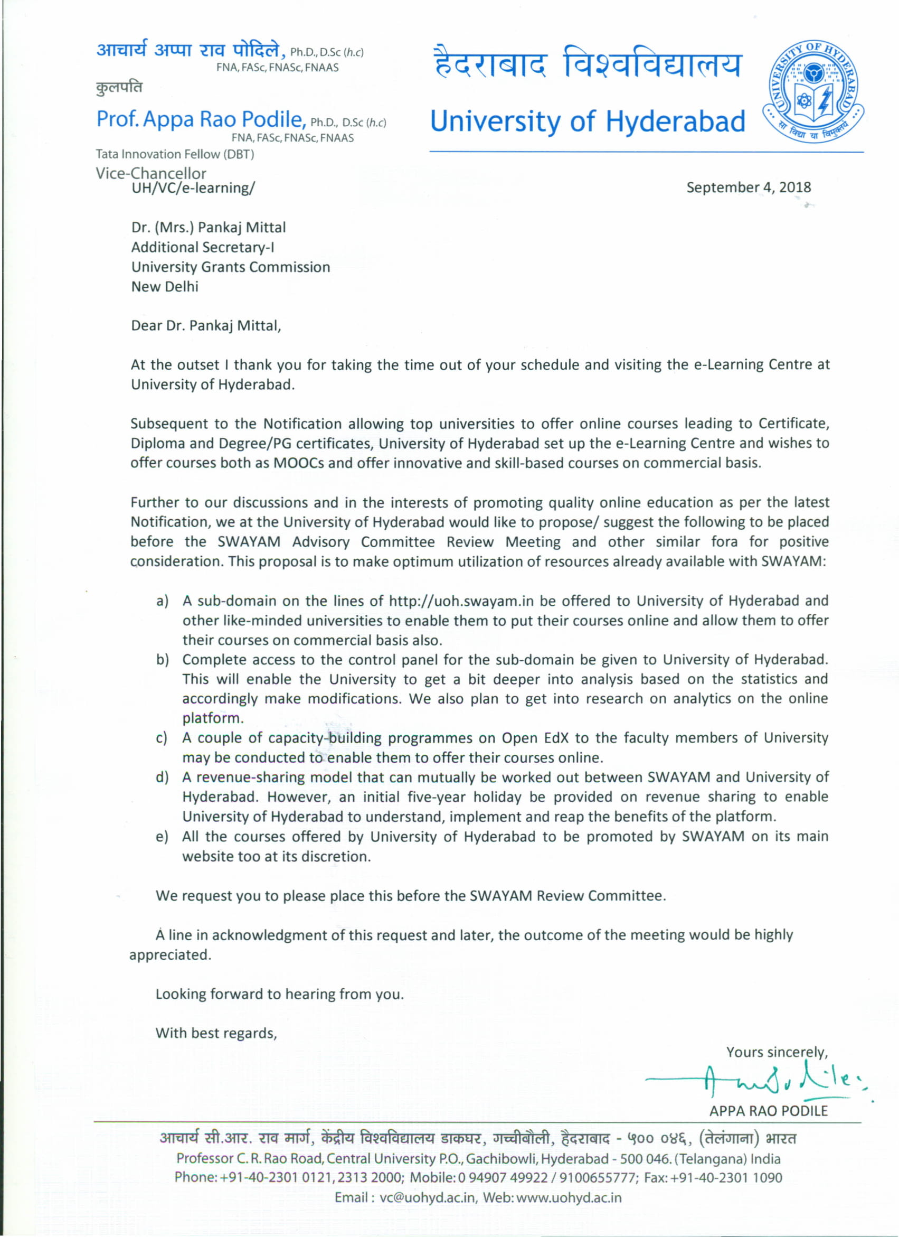

Agenda Item No. 7

Proposal for Social Media Campaign for SWAYAM
(Submitted by M/s EdCIL (India) Ltd.)

Purport
The objective of this Note is to seek the approval of the Board on the proposal for Social Media Campaign submitted by M/s EdCIL (India) Ltd. is placed at Annexure II.

Background
In the 7th Board meeting it was realized that social media campaign under this programme is very weak. It was decided that EdCIL will manage the social media campaign in a centralized manner and also will take up the task of verification of social media accounts. .

Proposal
M/s EdCIL (India) Ltd. has made the below commercial proposal of amount Rs. 28,03,500/- with below details:
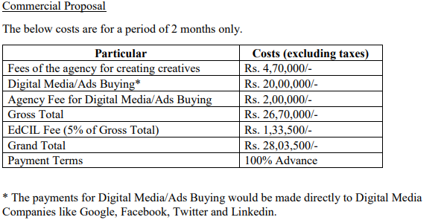

Approval sought
Approval of the Board is sought on the above proposal of M/s EdCIL for the social media campaign of SWAYAM courses.

Annexure II

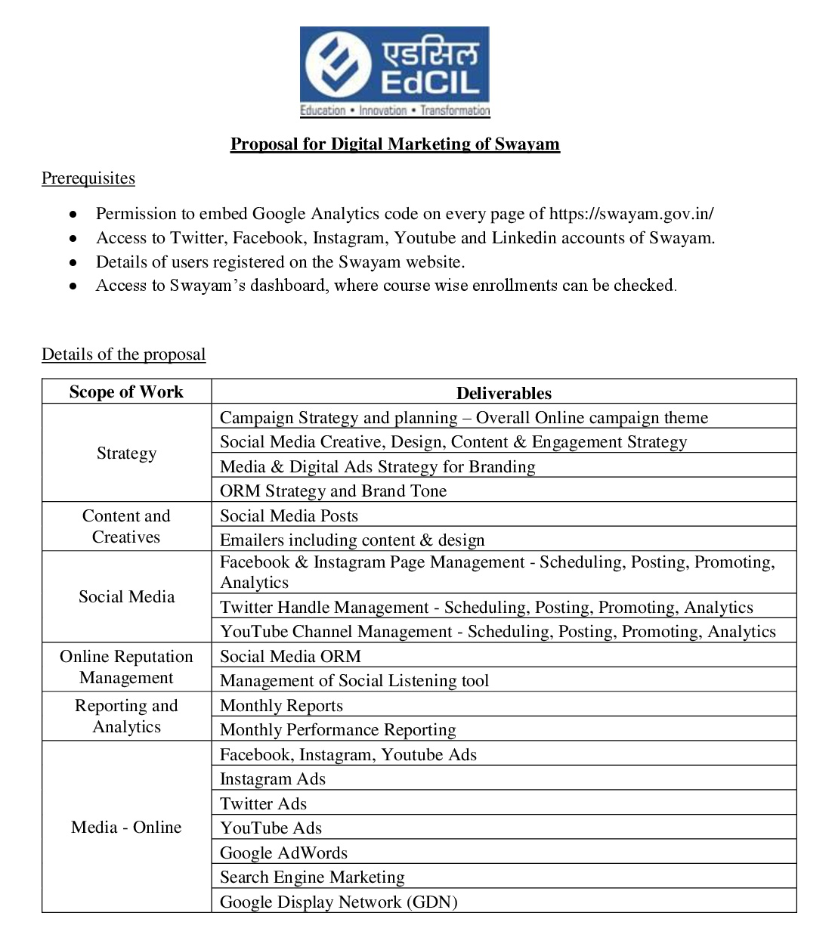

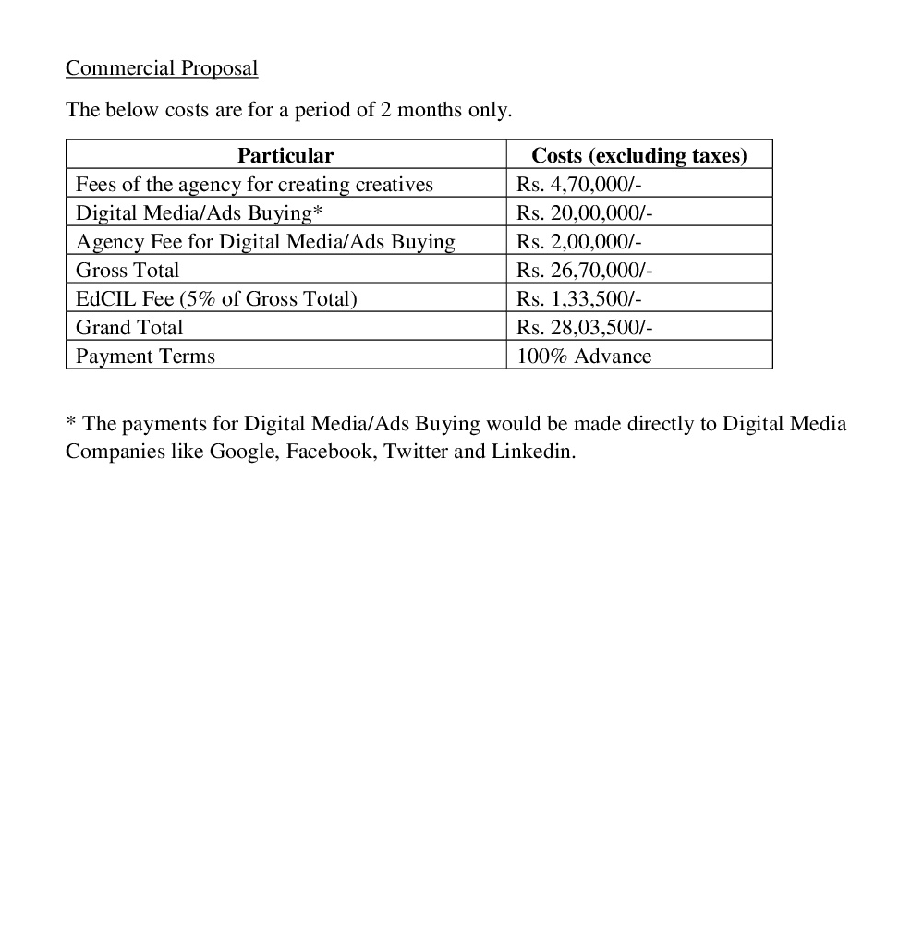

Agenda Item No. 8

List of Courses on offer for January, 2019 Semester Courses

Purport
The objective of this Note is to request all NCs to prepare the list of January, 2019 Semester Courses to be put on offer on SWAYAM.
Background
From the experience of the past cycles of SWAYAM Courses launched, it is learnt that there should be ample time needed to attract students for registration and publicity of courses. Also it is felt that the Universities/ Institutions needed more time to approve the SWAYAM Courses for their current semester for credit transfer.
Proposal
It is proposed to prepare the list of courses on offer for semester of January 2019 by the NCs, so that there will be sufficient time for publicity and approval of the courses.
Decision Sought
SWAYAM Board is requested to decide on the deadline to provide the list of courses on offer for Semester of January, 2019 by the NCs

Agenda Item No. 9

Presentation on Status of AI in Education by IIM Bangalore

Agenda Item No.10

Items raised by CEC and UGC

- Guidelines for preparation of Question Paper and Evaluation by CEC

- On Examination Fees related issues by UGC:

At the time of enrolment in the university the student pays the fees for the entire session and at the time of exam fees is included in the tuition fee. If the students will be charged for writing MOOCs course examination, then this will be an overburden for them in respect of money, as because they are paying the examination fees twice for the same semester.

Thank You

