Agenda Papers

9th Meeting
SWAYAM BOARD

12th November 2018

Ministry of Human
Resource Development
Shastri Bhawan
New Delhi – 110001

AGENDA
09th Meeting of the SWAYAM Board

S. No. | Agenda Items | Page No.
1 | Agenda Item No. 1  Confirmation of Minutes of 8th SWAYAM Board Meeting | 2 - 6
2 | Agenda Item No. 2  Action Taken Report | 7 - 8
3 | Agenda Item No. 3  Status Report on SWAYAM Courses | 9 - 10
4 | Agenda Item No. 4  Status Report on SWAYAM Examination | 11
5 | Agenda Item No. 5  Courses on offer for January 2019 Semester | 12 - 21
6 | Agenda Item No. 6  Appointment of AICTE as National Coordinator for PMMMNMTT - Ratification | 22
7 | Agenda Item No. 7  Status on SWAYAM Office Setup of National Coordinators | 23
8 | Agenda Item No. 8  Presentation on SWAYAM 2.0 - IIT Madras | 24
9 | Agenda Item No. 9  Extension of Contract of M/s Azure Cloud Services for SWAYAM MOOCs Platform for 6 Months w.e.f. 08.02.2019 | 25
10 | Agenda Item No. 10  Extension of Contract of Bulk SMS Gateway and E-Mail Service Provider awarded to M/s Netcore Solutions Pvt. Ltd., New Delhi upto 31st March, 2019 | 26
11 | Agenda Item No. 11  Performance Review of M/s CtrlS | 27
12 | Agenda Item No. 12  AI - Based Tool for Learning - Proposal for Pilot | 28 - 30
13 | Agenda Item No. 13  Items raised by NPTEL | 31
14 | Agenda Item No. 14  SWAYAM Prabha - Allocation of Time Slot for YOGA and Allocation Channel No. 19 | 32 - 34
15 | Agenda Item No. 15  Any other item with the permission of Chair

Agenda Item No. 1
Confirmation of Minutes of the 8th SWAYAM Board Meeting held on 10.09.2018

Minutes

The 8th Meeting of the SWAYAM Board was held under the Chairmanship of Shri R. Subrahmanyam, Secretary (HE), M/o HRD on 10.09.2018. List of Participants is enclosed.

2. The status of SWAYAM Courses that was placed before the Board is summarized below:

- Total Courses : 1551
- Active Courses : 643
- Courses Completed : 874
- Upcoming Courses : 34
- Students Registered : 23,41,812
- Students Enrolled for courses : 37,57,083

It was noted that there have been additional enrolment of 2 Lakhs learners since the last month review. There are average 3,135 learners per course. However, there are 132 Courses which are having less than 500 learners, which is a cause of concern. The NC-wise details are in Annexure I.

3. The following was the action taken on the decisions of the 7th SWAYAM Board Minutes:

(i) Awareness Creation & Publicity:

- Workshops were held by UGC and NIOS which were reported to be highly successful.
- UGC also informed that the posters will be dispatched to Universities immediately by end of this month.
- UGC was also requested to provide the complete status regarding the number of Courses adopted for credit transfer: Total Number of student benefited from credit transfer, process of credit transfer in the 106 Universities/ Institutions which have approved the credit transfer of SWAYAM courses. This may be ensured by UGC at the earliest.

(ii) Gap/ Unavailability of Courses:

Among the existing courses on offer in the SWAYAM platform by UGC and CEC, it has been noticed that no courses are available for some of the major areas/fields of study. This makes it difficult for the Universities/Institutions to adopt SWAYAM courses as part of their UG/PG curriculum.

- It was decided that UGC/AICTE will identify and prepare courses for these gap areas which are essential for the UG/PG to earn a degree; and report in the next Board meeting.
- All NCs will send the list of courses for the January, 2019 semester, latest by 20th September 2018.

(iii) Application Service Provider (ASP):

M/s Persistent Systems made a presentation on ASP transition and cost optimization. Board requested NPTEL to make a detailed YouTube video and presentation on how to use new features like Google Discussion Forum in SWAYAM.

Board requested Prof. Andrew Thangaraj, IIT Madras to present the Cloud Transition progress report of M/s CtrlS evaluated by Technical Expert Committee in the next SWAYAM Board meeting.

(iv) SWAYAM 2.0:

Board requested IIT Madras to prepare a concept paper on SWAYAM 2.0 and circulate to all NCs before 20th September, 2018. All NCs were requested to meet and discuss on the SWAYAM 2.0 approach. A Workshop for the same shall be organized at 11.00 am on 1st October, 2018 at AICTE HQ New Delhi. The consensus arrived at shall be presented in next SWAYAM Board meeting.

4. Other decisions:

- The recommendations made by the review committee of courses with less than 500 enrolments were discussed and approved, with the modification that the minimum number may be left at 500. It was also decided that the Committee may review the courses with less than 500 enrolments and present report on individual courses in the next meeting.

- On the proposal from University Of Hyderabad for offering of MOOCs on Commercial Basis, it was felt that more clarity is required on the proposal before Board can take a call on the same. It was decided that UGC would request University of Hyderabad to make a detailed presentation and evaluate the same. JS (TEL&ICC) and other concerned officers from MHRD would also attend the presentation.

- On the Proposal for Social Media Campaign for SWAYAM, the proposal of M/s EdCIL (India) Ltd for carrying out the Social Media campaign for SWAYAM at a cost of Rs.28,03,500 was approved. EdCIL would follow the government norms including GFR in its activities.

- List of Courses on offer for January, 2019 Semester courses will be finalized and submitted to the Board in next SWAYAM Board meeting. The courses may be classified programme-wise (B.A., M.A., B.Sc., M.Sc. Subject /Area) etc.

- The guidelines for preparation of Question paper and Evaluation prepared by the CEC were circulated to all Board members and it was decided that this shall be taken as suggestions by the NCs.

5. Presentation on AI in education: Prof. P.D. Jose made a presentation on AI in Education. The
Sub-Domains of AI where it is directly influencing education and learning sciences. The Sub-Domains are:

• Intelligent Tutoring Systems, Personalized Learning, AI-Tutor/Teaching Assistant
• Adaptive Learning Approaches
• Natural Language Processing, Chatbots or Conversational AI
• Big Data, Educational Data Mining, High-Performance Computing

As a follow up to the August workshop conducted at IIM Bangalore with key players in the industry, a three-step follow is now proposed.

- To experiment with an AI-based tutor for at least one course using IBM Watson (to be implemented before 2019)
- Also, create use case scenarios for AI-based tools for adoption on the SWAYAM platform
- A complete integration of an AI-based layer for SWAYAM would be attempted by June 2019

Secretary (HE), M/o HRD desired that by July, 2019, AI layer for SWAYAM should be implemented.

6. Organizing examinations for July, 2018 Semester Courses: For the July, 2018 Semester Courses, the Board felt that the Modalities for Organising Examinations should be finalized before the next Board meeting.

The Board authorized a committee under the chairmanship of Prof. Anil D Shasrabudhe Chairman AICTE along with Dr. N. Saravana Kumar Joint Secretary (TEL & ICC) MHRD, Prof. Andrew Thangaraj IIT Madras, CMD M/s EdCIL (India) Ltd., DG NTA, Prof. Uma Kanjilal IGNOU, Prof. Pankaj Mittal AS UGC, Prof. Jagat Bhushan Nadda Director CEC, Prof. C. B. Sharma Chairman NIOS, Ms. Malathi Narayanan Deputy Secretary (TEL), MHRD and Shri Parameswaran N. Advisor NMEICT (Convener) to take decision on the different aspect of conducting the examination such as online/offline mode, cost, process in conducting examination and other related aspects.

7. The next meeting of the SWAYAM Board would be held at 10.30 Hrs. on 8th October, 2018.

******

Annexure I
National Coordinator Report on SWAYAM Courses

National  Coordinator  Name | Total no. of courses produced till date  (Also indicate within bracket the credit courses among them.) | Total no. of courses delivered through SWAYAM (a+b) -  Breakup  (a) First Run  (b) Re Run | No. of courses that are currently in production | Date of holding the last Academic Advisory Council (AAC) meeting  (a) No. of courses examined  (b) No. of Courses approved | No. of courses in which exams have been conducted for Credit Transfer / Certificates | No. of Universities that have approved credit transfer.
UGC | 91 (60)  (49 course for  credit and 42 non-  credit) | FIRST RUN:-  July-Dec17-  Total 60 course  July-  Dec,18:-  31 Re-purp.  +16 Re-run | 59 (48 New + 11  Invited) | 3rd Meeting13.06.2018 | 7 (During the  session July-Dec-17) | 63 University. Reduced to 63 from 66.
CEC | 162 (160) Credit Courses | 192  (a) 54  (b) 23  (c)115 Courses are  being offered on SWAYAM (including 22  rerun courses) | 130 (50 Repurpose + 80 Fresh) | 19th March, 2018  23rd March, 2018  159 Examined  80 (102) Approved | 1 Course.  (Exam for 3 more  Courses are  scheduled for  September, 2018) | 17 Univ.
NPTEL | 482 | 740  (a) 482 First Run  (b) 258 Rerun | 156 (to be offered in July 2018 - new courses) | 04th August, 2018 | 740 upto April, 2018 | 26 Institutions
IIM B | 26 (All Credit) | 26  (a) 17 First Run  (b) 09 Rerun | 7 | AAC not held  Planned in August, 2018 | 18 | -
IGNOU | 14 | 22  (a) 11 First Run  (b) 11 Rerun | 44  (31 IGNOU, 13 Other Univ.) | Held on 18th April, 2018  (a) No. of courses examined: 32  (b) No. of Courses approved: 24 (in principle) | - | -
NCERT | 20 | 24  (a) 8 First Run  (b) 16 Rerun | 24 | 23rd March 2018 (2nd meeting)  20 Courses examined  4 Proposals examined  20 Courses approved  2 Proposals approved | - | -
AICTE | 12 | 12 | 12 | 20th March, 2018 | - | -
NITTTR | 16  (All are credit  courses) | 1 Running  6 Opened for Registration | 19 | 6th December, 2017  43 Examined  35 Approved | - | -
NIOS | 19 All Credit | Total 40  (a) 22 First Run  (b) 18 Re-run | 8+3 =11  For January, 2019 | 30th January, 2018  10th August,2018  52 Examined  52+3=55 Approved | 17  (14 Sec + 3 D.El.Ed. | -

Enrollment of July, 2018 Semester Courses 6th September, 2018
NC Name | Total Courses | Total Enrollments | Average Enrollments  per course | Courses Enroll. ≤ 500 | Courses Enroll. 500 < 1000 | Courses  Enroll. ≥ 1000
UGC | 47 | 32913 | 700 | 20 | 21 | 6
CEC | 117 | 84904 | 725 | 57 | 34 | 26
NPTEL | 270 | 1468507 | 5438 | 7 | 33 | 230
IIM B | 8 | 7840 | 980 | 2 | 2 | 4
IGNOU | 13 | 14469 | 1113 | 1 | 4 | 8
NCERT | 20 | 21596 | 1079 | 5 | 7 | 8
NIOS | 34 | 9702 | 285 | 31 | 2 | 1
NITTTR | 10 | 5574 | 557 | 6 | 2 | 2
AICTE | 7 | 3965 | 566 | 3 | 4 | 0
 | 526 | 16,49,470 | 3135 | 132 | 109 | 285

Comparison between 5th July, 2018, 8th August, 2018 and 6th September, 2018
NC Name | Enroll.  5th July, 2018 | Enroll.  8th August , 2018 | Enroll.  6th September, 2018 | Average Enroll. per Course: 5th July, 2018 | Average Enroll.  per course:  8th August, 2018 | Average Enroll.  per course:  6th September, 2018
UGC | 5823 | 23815 | 32913 | 129 | 506 | 700
CEC | 16886 | 49882 | 84904 | 170 | 430 | 725
NPTEL | 475307 | 1333530 | 1468507 | 1766 | 4939 | 5438
IIM B | 3352 | 5811 | 7840 | 419 | 726 | 980
IGNOU | 8088 | 11593 | 14469 | 622 | 891 | 1113
NCERT | 8633 | 13313 | 21596 | 431 | 665 | 1079
NIOS | 1840 | 7802 | 9702 | 54 | 229 | 285
NITTTR | 464 | 684 | 5574 | 77 | 171 | 557
AICTE | 338 | 2839 | 3965 | 67 | 473 | 566
Total | 5,20,731 | 14,49,269 | 16,49,470 | 1043 | 2792 | 3135

Agenda Item No. 2

Action Taken Note on the Points decided in the 8th SWAYAM Board Meeting held on 10th September, 2018

S.No | Action Points | Inputs to be provided by:
1 | Awareness Creation & publicity.  - Local Chapters activity | UGC:  1. UGC has conducted Two Workshops on Adoption, Promotion, Production of MOOCs on 12th October & 15th -16th October, 2018 at Gujarat Forensic Sciences University, Gandhinagar and IIM Bangalore respectively.  2. UGC has created a new Video testimonial including all the regional languages with other quadrants such as discussion forum and assessment.  3. A letter to VCs of the all Universities requesting them to encourage students to register for exams.  NIOS :  - NIOS organized 7 workshops on different locations across the country and two workshops are proposed to held in the month of November.  - NIOS also designed & developed a SWAYAM Brochure,  E-BOOK and poster for publicity.  CEC  - 7-Day Workshop was conducted by EMRC Chennai 11.10.2018 to 17.10.2018  - One-Day Workshop for Development on 9th November, 2018 at Alagappa University  NPTEL  20 + workshops are being planned in the months of November and December: Nashik, Aurangabad, Pune, Eluru, Guntur, Warangal, Tirupati, Calicut, Trivandrum, Udaipur, Nagpur, Srinagar, Ludhiana and some places in the North East.
 | - Dispatch of posters to Universities:  Board directed to complete by the end of September. | Printing of the total 1,18,620 have been completed. UGC is in process of packing and dispatch of these posters.
 | - Complete status reg. the number of Courses adopted for credit transfer: Total Number of student benefited from credit transfer, process of credit transfer in the 106 Universities/ Institutions which have approved the credit transfer of SWAYAM courses. | UGC: 92 Universities have given the acceptance for credit transfer. Current Status to be provided by UGC
 | - Social Media Campaign Strategy for SWAYAM | MHRD Sanctioned Rs.28,03,500/- to M/s EdCIL (India) Ltd.  M/s EdCIL (India) Ltd.: Tender Process initiated for Media Buying on Google-Search Engine, Facebook Advertisement and Media Agency for Creatives
2 | Gap/ Unavailability of Courses :  - Identification of Gap areas for UG/PG UGC/AICTE to earn a degree | UGC: A meeting of Chairpersons of Learning Outcome based Curriculum Framework (LOCF) held for the same, outcome awaited.  AICTE:
 | - Preparation of courses in Gap areas | UGC: The list of MOOCs Courses in gap area is awaited.  CEC: Identified 13 courses and scheduled for January, 2019 Semester.
 | - List of Courses on offer for January, 2019 Semester courses | Agenda Item No.4  List awaited from UGC  (Separate Agenda Item)
3 | List of courses (for July, 2018 semester):  - July, 2018 Semester Courses by NITTTR | NITTTR: 11 Courses out of 32 committed
 | - NITTTR courses review by Chairman AICTE. | NITTTR: Submitted for review (Initial Course Videos)
4 | Application Service Provider  - Cloud Transition progress report of  M/s CtrlS  - Cloud Consumption report (Azure)  - YouTube video on new features | Presentation by IIT Madras  (Separate Agenda Item)
5 | SWAYAM 2.0 Status  Brainstorming session for SWAYAM 2.0 approach. | A Workshop was organized on 1st October 2018 at AICTE HQ, New Delhi  IIT Madras would be presenting the status  (Separate Agenda Item)
6 | Enrollment in July, 2018 Semester Courses | Please refer Agenda Item No. 3: Status Report on SWAYAM Courses
7 | Presentation by University Of Hyderabad for offering of MOOCs on commercial basis | UGC: To provide update
8 | Examinations for July, 2018 Semester Courses: | Three Meetings of Examination Committee were held on 12th September, 25th September and 30th October, 2018 respectively.  (Separate Agenda Item: Status Report on SWAYAM Examination)  NPTEL Exams were conducted for 1,61,000+ candidates on 7th October,2018 and 28th October, 2018. Results for 85 courses already released, e-Certificates generated. Hard copy dispatch has started.
9 | Mapping of SWAYAM Courses to the Model Curriculum  Status on curriculum mapping to model curriculum | UGC has written to 92 Universities to map the courses selected by them with the academic programmes being run by their university. Update to be provided by UGC  AICTE: Update to be provided

Agenda Item No. 3

Status Report on SWAYAM Courses

Status of SWAYAM Courses as on 01.10.2018
Total Number of Courses Listed on SWAYAM : | 1620
Past Courses listed on SWAYAM : | 1253
Current Courses listed on SWAYAM : | 335
Upcoming Courses listed on SWAYAM : | 32

Registration & Enrollment Status as on 01.10.2018
Total number of Registration on SWAYAM Platform | 2461710
Total number of Enrollment on SWAYAM Courses | 3944862
Total number of Enrollment on NPTEL Courses on NPTEL Platform | 3371407

Top 15 Certificate / Credit Courses for July, 2018 Semester (Enrollment-wise) on SWAYAM Platform
(except DEl.Ed.)
S.No. | Course Name | Institute Name | Enrollment
1 | Information Technology | CEC | 6858
2 | Business Planning And Project Management | CEC | 5836
3 | Human Resources Management *(Course: No Content) | CEC | 5576
4 | E-Content Development | NITTTR | 4563
5 | NCERT Physics 01 – Class XI – 2018 | NCERT | 4247
6 | Food Nutrition for Healthy Living | NCERT | 3882
7 | July 2018: Developing Soft Skills and Personality | NPTEL | 3710
8 | Fundamentals of Banking and Insurance | CEC | 3366
9 | ICT in Teaching and Learning | NITTTR | 3262
10 | Disaster Management | CEC | 3191
11 | Organisation Behaviour | UGC | 2977
12 | July 2018: The Joy of Computing using Python | NPTEL | 2913
13 | Principles of Marketing | CEC | 2885
14 | July 2018: Introduction to Internet of Things | NPTEL | 2857
15 | Awareness Programme on Solar Water Pumping System | IGNOU | 2792

* Course on Human Resources Management does not contain any content (No Video, No E-Text). Hence, the course even after start date never took off. Received Grievances from SPOCS of Universities.
Enrollment in July 2018 Semester Courses
Enrollment of July, 2018 Semester Courses 1st November, 2018
NC Name | Total Courses | Total Enrollments | Average Enrollments  per course | Courses Enroll. ≤ 500 | Courses Enroll. 500 < 1000 | Courses  Enroll. ≥ 1000
UGC | 47 | 39453 | 839 | 18 | 15 | 14
CEC | 117 | 117260 | 1002 | 45 | 35 | 37
NPTEL | 270 | 1387986 | 5140 | 11 | 34 | 225
IIM B | 8 | 12529 | 1566 | 1 | 1 | 6
IGNOU | 13 | 19878 | 1529 | - | 4 | 9
NCERT | 20 | 29746 | 1487 | 3 | 6 | 12
NIOS | 34 | 15127 | 444 | 28 | 3 | 3
NITTTR | 11 | 20109 | 1828 | 1 | 2 | 8
AICTE | 6 | 4845 | 807 | 1 | 3 | 2
 | 526 | 1646933 | 3131 | 108 | 103 | 316

Comparison of Enrollments in Courses
5th July, 2018 , 8th August, 2018 ,6th September, 2018 and 1st Nov 2018
NC Name | Enroll.  5th Jul. 2018 | Enroll.  8th Aug. 2018 | Enroll.  6th Sept. 2018 | Enroll.  1st Nov. 2018 | Average Enroll. per Course: 5th July, 2018 | Average Enroll.  per course:  8th Aug. 2018 | Average Enroll.  per course:  6th Sept. 2018 | Average Enroll.  per course:1st Nov. 2018
UGC | 5823 | 23815 | 32913 | 39453 | 129 | 506 | 700 | 839
CEC | 16886 | 49882 | 84904 | 117260 | 170 | 430 | 725 | 1002
NPTEL | 475307 | 1333530 | 1468507 | 1387986 | 1766 | 4939 | 5438 | 5140
IIM B | 3352 | 5811 | 7840 | 12529 | 419 | 726 | 980 | 1566
IGNOU | 8088 | 11593 | 14469 | 19878 | 622 | 891 | 1113 | 1529
NCERT | 8633 | 13313 | 21596 | 29746 | 431 | 665 | 1079 | 1487
NIOS | 1840 | 7802 | 9702 | 15127 | 54 | 229 | 285 | 444
NITTTR | 464 | 684 | 5574 | 20109 | 77 | 171 | 557 | 1828
AICTE | 338 | 2839 | 3965 | 4845 | 67 | 473 | 566 | 807
Total | 5,20,731 | 14,49,269 | 16,49,470 | 16,46,933 | 1043 | 2792 | 3135 | 3131

- 80,521 Enrollments were withdrawn from the NPTEL courses, so there is reduction in NPTEL figure of 15th November, 2018.

Agenda Item No. 4

Status Report on SWAYAM Examination

- SWAYAM Examination will be held on 01st and 02nd December, 2018 in Four Slots.
- Each day has Two Slots i.e. Morning Slot (09:00 A.M. to 12:00 Noon) and Evening Slot (02:00 P.M. to 05:00 P.M.)
- Exam will be held for different set of courses in each slot as per following detail:
- Slot 1 - 29 Courses - 01st December, 2018 Morning Slot
- Slot 2 - 32 Courses - 01st December, 2018 Evening Slot
- Slot 3 - 29 Courses - 02nd December, 2018 Morning Slot
- Slot 4 - 31 Courses - 02nd December, 2018 Evening Slot
- Courses offered by different NCs
- CEC - 88 Courses
- UGC - 25 Courses
- IIMB - 8 Courses
- Total Courses offered for examination is 121. Exam will be conducted only for 103 Courses and rest 18 Courses, there is no registration.
- The duration of the examination would be 3 Hours.
- The Exam will be conducted in 132 Centres / Cities across India.
- Centres / Cities with large no. of students:
- Chennai (1159)
- Coimbatore (696)
- Kurnool (502)
- Jammu (211)
- Patiala (138)
- Faridabad (122)
- Delhi (113)
- Salem (109)
- 5 Students have registered for exam in Srinagar City.
- Total No. of Centres / Cities with less no. students:
- 26 Centres / Cities with 1-2 Students.
- 29 Centres / Cities with 3-5 Students.
- 13 Centres / Cities with 6-10 Students.
- 24 Centres / Cities with no registration
- Total Student registered for Examination - 4184
- Category-wise detail:
- General - 2752
- OBC - 1016
- SC/ST - 416
- PWD - 0
- Gender-wise detail
- Male - 1434
- Female - 2749
- Transgender - 1
- Slot-wise Detail:
- 01st December, 2018 Morning Slot (Slot 1) - 1568 Students
- 01st December, 2018 Evening Slot (Slot 2) - 913 Students
- 02nd December, 2018 Morning Slot (Slot 3) - 872 Students
- 02nd December, 2018 Evening Slot (Slot 4) - 831 Students
- Exam Fee Rs. 1,000/- for General Male Students and Rs. 500/- for Female / SC / ST / OBC / PwD. Exam Fees to be reimbursed on clearing the exam (40 %).

Agenda Item No. 5

Courses on offer for January 2019 Semester

Purport
The objective of this Note is to present the List of January, 2019 Semester Courses to be put on offer on SWAYAM by the NCs. The List of January, 2019 Semester Courses is placed at Annexure II
Background
SWAYAM Board in its meeting held on 10.09.2018 decided that all NCs would finalize and submit the list of January, 2019 Semester Courses to MHRD within a month, so that there will be sufficient time for publicity and approval of the courses.
It has been observed that due to lack of proper monitoring by NCs, in some of the courses video lectures, assignments, tests are not provided in sufficient numbers. Also some NCs were adding courses in SWAYAM in random manner not following any schedule.
Courses proposed for January, 2019 Semester:
NPTEL - 265 NCERT- 8 NITTTR- 24 UGC - Not provided
CEC - 82 IIM B- 9 NIOS- 11 IGNOU- 3
Observations:
It is observed that:

1. In CEC Course List, Some Course Coordinators are delivering multiple courses, with one CC delivering as high as eight courses.
2. Each NC has to map these courses with model curriculum of UG / PG to enable efficient credit transfer. This will enable student as well as University / Institution to opt courses for credit transfer. As per CEC, only 13 of the 82 courses proposed are mapped to curriculum.
3. New Courses to be produced fresh as repurposing of old material is not encouraged. CEC is proposing 76 repurposed courses out of 82.
4. Start dates of all the courses should be within 15 days of start of the Semester, so that exams can be planned at the same time.
5. Rerun of the courses are to be with the approval of Academic Council only. Courses with less than 500 Enrollments and Courses with low performance and feedback shall not be allowed to rerun.
6. Maximum two courses by a course coordinator in a semester only should be allowed.

Decision Sought
SWAYAM Board is requested to kindly deliberate and take a decision on the courses proposed to be offered in January, 2019 Semester.

Annexure II
List of Courses proposed for January, 2019 Semester by the NCs
UGC New Delhi: Not Received
CEC New Delhi:
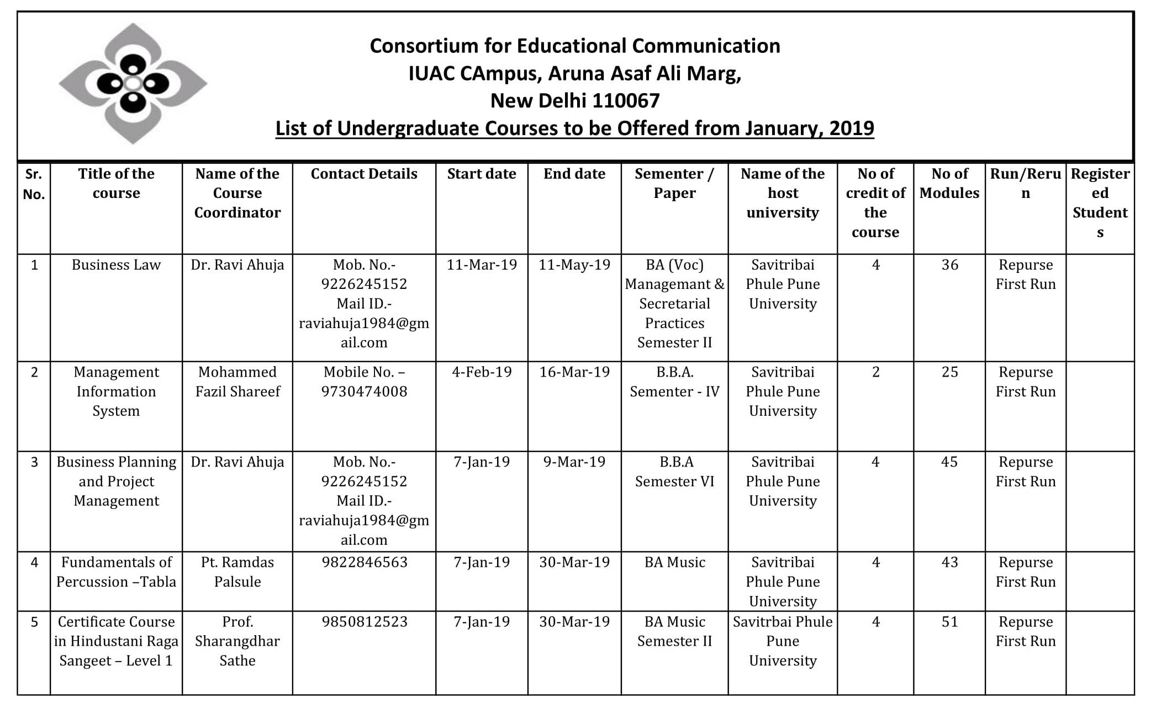
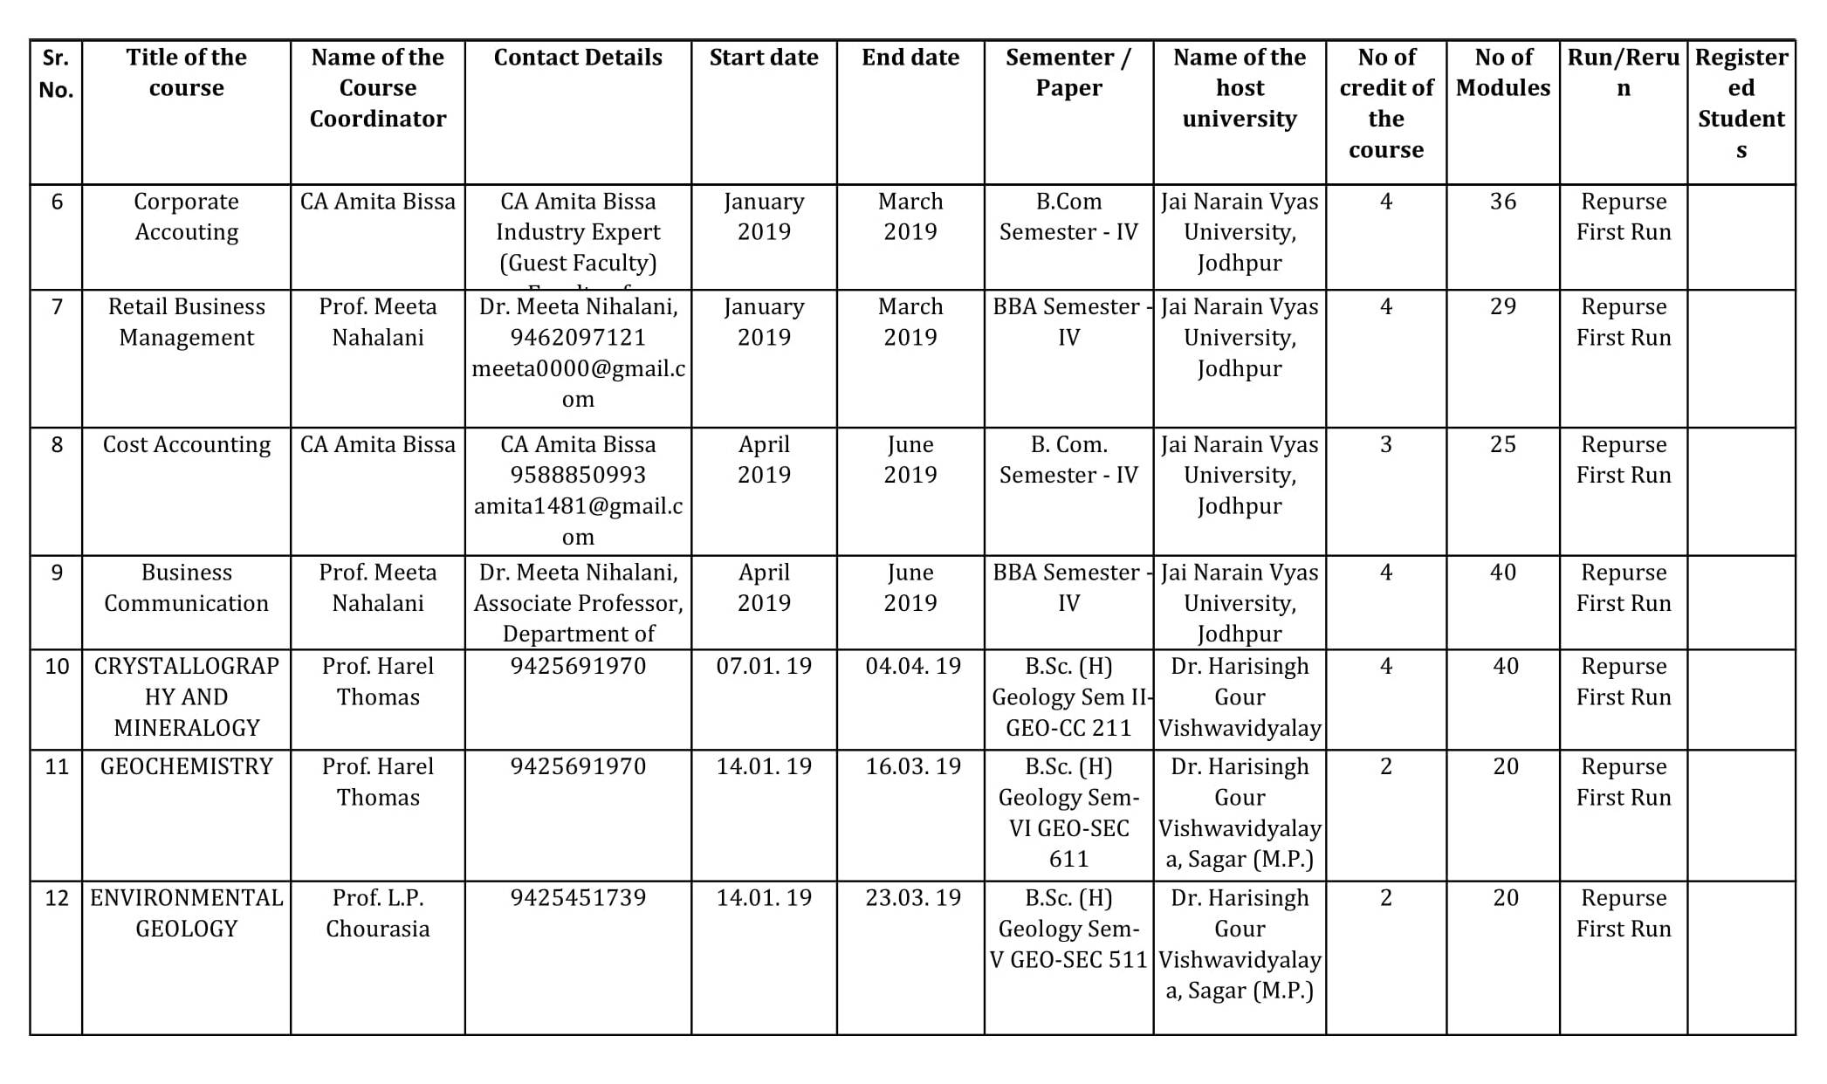

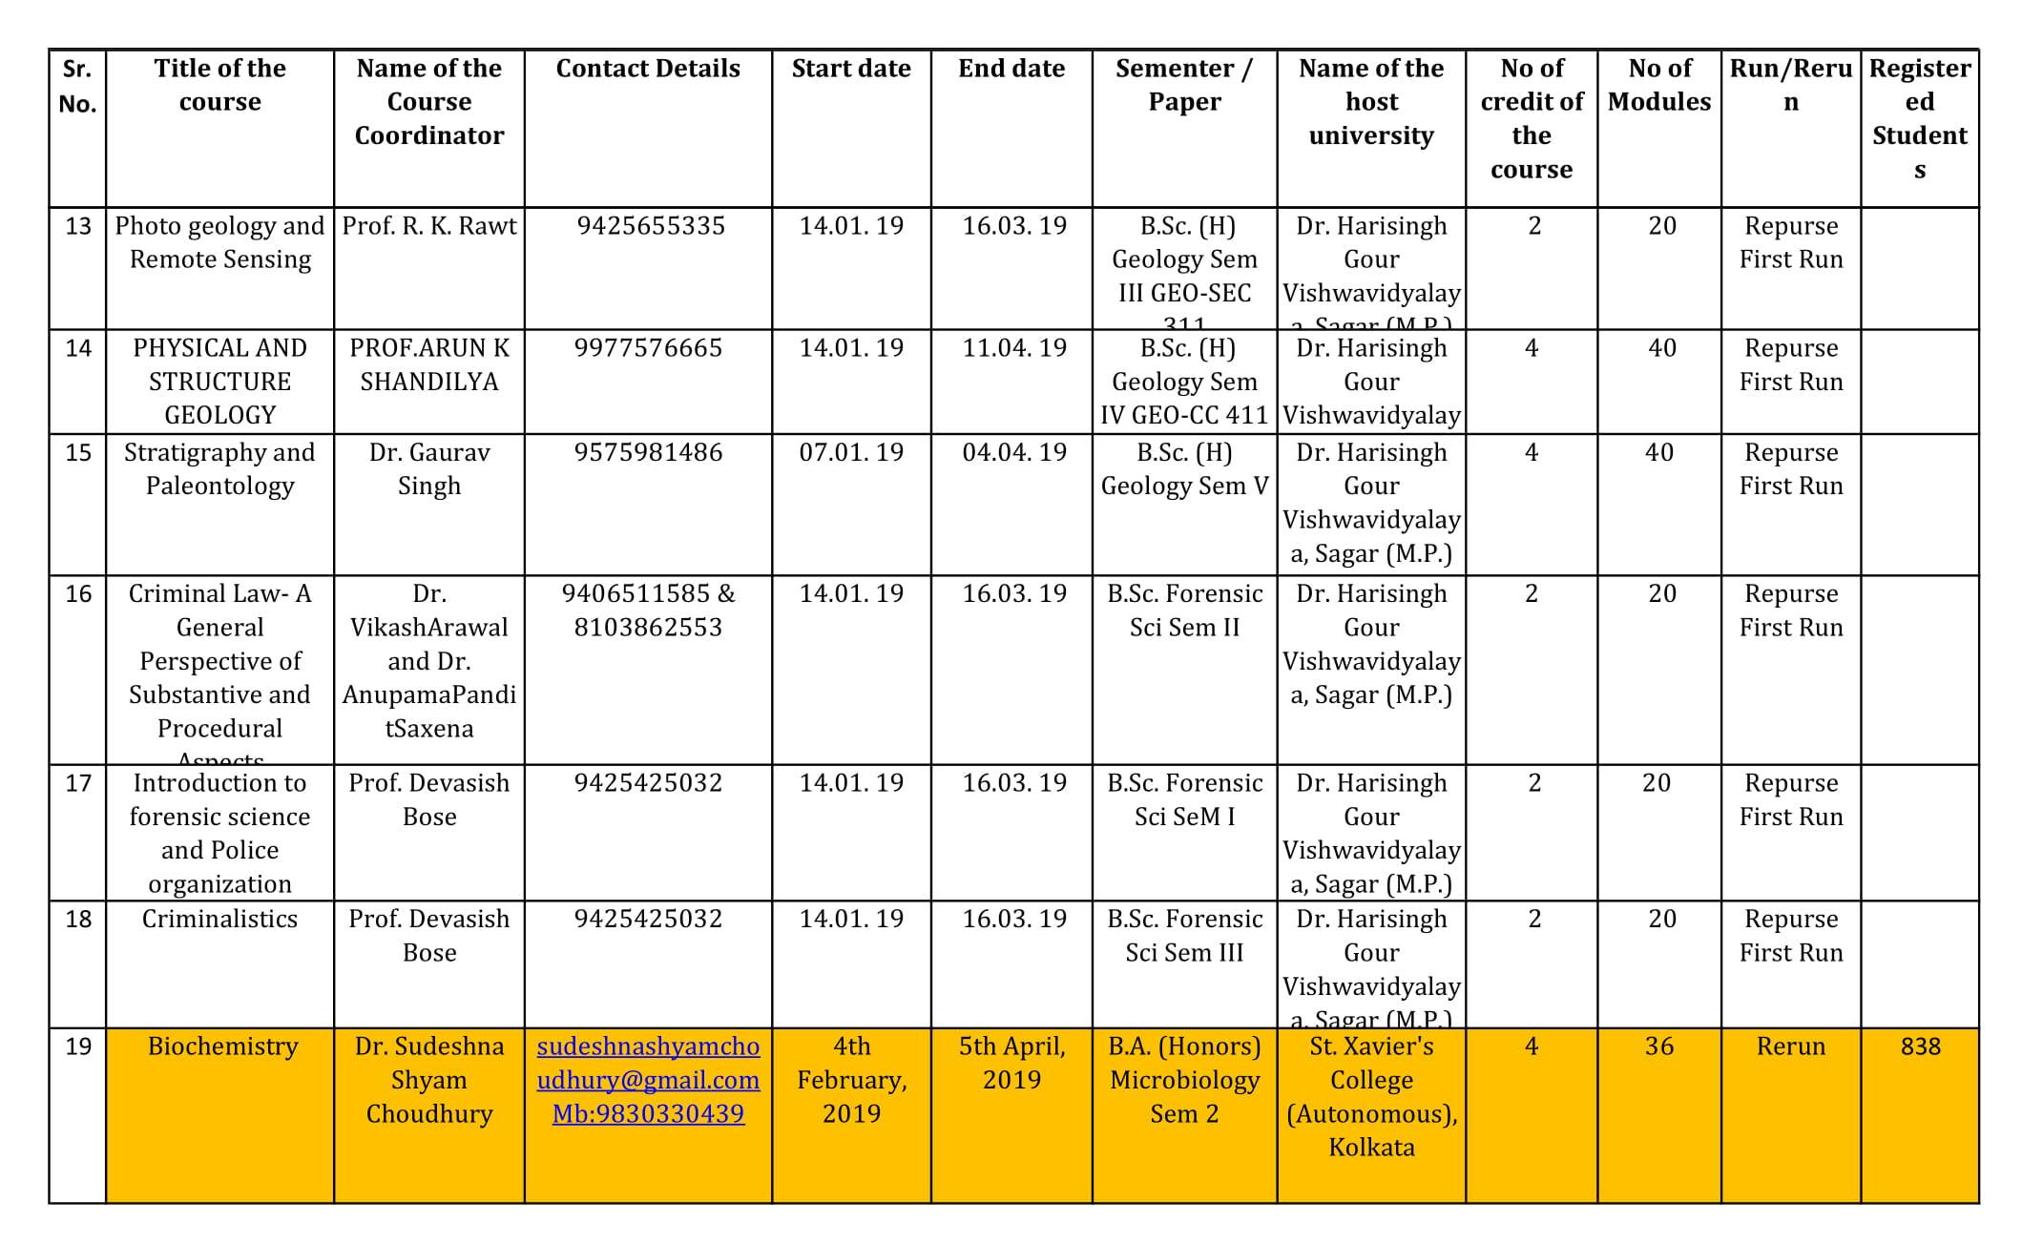
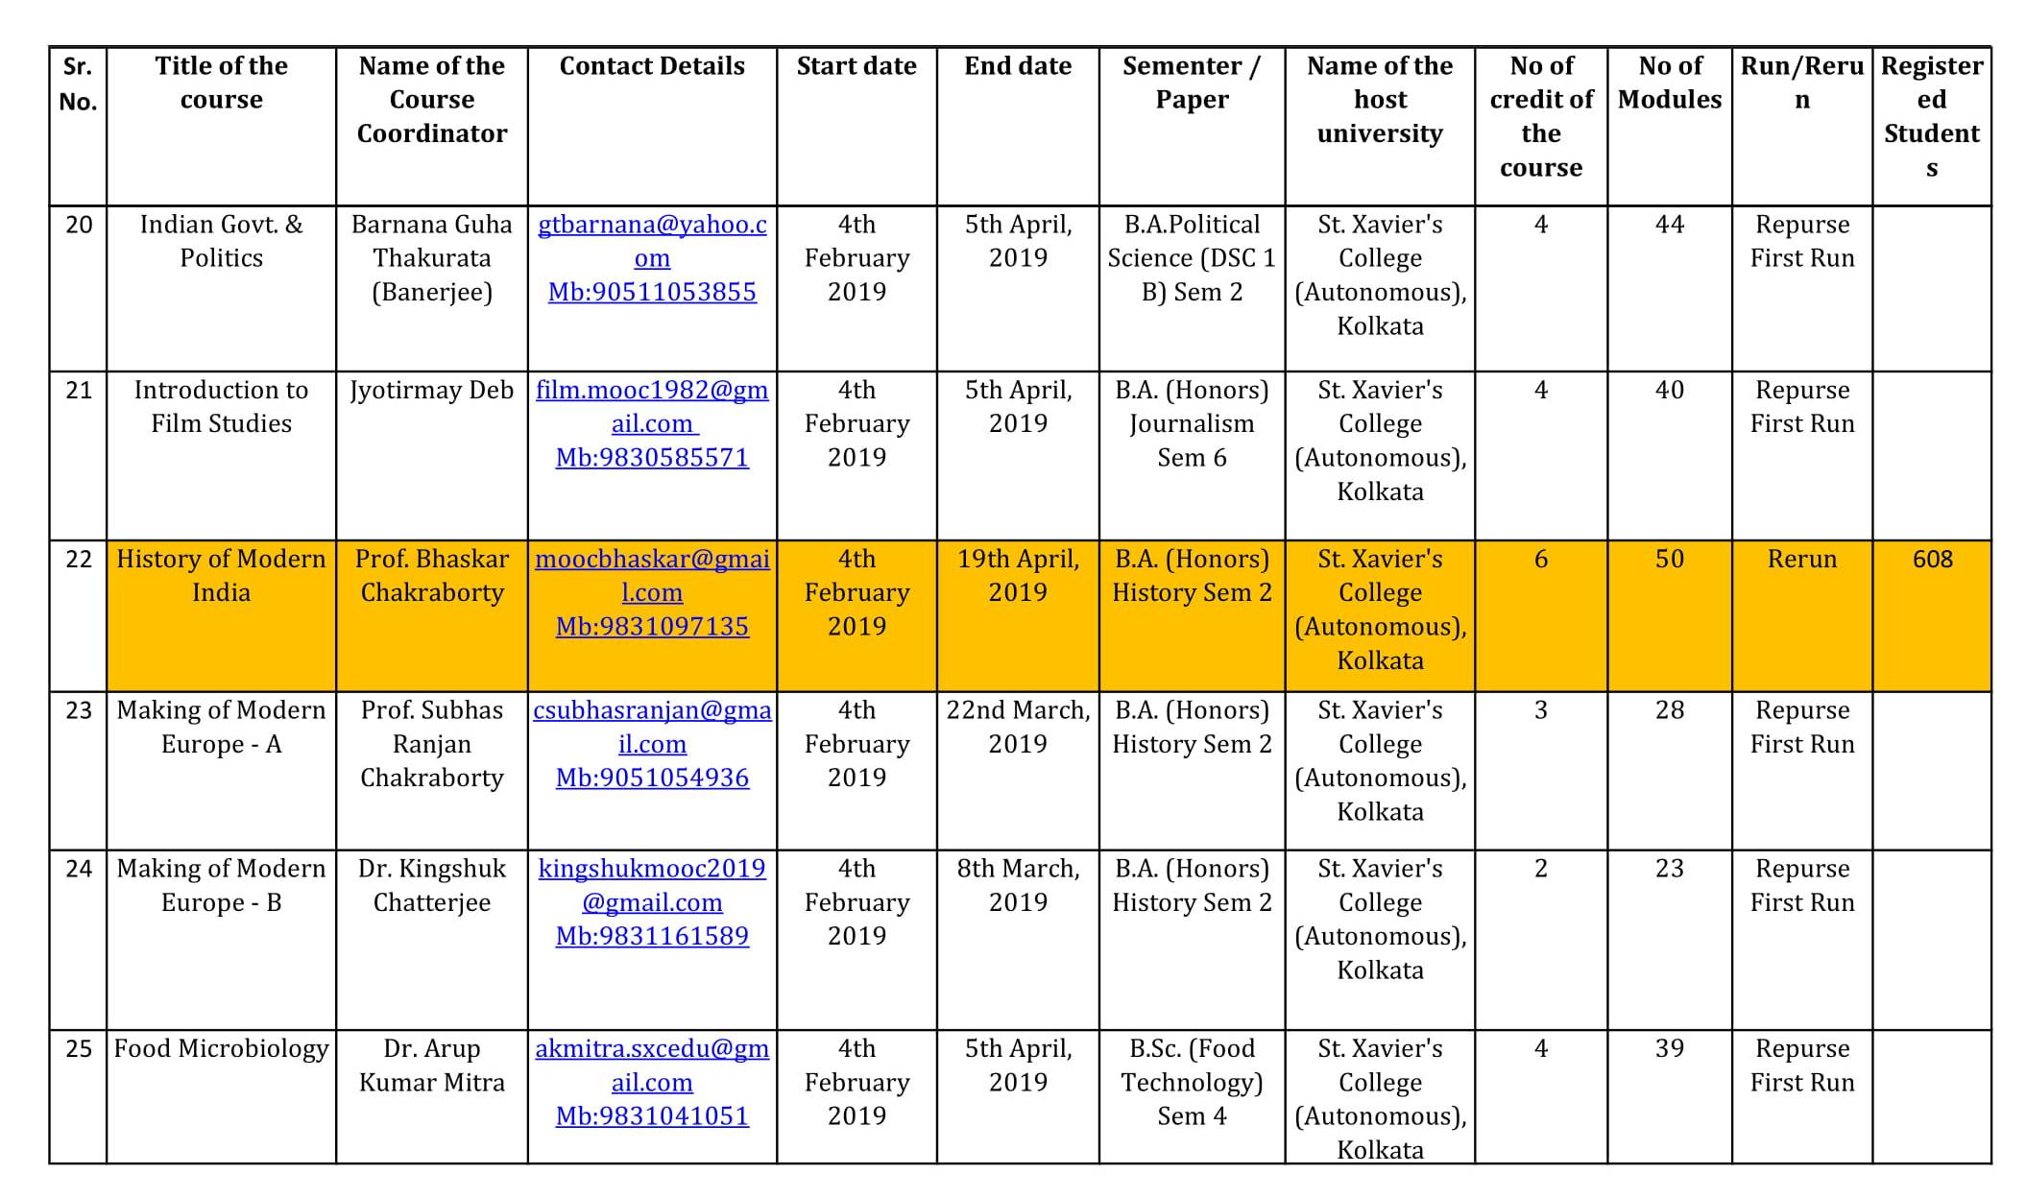

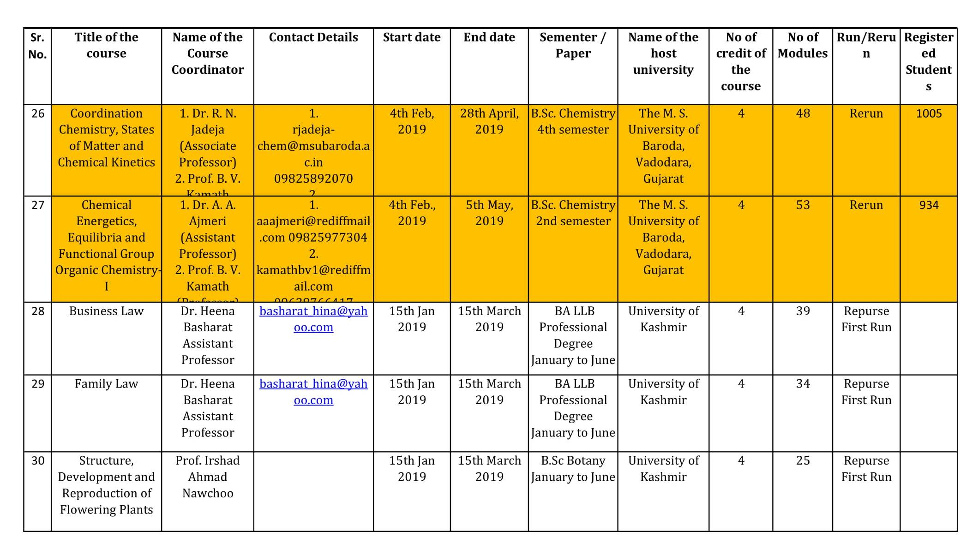
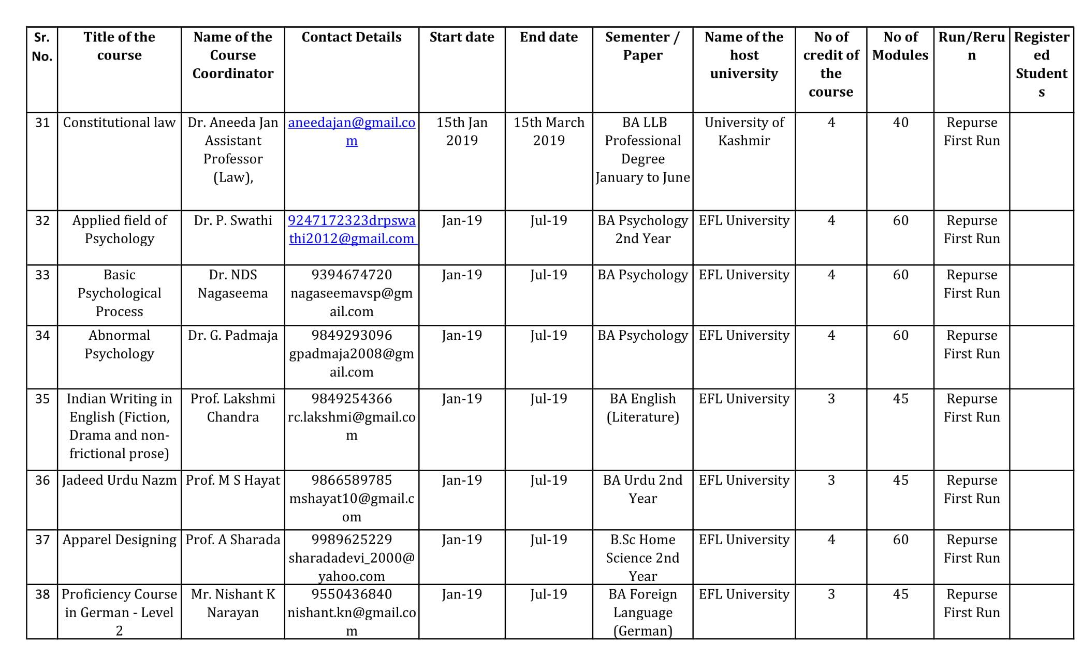

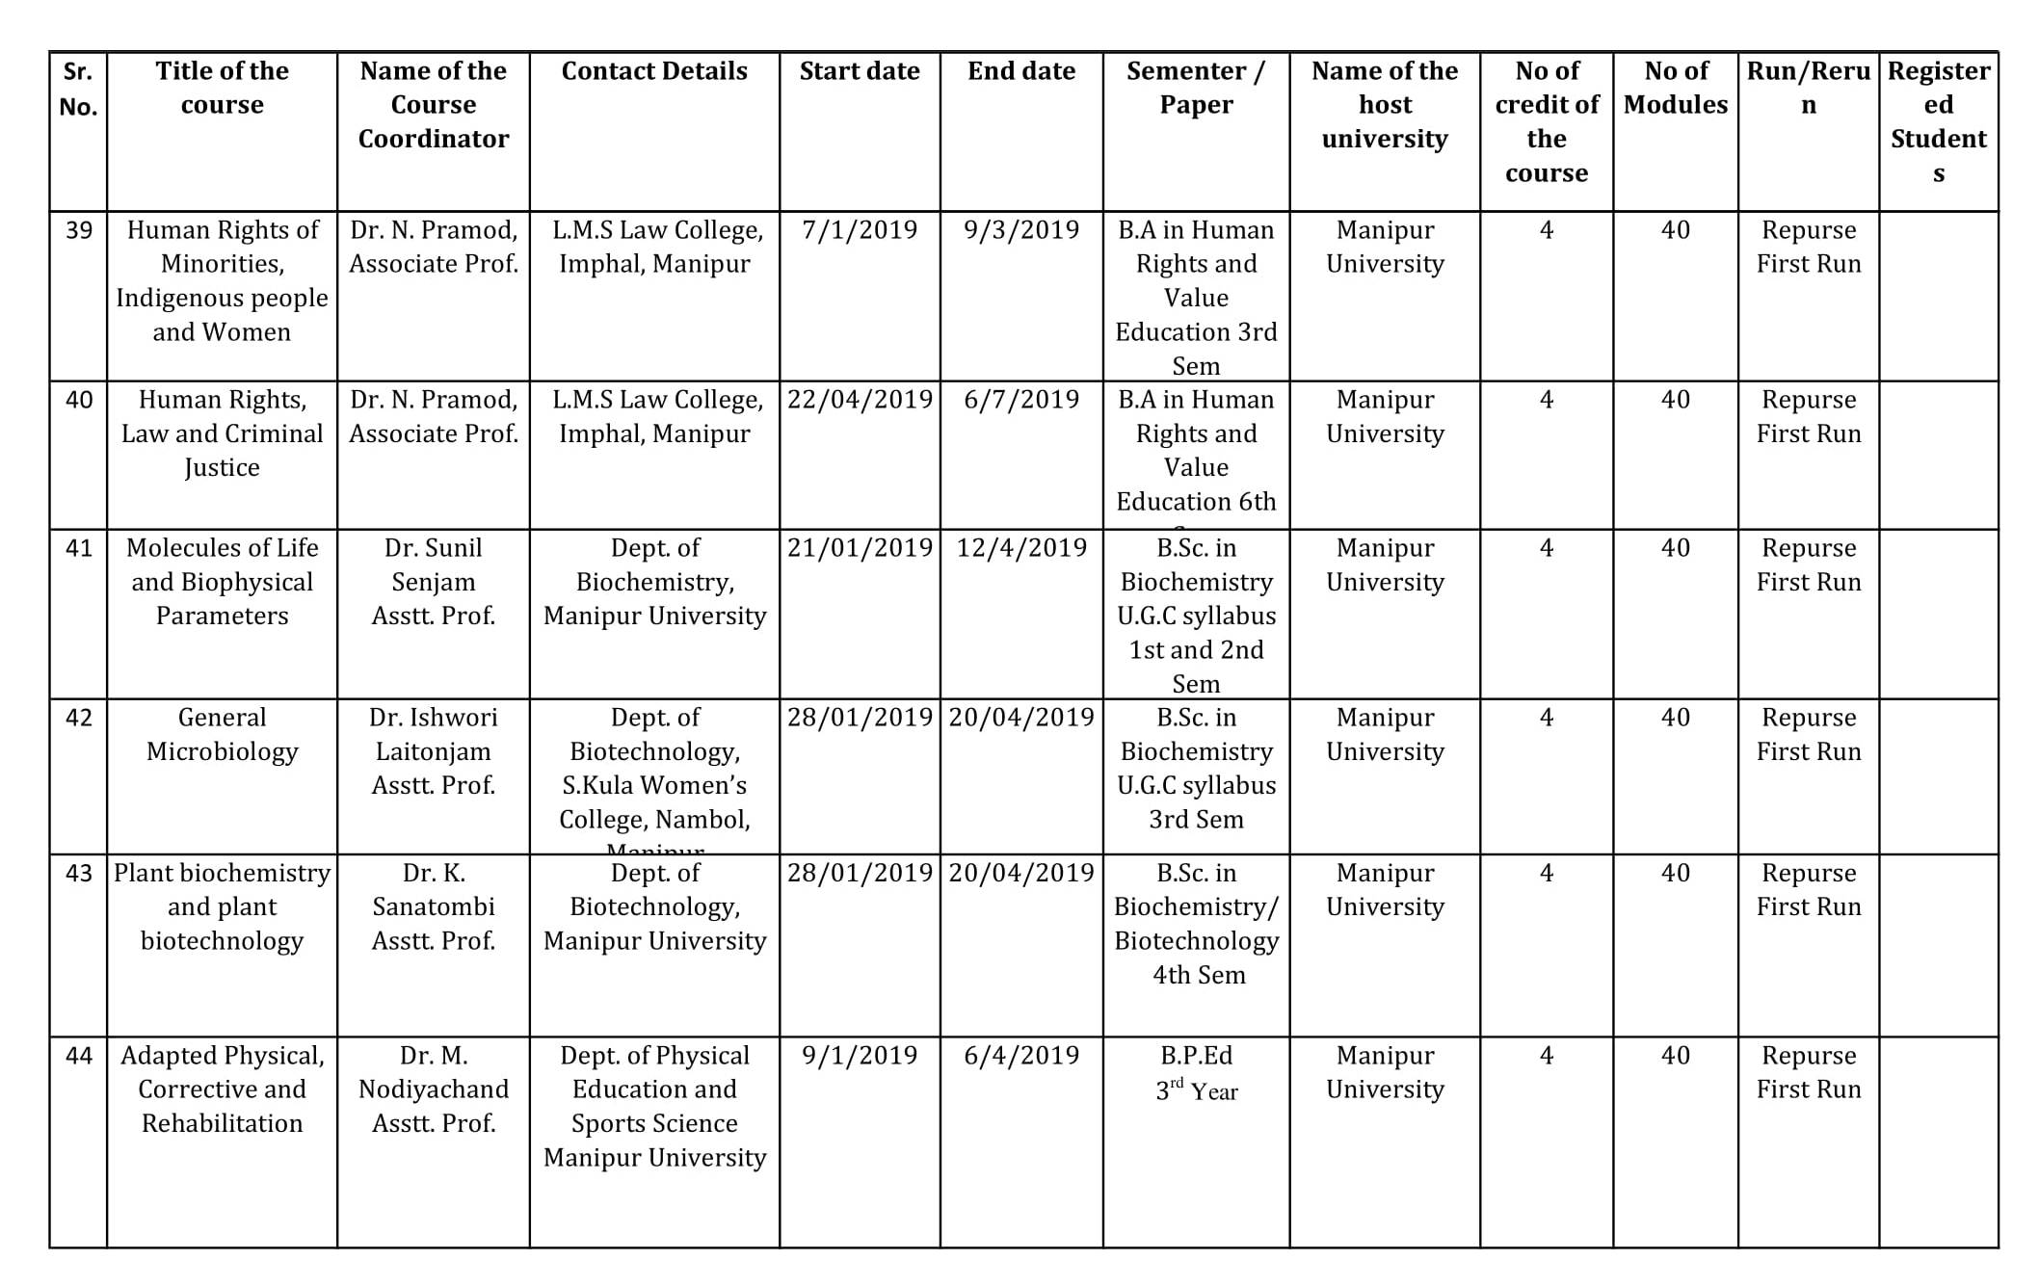
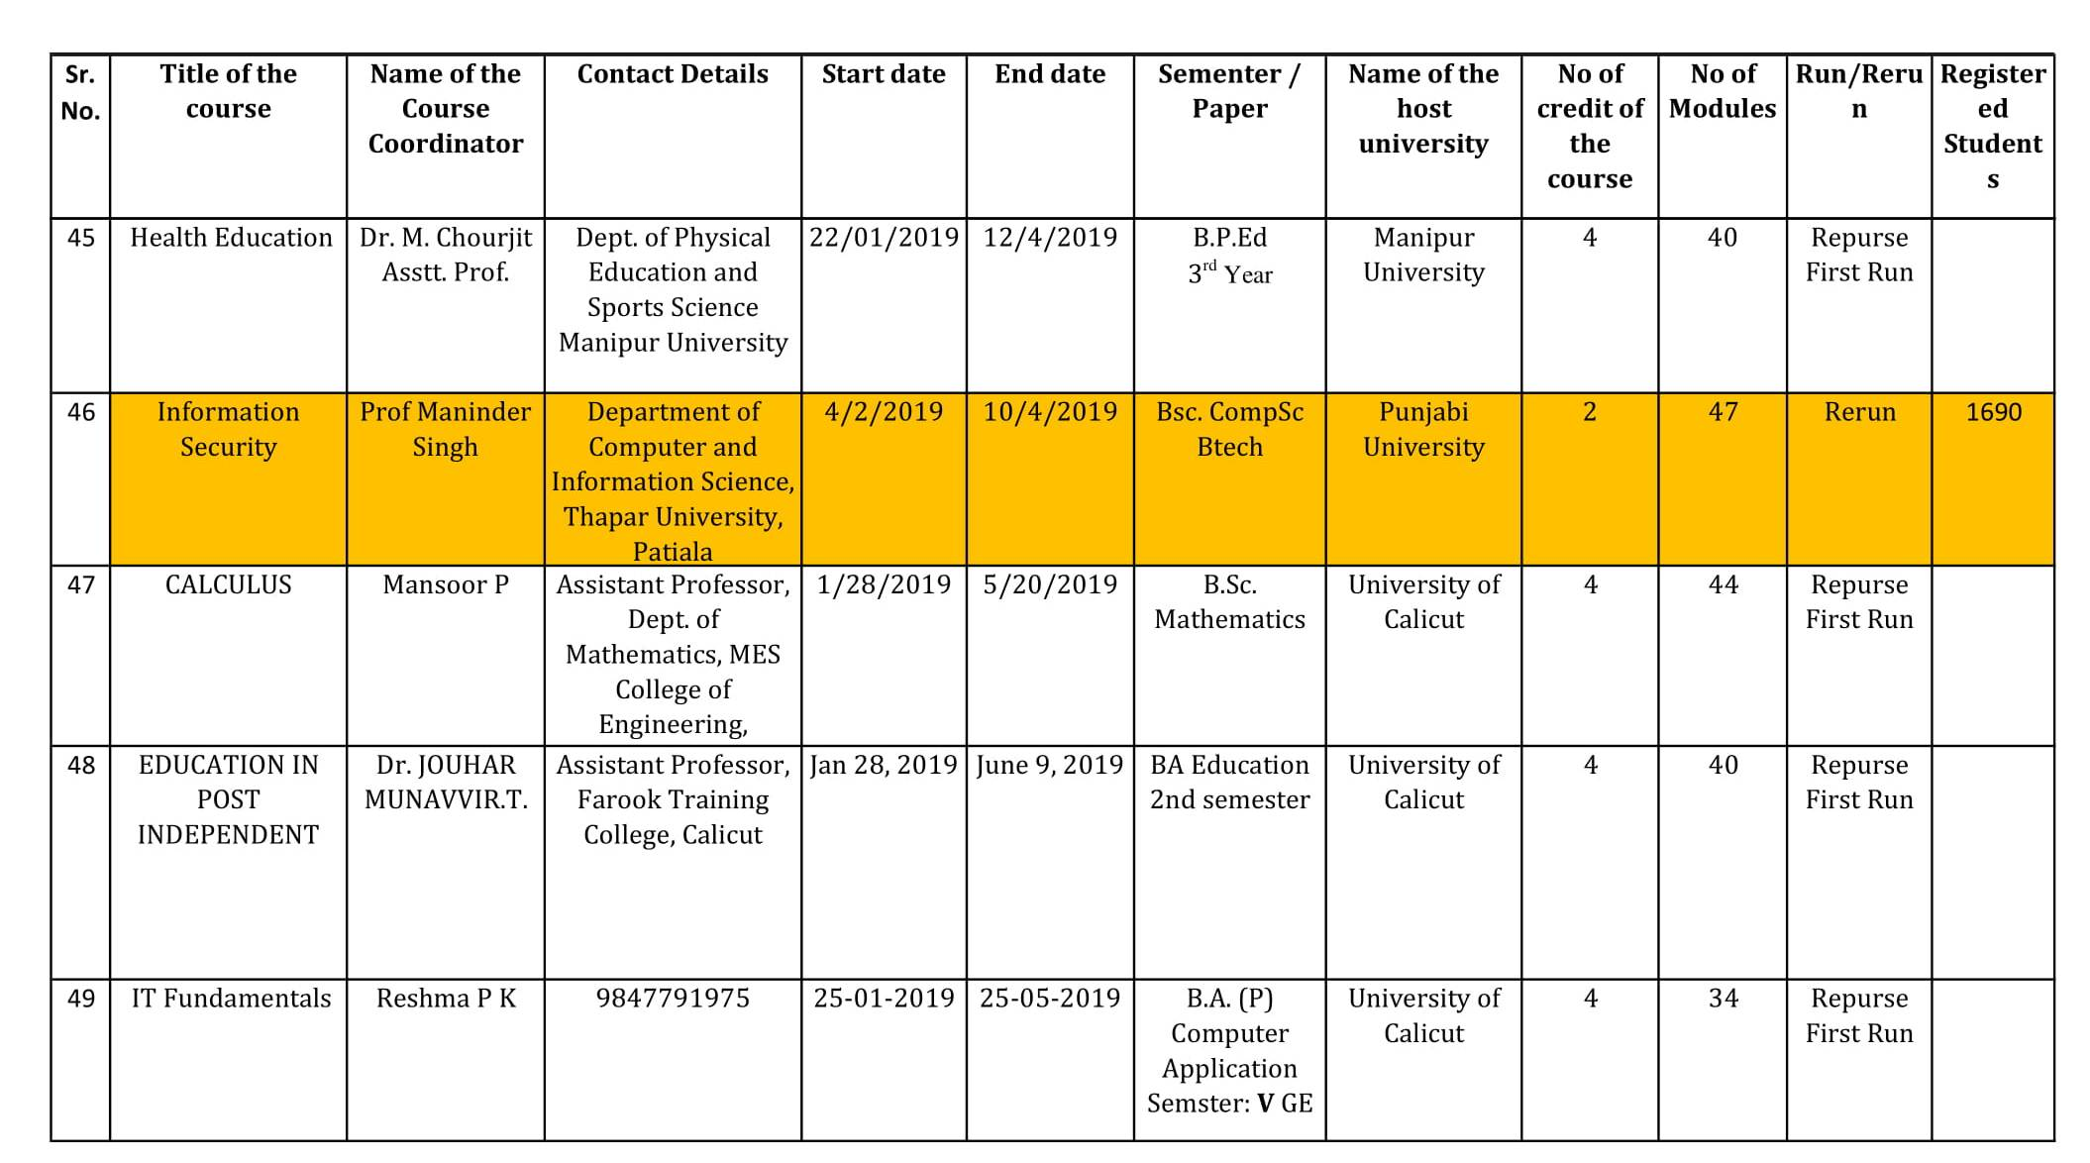

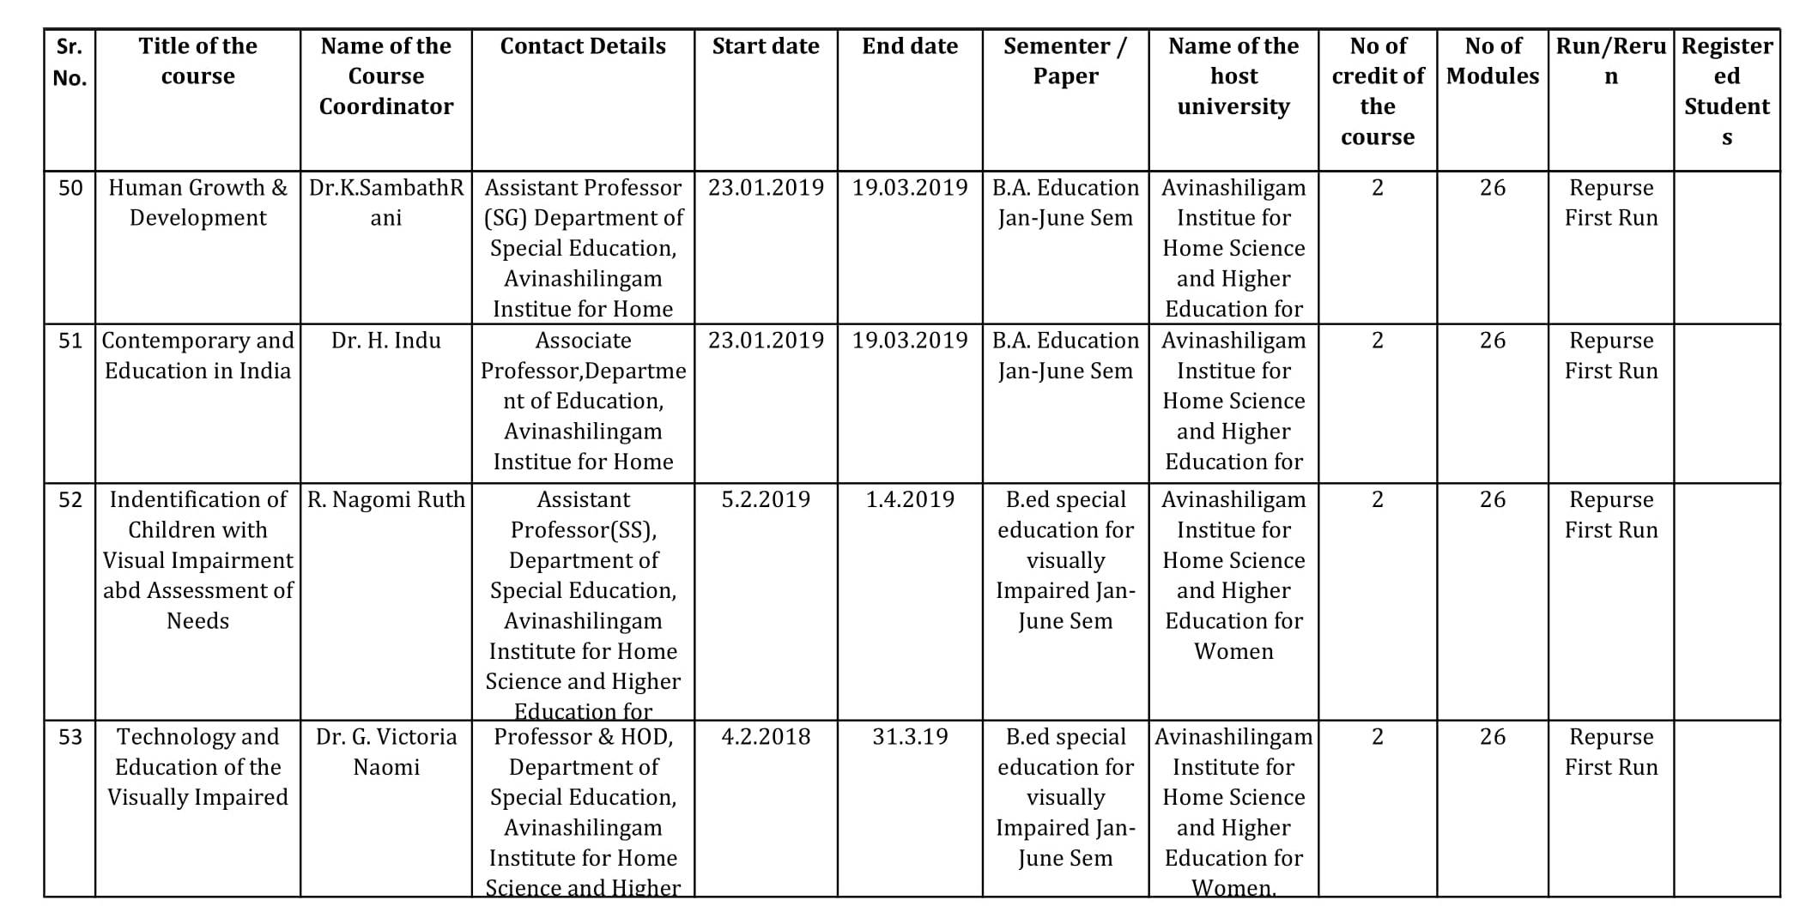
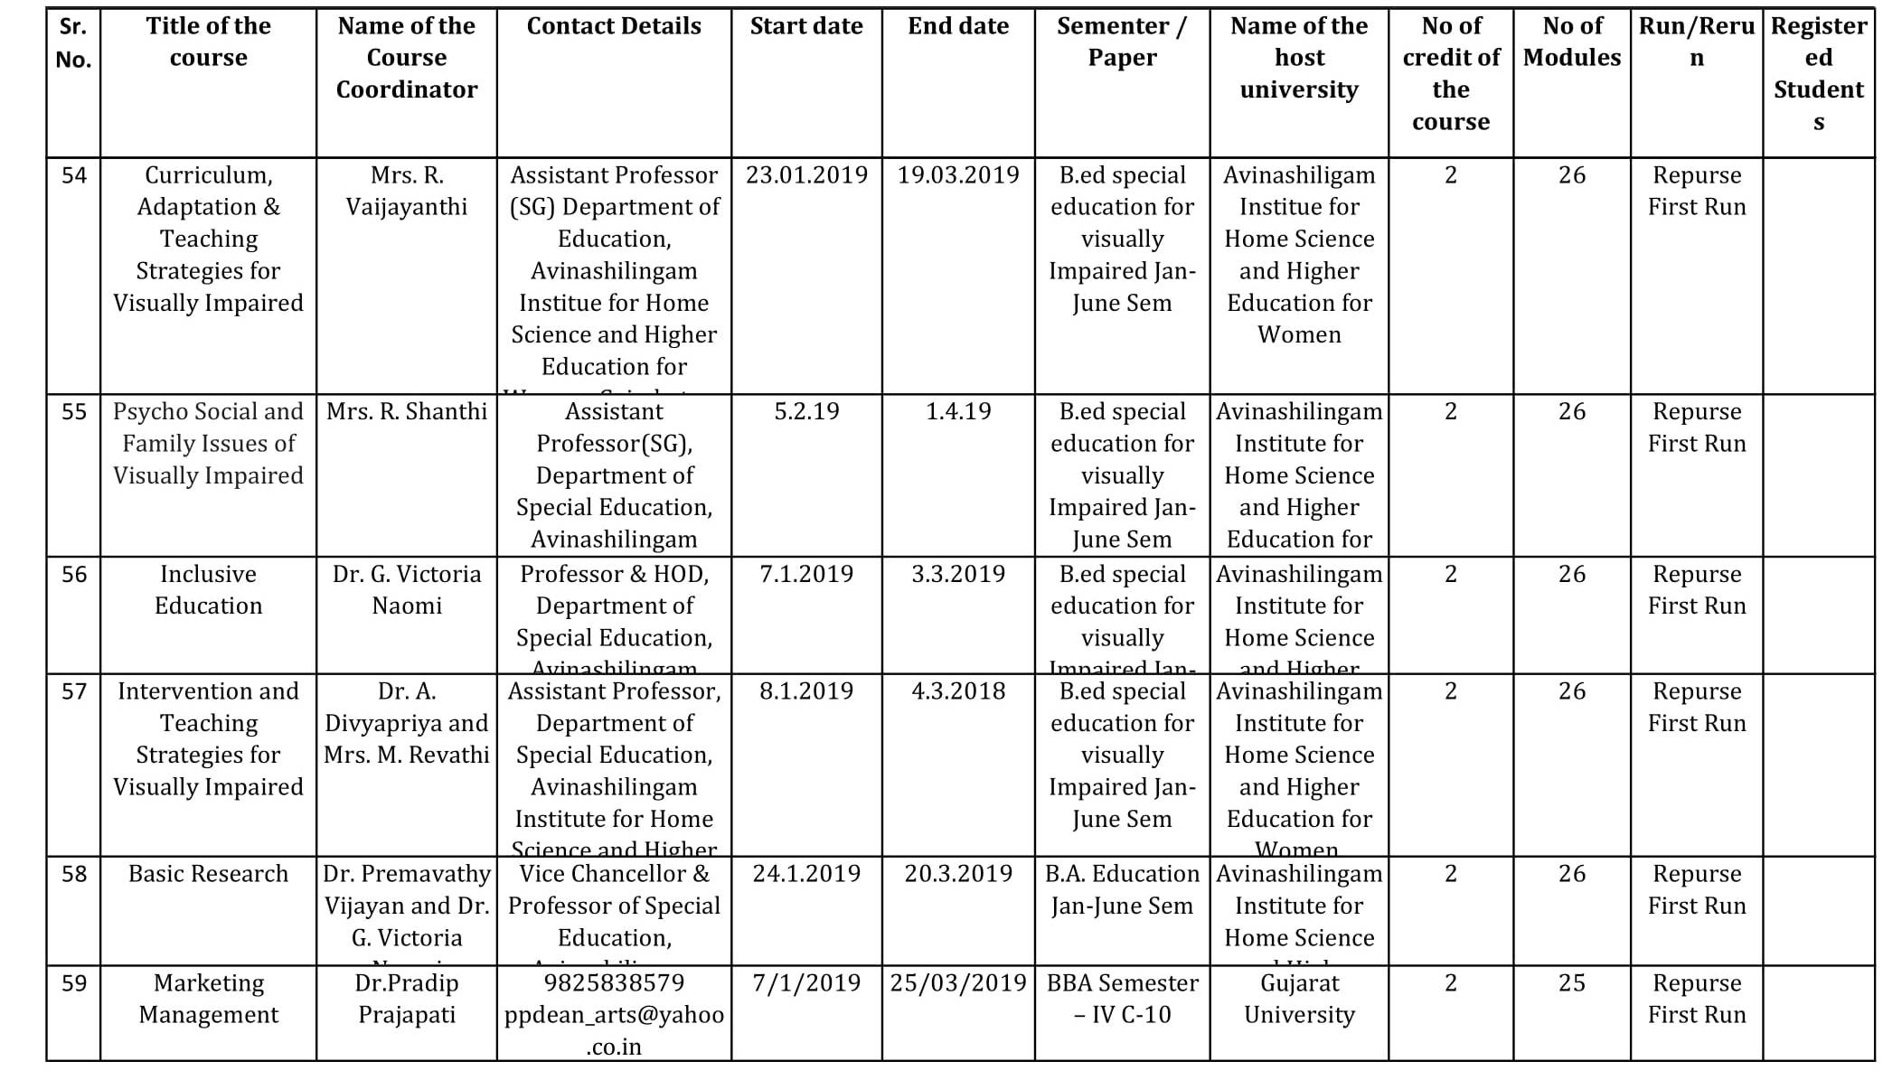

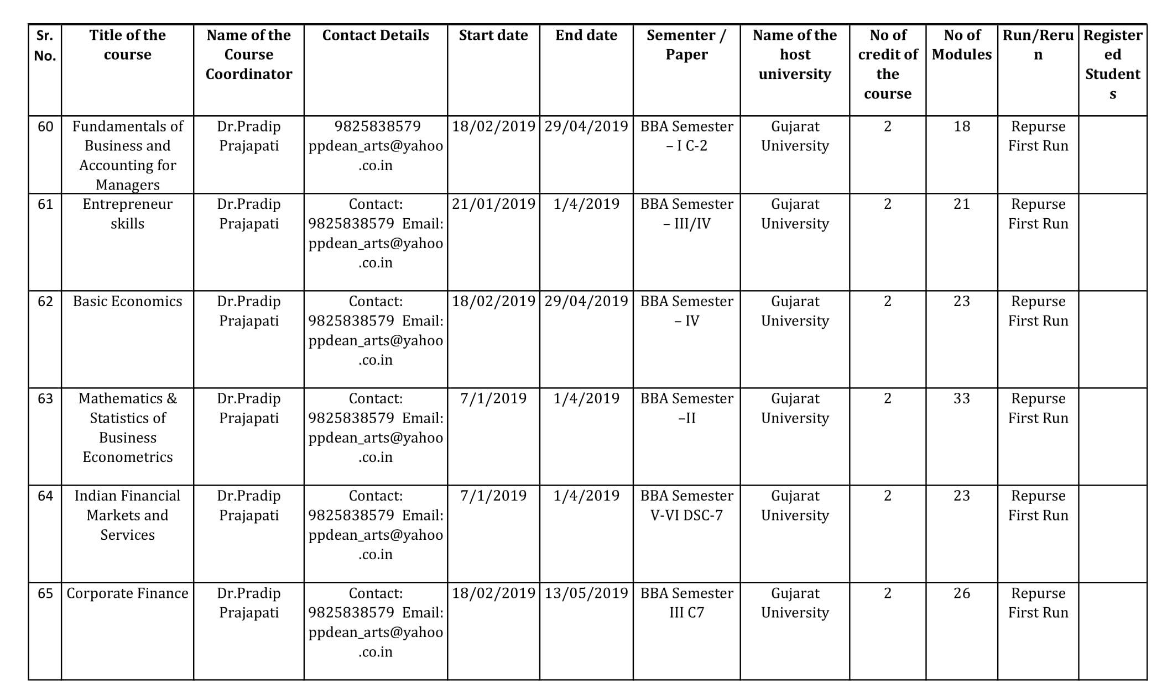
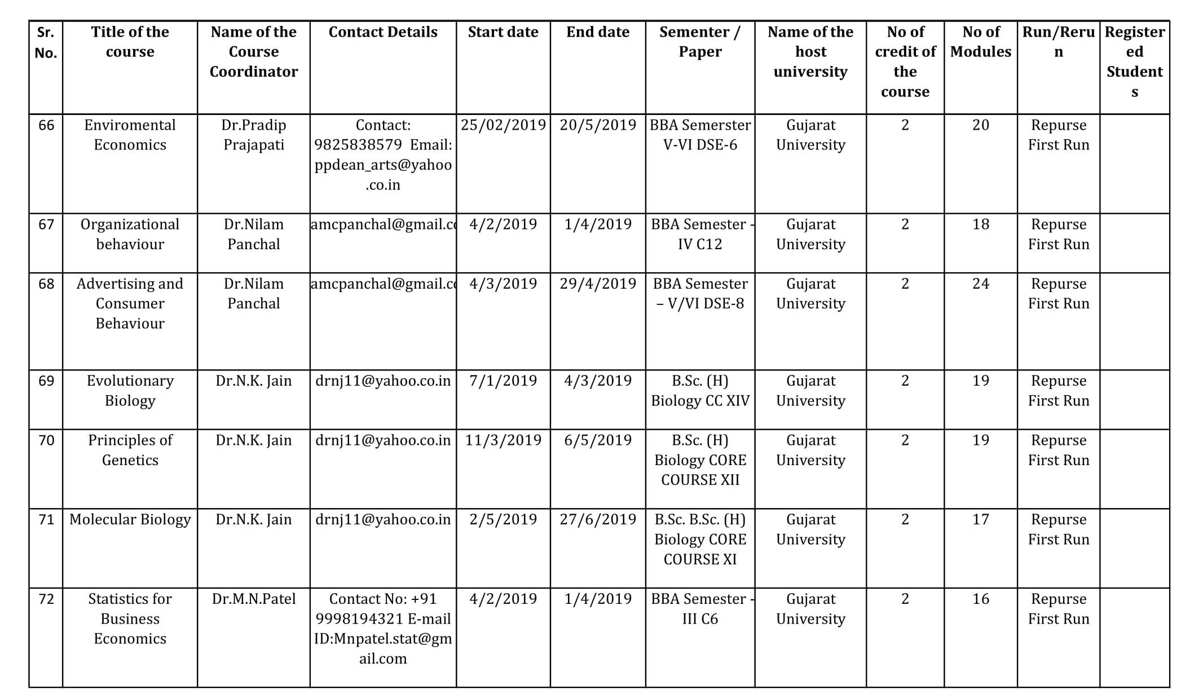

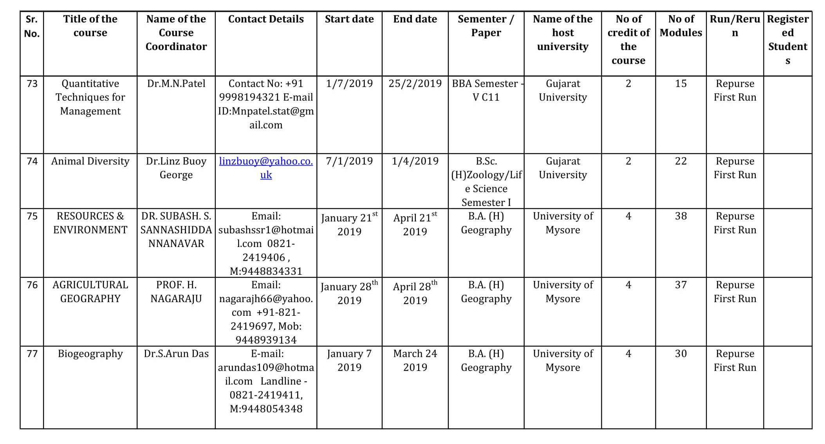
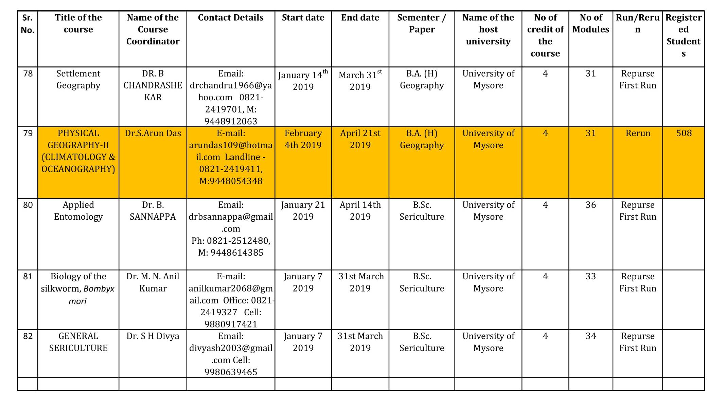

IIM Bangalore:
Sr.No. | Course Title | Course Faculty | Area | Institute offering the Course
1 | Managerial Economics | Subhashish Gupta | Economics | IIMB
2 | Introduction to Operations Management | B Mahadevan | Production and Operations Management | IIMB
3 | Intellectual Property Rights | Damodaran | Strategy | IIMB
4 | Leading with Joy | Ramya Ranganathan | Organizational Behaviour | IIMB
5 | Business Communication | Bringi Dev and Rakesh Godhwani | Management Communication | IIMB
6 | Accounting for Decision Making | MS Narasimhan | Accounting and Finance | IIMB
7 | Introduction to Marketing Essentials | Ashis Mishra | Marketing | IIMB
8 | Strategy and the Sustainable Enterprise | PD Jose | Strategy | IIMB
9 | Consumer Buyer Behaviour | Ashish V Hathi | Marketing | Welingkar *(*In planning/ review process)

NITTTR Chennai:
S.No. | Name of the Courses | Duration of Course (Hrs.) | Coordinators Name | Course Offered by
1 | Fundamental of Curriculum in Engineering Education | 20 | Dr. Joshua Earnest | NITTTR,Bhopal
2 | Learning and Instruction | 20 | Dr. Kiran Saksena | NITTTR,Bhopal
3 | Basic Instructional Methods | 20 | Dr. (Mrs.)Susan.S.Mathew | NITTTR,Bhopal
4 | Quality Management- Tools and Techniques | 20 | Dr. R.B.Shivagunde | NITTTR,Bhopal
5 | Industry-Institute–Community Partnership | 20 | Dr. R.G.Choucksey | NITTTR,Bhopal
6 | Performance Appraisal and Management | 20 | Dr. Parag Dubey | NITTTR,Bhopal
7 | Instructional Media | 20 | Dr. S.S.Kedar | NITTTR,Bhopal
8 | Advanced Instructional Methods | 20 | Dr. A.A.Khajanchee | NITTTR,Bhopal
9 | Technical Education for Sustainable Development | 20 | Dr. S.K.Gupta | NITTTR,Bhopal
10 | Instructional Planning | 20 | Dr. P.K Tulsi | NITTTR,Chandigarh
11 | Entrepreneurship Development | 20 | Dr. S.K Dhameja | NITTTR,Chandigarh
12 | Academic Audit | 20 | Dr. Rakesh K Wats | NITTTR,Chandigarh
13 | Educational Video Production | 20 | Dr. Maitreyee Dutta | NITTTR,Chandigarh
 |  |  | Dr. S S Pattnaik
 |  |  | Mr. G B Pande
14 | Academic Leadership | 20 | Dr. B S Pabla | NITTTR,Chandigarh
15 | Group Dynamics | 20 | Dr. Sunil Dutt | NITTTR,Chandigarh
16 | Problem Based Learning | 20 | Dr. Indrajit Saha | NITTTR,Kolkata
17 | Academic and Research Report Writing | 20 | Dr. Samir Roy | NITTTR,Kolkata
18 | LMS through MOODLE | 20 | Dr. V.Shanmuganeethi | NITTTR,Chennai
 |  |  | Dr. K. S. A. Dinesh Kumar
 |  |  | Dr. G. Janardhanan
19 | OER for Empowering Teachers | 20 | Dr. P.Malliga | NITTTR,Chennai
20 | Student Psychology | 40 | Dr. Renukadevi | NITTTR,Chennai
21 | Guidance and Counselling | 20 | Dr. R.Rajendran | NITTTR,Chennai
22 | Strategic Planning for Technical Institutions | 20 | Dr. S.Dhanapal | NITTTR,Chennai
23 | Outcome Based Assessment | 20 | Dr. K.S.A. Dinesh Kumar | NITTTR,Chennai
 |  |  | Dr. G. Janardhanan
 |  |  | Dr. V.Shanmuganeethi
24 | Outcome Based Education | 40 | Er. V. Sivakumar | NITTTR,Chennai

NCERT New Delhi:
S.No. | Course Name
1 | Accountancy 03- XII
2 | Biology 02 –XI
3 | Biology 04 –XII
4 | Business Studies 01- XI
5 | Business Studies 03- XII
6 | Sociology 02 –XI
7 | Sociology 04 –XII
8 | Action Research for Teachers
NIOS New Delhi:
S.No. | Course Name
1 | Veda Adhyayan
2 | Sanskrit Viyakaran
3 | Bhartiya Darshan
4 | Sanskrit Sahitya
5 | History
6 | Business Studies
7 | Accountancy
8 | Introduction to Laws
9 | Insurance Services
10 | Four wheeler mechanism
11 | CRM Domestic voice

IGNOU New Delhi:
S.No. | Course Name
1 | Introduction to GST
2 | Introduction to Cyber Security
3 | Commercial Fruit Production: Pomegranate & Guava

Agenda Item No. 6

Appointment of AICTE as National Coordinator for PMMMNMTT - Ratification

Purport
The objective of this Note is to seek post-facto approval of the Board regarding appointment of AICTE as a National Coordinator for the Teacher Teaching / Refresher Courses produced under PMMMNMTT Scheme.

Background
MHRD identified 75 institutions to act as National Resource Centres (NRCs) to prepare online training material for Massive Open Online Courses (MOOCs) with focus on latest developments in the discipline, new & emerging trends, pedagogical improvements and methodologies for transacting revised curriculum. In the first phase, 75 discipline-specific National Resource Centres have been identified, under the Ministry’s Pandit Madan Mohan Malaviya National Mission on Teachers and Teaching (PMMMNMTT) located in Central Universities, IISc, IUCAA, IITs, IISERs, NITs, State Universities; UGC’s Human Resource Development Centres (HRDCs), National Institutes for Technical Teachers Training (NITTTRs), IIITs, Open Universities.
Under this initiative, all in-service teachers, irrespective of their subject and seniority have an enabling opportunity to keep abreast of the latest developments in their disciplines through the technology based online refresher course, through SWAYAM, India’s own MOOCs platform.
AICTE has been appointed as the National Coordinator for the courses under PMMMNMTT Scheme.

Approval Sought
SWAYAM Board is requested to ratify the appointment of AICTE as a National Coordinator for the courses under PMMMNMTT scheme.

Agenda Item No. 7
Status on SWAYAM Office Setup of National Coordinators

Purport
The objective of this Note is to present the Status on the Establishment of SWAYAM Office by the National Coordinator’s.

Background
National Coordinators are expected to coordinate and manage the overall selection, production and delivery of SWAYAM courses. National Coordinator would have to ensure strict compliance with the quality, procedural and financial guidelines issued by Ministry. National Coordinators have to regularly organize Academic Advisory Board and Subject Matter Expert Groups (SMEG) meetings for selection of new courses and acceptance of the same afterwards as per Guidelines. National Coordinators are earmarked funds under "Support to the National Coordinator (NC)” on yearly basis as per the Financial Guidelines issued on 4th December, 2017.
NCs are expected to have a Functional Office for the Coordination, Management and Monitoring Activities regarding Selection, Development, Acceptance and Delivery of SWAYAM Courses.
Status:
NPTEL, IIM Bangalore, NCERT, NIOS and AICTE are having Regular Functioning Offices.
IGNOU: Office set up in October, 2018 with One Project Associate, One Account Assistant, One Computer Operator.

CEC: One Project Coordinator and One DEO are working

UGC may update the status

Agenda Item No.8

Presentation on SWAYAM 2.0 - IIT Madras

Agenda Item No.9

Extension of Contract of M/s Azure Cloud Services for SWAYAM MOOCs Platform for 6 Months w.e.f. 08.02.2019

Background:

The Joint Committee of SPC in its 30th Meeting held on 13-12-2017 decided that AICTE may take necessary steps to invite a short term offline Tender to select L-1 vendor to provide Azure Based Cloud Services to SWAYAM till the CSP vendor viz. M/s CtrlS Datacentre successfully migrates the application to the new environment. In compliance to this decision M/s Embee Software Pvt. Ltd. was selected for providing M/s Azure Cloud Services for SWAYAM Platform for a period of Six Months from 8th February, 2018 to 7th August, 2018.

During the review of SWAYAM Project taken by Joint Secretary (TEL & ICC), MHRD on 7th June, 2018, it was informed that M/s CtrlS Datacentre has not been able to complete the Phase-3 deployment for migration of Cloud Service on new environment. Accordingly, it was decided to put up an Agenda before the SWAYAM Board in its 5th Meeting to be held on 11.06.2018 for approval to extend the contract for another six months with a clause of termination of service anytime by giving one month notice.

The SWAYAM Board in its 5th Meeting held on 11th June, 2018 approved the extension of contract of M/s Embee Software Pvt. Ltd. for six months i.e. from 08.08.2018 to 07.02.2019 for providing M/s Azure Cloud Services for SWAYAM Platform, on the existing terms and conditions of the Contract of Agreement and the Work Order with the condition that services could be terminated by giving one month notice. Accordingly, letter of extension dated 24th July, 2018 was issued in favour of M/s Embee Software Pvt. Ltd. for a further period of six months i.e. from 08.08.2018 to 07.02.2019.

It would be seen that the Contract awarded to M/s Embee Software Pvt. Ltd., New Delhi for providing M/s Azure Cloud Services for SWAYAM Platform would expire on 07.02.2019. However, this is to bring to the notice of SWAYAM Board that M/s CtrlS Datacentre has still not been able to complete the Phase-3 deployment for migration of Cloud Service on new environment. There is a separate Agenda Note on the Status of M/s CtrlS Performance.
Proposal:
Consideration the fact that SWAYAM Platform cannot function without M/s Azure Cloud Services and the performance of M/s CtrlS Datacentre is not satisfactorily till date, there is need to extend the contract for M/s Azure Cloud Services.
Approval Sought:
The SWAYAM Board is requested kindly consider extension of the Contract of M/s Embee Software Pvt. Ltd. for providing M/s Azure Cloud Services for a further period of six months i.e. from 8th February, 2019 to 7th August, 2019 on the existing terms & conditions with a clause of termination of service anytime by giving one month notice.

Agenda Item No.10

Extension of Contract of Bulk SMS Gateway and E-Mail Service Provider awarded to M/s Netcore Solutions Pvt. Ltd., New Delhi upto 31st March, 2019

Background:

The Joint Committee of SPC in its 14th Meeting held on 24th August, 2016 approved the award of work to M/s Netcore Solutions Pvt. New Delhi, an empanelled Agency of D.A.V.P. @ Rs.2.75 paisa per SMS+ Service Tax (with TRAI exemption) and 0.95 paisa per e-mail+ Service Tax for providing Bulk SMS Gateway and E-mail services for AICTE-SWAYAM Project. However, TRAI (Telecom Regulatory Authority of India), Govt. of India vide their letter dated 31.10.2016 did not approve the exemption of Rs.0.05 per SMS under Transactional SMS category. This was brought to the notice of Joint Committee of SPC in its 22nd Meeting held on 19th December, 2016. It was then decided to take up the matter with TRAI at MHRD level. However, it was informed by TRAI that being the policy decision, the permission for exemption cannot be granted for SWAYAM project and AICTE has to pay the charges of Bulk SMS/e-Mail services “without TRAI exemption” rates. Accordingly, the Joint Committee in its 23rd Meeting held on 6th January, 2017 approved the payment to M/s Netcore Solutions Pvt. Ltd. on “without TRAI exemption” rates. Accordingly, the e-mail services are being provided by M/s Netcore Solutions Pvt. Ltd., New Delhi for SWAYAM Project regularly and the payments are being made as per DAVP approved rates.
The Joint Committee in its 26th Meeting held on 24th May, 2017 approved the extension of M/s Netcore Solutions Pvt. Ltd., New Delhi upto 31st March, 2018 as per the terms & conditions of the contract. It would be worthwhile to mention here that M/s Netcore Solutions Pvt. Ltd., New Delhi are providing only e-mail Services to SWAYAM Platform presently though the bulk SMS gateway is also active. Since the bulk SMS/e-mail services are essential for SWAYAM Platform, further extension of the services of M/s Netcore Solutions Pvt. Ltd., is required upto March, 2019. The process for inviting fresh tenders for bulk SMS/e-mail services on DAVP approved rates would be taken to be effective from 01.04.2019.

Approval Sought:
SWAYAM Board is requested kindly to accord approval for Extension of Contract of Bulk SMS Gateway and E-Mail Services to M/s Netcore Solutions Pvt. Ltd., New Delhi upto 31st March, 2019 on the existing terms & conditions.

Agenda Item No.11

Performance Review of M/s CtrlS

Agenda Papers to be circulated by AICTE.

Agenda Item No.12

AI - Based Tool for Learning - Proposal for Pilot

Purport
The objective of this Note is to seek approval of the SWAYAM Board on the proposal for pilot by M/s VideoKen Platform Services (AI Tool) for SWAYAM.
Background
Videos represent a powerful medium to support learning. The Ministry of Human Resource Development (MHRD), Government of India, has made a significant investment in the creation of video lectures and making them freely available under the SWAYAM programme. However, most learners do not have the patience to watch video lectures end-to-end, often leading to their disengagement with these videos. In a textbook, we utilize the table-of-contents and the index associated with a textbook to identify the key topics being covered and usually read a specific topic at a given time. The proposal is to try similar AI-Based Tool in the Videos of SWAYAM Courses. M/s VideoKen has developed an AI Engine and Player for the same.
Proposal
M/s VideoKen was proposed (Annexure III) for a free pilot of the VideoKen AI Engine and Player for a set of 10 courses being offered under the SWAYAM program. The objective of this pilot will be to assess the value of using the VideoKen AI technology for video-based learning. M/s VideoKen will process the videos to create a table-of-contents (currently works well only for slide-based videos), phrase cloud and a searchable transcript for each video. An editing tool will be provided to instructors to support human editing of automatically generated table-of-contents or phrase cloud. M/s VideoKen will make its AI player available to play the indexed versions of those videos. M/s VideoKen will further provide monthly reports showing usage of the videos, with powerful visualization showing detailed usage for various segments of each video.

Approval Sought
Approval of the SWAYAM Board is sought for conducting a free trial of the M/s VideoKen AI Engine and Player in 10 SWAYAM Courses.

Annexure III

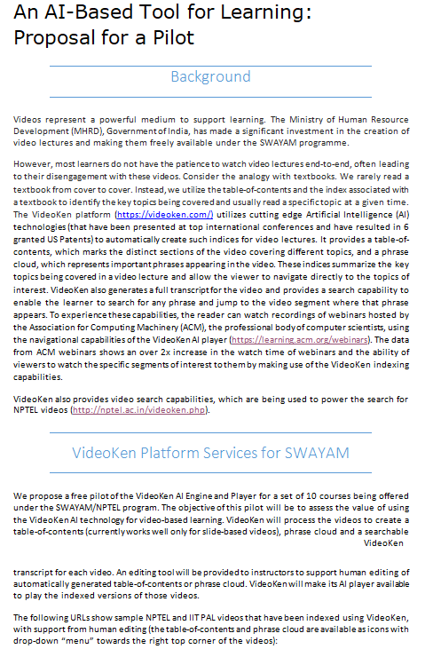

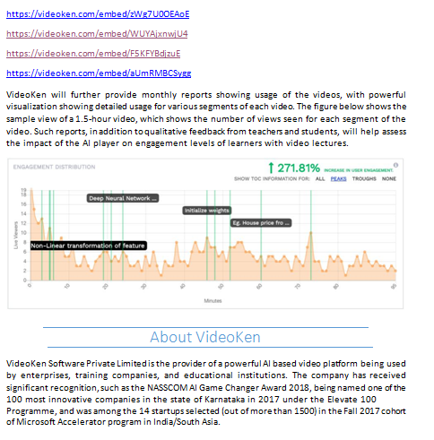

Agenda Item No.13

Items raised by NPTEL
- The Exam dates for NPTEL Exams in the next Semester are 31st March, 27th April and 28th April, 2019. Request that UGC and AICTE may kindly publish this to all their colleges so that no other events are scheduled affecting learners from taking the exams.

- Request to include the GST exemption for exam fees in the next board Minutes.

- NPTEL sent reminder to M/s EdCIL (India) Ltd. to help us make our FB / Twitter Pages get the Official Tag. We have not received any reply from there even after reminders. Request for assistance on this.

- For Conversion of GIAN Courses in MOOCs Format, costing to be done as repurposed course?

Agenda Item No. 14

SWAYAM Prabha - Allocation of Time Slot for YOGA and Allocation of Channel No. 19

1. Allocation of Time Slot for YOGA:

Background:

S-VYASA (Swami Vivekananda Yoga Anusandhana Samsthana), Bengaluru is a Deemed-to-be University offering Courses on YOGA. These courses are offered on SWAYAM Platform also. They feel that void in the field of Yoga Education is because of lacking of demonstrations of Yoga practices in graphic visual form.

They appreciate SWAYAM Prabha initiative of MHRD and suggested that Yoga Education should also be part of SWAYAM Prabha. They have further requested for time slot on SWAYAM Prabha Channel to telecast videos on Yoga Education. The videos will be provided by S-VYASA. (Refer Annexure IV)

Approval is sought to allocate a One Hour Time Slot to telecast Yoga Education videos on a SWAYAM Prabha Channel.

Approval Sought:

Approval of the SWAYAM Board is sought for allocating One Hour Time Slot in one SWAYAM Prabha Channel (presently Channel No. 29) to telecast YOGA Education. Videos to be provided by S-VYASA.

2. Allocation of Channel No. 29

With the completion of QEEE Project, the Channel No. 29 became free. In the SWAYAM Prabha Workshop held on 29.08.2018, INFLIBNET Centre requested that this Channel be allocated to them as they have large number of video programmes for Post Graduate Courses produced under the e-PG Pathshala. So, the Channel was allocated to INFLIBNET Centre. INFLIBNET Centre is currently under discussion with Gujarat Government for contents on English Speaking and Comprehension. Board may kindly allocate Channel No. 29 to INFLIBNET Centre.

Annexure IV

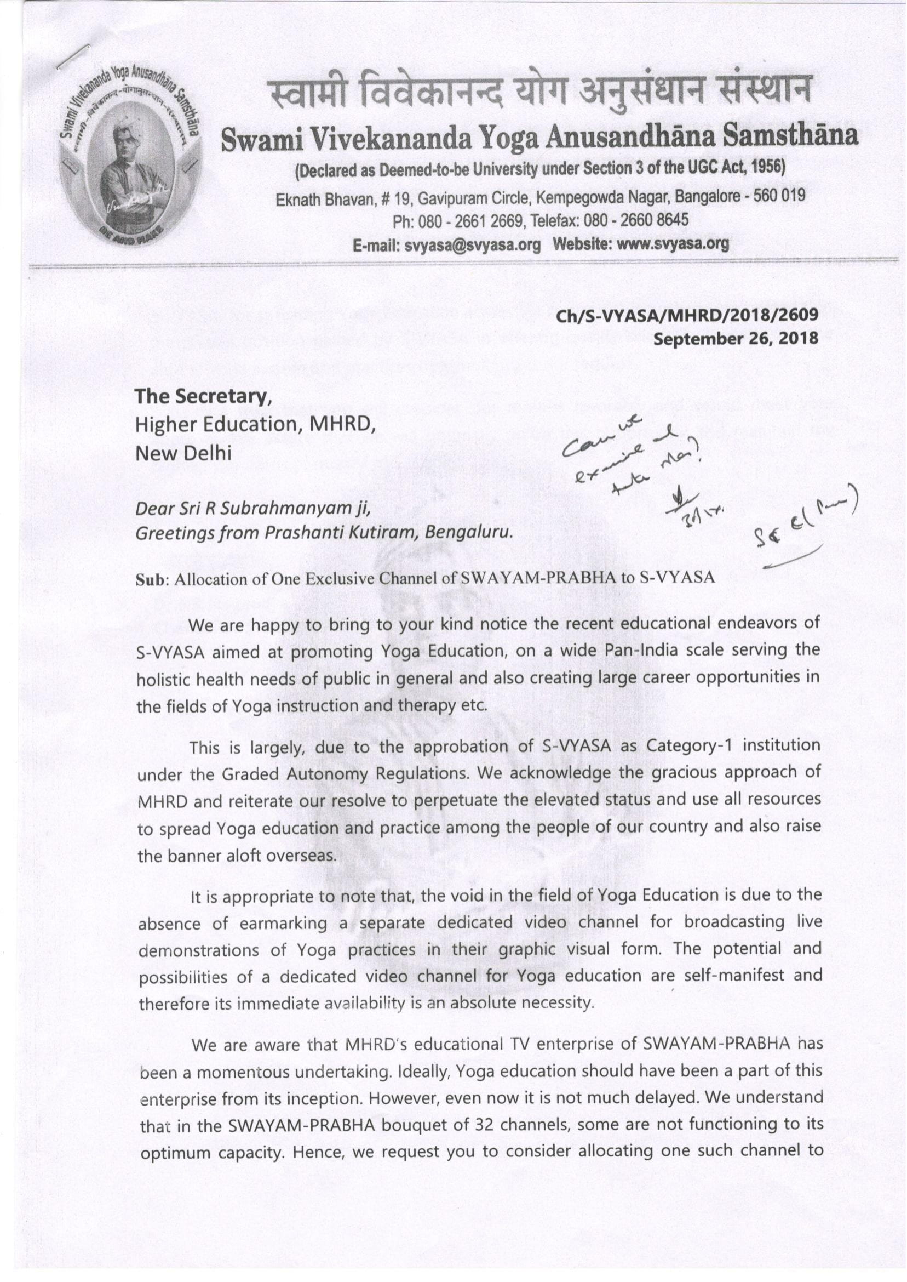

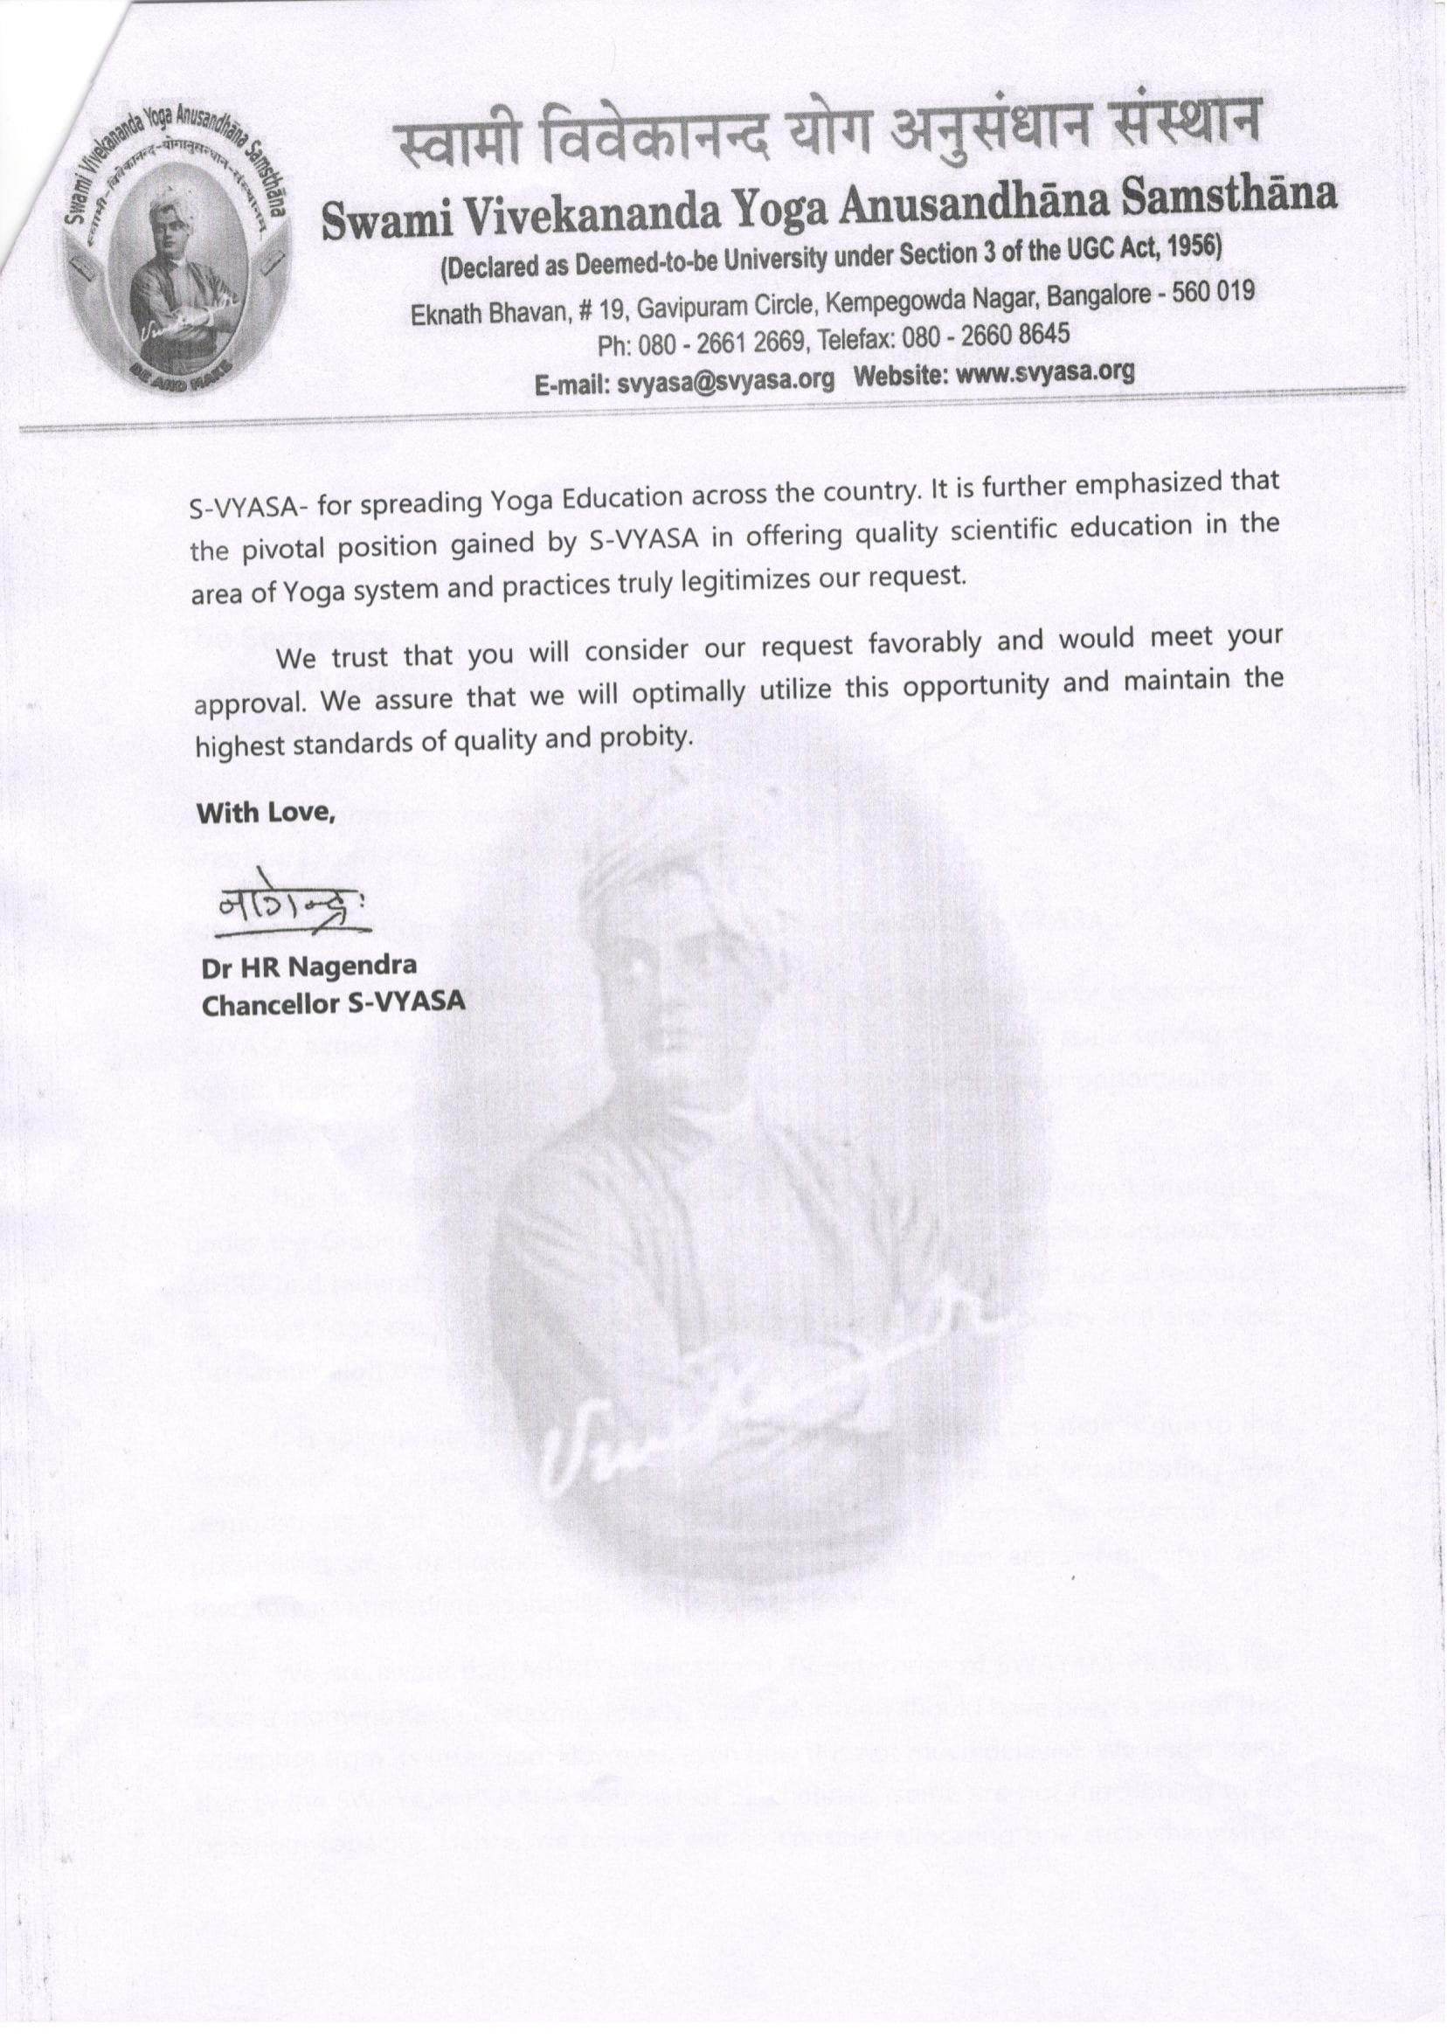

Thank You

